OMB CONTROL NUMBER: 0704-0553

OMB EXPIRATION DATE: 05/31/2025

**AGENCY DISCLOSURE NOTICE**

The public reporting burden for this collection of information, 0704-0553, is estimated to average 5 minutes per response, including the time for reviewing instructions, searching existing data sources, gathering and maintaining the data needed, and completing and reviewing the collection of information. Send comments regarding the burden estimate or burden reduction suggestions to the Department of Defense, Washington Headquarters Services, at whs.mc-alex.esd.mbx.dd-dod-information-collections@mail.mil. Respondents should be aware that notwithstanding any other provision of law, no person shall be subject to any penalty for failing to comply with a collection of information if it does not display a currently valid OMB control number.

**Military Community Support Programs (MCSP) ______________(Installation for the Site Visit)**

**Post-Site Visit Questionnaire**

Please complete this short questionnaire regarding Military Community Support Programs in support of the Site Visit that was held on_________ at________. Your responses will help enhance our understanding of the user experience and shape the briefings we provide to stakeholders after the visit. This questionnaire is anonymous and feedback will not be attributed to individuals. This questionnaire is voluntary and takes typically less than five minutes to complete. Thank you for providing your feedback. (Click the arrow below to continue).

**Level of Familiarity with Military Community Support Programs (MCSP) after attending the Site Visit**

How familiar do you now feel with the following MCSP programs or services after participating on the site visit?

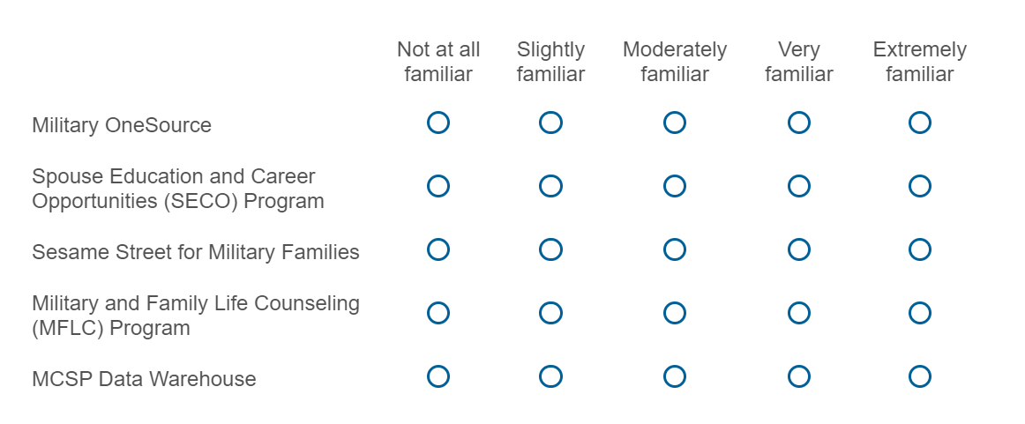

**Post Feedback for Improvement** (Please do not include any personally identifiable information.)

After participating in this site visit, what recommendations would you have for MCSP to increase familiarity of programs such as Military OneSource, SECO, MFLC, and Sesame Street for Military Families? (Write in below)

Did the Site Visit increase your familiarity of programs provided by MCSP, such as Military OneSource, SECO, MFLC, and Sesame Street for Military Families? (Yes or No)