https://survey.foreseeresults.com/store/controller?id=dwwec8v&locale=en&cpp%5btype%5d=qrcode&reload=1
Landing Page drop downs:
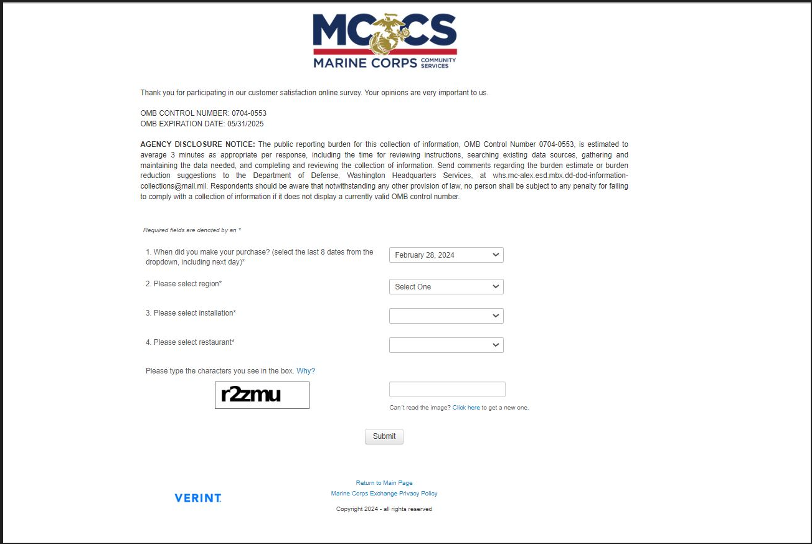
Note: Landing page- drop down details
- Once the region is selected, the second layer populates installation locations.
- Once the installation is selected, the third layer populates restaurant locations.
- See accompanying Excel document for drop down lists.
FEEDBACK SURVEY

- What is your overall satisfaction with your visit to this restaurant?
1=Very Dissatisfied
2
3
4
5 = Very Satisfied

- How likely are you to visit this restaurant in the future?
1=Very Unlikely
2
3
4
5 = Very Likely

- How likely are you to recommend this restaurant to others?
1=Very Unlikely
2
3
4
5 = Very Likely

- Please describe your type of visit.
Dine In
Carry Out
Delivery

- How well did the restaurant's cleanliness meet your expectations?
1=Fell Short
2
3
4
5 = Exceeded

- How well did the service during your visit meet your expectations?
1=Fell Short
2
3
4
5 = Exceeded

- How well did the menu options meet your nutritional needs?
1=Fell Short
2
3
4
5 = Exceeded

- How were your nutritional needs not met (that is, what specific nutritional needs were not met)? Do not include Personally Identifiable Information.

- Please rate the presentation of your order.
1=Fell Short
2
3
4
5 = Exceeded

- Please rate the overall value of your order for the price.
1=Poor Value
2
3
4
5 = Excellent Value

- Is the menu priced affordably for your budget?
Yes
No

Note: Open ended question (last question) provides instruction to not include PII.
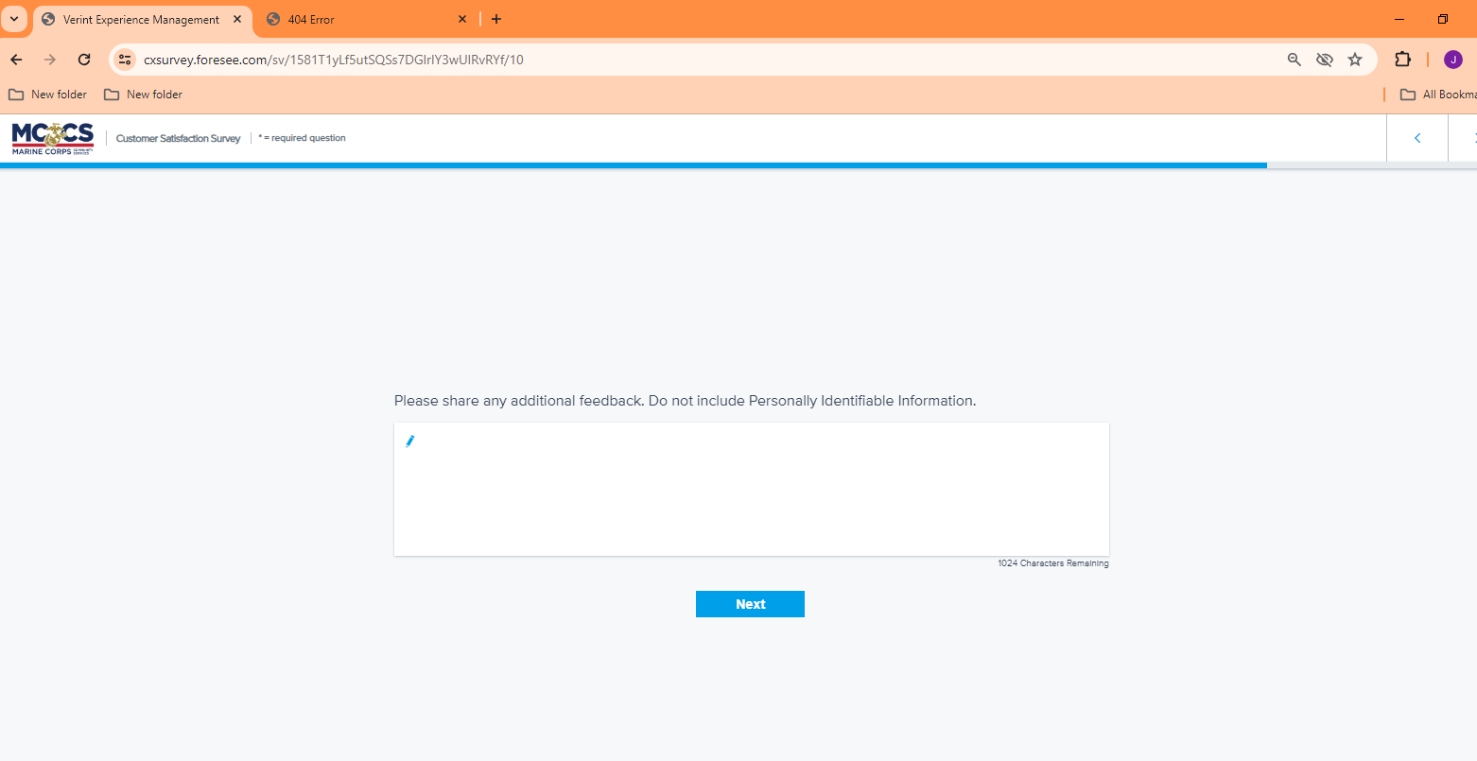

Note for, “Would you like to be contacted by a manager about your experience?”
- If yes – the respondent will receive a ‘follow up’ page (see page4).
- If no – the respondent will receive a ‘thank you’ page (see page 5).
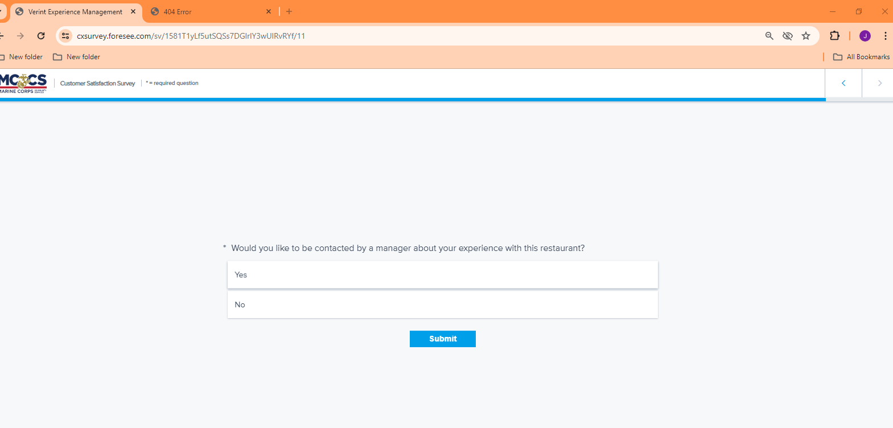

If the respondent selects “yes” to being contacted, they receive the following:
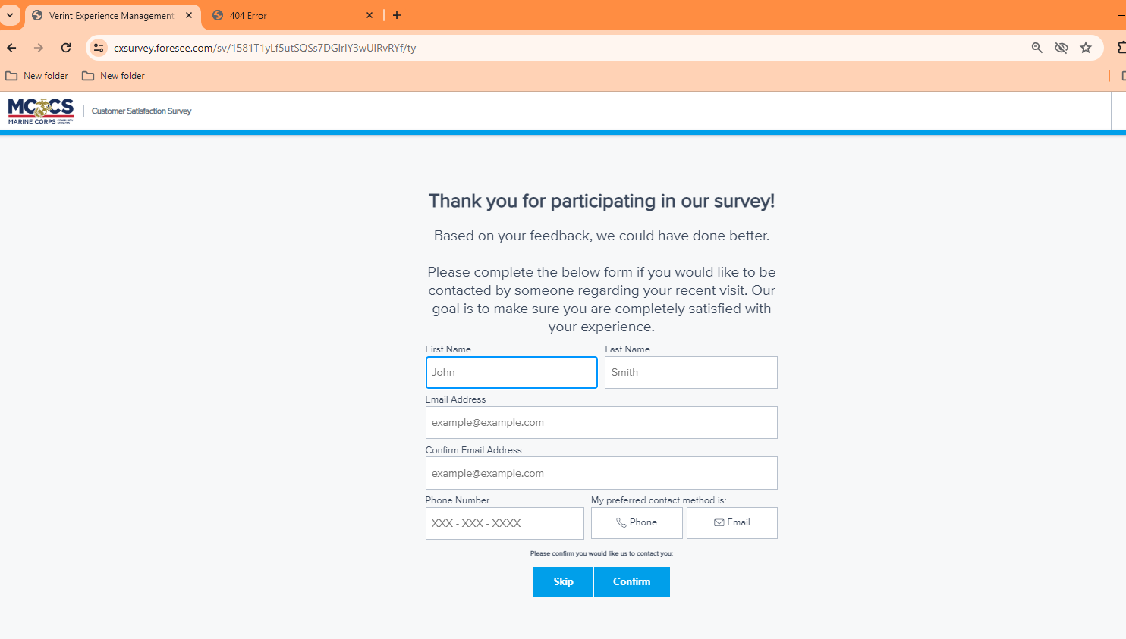

If the respondent selects “no” to being contacted, they receive the following:
