OMB CONTROL NUMBER: 0704-0553
OMB EXPIRATION DATE: 05/31/2025

AGENCY DISCLOSURE NOTICE

The public reporting burden for this collection of information, 0704-0553, is estimated to average 2 minutes per response, including the time for reviewing instructions, searching existing data sources, gathering and maintaining the data needed, and completing and reviewing the collection of information. Send comments regarding the burden estimate or burden reduction suggestions to the Department of Defense, Washington Headquarters Services, at whs.mc-alex.esd.mbx.dd-dod-information-collections@mail.mil. Respondents should be aware that notwithstanding any other provision of law, no person shall be subject to any penalty for failing to comply with a collection of information if it does not display a currently valid OMB control number.

Tier 1, 2 and 3 Helpdesk Customer Satisfaction Feedback

Purpose
Military Community and Family Policy would like to standardize the collection instrument used to receive comments from military service members, their families and related stakeholders. The Application Messaging System is an online resource for use by the public to submit questions, report problems or request assistance from MC&FP websites and applications. The help desk staff will use the system to respond to email, also referred to as webmail. The AMS also enables staff to prioritize webmail messages, assign them to subject matter experts and store the communication thread.
Military Community and Family Policy would also like to gather feedback from military service members, their families and related stakeholders after they submit inquiries through the AMS. This collection covers:
- Customer support inquiry form received from users who have general questions/feedback about the Military OneSource program or website (https://public.militaryonesource.mil/feedback).
- Customer satisfaction feedback form requested from users visiting Military OneSource who have submitted an inquiry using our Customer Support form.
The objectives of the customer satisfaction feedback form are to:
- Assess satisfaction levels and gather insights on Military Community and Family Policy Customer Support
- Identify strengths and areas for improvement based on survey feedback
- Enhance support programs and services for military personnel and their families

Customer Support (Form 1 – initial customer inquiry) (https://public.militaryonesource.mil/feedback)
OMB CONTROL NUMBER: xx / OMB EXPIRATION DATE: xx

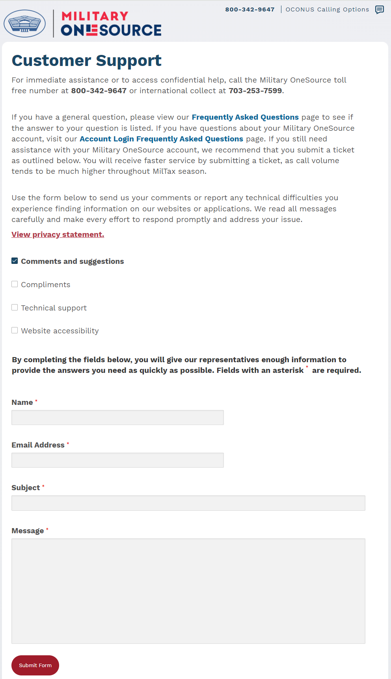

Privacy Act Statement
AUTHORITY: 10 U.S.C. 136, Under Secretary of Defense for Personnel and Readiness; 10 U.S.C. 1788, Additional Family Assistance; 10 U.S.C. Chapter 88, Military Family Programs and Military Child Care, Subchapter I, Military Family Programs; 10 U.S.C. 53, Miscellaneous Rights and Benefits; Directive-type Memorandum (DTM)–17–004, DoD Expeditionary Civilian Workforce; DoD Directive 1322.18, Military Training; DoD Instruction (DoDI) 1342.22, Military Family Readiness; DoDI 6490.06, Counseling Services for DoD Military, Guard and Reserve, Certain Affiliated Personnel, and Their Family Members; and DoDI 1322.26, Distributed Learning (DL).
PURPOSE: To submit and track questions, reports of problems, or requests for assistance with Military OneSource websites and applications.
ROUTINE USES: Disclosure of records are generally permitted under 5 U.S.C. 522a(b) of the Privacy Act of 1974, as amended. To contractors, grantees, experts, consultants, students, and others performing or working on a contract, service, grant, cooperative agreement, or other assignment for the Federal Government when necessary to accomplish an agency function related to this system of records. To the appropriate Federal, State, local, territorial, tribal, foreign, or international law enforcement authority or other appropriate entity when necessary pursuant to a showing of compelling circumstances affecting the health or safety of an individual. Additional routine uses are listed in the applicable System of Records Notice, DPR 45, Military OneSource Business Operations Information System, at: https://www.federalregister.gov/d/2022-27671.
DISCLOSURE: Voluntary, however, failure to provide the requested information may inhibit the ability of Military OneSource to provide a response to your customer support request.

Customer Support Satisfaction Survey (Form 2 – sent to users two days after their customer feedback inquiry is closed)
OMB CONTROL NUMBER: xx / OMB EXPIRATION DATE: xx

Intro text:
Your feedback about our helpdesk support is important in helping us improve your Military OneSource experience. Let us know if Military OneSource is meeting your needs.
View Privacy Policy

Basic survey questions that focus on a user’s interaction with the helpdesk:
1. Did we meet your needs?
No [ ] Yes [ ]
2. Were you satisfied with how responsive we were to your questions or concerns?
No [ ] Yes [ ]
3. Please rate on a scale of 1-5 how easy it was to interact with us.
1 (Very difficult) 2 3 4 5(Very easy)
4. Which features of Military OneSource are the most valuable to you? Please select all that apply.
Non-medical counseling
MilTax
Moving resources
Service provider resources
General military information
Military OneSource is your 24/7 gateway to trusted information, resources and confidential help. When life happens, it’s your “first line of support” — giving service members and military families tools to not just navigate military life, but thrive. Call us anytime at 800-342-9647 or Live Chat — we are here for you.

[SUBMIT]

