**_______ Lake Boating Survey**

**The US Army Corps of Engineers (USACE) is conducting this survey to learn more about boater’s use and perceptions about _______ Lake. You have been provided this survey as an individual identified as leasing a marina slip or holding a dock permit. We will be conducting similar surveys with park visitors and other stakeholders. Collectively the information will help lake managers provide the public with quality outdoor recreation experiences.**

**Your participation is voluntary and the survey will take about 15 minutes to complete. Please complete this survey and return in the prepaid envelope. Responses will be accepted between [date] and [date].**

**AGENCY DISCLOSURE NOTICE**

The public reporting burden for this collection of information, [0710-xxxx], is estimated to average 15 minutes per response, including the time for reviewing instructions, searching existing data sources, gathering and maintaining the data needed, and completing and reviewing the collection of information. Send comments regarding the burden estimate or burden reduction suggestions to the Department of Defense, Washington Headquarters Services, at whs.mc-alex.esd.mbx.dd-dod-information-collections@mail.mil. Respondents should be aware that notwithstanding any other provision of law, no person shall be subject to any penalty for failing to comply with a collection of information if it does not display a currently valid OMB control number.

**PLEASE DO NOT RETURN YOUR RESPONSE TO THE ABOVE ADDRESS.**

**RESPONSES SHOULD BE SENT TO:**

[name and address of data collection contractor]

.

**_______ Lake Boating Survey for Marina Tenants**

1. How many times per year do you typically boat on _______ Lake? ________ times per year

Think about your last boating trip to ______ Lake and answer the following questions:

2. a. Including yourself, how many people were in your boat? __________

b. How many of those were less than 18 years of age? ____________

3. a. How much time to the nearest hour did you spend on the water? (to the nearest hour, select only 1)

🞎 Less than an hour 🞎 1 hour 🞎 2 hours 🞎 3 hours

🞎 4 hours 🞎 5 hours 🞎 6 hours 🞎 7 hours

🞎 8 hours 🞎 more than 8 hours 🞎stayed overnight on the lake

b. What percent of that time would you estimate your boat motor was running? __________%

4. What is the primary type of boat you use? (circle one)

🞎 Runabout/Speedboat/Ski Boat 🞎 Houseboat 🞎 Cabin Cruiser  
 🞎 Pontoon Boat 🞎 Canoe/Kayak 🞎 Fishing Boat  
 🞎 PWC (Jet Ski) 🞎 Sailboat  
 🞎 High Performance Boat (cigarette boat) 🞎 Other: ______________________________

5. What is the length of the primary boat you use? Feet: _____ Inches:______

6. What is the horsepower? ________________

7. Please estimate the amount of time spent the last day you boated on the following activities. (percentages should add to 100%)

If Other, describe activity here:

_______________________

_______________________

|  |  |  |  |
| --- | --- | --- | --- |
| Fishing | ________% | Swimming | ________% |
| Cruising | ________% | Relaxing | ________% |
| Water Skiing | ________% | Sailing | ________% |
| Tubing | ________% | Other: | ________% |

8. Did you pull your boat ashore and step out of your boat to access the shoreline the last time you boated? (check one) 🞎 Yes 🞎 No

For the next three questions, refer to the map below.

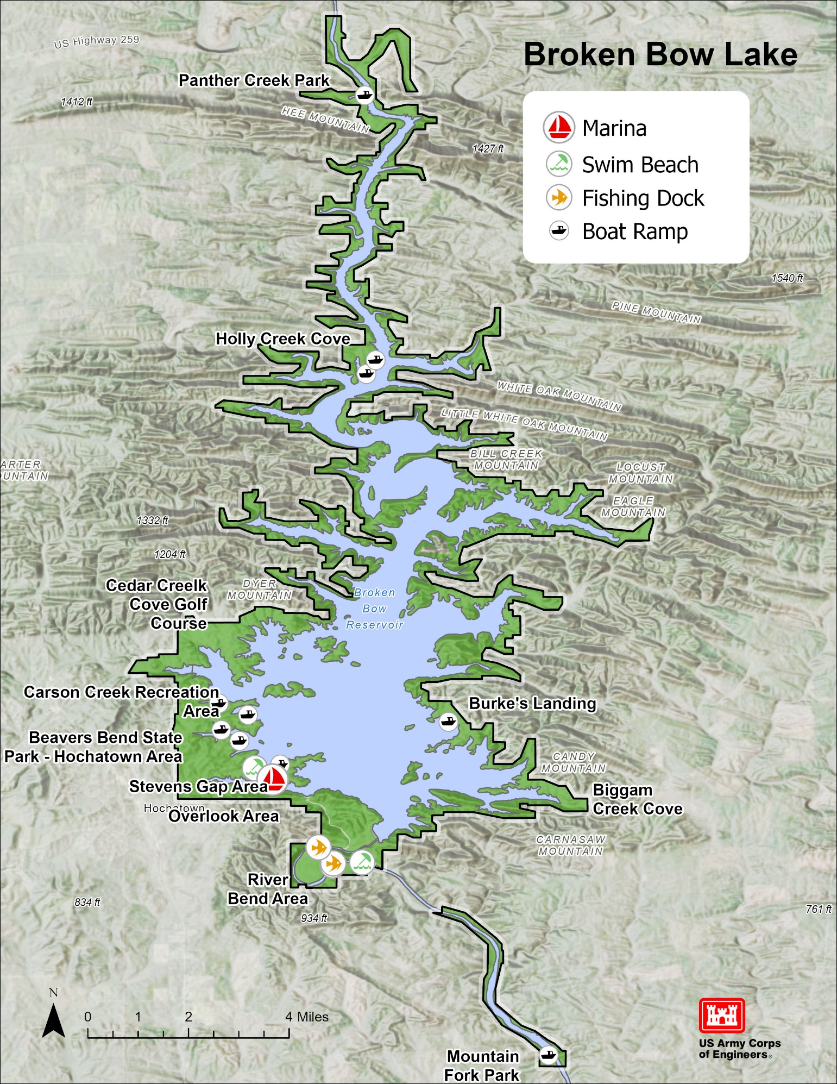

9. Do you have a favorite place to go on the lake? 🞎 Yes 🞎 No

If yes, please circle your favorite place on the lake map and mark with an “F”.

Why is this your favorite location? _________________________________________________________

10. Are there locations you deliberately avoid? 🞎 Yes 🞎 No

If yes, please circle the places you avoid on the lake map and mark with “A1”, “A2”, etc

Why do you avoid these locations? _________________________________________________________

11. Are there locations where you feel unsafe? 🞎 Yes 🞎 No

If yes, circle the places where you feel unsafe and mark with “U1”, “U2”, etc. If this happens to be the same as a place you avoid, only add the “U1”, etc to the marking made in response to prior question.

Why do you feel unsafe in these locations? ___________________________________________________

12. The last time you boated, how safe did you feel at the following locations? Circle your choice.

|  |  |  |  |  |  |
| --- | --- | --- | --- | --- | --- |
| **Location** | **Not at all safe** | **Somewhat safe** | **Moderately safe** | **Very Safe** | **Extremely safe** |
| At the boat ramp when launching your boat | 1 | 2 | 3 | 4 | 5 |
| On the water while boating | 1 | 2 | 3 | 4 | 5 |

13. The last time you boated, did you feel crowded by the number of boaters at the following locations? Circle your choice.

|  |  |  |  |  |  |
| --- | --- | --- | --- | --- | --- |
| **Location** | **Not at all crowded** | **Somewhat crowded** | **Moderately crowded** | **Very Crowded** | **Extremely crowded** |
| At the boat ramp when launching your boat | 1 | 2 | 3 | 4 | 5 |
| On the water while boating | 1 | 2 | 3 | 4 | 5 |
| At the boat ramp when loading your boat? | 1 | 2 | 3 | 4 | 5 |

14. For each of the following, please indicate whether you think there are too many on the lake, the number on the lake is about right, or there needs to be more on the lake. (check one for each )

Boat Ramps 🞎 Too many 🞎 About enough 🞎 more needed

Parking Areas 🞎 Too many 🞎 About enough 🞎 More needed

Water Patrol Officers 🞎 Too many 🞎 About enough 🞎 More needed

Park Rangers 🞎 Too many 🞎 About enough 🞎 More needed

Marinas 🞎 Too many 🞎 About enough 🞎 More needed

15. Have you noticed any positive or negative changes at this lake in the last five years? (check one response)

🞎Yes 🞎No

**IF YES**, , can you describe those changes?

Positive changes: _____________________________________________________________________

Negative changes: ____________________________________________________________________

16. Thinking back to your most recent boating experience at ____________ Lake, we would like to know if you agree or disagree with the following statements. Please circle the number that best represents your level of agreement where 1 is strongly disagree and 5 is strongly agree.

|  |  |  |  |  |  |
| --- | --- | --- | --- | --- | --- |
| **Statement** | **Strongly Disagree** | **Disagree** | **Neutral** | **Agree** | **Strongly Agree** |
| The overall quality of my experience has been positive. | 1 | 2 | 3 | 4 | 5 |
| The level of noise from motorized boating is acceptable to me | 1 | 2 | 3 | 4 | 5 |
| The quality of water is acceptable to me. | 1 | 2 | 3 | 4 | 5 |
| The traffic on the water from motorized boats is acceptable to me. | 1 | 2 | 3 | 4 | 5 |
| The size of the boats that I saw is acceptable. | 1 | 2 | 3 | 4 | 5 |

17. What is the city, state and zip code of your primary residence?

City: __________________________ State: _____ Zip: ________________

18. Do you have any additional comments? (Write comments below)

Please mail in your survey no later than [date} to:

Attn: [name and address of data collection contractor]

THANK YOU FOR YOUR TIME