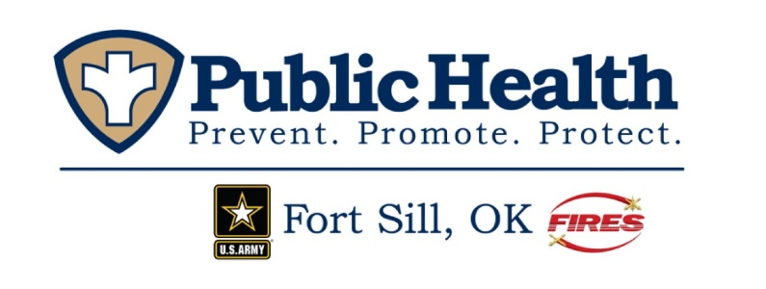

Public Health Messaging Survey
Help us improve our public health education messaging! Please take a moment to answer the following questions. Your feedback will assist the Fort Sill Department of Public in developing meaningful health education for our community.

OMB CONTROL NUMBER: 0704-0553
OMB EXPIRATION DATE: 05/31/2025

AGENCY DISCLOSURE NOTICE

The public reporting burden for this collection of information, 0704-0553 is estimated to average 5 minutes per response, including the time for reviewing instructions, searching existing data sources, gathering and maintaining the data needed, and completing and reviewing the collection of information. Send comments regarding the burden estimate or burden reduction suggestions to the Department of Defense, Washington Headquarters Services, at whs.mc-alex.esd.mbx.dd-dod-information-collections@mail.mil. Respondents should be aware that notwithstanding any other provision of law, no person shall be subject to any penalty for failing to comply with a collection of information if it does not display a currently valid OMB control number.

- How do you prefer to receive health information?
In writing (brochure, pamphlet, etc.)
Face to face
Social Media
Other:___________________________________

- What types of health information are you interested in receiving? Select all that apply.
Hearing health/ Tinnitus
Sexually Transmitted Infections/ HIV
Tobacco Cessation
Water and food safety
Home environment safety (mold, lead, etc.)
Heart Health
Nutrition
Physical Fitness
Communicable disease
Occupational Health
Behavioral/ Emotional Health
Sleep
Personal Hygiene in the field
Other_____________________________________

- What Social Media platform do you prefer to receive information?
Facebook
Instagram
X
YouTube
TikToK
LinkedIn
Other_________________________________________

4. What catches your attention on a social media post or written literature (brochure, pamphlet)?

5. What is important to you when learning new health information?

