The following webinar feedback survey question screenshots exhibit the questions to be used during a live, recorded webinar.

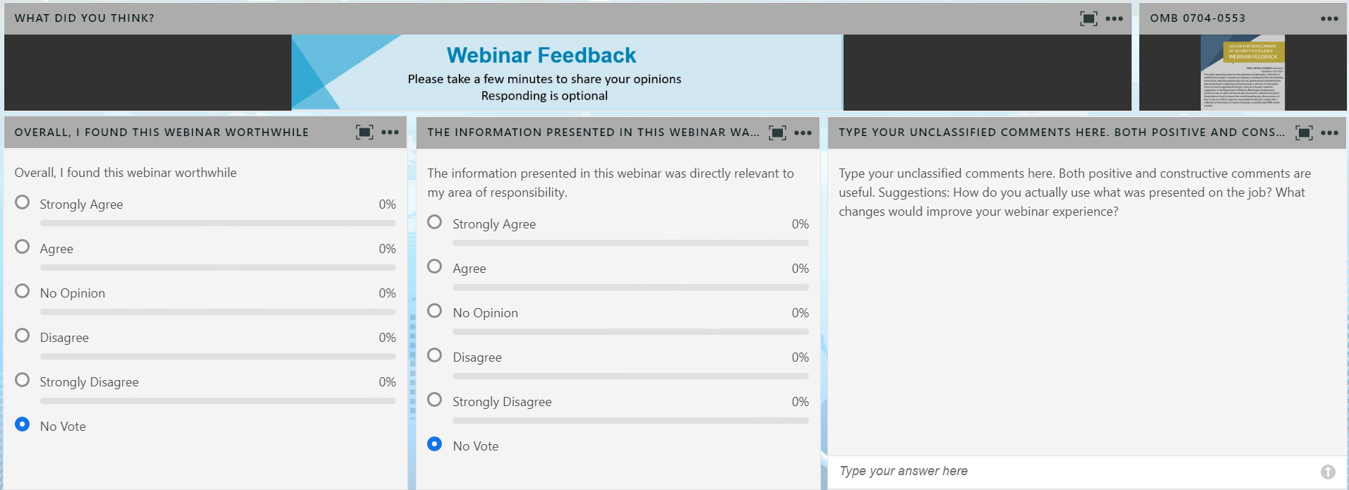

Following is the enlarged text of the current Agency Disclosure Notice (ADN) included in the upper right hand corner of the screen capture:

Agency Disclosure Notice

---

OMB CONTROL NUMBER: 0704-0553

Expiration date: 5/31/2025

The public reporting burden for this collection of information, 0704-0553, is estimated to average 3 minutes per response, including the time for reviewing instructions, searching existing data sources, gathering and maintaining the data needed, and completing and reviewing the collection of information. Send comments regarding the burden estimate or burden reduction suggestions to the Department of Defense, Washington Headquarters Services, at [whs.mc.alex.esd.mbx.dd-dod-information-collections@mail.mil](mailto:whs.mc.alex.esd.mbx.dd-dod-information-collections@mail.mil). Respondents should be aware that notwithstanding any other provision of law, no person shall be subject to any penalty for failing to comply with a collection of information if it does not display a currently valid OMB control number.