Sample West Point Band Communications to Potential Survey (0704-0553) Respondents

Sample Live Concert Announcements

1. “Thank you for attending today’s performance! We hope you enjoyed it as much as we enjoyed performing for you. If you’d like to provide your thoughts and feedback directly to us, we now have a short survey available to our audiences! It should only take about ten minutes, and all responses are optional and anonymous. Please go to [insert URL here] to participate.”

2. Static or electronic display (if either are utilized) with QR code. Sample display:

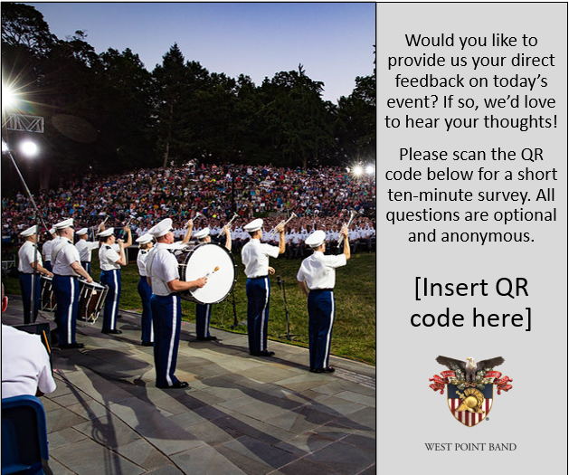

Sample Social Media Post

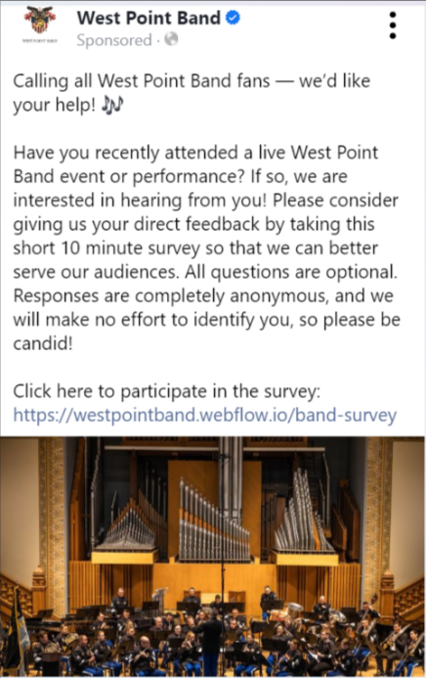
Sample Email Communication

Portion of email to bring awareness to survey:

Have you recently attended a live West Point Band event or performance? If so, we are interested in hearing from you! Please consider giving us your direct feedback by taking this short 10-minute survey so that we can better serve our audiences. All questions are optional. Responses are completely anonymous, and we will make no effort to identify you, so please be candid! Please click the link below to participate:
[Insert link here]

