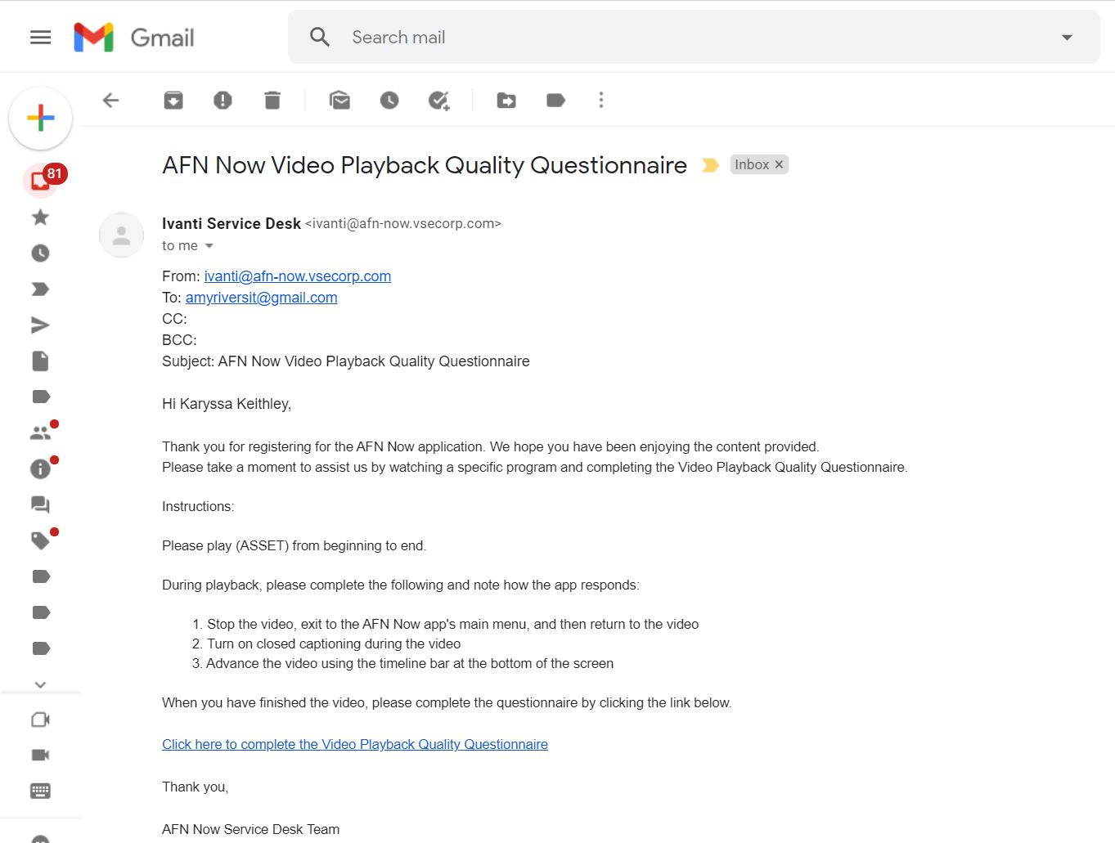
AFN Now Service Desk Questionnaire
AFN Now Service Desk Questionnaire
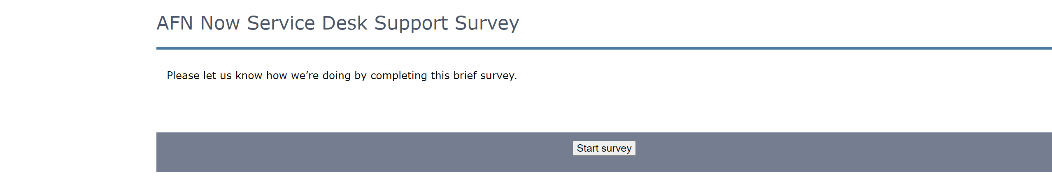
AFN|now Satisfaction Survey
OMB CONTROL NUMBER: 0704-0553
OMB EXPIRATION DATE: XX/XX/XXXX
RCS: DD-PA-XXXX

AGENCY DISCLOSURE NOTICE

The public reporting burden for this collection of information, OMB 0704-0553, is estimated to average five minutes per survey response, including the time for reviewing instructions, searching existing data sources, gathering and maintaining the data needed, and completing and reviewing the collection of information. Send comments regarding the burden estimate or burden reduction suggestions to the Department of Defense, Washington Headquarters Services, at whs.mc-alex.esd.mbx.dd-dod-information-collections@mail.mil. Respondents should be aware that notwithstanding any other provision of law, no person shall be subject to any penalty for failing to comply with a collection of information if it does not display a currently valid OMB control number.

PURPOSE: To collect end-user feedback on the AFN|now application registration process, platform content, application functionality, and service desk experience.
