OMB CONTROL NUMBER: 0704-0553
OMB EXPIRATION DATE: 05/31/2025

AGENCY DISCLOSURE NOTICE
The public reporting burden for this collection of information, OMB Control Number 0704-0553, is estimated to average 60 minutes as appropriate per response, including the time for reviewing instructions, searching existing data sources, gathering and maintaining the data needed, and completing and reviewing the collection of information. Send comments regarding the burden estimate or burden reduction suggestions to the Department of Defense, Washington Headquarters Services, at whs.mc-alex.esd.mbx.dd-dod-information-collections@mail.mil. Respondents should be aware that notwithstanding any other provision of law, no person shall be subject to any penalty for failing to comply with a collection of information if it does not display a currently valid OMB control number.

Personal Data (verify information provided by the Installation POC) (1 min)

Installation: _______________________________

Segment (check all that apply):
___ Core Marine
___ Career Marine
___ Spouse (of Active-Duty Marine)
___ USMC Retiree
___ USMC Veteran (authorized patron)
___ DOD Civilian (authorized patron)

Code Name: _______________________________ (may be added at end of session)
Rank: _______________________________ (or role/position, for civilians)

Sex: Male / Female
Age Bracket: 17-20 / 21-25 / 26-30 / 31-35 / 36-40 / 41-45 / 46-50 / 51+

Marital status: ________________________
Children: Yes, live with / Yes, live apart / No

Housing: On Base /Off Base; Government / Private

Other:

Introduction:

Hi, I’m [name] and I’m from a consulting firm that’s been hired by Marine Corps Community Services to better understand your lifestyle and the activities that make up your day, week, or even year for that matter. It’s through this and many other similar conversations that we’ll gather and analyze the truths that we hear so that we can help the Marine Corps provide better solutions that will improve your quality of life in both small and more meaningful ways. We will be saving your responses by generic identifiers, not your name, and to protect your confidentiality, please do not provide your personally identifiable information (PII) in your responses.

So, if that makes sense to you, we’re going to start at 30,000 feet.
SECTION 1 Interviewer to read aloud: Please do not provide any Personally Identifiable Information (PII) in your responses.
(5 mins)
Insight: Open them up and center them on the topic of their emotional connection to the MC.

Core Marine/Career Marine:
Ask: Why did you become a Marine?
Follow ups:
- What’s the best thing about being a Marine?
- What’s the worst thing about being a Marine?

Spouse:
Ask: From a personal identity perspective, how would you describe yourself?
Follow ups:
- What’s your relationship to the Marine Corps?
- What’s good, or bad, about that?

Retiree:
Ask: What do you miss most about the Marine Corps?
Follow ups:
- What do you miss least?
- What’s your current relationship with the Marine Corps?

Veteran:
Ask: What do you miss most about the Marine Corps?
Follow ups:
- What do you miss least?
- What’s your current relationship with the Marine Corps?

DOD:
Ask: From a personal identity perspective, how would you describe yourself?
Follow ups:
- What’s your relationship to the Marine Corps?
- What’s good or bad about that?

ALL:
Ask: Are you familiar with MCCS and its offerings?
- (If yes) What do you think of MCCS?
- Would you recommend MCCS programs and services to your family or friends?
Follow ups:
- What are MCCS’ strengths?
- What are MCCS’ weaknesses?

SECTION 2 (Please read aloud) Please do not provide Personally Identifiable Information (PII) in your responses.
(Time 14)
Insight: We want to understand how they define their JOBS TO BE DONE (their needs) and how it fits into their Duty Balance Cycle.

ALL:
Ask: This is the Duty Balance Cycle. We learned that work –or duty– is balanced with 'reset' -- time to recenter yourself to stay at your best. What can get in the way of keeping that balance are necessary chores, or the things needed to 'Get Stuff Done.' I’d like you to sort the cards in each group based on what fits your needs today. Does this Duty Balance Cycle match your experience?

Card Sort Exercise: This exercise will be used to explore what are the needs that are relevant and represent an unmet need –or problem to solve- for them today. Needs are represented as group cards.
Ask: Using the cards, can you please sort into two categories: ‘For Me’ (things that are relevant to your needs today) and ‘Not for Me.’
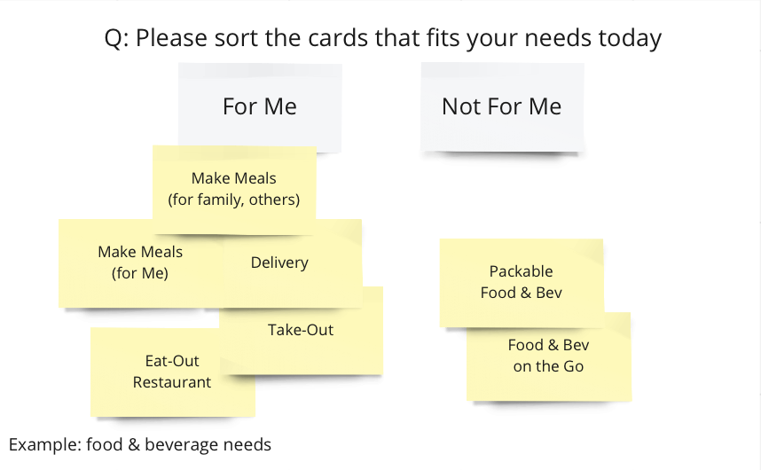
Follow-up:
- What is missing from these cards? [add new card(s)]
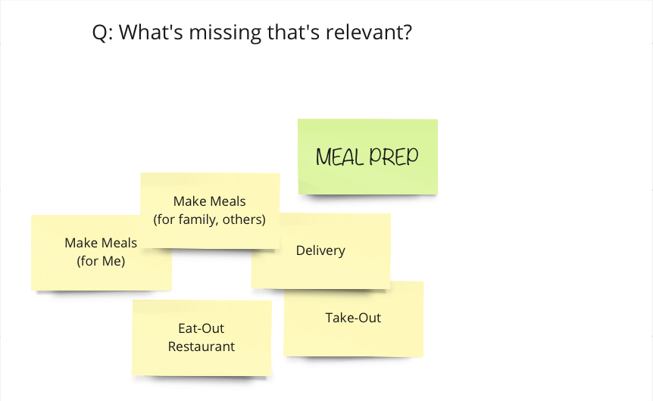
Ask: Prioritize your list by ‘most frustration’ (open to solutions) to ‘least frustration’ (I have a solution).
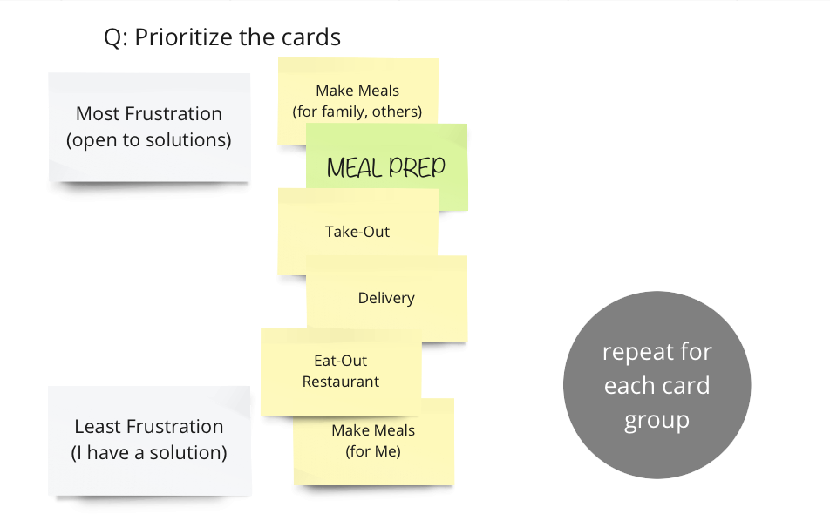

Repeat for each card group

Ask: Choose the top three cards that reflect where you're open to new solutions that can be found on-base or on-line.
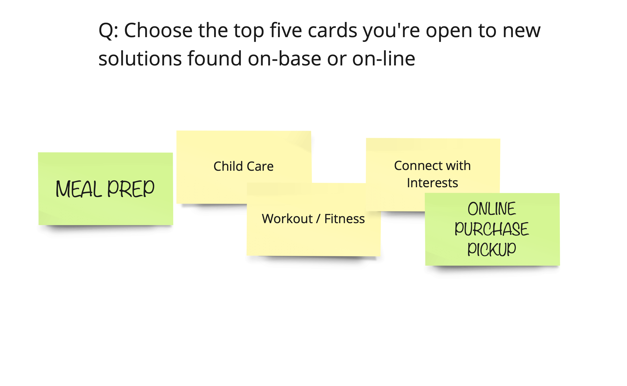

Ask: Of the cards we reviewed for ‘recharge,’ which is your off-work time, are there any things that we’ve missed?

Follow-up:
- What’s your most-preferred activity off-duty, off-base?
- What’s you most-preferred activity off-duty, on-base?
- What do you like to do to relax when you are on liberty or leave?

List of Cards to be used for Card-Sort Exercise
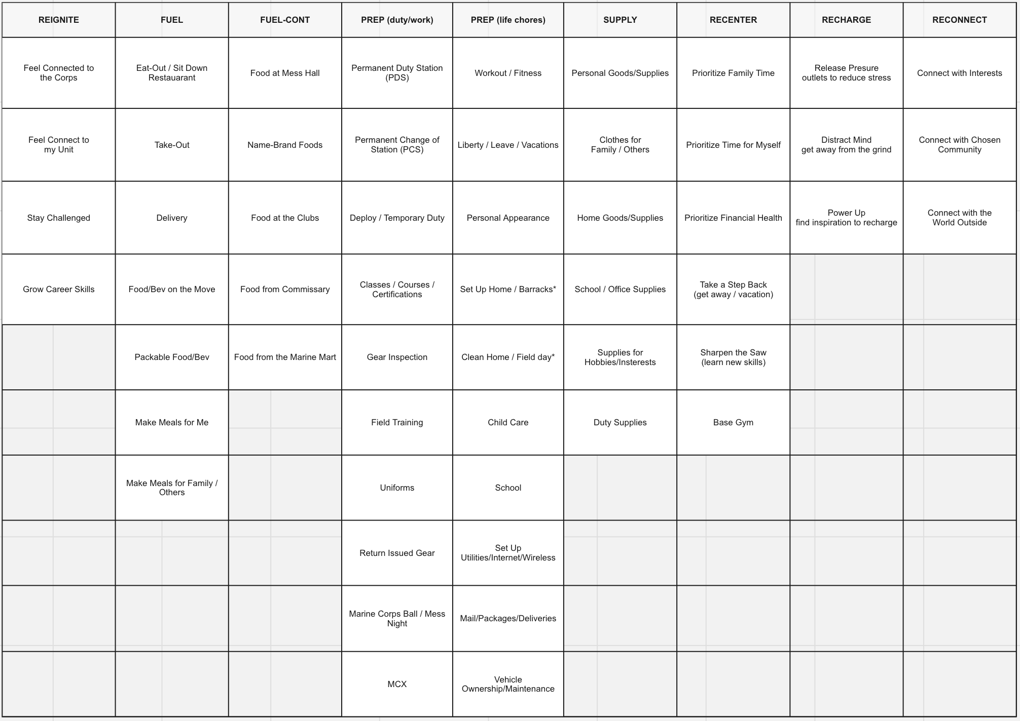

SECTION 3 3 (Please read aloud) Please do not provide Personally Identifiable

(Time 6)
Insight: In this section, we're taking a deeper dive into the areas (places, services, or experiences) that make them happy or frustrated, and the companies/brands that are most associated with those moments, as these are areas that might present the best opportunity for MCCS to connect them emotionally with the appropriate offering.

Ask: During the course of your day, month, year, life… what are the things, activities, or places that make you (or your family) HAPPY?
Follow-up/ For each activity that makes them happy, ask:
- What brands/companies do you associate with those activities and why those brands?
- Why them over the equivalent MCCS offering, and if so, how did it compare?

Ask: Now let's move to the exact opposite. During your day, month, or year, what are the things, activities, or places that cause you (or your family) strain, pressure, or frustration?
Follow-up/ For each activity that frustrates them, ask:
- What brands are associated with those frustrations (if there are companies causing the issues)?
- (If the brands aren’t a MCCS brand): Have you tried the MCCS alternative, and if so, how did that compare?

SECTION 4

(Time 20)
Insight: In this section we're uncovering insights into their perception and usage of the various MCCS offerings relative to alternative brands. We want to discover how we make the offerings more desirable to the various audiences.

GENERAL
Ask:
- (If on base) What stores, products, or services do you feel you need to go off base for?
- (If off base) What stores, products, or services would you consider coming back to the base for?
- Of those you just mentioned, which would you consider ordering online?

RETAIL
Ask: In the category of retail stores, what are the top 5 non-food related stores (department, convenience, electronics, clothing, etc.) that you frequent most?
Follow-up:
- Why do you choose those particular brands?
Follow-up / prompt if they don’t specify: what about online retail?
- Do you shop online, and if so, which websites do you frequent most?
Follow-up:
Let's talk about the Marine Corps specific offerings. I want to know if you've shopped at these specific locations and if so, what your experience was like. We'll start with the MCX.
MCX:
- Have you ever shopped at the MCX and if so, with what frequency?
  - (If yes) Would you recommend it to your family or friends?
- What are your feelings about the experience?
- What do you buy most frequently at the MCX?
- Are you satisfied with the selection?
- Is there anything that frustrates you about the store?
- Quadrant activity: position against ease and value

Quadrant Exercise: This exercise will be used with many of the categories to provide insight into the relative position of the MCCS offering versus other brands in the consideration set.
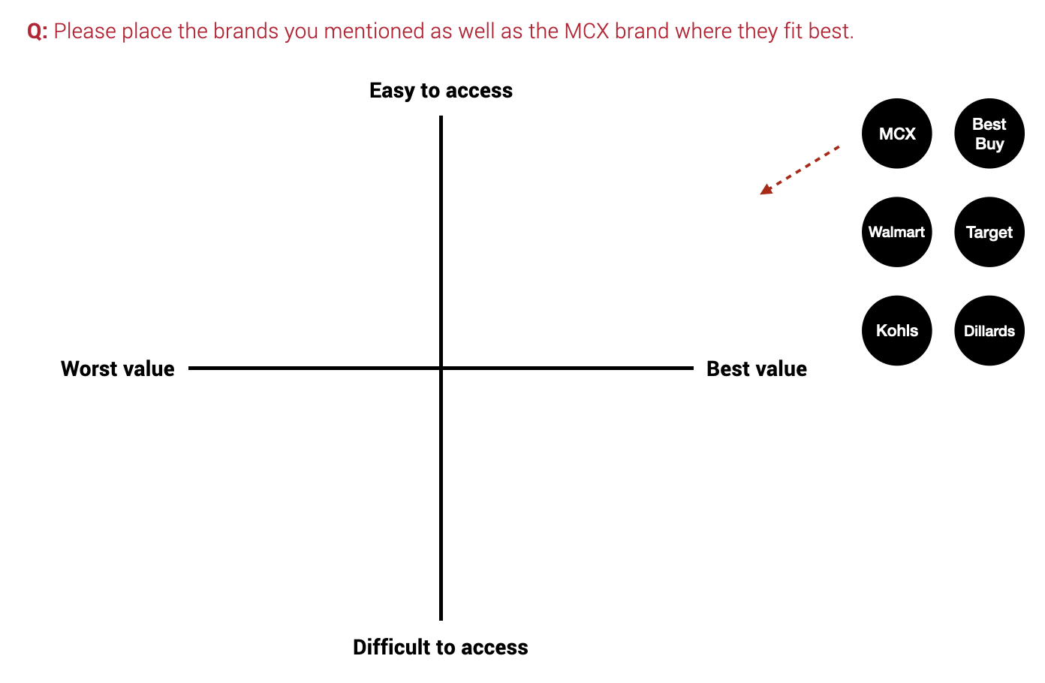
Follow-up:
- Have you ever tried shopping at the MCX online?
  - If "Yes" ask: How would you characterize the experience?
  - If Amazon's online shopping experience is a 9 out of 10, where would you rank the MCX online shopping experience?

MCX Marine Mart:
- Do you ever shop there, and if so, how often?
  - (If yes) Would you recommend it to your family or friends?
- What are your feelings about the experience?
- What do you buy most, and are you satisfied with the product selection?
- Is there anything that frustrates you about the store?
- Quadrant Exercise: position against ease and value
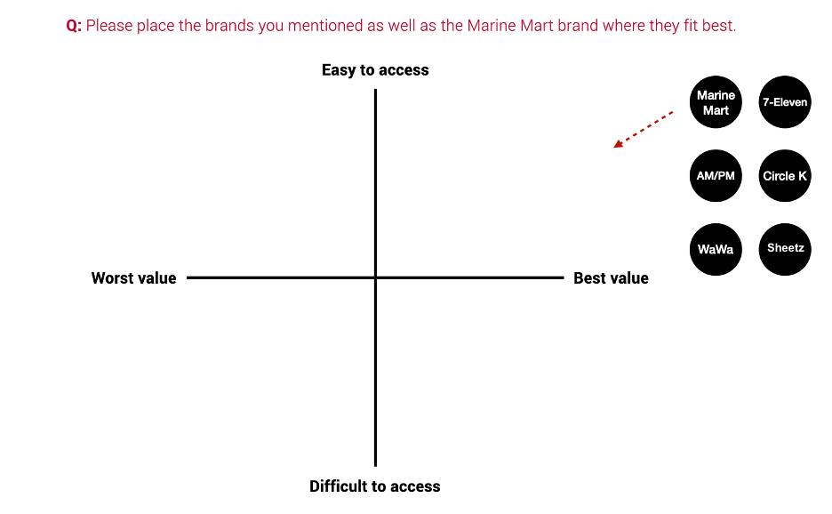

FOOD
Ask: In the category of food in general and meals and snacking, how would you describe your daily or weekly approach to eating?

Follow-up:
- I'd like to explore some specific areas related to food and meals.
Groceries:
- Where and how do you shop for groceries?
- How frequently do you buy food at the MCX or the Marine Marts?
    - (If yes) What are your feelings about the experience?
    - Is there anything that frustrates you about the store's food offering?
- Do you have any groceries or home supplies delivered on a regular basis or by subscription?
  - If yes, what are the items and what’s the frequency?

Fast Casual and Fine Dining:
- Do you ever go to fine dining or fast casual restaurants on base (e.g., the clubs)?
- What are your feelings about the experiences?
- What could make those experiences better?
- Would you like online ordering or home delivery from these locations?

Grab and Go Pre-Prepared Foods:
- Do you ever buy grab and go snacks or meals, and if so, from where?
- What do you look for in this type of food?
- Do you ever buy prepared food at the MCX, Marine Marts, or base cafes?
  - If yes, what are your feelings about the experience?
  - What could be done to improve that experience?
- When it comes to grab and go food, how important would online ordering for fast pick-up be? How important would delivery be?

Follow-up:
- When thinking about delivery (to where you live, not the gate), please place the various food categories discussed in their proper location on the following chart:
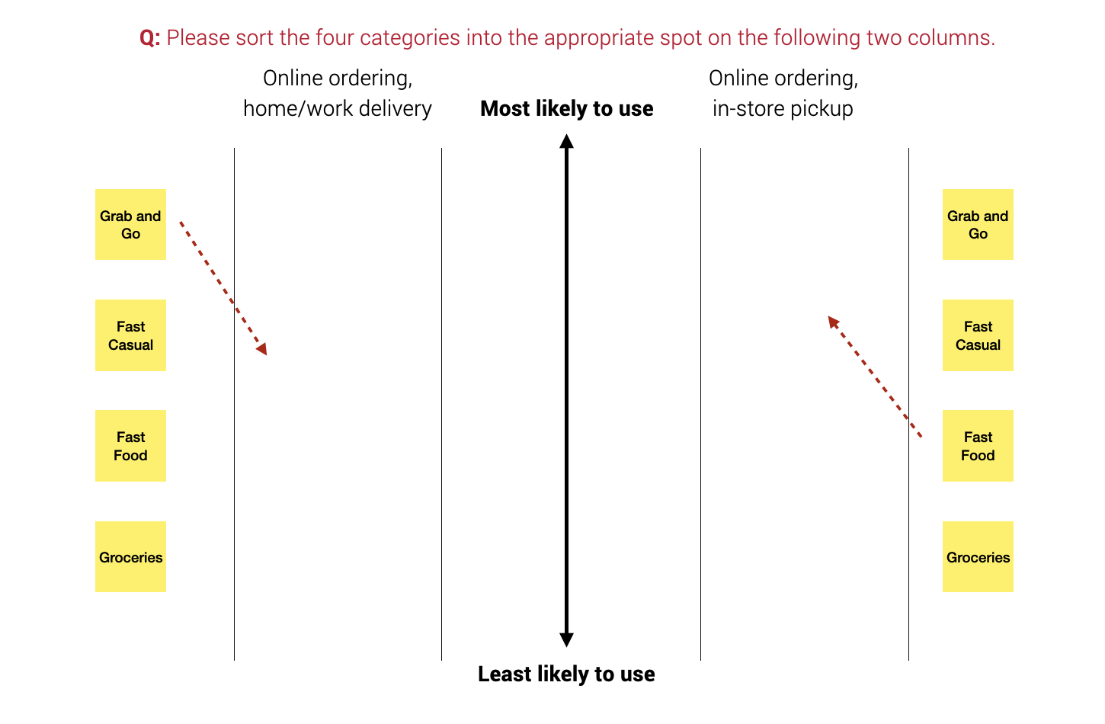
  - Would your "home/work delivery" answers change if the delivery were to the gate rather than to where you live?
  - We've talked a lot about food, but in general, what would you say are your biggest frustrations when it comes to the food offering available on base?

PHYSICAL FITNESS
Ask: Where do you work out?
  - (If MCCS) Would you recommend it to your family or friends?
- What are your feelings about the experience at your facility?
- (If not a MC facility) Why do you choose that over the on base facility?

RECREATION (Show them the visual of the offerings to focus them on the category)
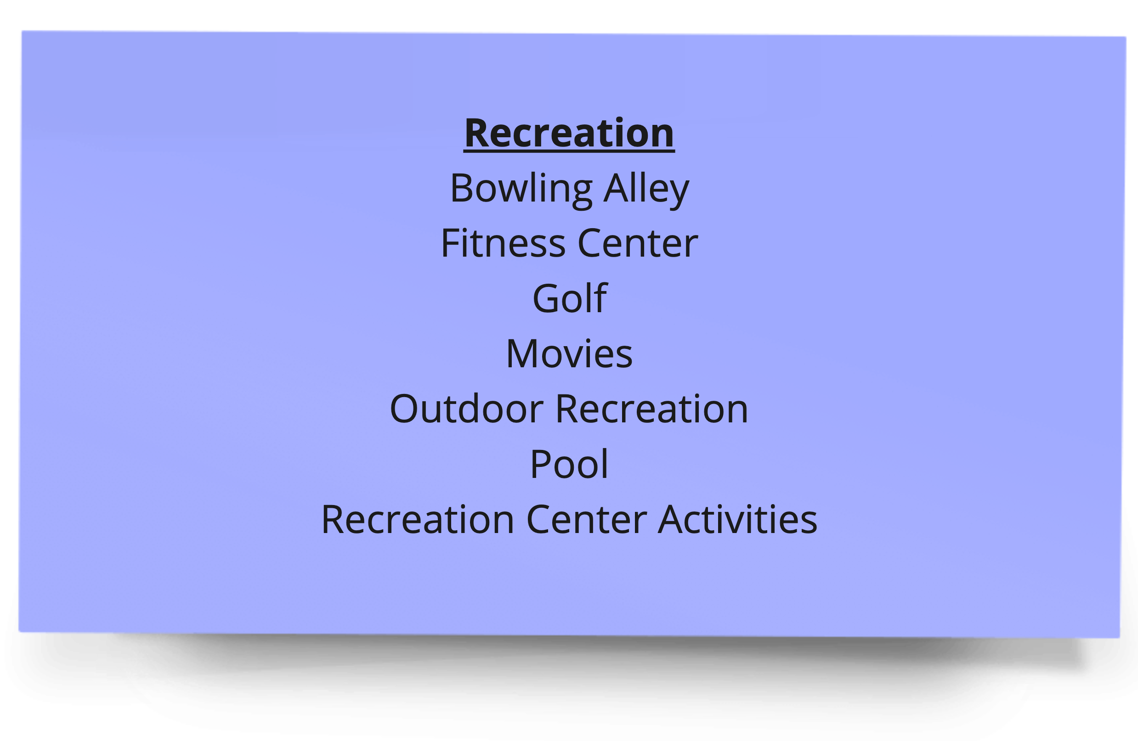
Ask: What MC recreational facilities do you use, and how frequently do you use them?

Follow-up:
- (If yes) Would you recommend it to your family or friends?
- What are your feelings about the experience?
- What could be improved?

CLUBS (Show them the visual of the offerings to focus them on the category)
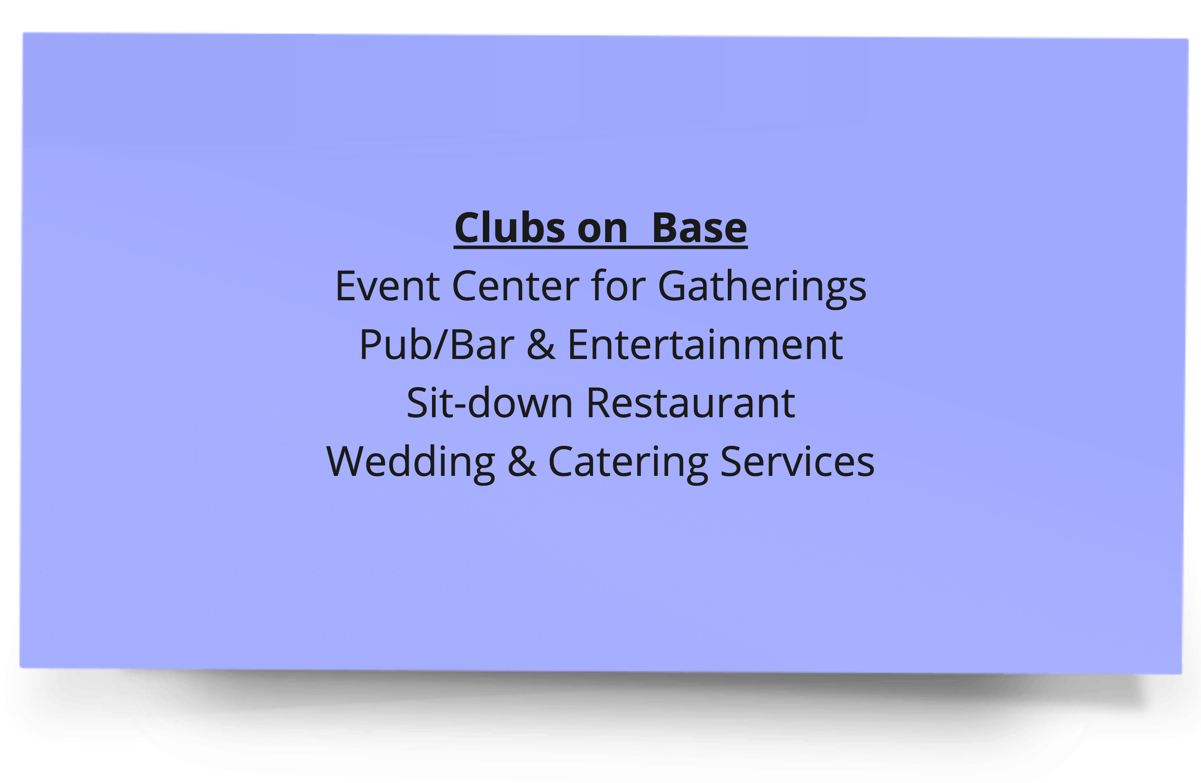
Ask: Do you ever frequent the club?
- (If yes) Would you recommend it to your family or friends?
- What do you most visit the club for?
- What are your feelings about the experience?
- Are you satisfied with the quality?
- Is there anything that frustrates you about the club?
- What could make it a better experience?
- On a scale of 1 to 5, where one is not interested at all and 5 is extremely interested, how interested would you be in online ordering or delivery from the club?

PERSONAL & PROFESSIONAL READINESS
(Show them the visual of the offerings to focus them on the category)
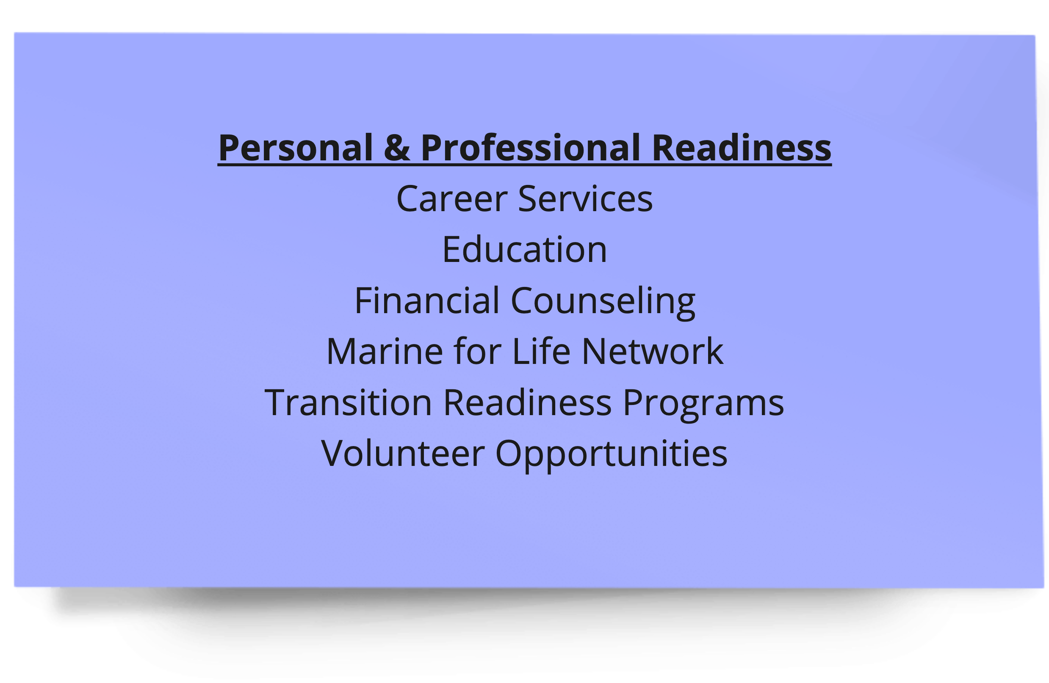
Ask: Are you aware of and/or have you utilized the service?
  - (If yes) Would you recommend it to your family or friends?
- What are your feelings about the experience?
- Are you satisfied with the quality?
- Is there anything that frustrates you about the offering?

TAKING CARE OF FAMILY
(Show them the visual of the offerings to focus them on the category)
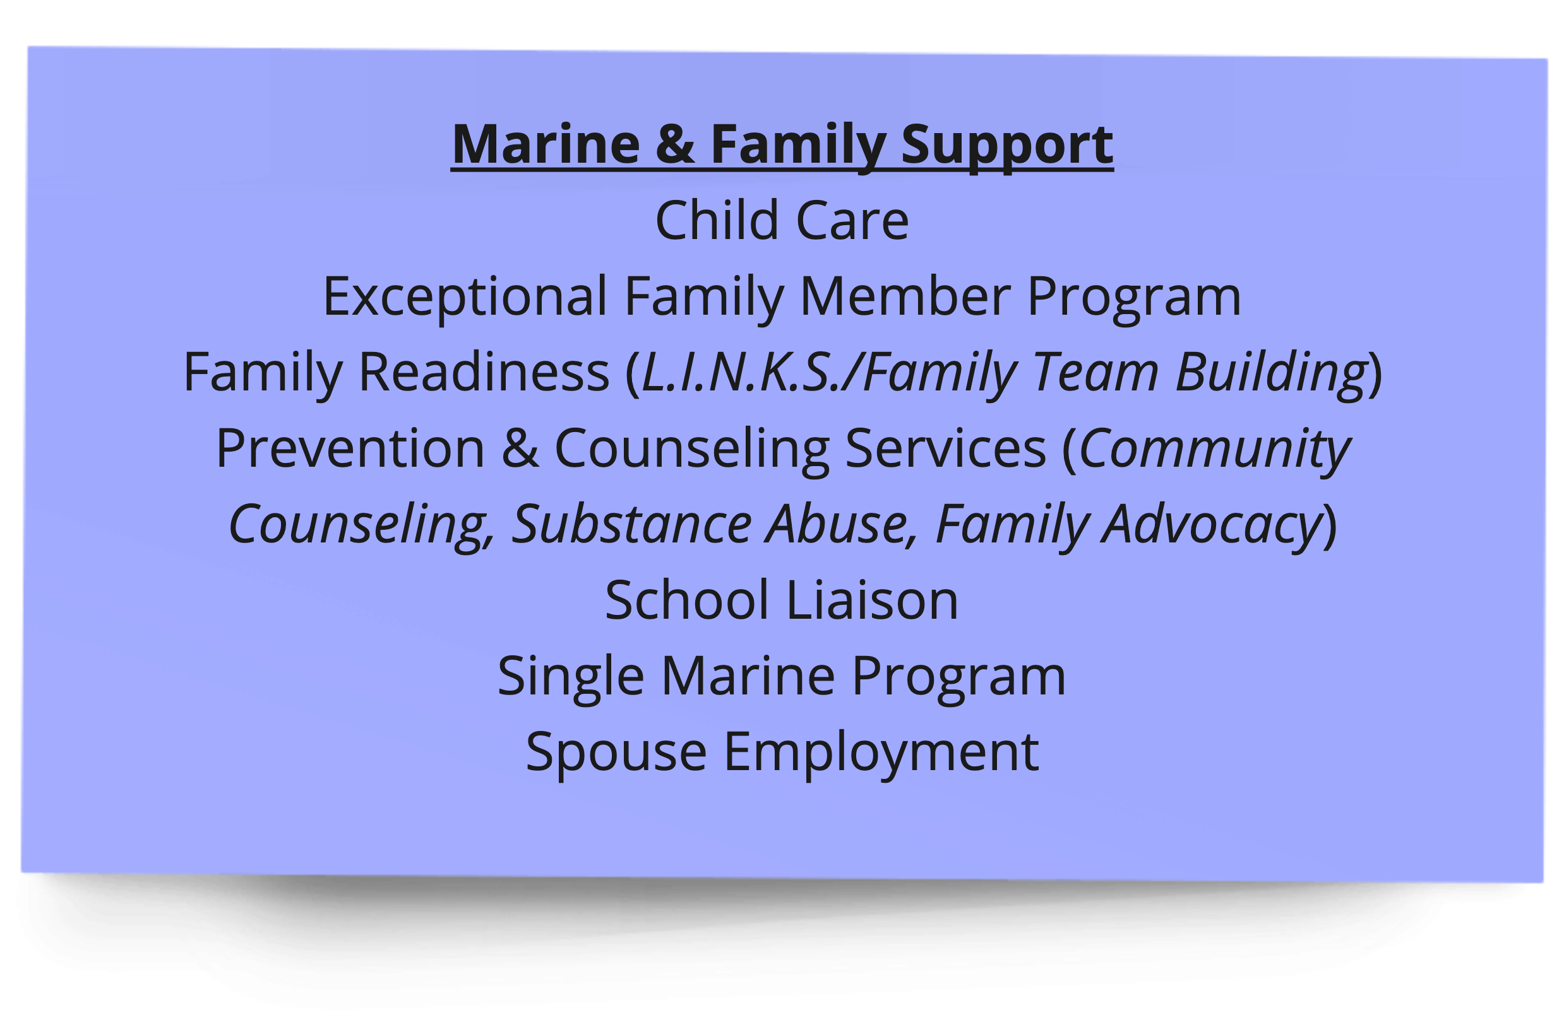
Ask: Are you aware of and/or have you utilized the service?
  - (If yes) Would you recommend it to your family or friends?
- What are your feelings about the experience?
- Are you satisfied with the quality?
- Is there anything that frustrates you about the offering?

SOCIAL CONNECTEDNESS
(Show them the visual of the offerings to focus them on the category)
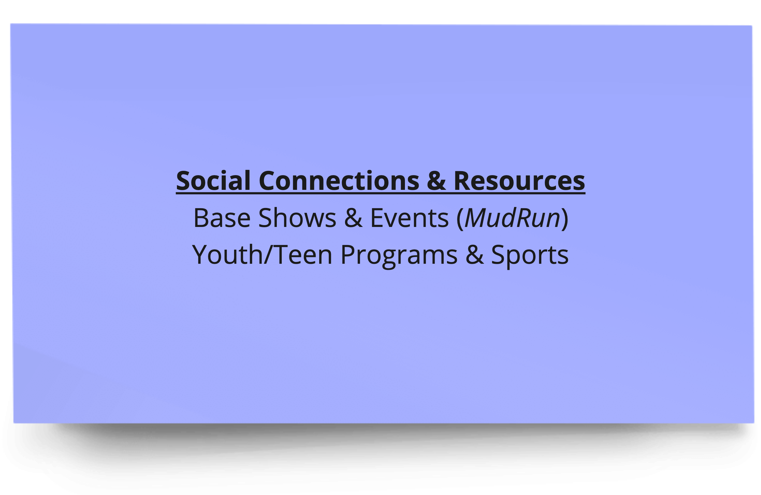
Ask: Are you aware of and/or have you utilized the service?
  - (If yes) Would you recommend it to your family or friends?
- What are your feelings about the experience?
- Are you satisfied with the quality?
- Is there anything that frustrates you about the offering?

Ask: We've talked about a lot of MCCS offerings, please rank them according to how likely you are to utilize them:
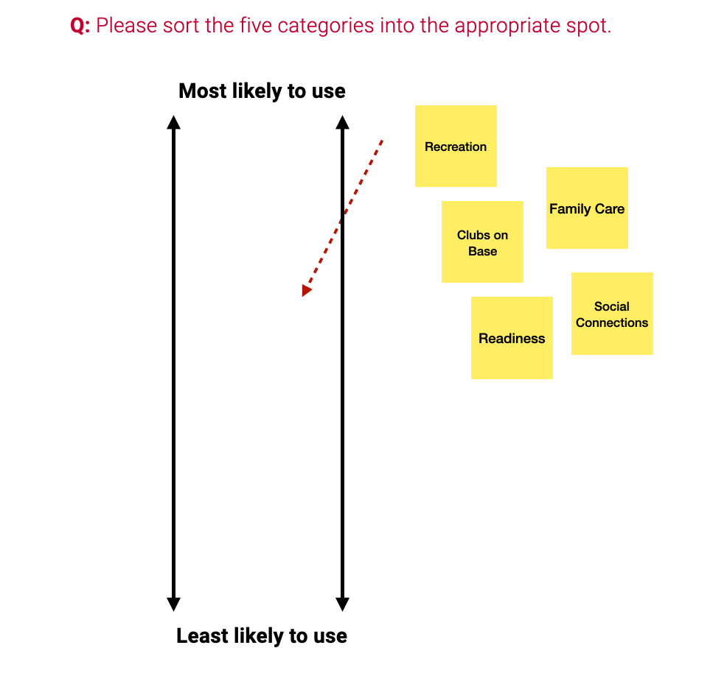

SECTION 5
For active-duty Marines and their spouses only: (all others skip to Section 5 Alt)
Please read aloud) Please do not provide Personally Identifiable Information (PII) in y our responses . (Time 10)

Insight: We want to discover causes of pressure, strain, and frustration and to understand their awareness, utilization, perception, and potential ways to improve the M+F offerings designed to help mitigate those challenges.

Ask: We had asked earlier about causes of pressure and challenges in your life and now we'd like to dig deeper into how you and your family are managing that?

Card Sort Exercise: This exercise will be used to explore your strategies for managing the pressures and challenges you're experiencing.
Ask: These cards represent a number of programs that the MCCS makes available to Marines and their families. Which programs have you heard about and what is your perception of the program?
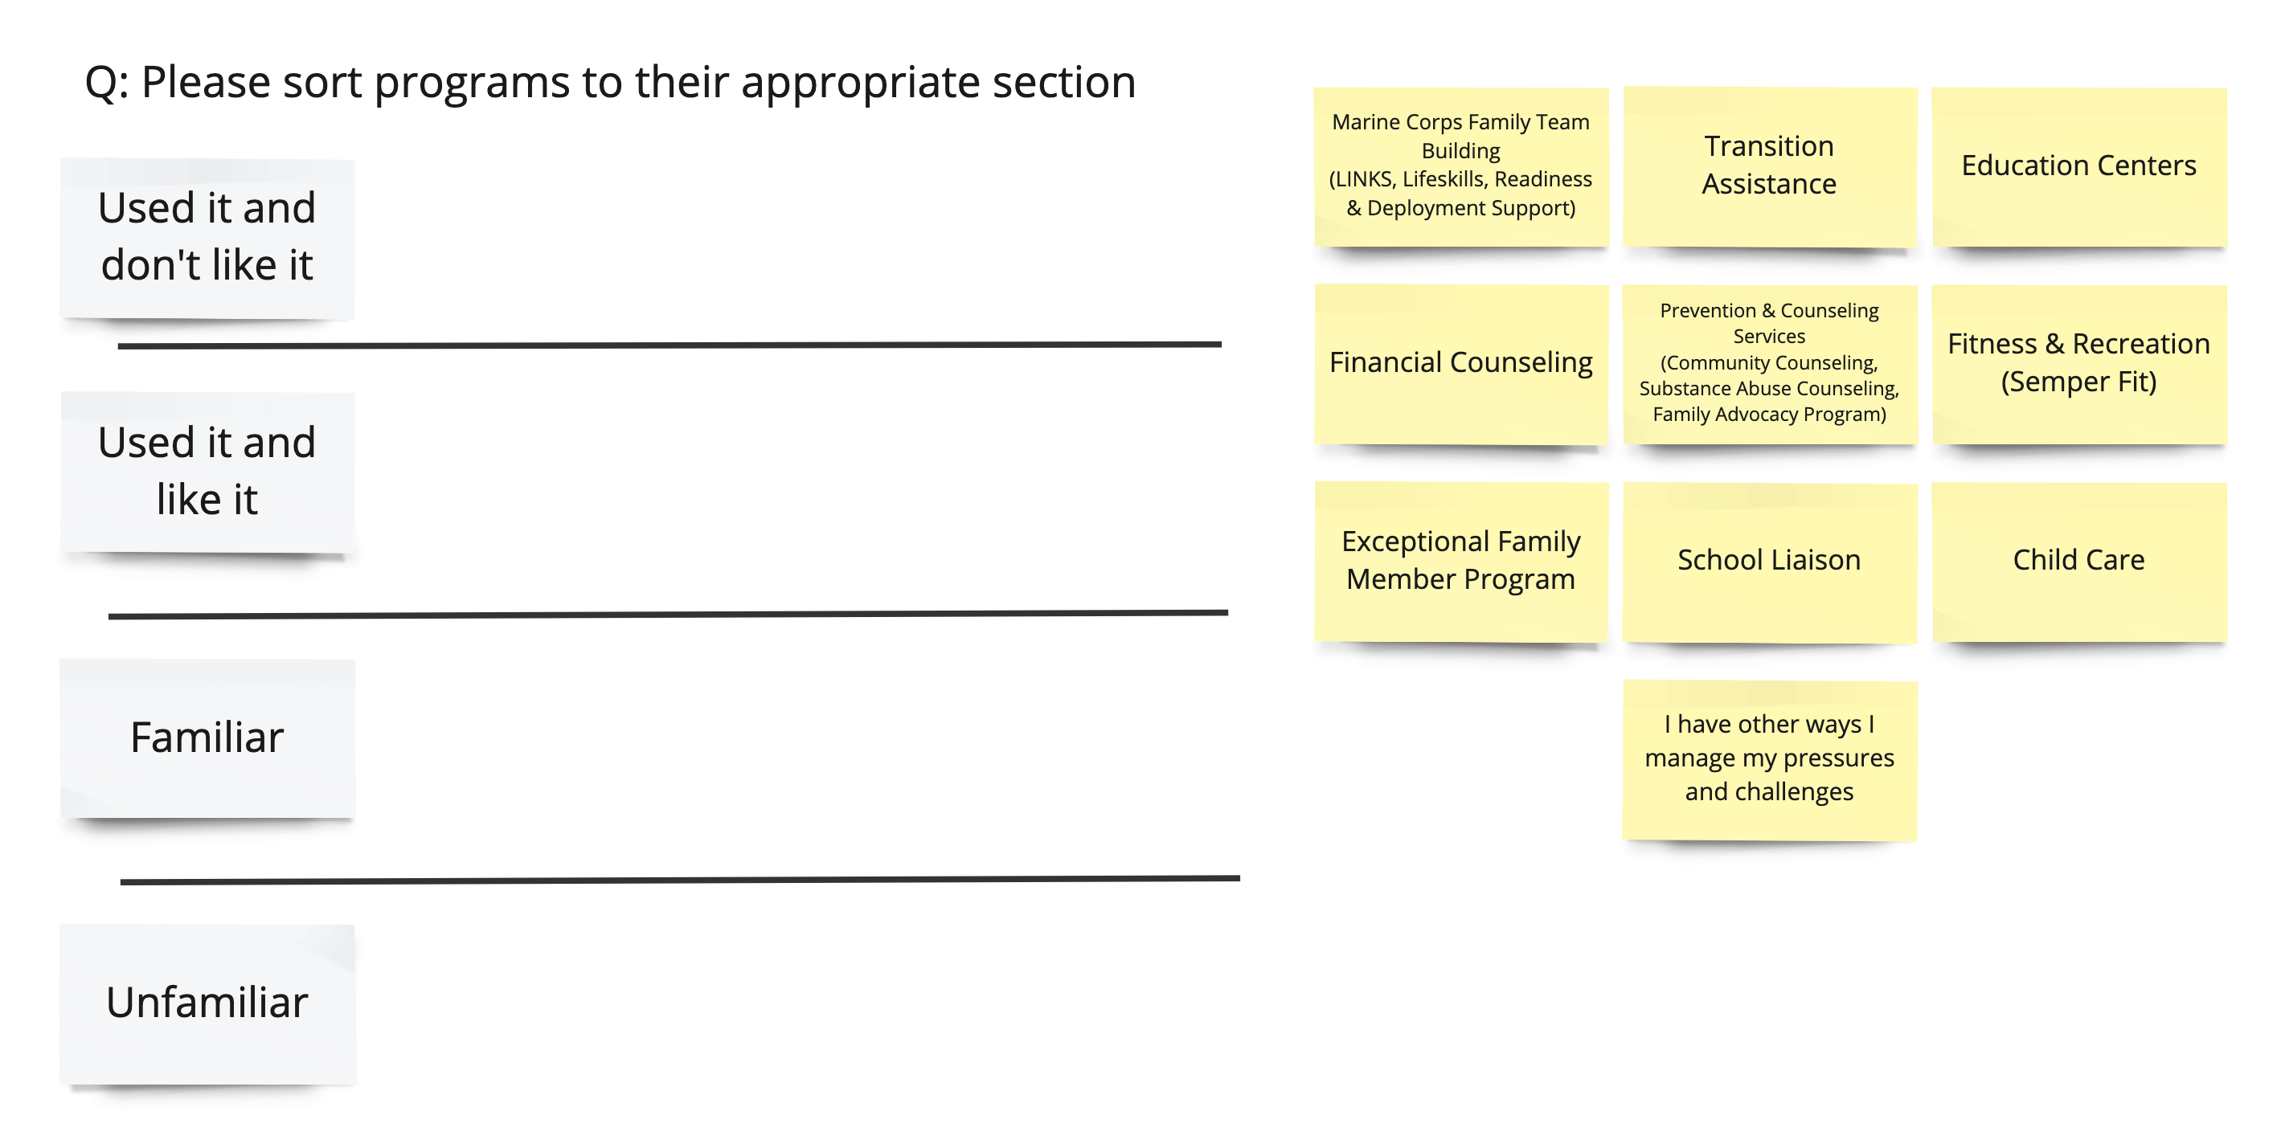

- Follow-up:
- If they have "Used it and liked it":
  - What did you like about it?
  - Would you recommend it to friends and family?
  - How did you find out about the offering?
- If they have "Used it and didn't like it":
  - What didn't you like about it?
  - How did you find out about the offering?
  - How would you make it better?
- If they have "Familiar":
  - What have you heard about it?
  - How did you find out about the offering?

Ask: Using the cards, please sort into two categories: ‘For Me and My Family’ (programs that would/could help you and/or your family) and ‘Not for Me.’
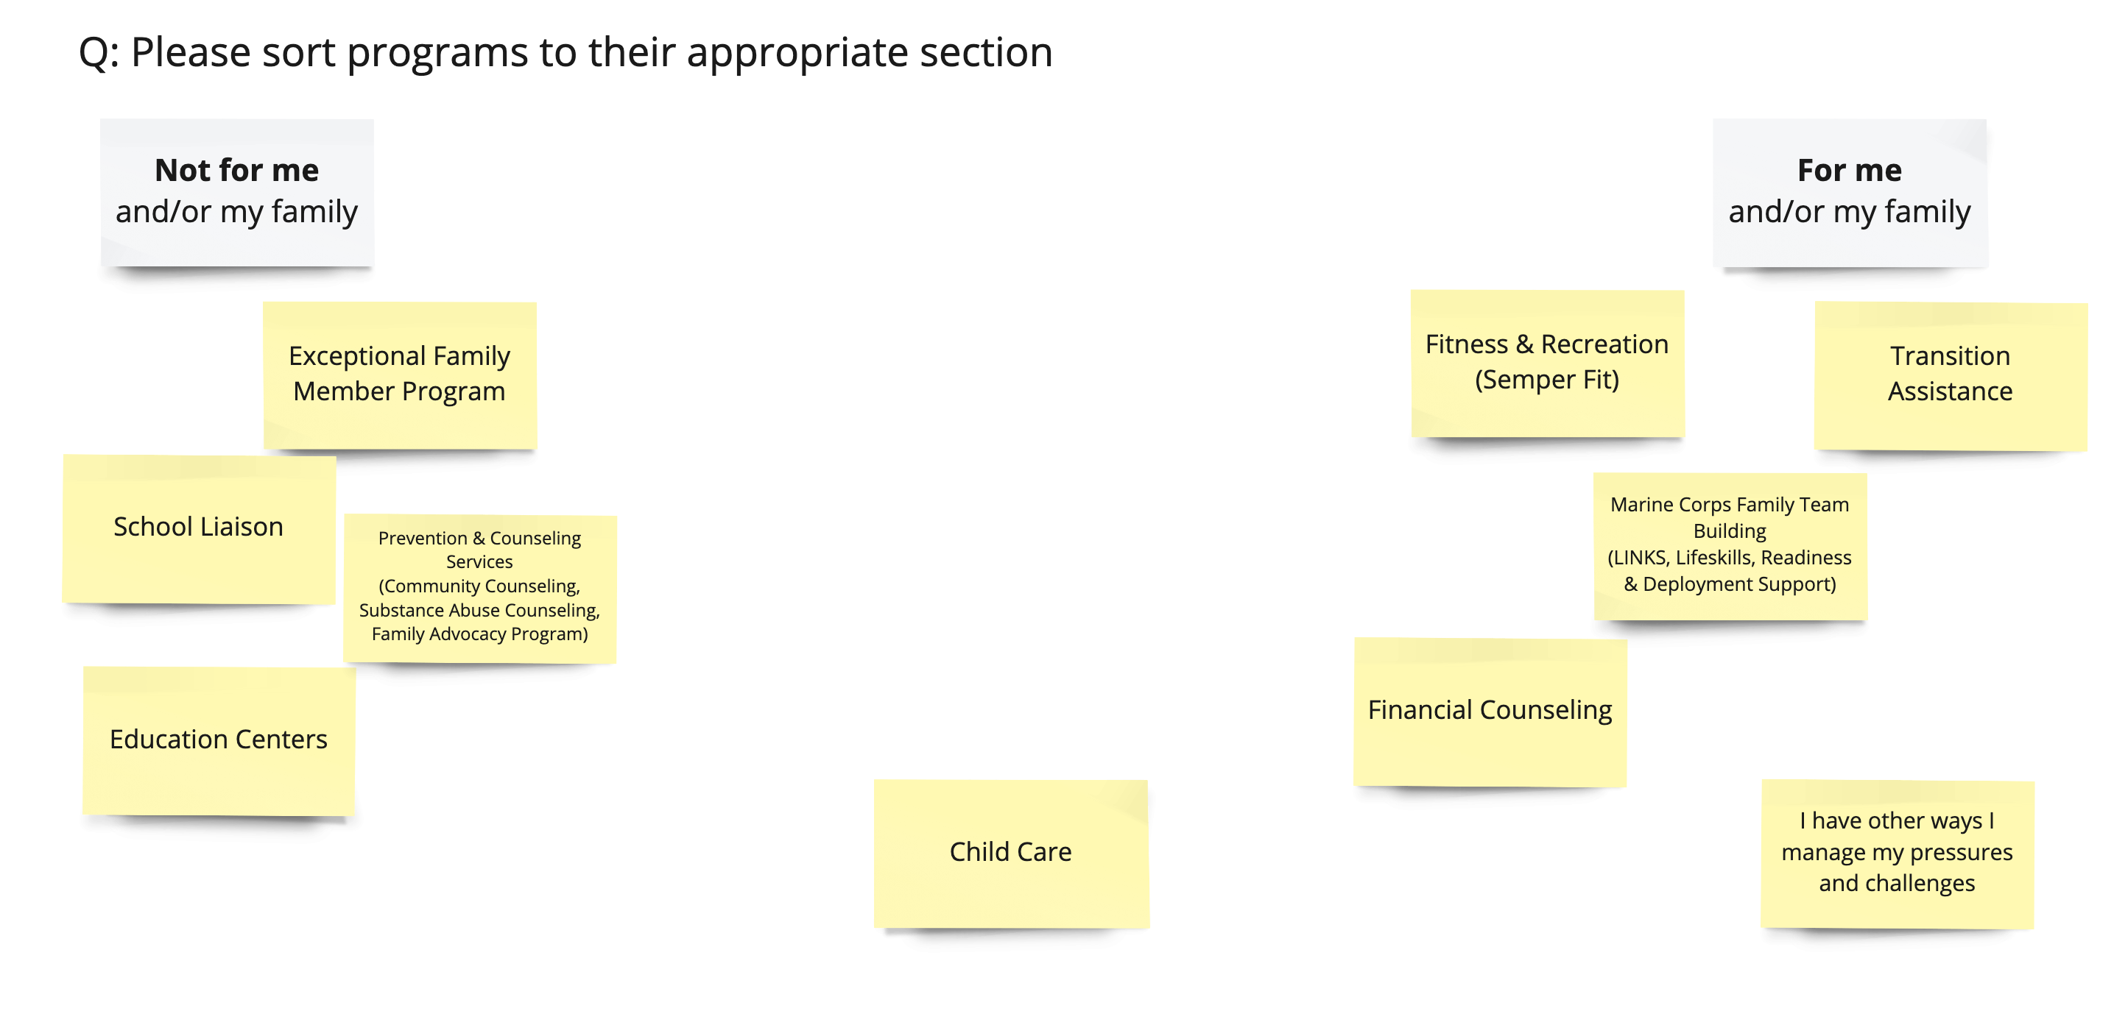
Follow-up:
- If they picked the card "I have other ways I manage my pressures and challenges”, please ask them what are some of the "other ways".
- What is missing from these cards? [add new card(s)]

Ask: Using the cards, can you please place the cards in their appropriate place on the continuum of most valuable to least valuable to you and your loved ones.
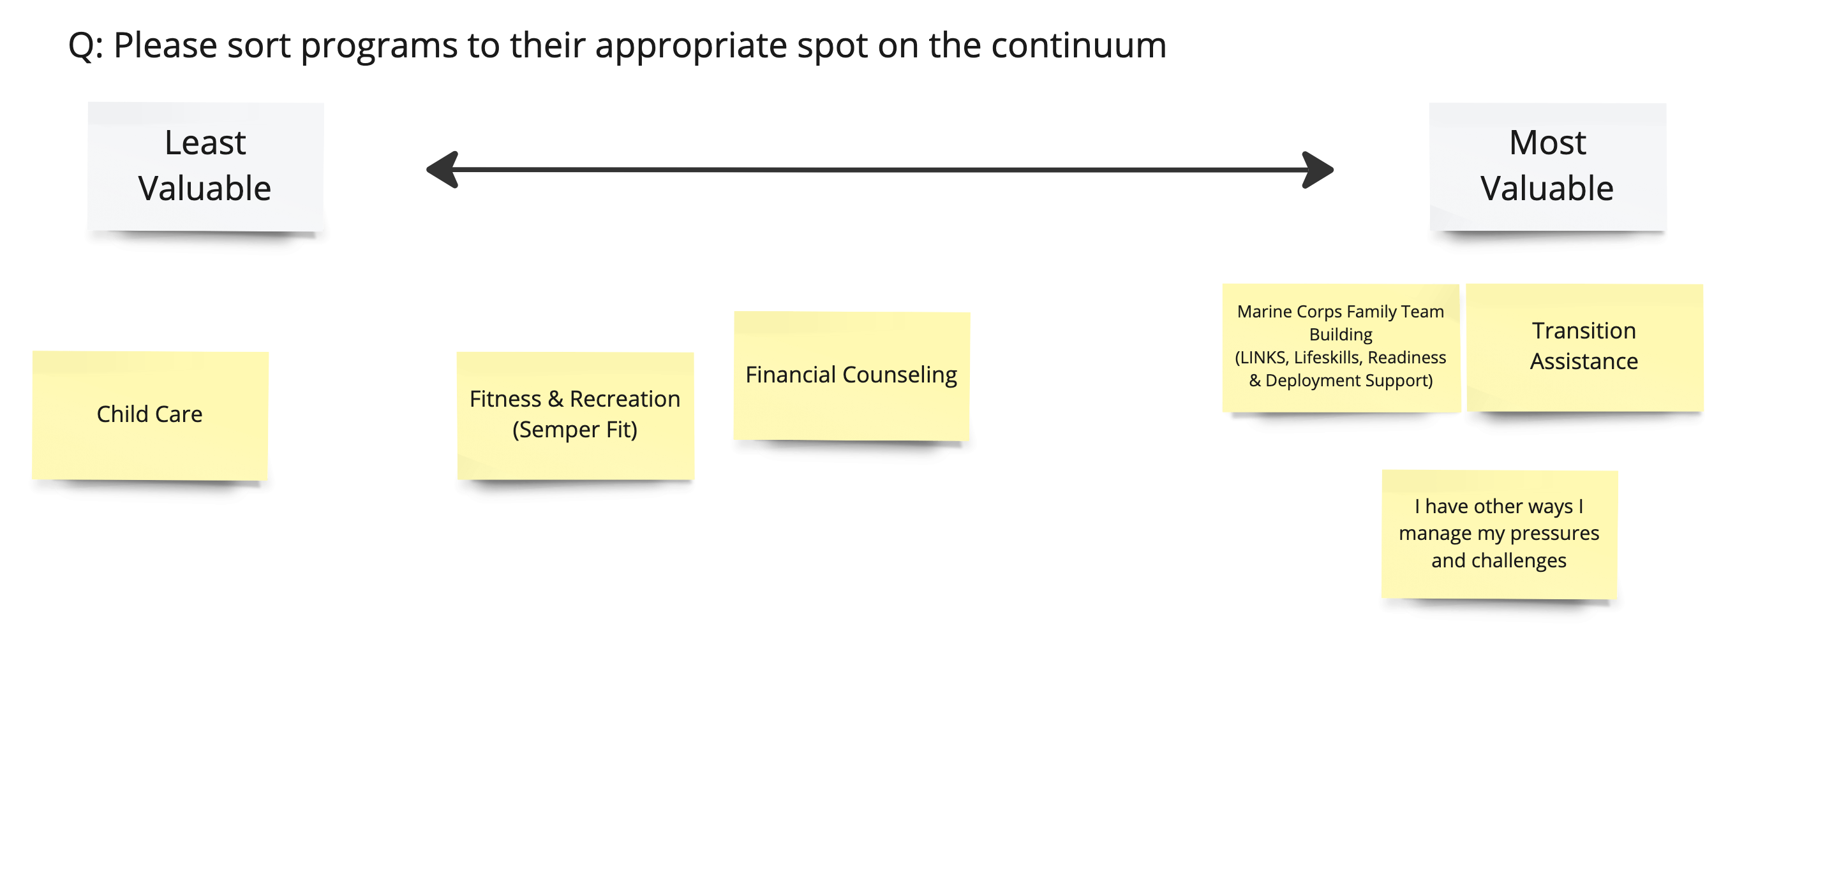

SECTION 5 ALT
For veterans, retirees, and DoD employees only:
(Time 3)

Insight: Give opportunity to voice anything not addressed.
Before we conclude our conversation, if you had a magic wand, what three things relative to MCCS would you change that would make your life easier or better?

Thank you for your time and your insight!

