Pharmacy Patient Satisfaction Survey
WEB DISPLAY
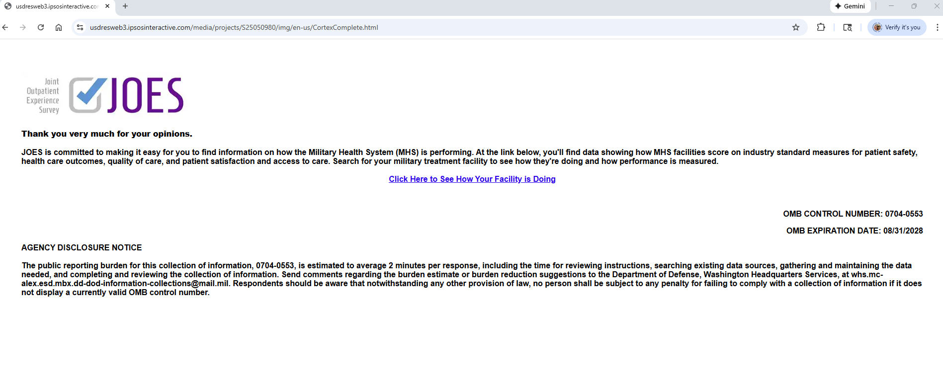
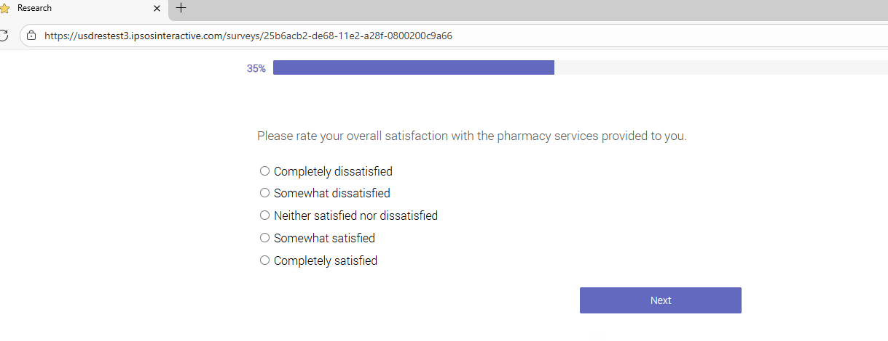
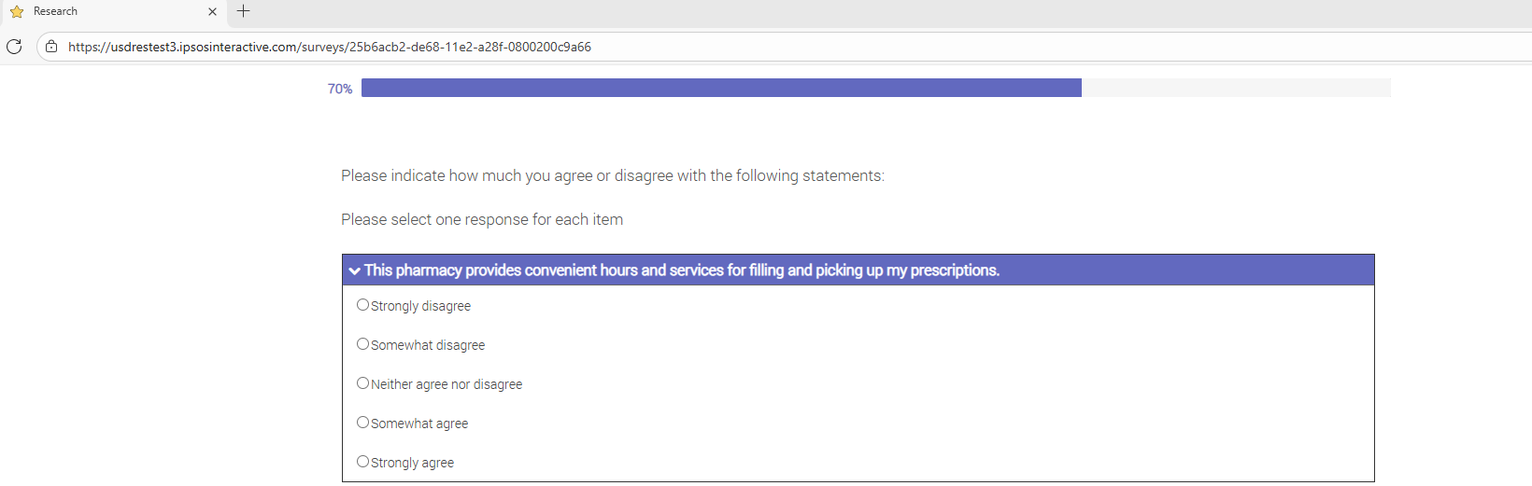
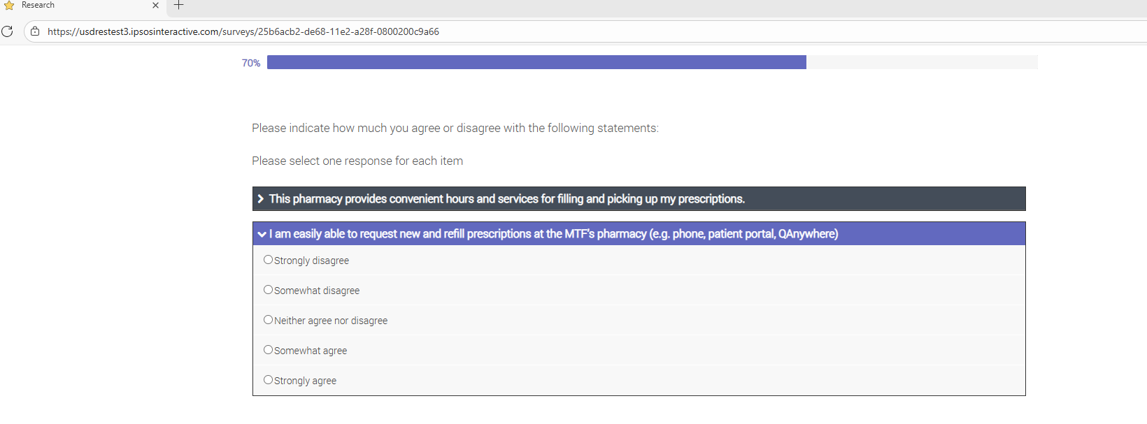
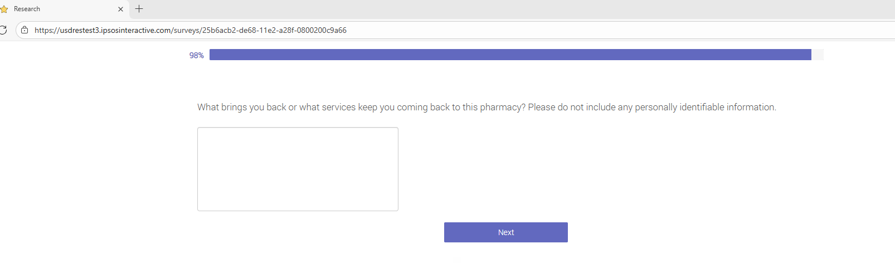

Pharmacy Patient Satisfaction Survey
QUESTION TEXT DISPLAY ONLY

OMB CONTROL NUMBER: 0704-0553
OMB EXPIRATION DATE: 8/31/2028

AGENCY DISCLOSURE NOTICE

The public reporting burden for this collection of information, 0704-0553, is estimated to average 2 minutes per response, including the time for reviewing instructions, searching existing data sources, gathering and maintaining the data needed, and completing and reviewing the collection of information. Send comments regarding the burden estimate or burden reduction suggestions to the Department of Defense, Washington Headquarters Services, at whs.mc-alex.esd.mbx.dd-dod-information-collections@mail.mil. Respondents should be aware that notwithstanding any other provision of law, no person shall be subject to any penalty for failing to comply with a collection of information if it does not display a currently valid OMB control number.

- Please rate your overall satisfaction with the pharmacy services provided to you.
- Completely dissatisfied
- Somewhat dissatisfied
- Neither satisfied not dissatisfied
- Somewhat satisfied
- Completed satisfied

- Indicate how much you agree or disagree with the following statements:
- This pharmacy provides convenient hours and services for filling and picking up my prescriptions.
- Strongly disagree
- Somewhat disagree
- Neither agree nor disagree
- Somewhat agree
- Strongly agree

- I am easily able to request new and refill prescriptions at the MTF pharmacy (e.g. phone, patient portal, QAnywhere)
- Strongly disagree
- Somewhat disagree
- Neither agree nor disagree
- Somewhat agree
- Strongly agree

- What brings you back or what services keep you coming back to this pharmacy? Please do not include any personal identifiable information.

