Radiology Patient Satisfaction Survey
WEB DISPLAY EXAMPLE
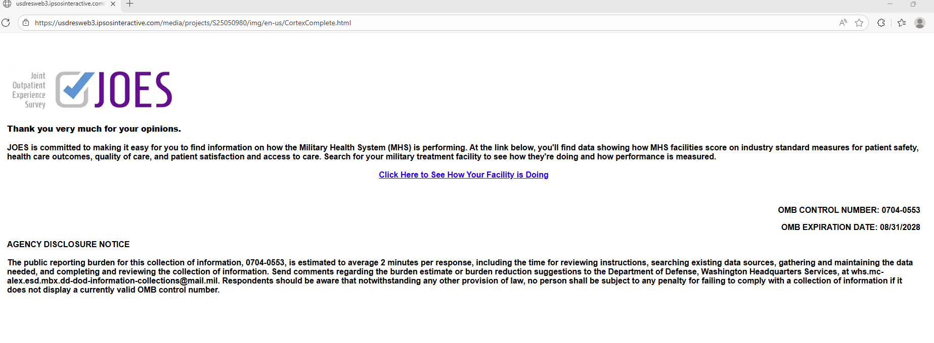
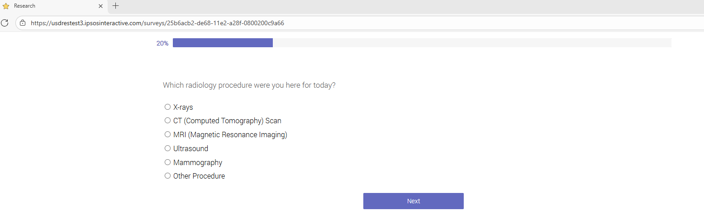
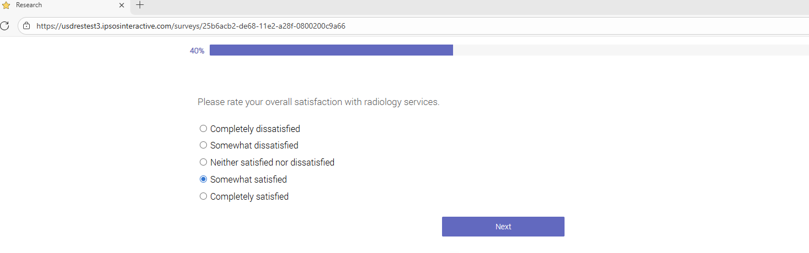

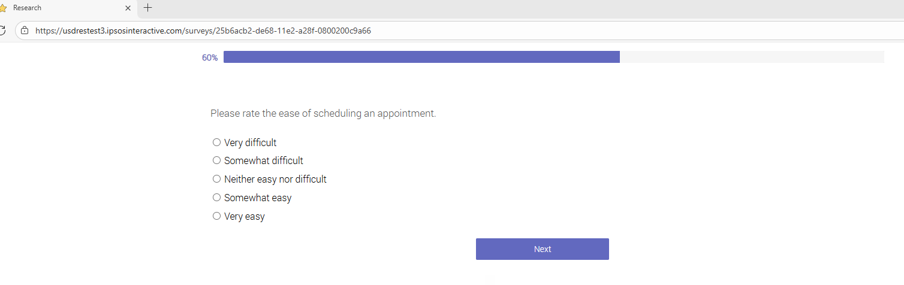
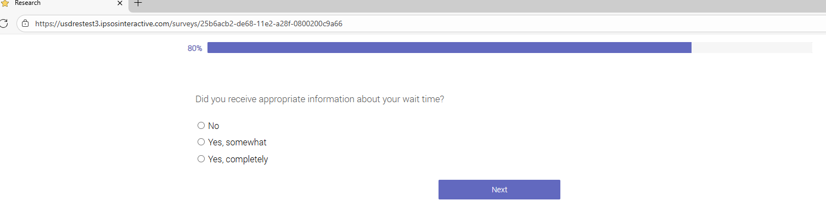
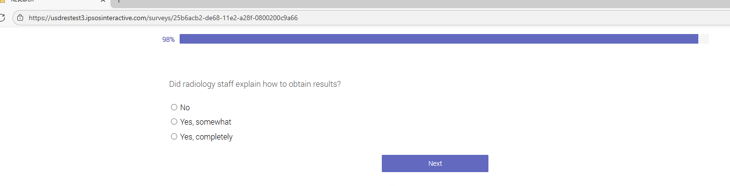

Radiology Patient Satisfaction Survey
QUESTION TEXT ONLY
OMB CONTROL NUMBER: 0704-0553
OMB EXPIRATION DATE: 8/31/2028

AGENCY DISCLOSURE NOTICE

The public reporting burden for this collection of information, 0704-0553, is estimated to average 2 minutes per response, including the time for reviewing instructions, searching existing data sources, gathering and maintaining the data needed, and completing and reviewing the collection of information. Send comments regarding the burden estimate or burden reduction suggestions to the Department of Defense, Washington Headquarters Services, at whs.mc-alex.esd.mbx.dd-dod-information-collections@mail.mil. Respondents should be aware that notwithstanding any other provision of law, no person shall be subject to any penalty for failing to comply with a collection of information if it does not display a currently valid OMB control number.

- Which radiology procedure were you here for today?

- Please rate your overall satisfaction with radiology services
- Completely dissatisfied
- Somewhat dissatisfied
- Neither satisfied not dissatisfied
- Somewhat satisfied
- Completed satisfied

- Please rate the ease of scheduling an appointment.
- Very difficult
- Somewhat difficult
- Neither easy nor difficult
- Somewhat easy
- Very easy

- Did you receive appropriate information about your wait time?
- No
- Yes, somewhat
- Yes, completely

- Did radiology staff explain how to obtain results?
- No
- Yes, somewhat
- Yes, completely

