**Survey Instrument – Assistance Reporting Tool (ART) Screenshots**

OMB control number: 0720-0060 Expiration: xx-xx-xxxx

exp

E

**Header (appears on every tab)**

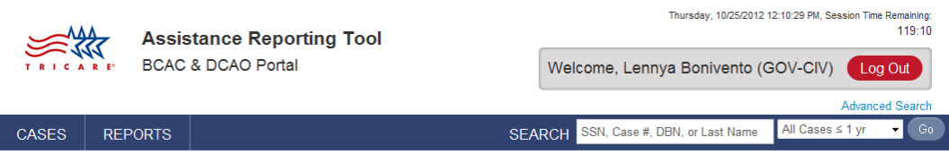

**Footer (appears on every tab)**

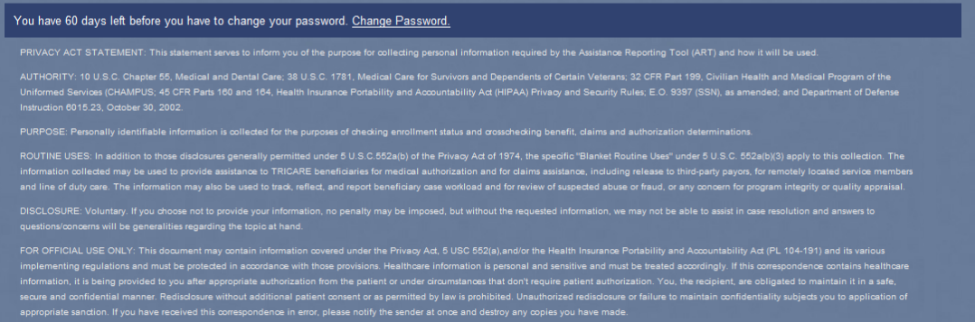

**AGENCY DISCLOSURE STATEMENT**

The public reporting burden for this collection of information, 0720-0060 is estimated to average 15 minutes per response, including the time for reviewing instructions, searching existing data sources, gathering and maintaining the data needed, and completing and reviewing the collection of information. Send comments regarding the burden estimate or burden reduction suggestions to the Department of Defense, Washington Headquarters Services, at whs.mc-alex.esd.mbx.dd-dod-information-collections@mail.mil. Respondents should be aware that notwithstanding any other provision of law, no person shall be subject to any penalty for failing to comply with a collection of information if it does not display a currently valid OMB control number.

**Basic Information Tab**

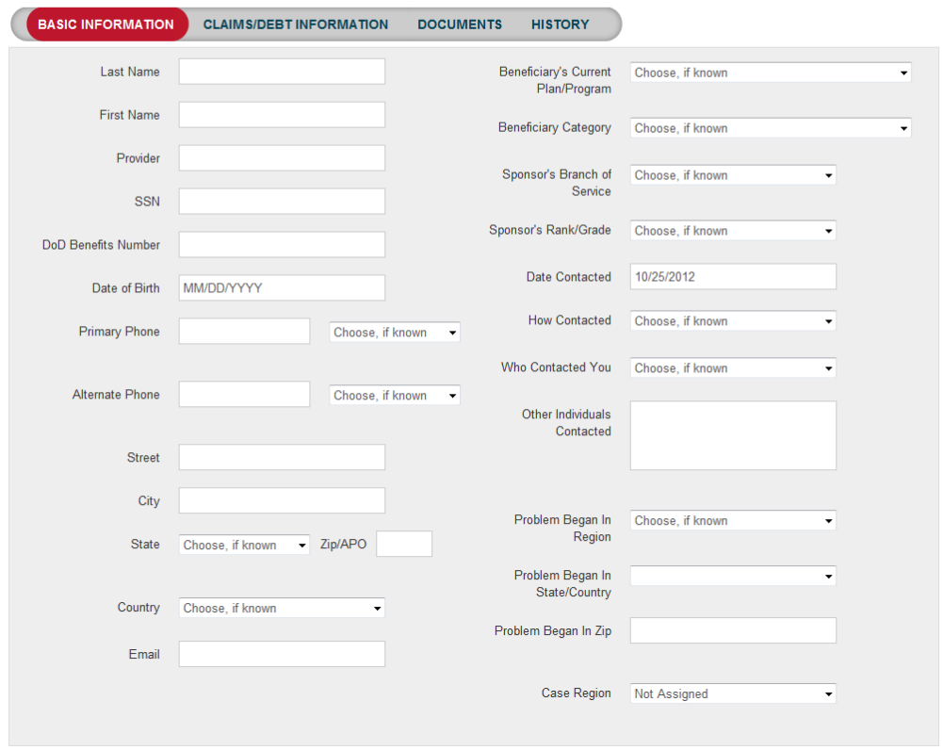

**Claims/Debt** **Information Tab**

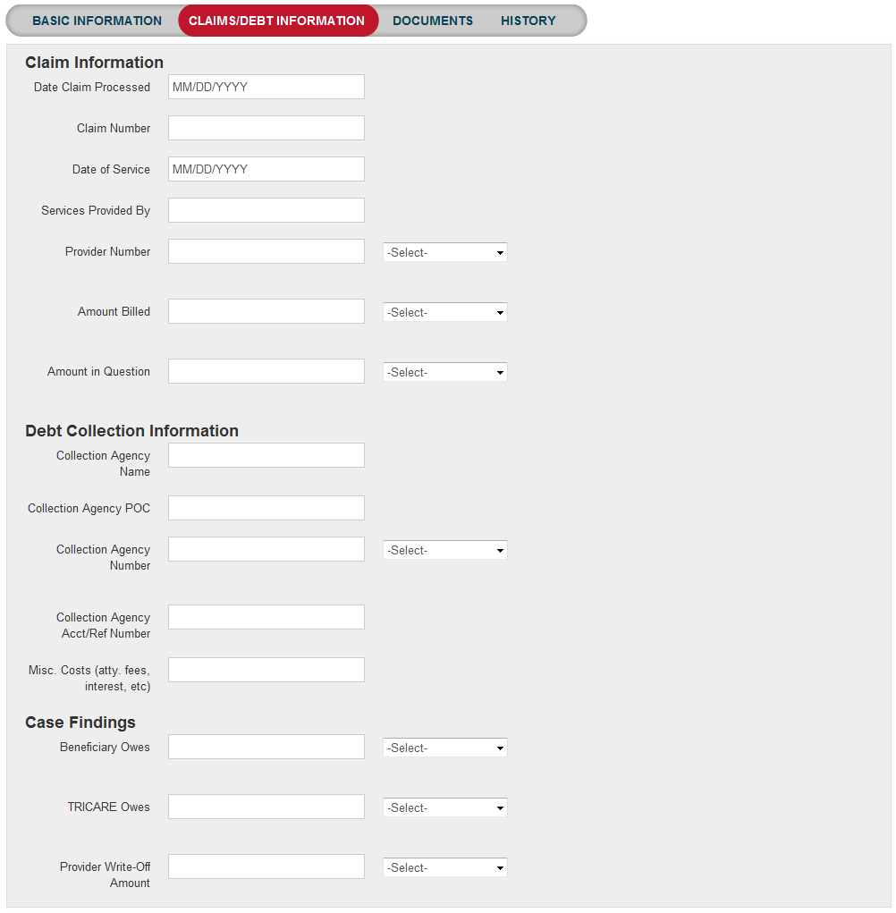

**Documents Tab**

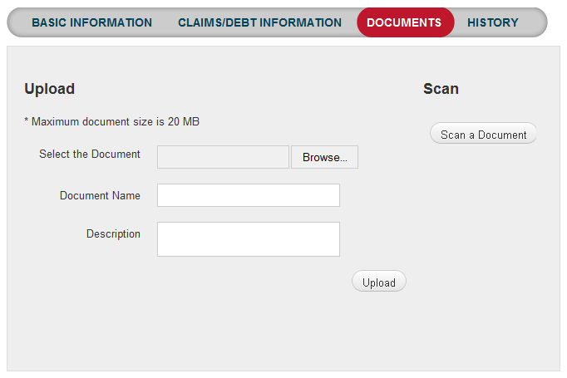

**Pre-authorization Tab**

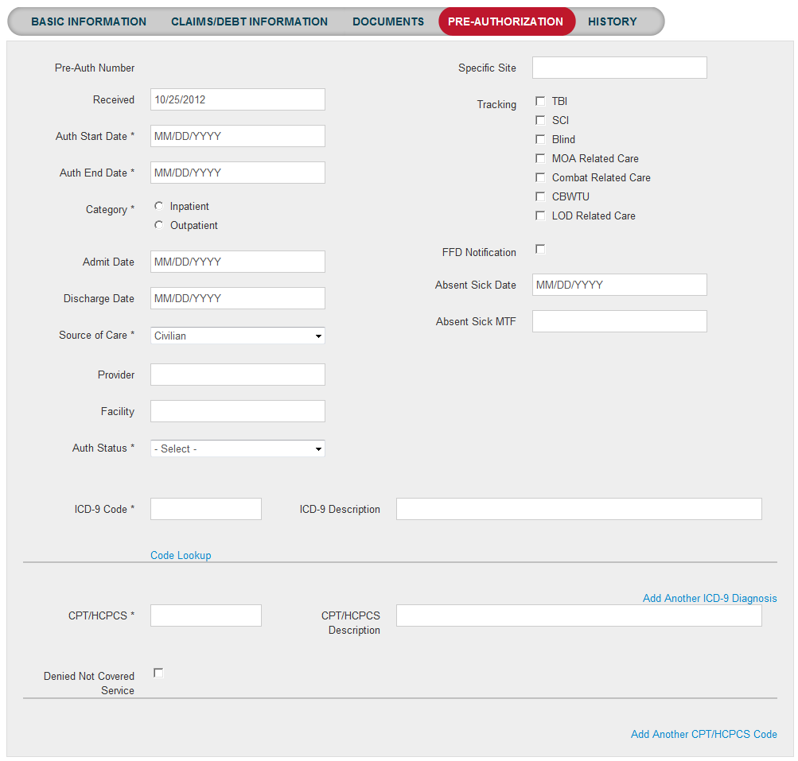

**Fitness for Duty Tab**

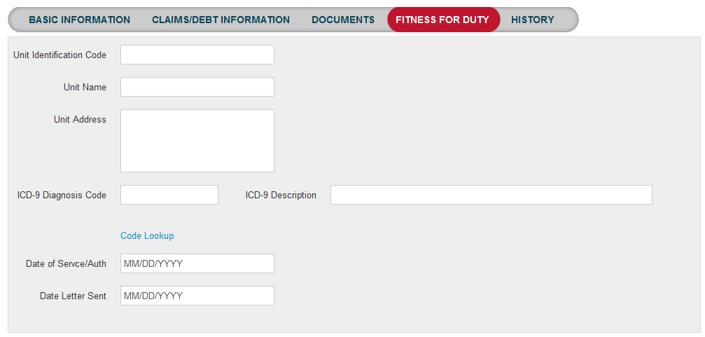

**Line of Duty Tab**

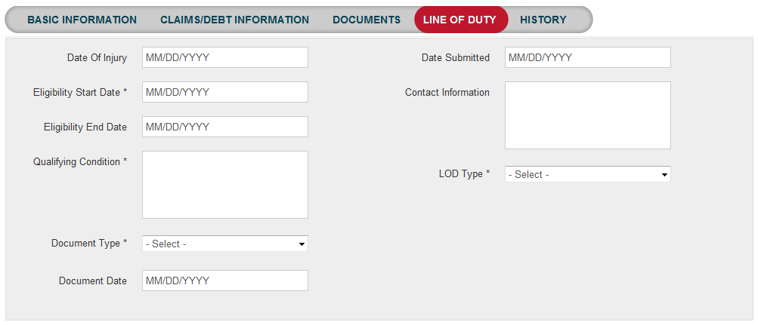

**Transitional Care for Service-related Conditions (1637) Tab** 