ATTACHMENT 6f

Pre-Exposure Survey:

Online, English

WEB SURVEY APPEARANCE
Optimization for best viewing and ease of use on multiple devices (desktop, laptop, tablet, smartphone)
Header Text: Prostate Cancer Screening Evaluation
Footer Text: If you have any questions about the study, please email the study coordinator at danielle.nielsen@icf.com
Logo:
Termination page: Thank you for your time and interest. You do not qualify for this survey at this time.
Prompt for required questions. Note, all questions should be programmed as soft prompt unless specified as “required”:
Please complete all the questions on this page before moving on.
PROMPT FOR ALL OTHER QUESTIONS IF RESPONDENT TRIES TO SKIP
You have not answered all the questions on this page. Please consider responding to all questions. If you are choosing not to answer a question(s), click next.
Survey Completion text: Thank you for completing this survey. If you have additional questions about the study, please email the study coordinator at danielle.nielsen@icf.com
Sample variables:
[Clinic]
Dr. [Name]

Survey Overall | please have navigation buttons display in Spanish using “Atras” (Back) and “Siguiente” (Next).

Imported Sample Variables
CLINIC
IMPORTED SAMPLE VARIABLE: Clinic Name
[TEXT BOX]

NAME
IMPORTED SAMPLE VARIABLE: Doctor’s Last Name
[TEXT BOX]

Patient Screener
[ASK ALL]

LANG.
In what language would you like to complete this survey?
¿En qué idioma le gustaría completar esta encuesta?
01 English
02 Español

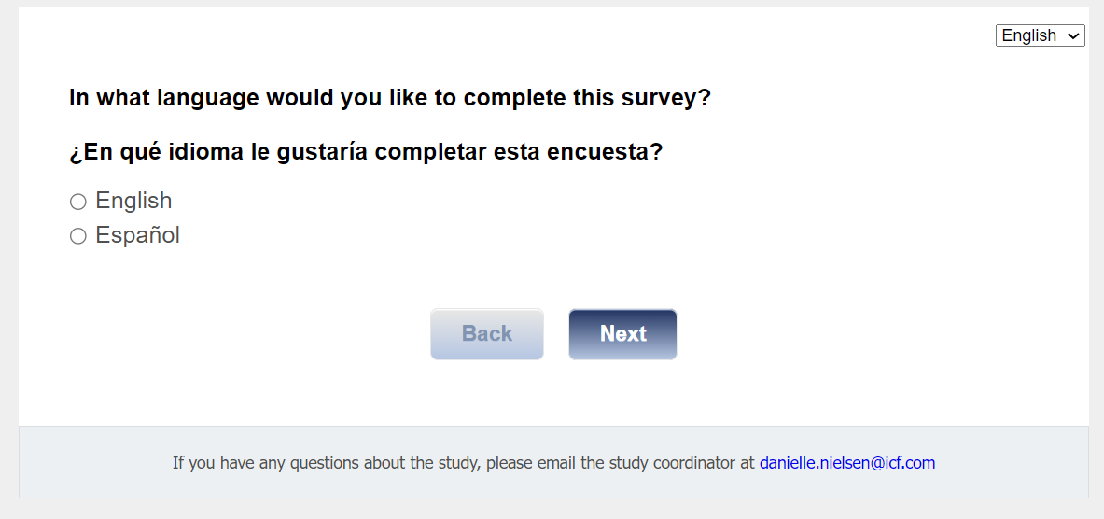

[ASK ALL]
B2.
Thank you for your interest in participating in this study. The purpose of this study is to learn whether different types of decision aid tools can help men make informed decisions about prostate cancer screening. This study can be a great way for you to learn more about prostate cancer screening and talk to your primary care provider about your options. We are partnering with your primary care provider, Dr. [NAME] on this study about prostate cancer screening. If you complete this survey, you will receive a $25 gift code.

If you feel you have been contacted for this study in error, please let us know. If you would like to remove your name from our contact list for future research studies, please contact us by phone (xxx UPDATE WITH helpdesk Phone #) or email <study@icfhelpdesk.com>.

If you choose to participate in this study, you will be assigned to one of three groups. Each group will receive a different type of educational material about prostate cancer screening. Depending on which group you are in, the study will require completion of up to four surveys or brief, live discussions over a period of six months. These will be conducted through secure web-based links and telephone. Surveys will take no more than 20 minutes to complete. If you are selected for a live discussion, that will last about 60 minutes. There is no cost for participation in the study. If you agree to participate, you will receive a gift card for each survey or discussion you complete as a thank you for your time and effort.

Today, we are screening people for eligibility for this study. Your participation in this screening process is completely voluntary and requires 5-8 minutes of your time to answer questions. Your answers are completely anonymous and confidential. If you meet the eligibility criteria outlined for this study, you will immediately be asked to complete a brief survey. Please reach out to Danielle Nielsen, ICF project manager, with any questions before, during, or after completing this screener.
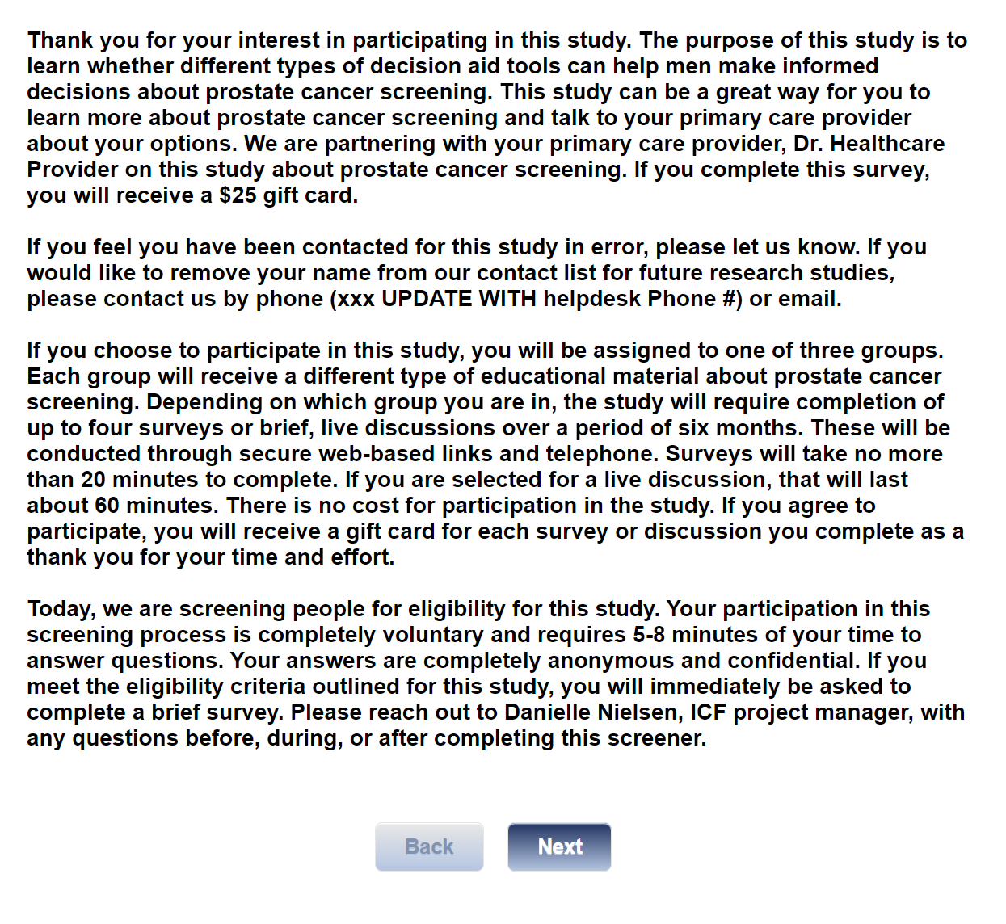

[ASK ALL]
[REQUIRED]
S1.
Are you between the ages of 55-69?
01 Yes
02 No
[terminate if s1=02]

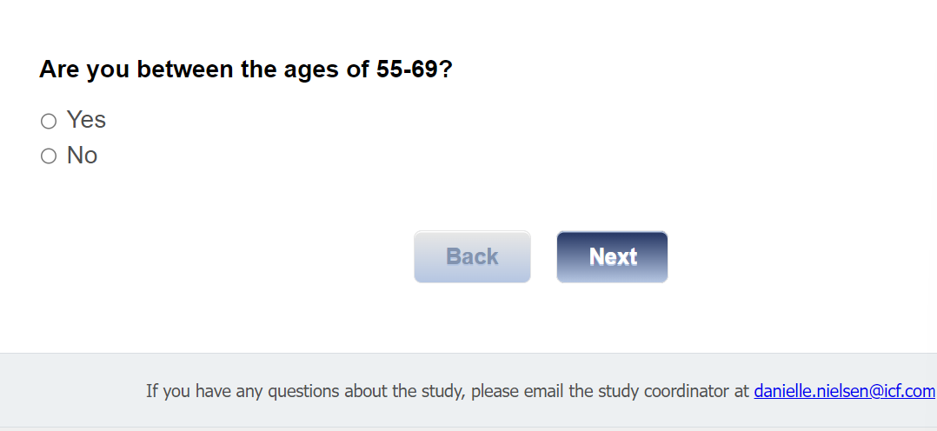

[ASK ALL]
[REQUIRED]
S2.
What was your assigned sex at birth?
01 Male
02 Female
03 Prefer not to disclose
[TERMINATE IF S2=02,03]

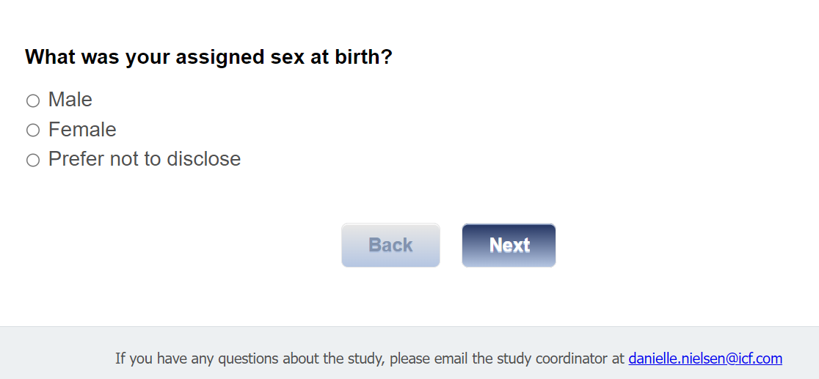

[ASK ALL]
[REQUIRED]
S3.
Do you have access to the internet?
01 Yes
02 No
[TERMINATE IF S3=02]

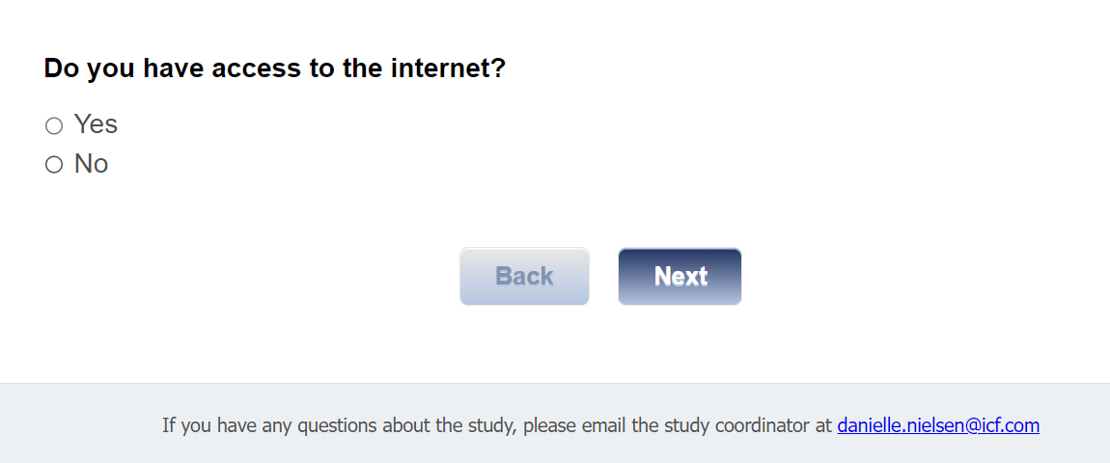

[ASK ALL]
[REQUIRED]
S4.
Do you have a valid email address?
01 Yes
02 No

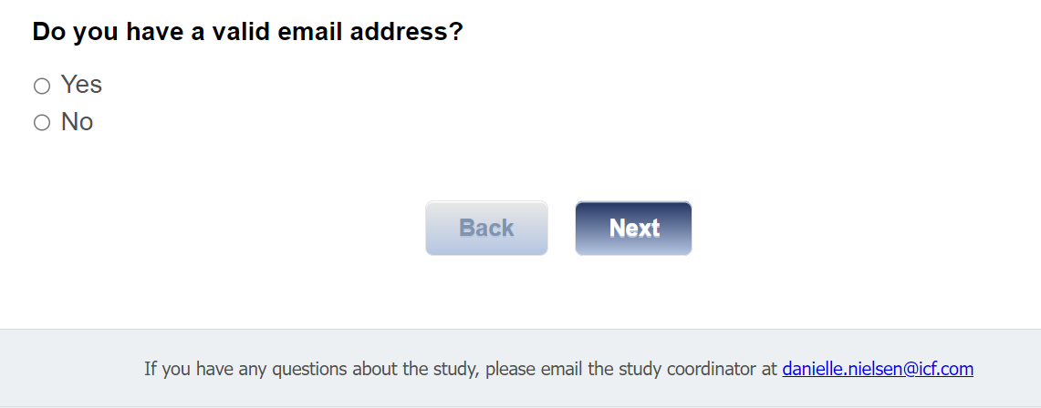

[ASK IF S4=02]
S4a.
Do you have a phone number with SMS (text message) capabilities?
01 Yes
02 No
[TERMINATE IF S4=02 AND S4a=02]
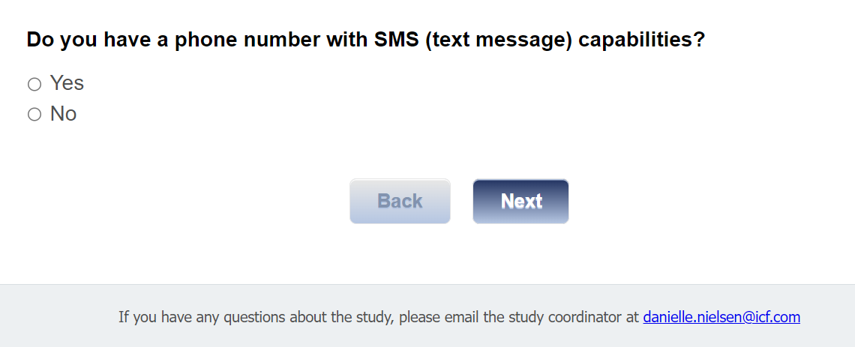

[ASK ALL]
[REQUIRED]
S5.
Do you have an upcoming visit with your health care provider?
01 Yes
02 No
[TERMINATE IF S5=02]

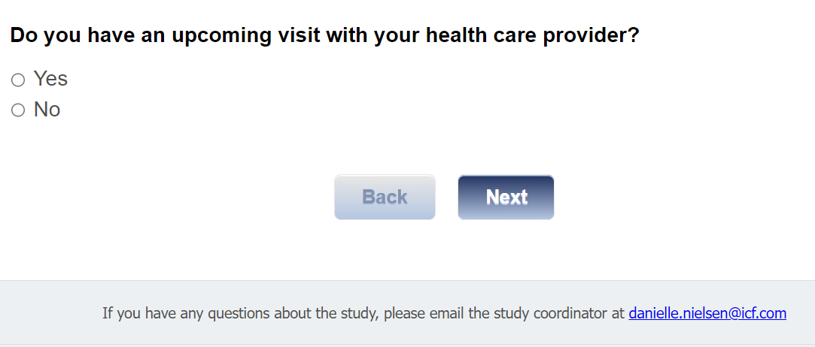

[ASK ALL]
[REQUIRED]
S6.
Are you interested in participating in this study?
01 Yes
02 No
[TERMINATE IF S6=02]

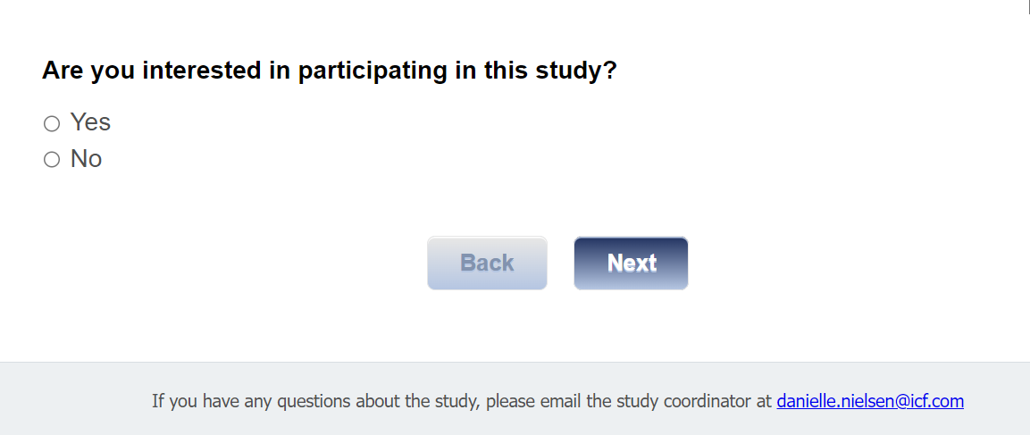

NOTE FOR PROGRAMMING: In full fielding, once eligible participants complete Screener Questions 1 through 6, they should move directly to the pre-exposure survey.

Informed Consent
[ASK ALL]
[REQUIRED]
C1CONSENT.
You are being asked to participate in this study because you receive care at [CLINIC] and are eligible for prostate cancer screening. The purpose of this survey is to gather information about your prostate cancer screening history and decision making. If you complete this survey, you will receive a $25 gift card.

Who is sending this survey? ICF is a consulting firm that is working with the Division of Cancer Prevention and Control (DCPC) at the Centers for Disease Control and Prevention (CDC) to evaluate different prostate cancer screening decision aids and their ability to help men aged 55-69 years make a decision whether to get a prostate-specific antigen (PSA) test. A PSA test is a blood test that measures the level of PSA in the blood. PSA is a substance made by the prostate.

How long will it take? This survey will take no longer than 20 minutes. Your participation in this study is 100% voluntary which means you can choose whether or not you want to take part in this study.

What are the risks and benefits of doing the survey? As a participant in our study, there is a minimal risk related to your privacy and/or confidentiality, but steps have been taken to remove your personal information so that you cannot be identified. Only members of the research team will have access to study information. Remember, you are free to choose not to participate in this study. You are also free to leave the study at any time. Leaving the study will not interfere with your care, payment for your health care, or your eligibility for health care benefits.

Is there a cost associated with the study? There are no costs to you for participating in this study.

What will happen next? The study team may contact you by text, email, or phone to share information or invite you to respond to other surveys or interviews. All requests for information are voluntary. The purpose and topic of each request for information will be shared with you so you can choose whether you want to participate. Your choice to participate or not participate in future requests will not interfere with your care at the clinic.

How will my information be shared outside of the study? Your personal responses will not be shared outside of the study. Summaries of survey results that are not linked to your name will be shared with CDC and/or may be published in a professional journal.

Who do I call about problems or questions? If you have questions about or concerns about your participation in this project, please contact the ICF project manager – Danielle Nielsen at Danielle.Nielsen@icf.com. For questions regarding your rights as a study participant, you can contact ICF’s Institutional Review Board (IRB) representative Christine Walrath at (646) 695-8154 or Christine.Walrath@icf.com.

If you agree to participate in this study, please click “Begin Survey.”

If you do not agree to participate, please click, “I decline.”
01 Begin survey
02 I decline
[TERMINATE IF CONSENT=02]

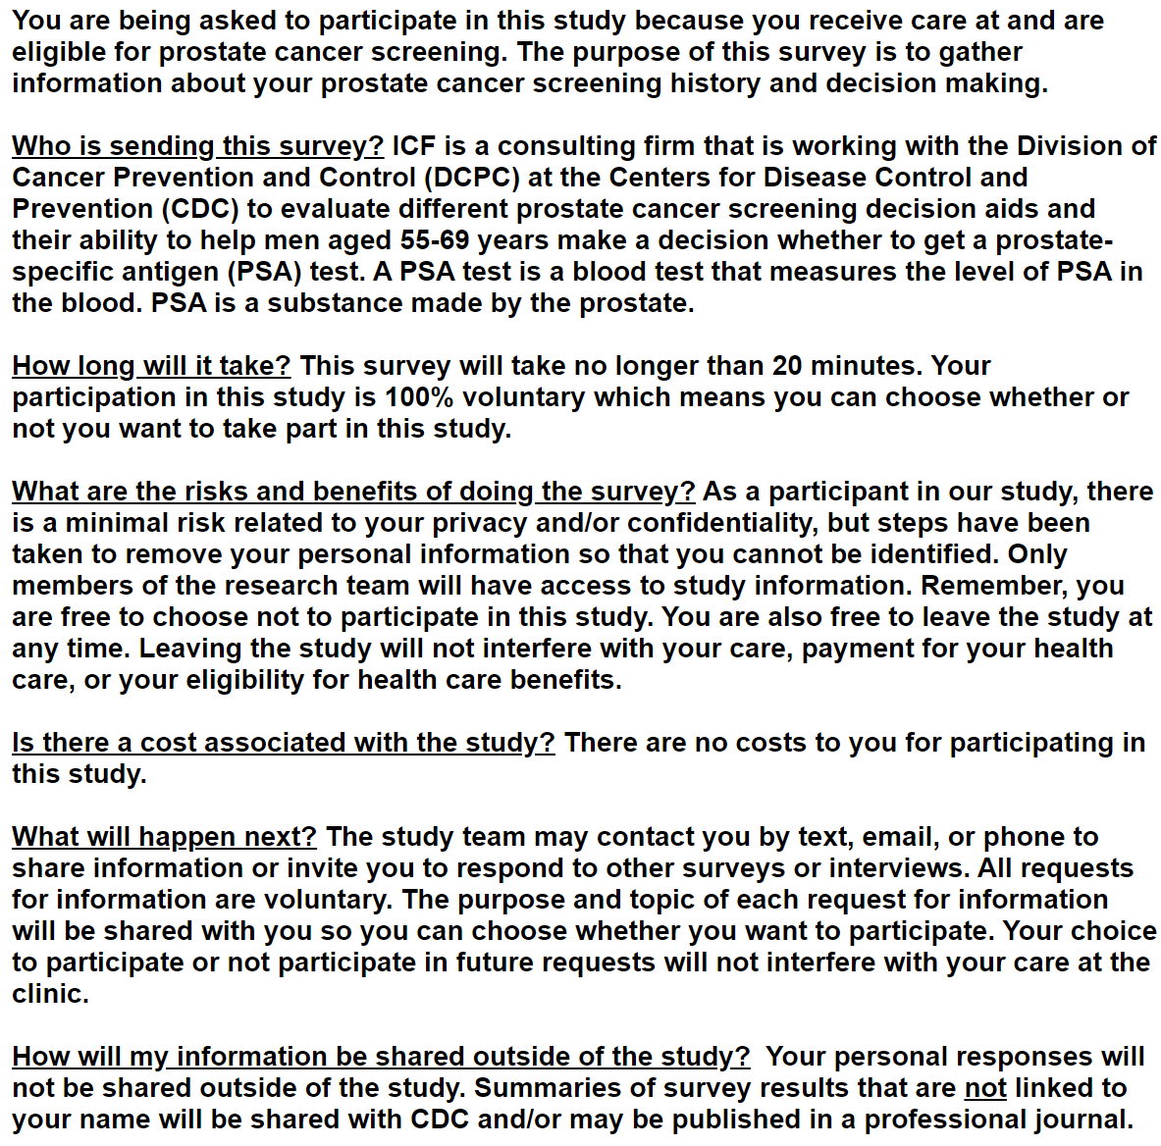
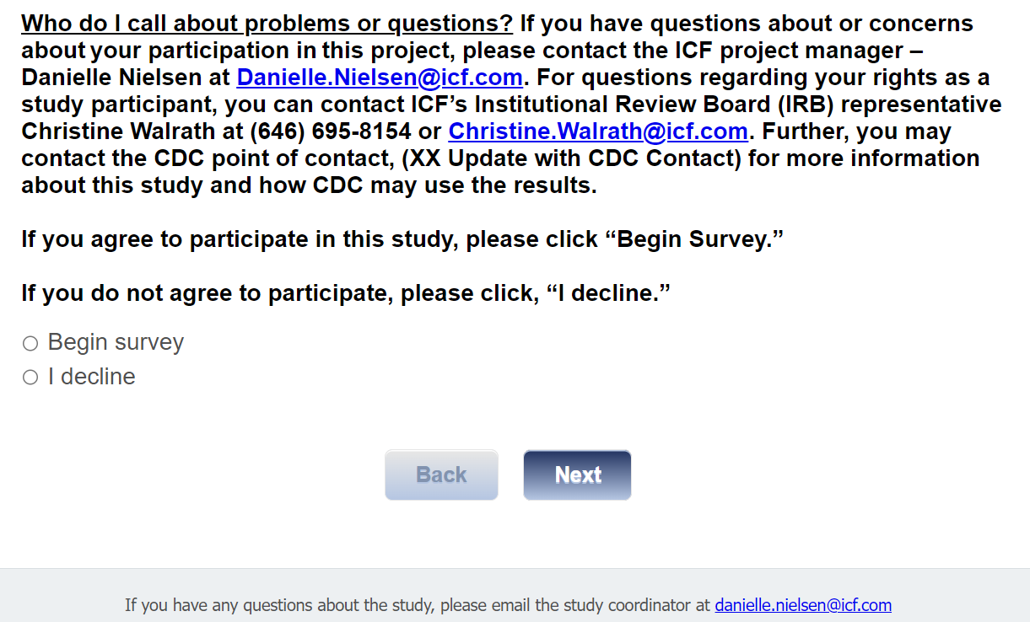

Section 1: Demographic Characteristics
[ASK ALL]
Q1.
For this first set of questions, we’d like to collect information about your background and lifestyle, which may or may not impact your prostate health. These questions will allow us to better understand certain background characteristics across survey participants, including age, race, ethnicity, income, work situation, marital status, and sexual orientation. If you are unsure about the answer to a specific question, please estimate the answer to the best of your ability.

What is your ethnicity?
01 Hispanic or Latino
02 Not Hispanic or Latino
99 I prefer not to say

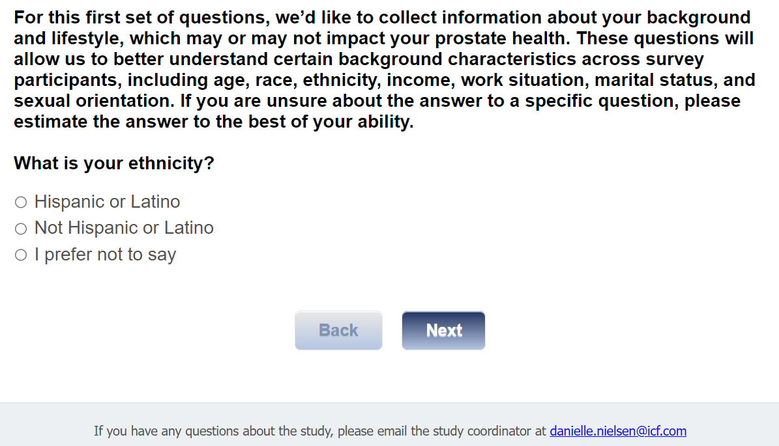

[ASK ALL]
[MUL=5]
Q2.
What is your race? (Select all that apply.)
01 American Indian or Alaska Native
02 Asian
03 Black or African American
04 Native Hawaiian or Other Pacific Islander
05 White
97 I prefer not to say [EXCLUSIVE]

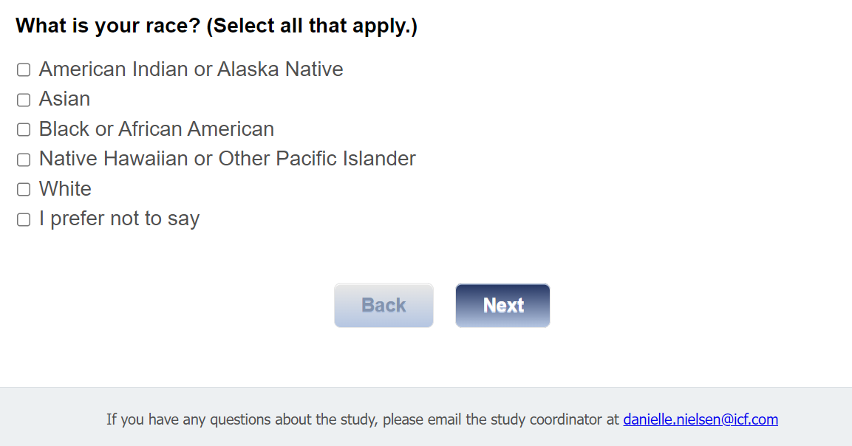

[ASK ALL]
Q3.
What is your primary language spoken?
01 English/Mostly English
02 Spanish/Mostly Spanish
03 Both English and Spanish equally
04 Other (specify) [TEXT BOX]

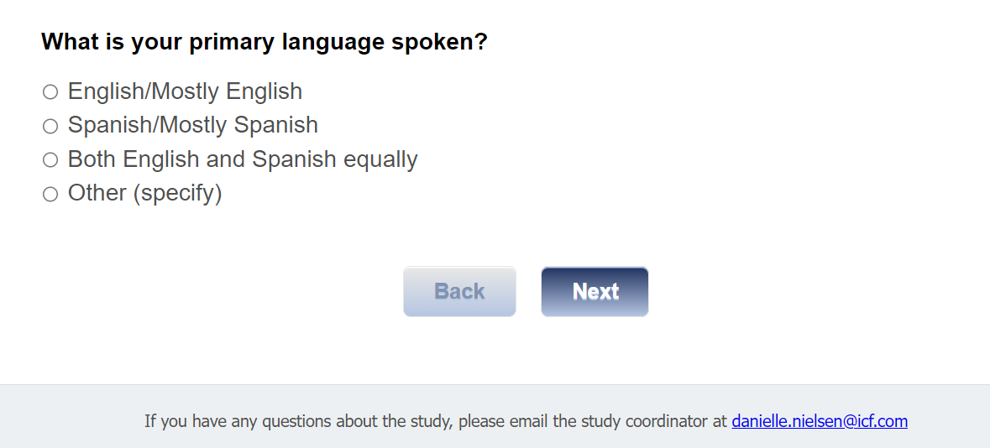

[ASK ALL]
SEXOR.
Which of the following best represents how you think of yourself?
01 Straight, that is not gay or lesbian
02 Gay or lesbian
03 Bisexual
04 I use a different term (specify)
99 I prefer not to say

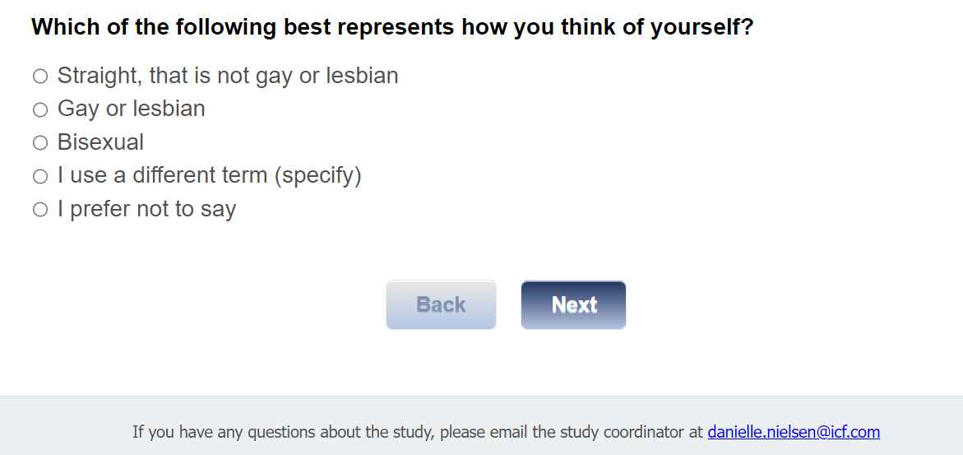

[ASK ALL]
TRANS.
Do you consider yourself to be transgender?
01 Yes, transgender, male-to-female
02 Yes, other (specify) [TEXT BOX]
03 No
99 I prefer not to say

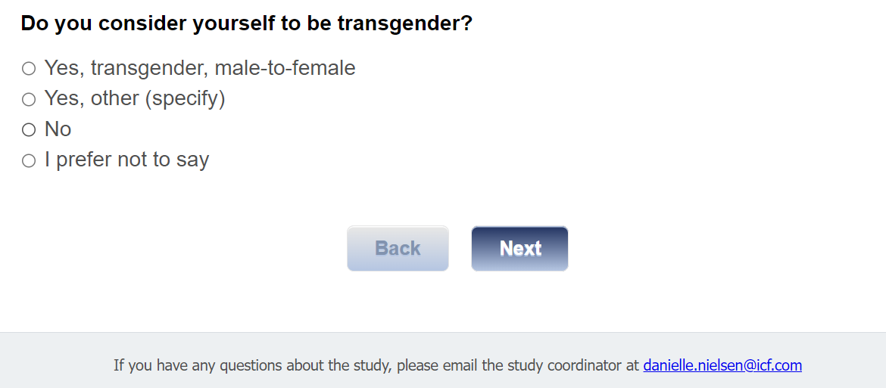

[ASK ALL]
Q4.
What is your marital status?
01 Married/living with partner
02 Widowed
03 Divorced
04 Separated
05 Never married

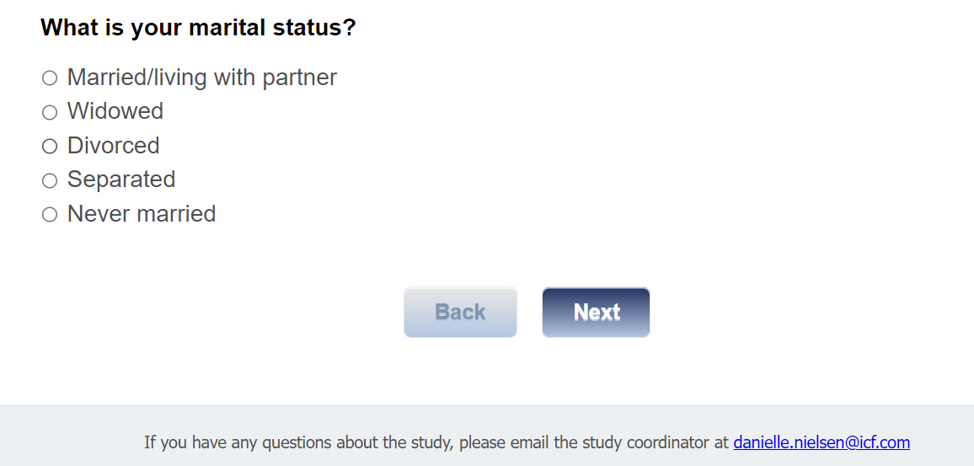

[ASK ALL]
Q5.
What is the highest grade or year of school you have completed?
01 Never attended school or only attended kindergarten
02 Grades 1 through 8 (Elementary)
03 Grades 9 through 11 (Some high school)
04 Grade 12 or GED (High school graduate)
05 College 1 year to 3 years (Some college or technical school)
06 College 4 years or more (College graduate)

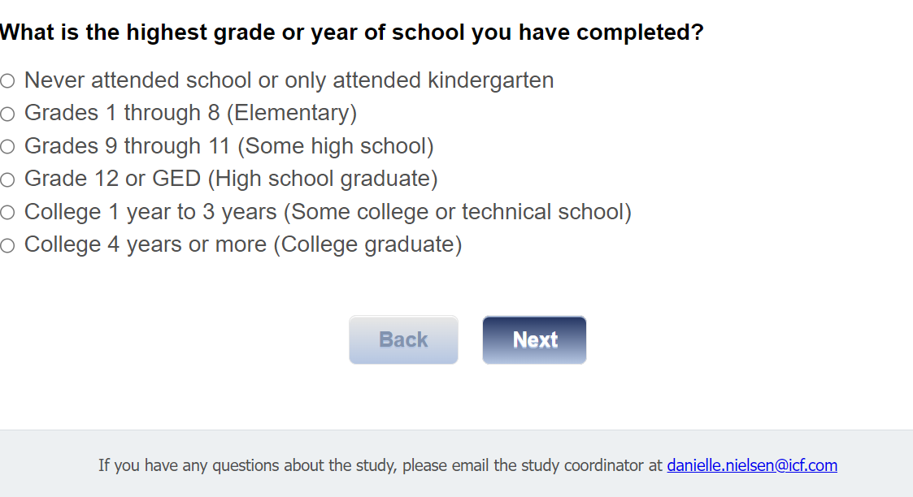

[ASK ALL]
Q6.
Are you employed?
01 Yes
02 No

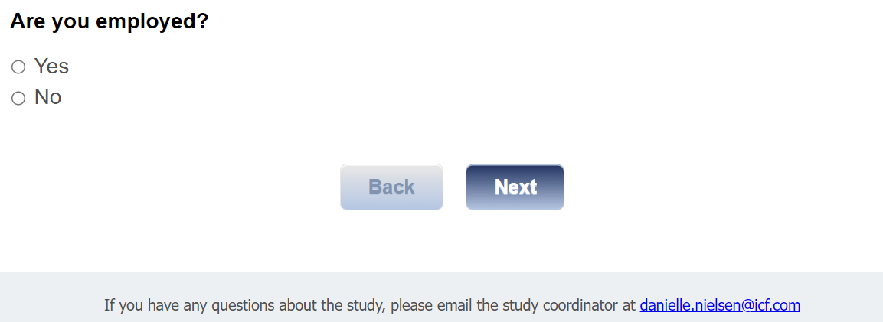

[ASK IF q6=01]
Q6a.
Are you employed:
01 Full-time
02 Part-time

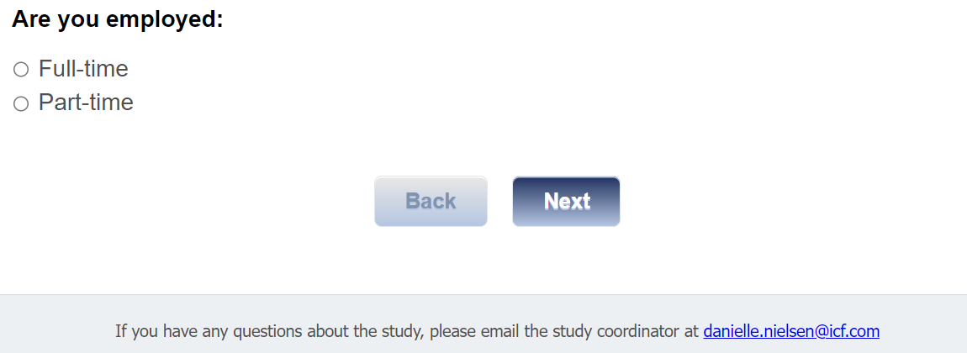

[ASK IF q6=02]
Q6b.
Are you:
01 Retired
02 A homemaker
03 Looking for work
04 On disability

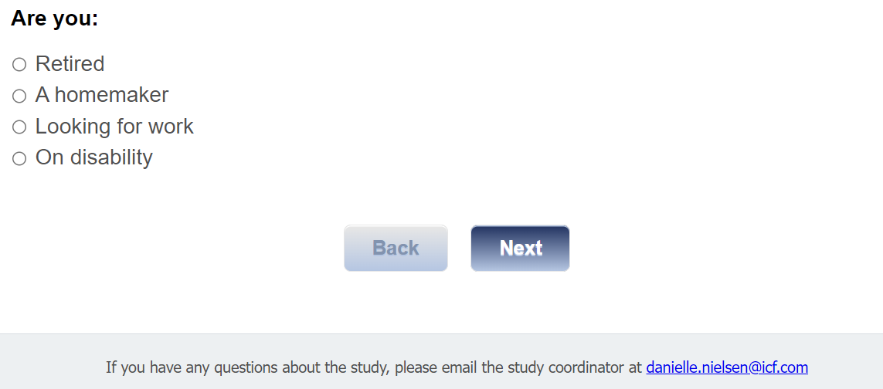

[ASK ALL]
Q7.
What kind of work do/did you do or what was your job title? (e.g., registered nurse, personnel manager, auto mechanic, accountant, grinder operator)
[TEXT BOX]
[250 CHARACTERS]

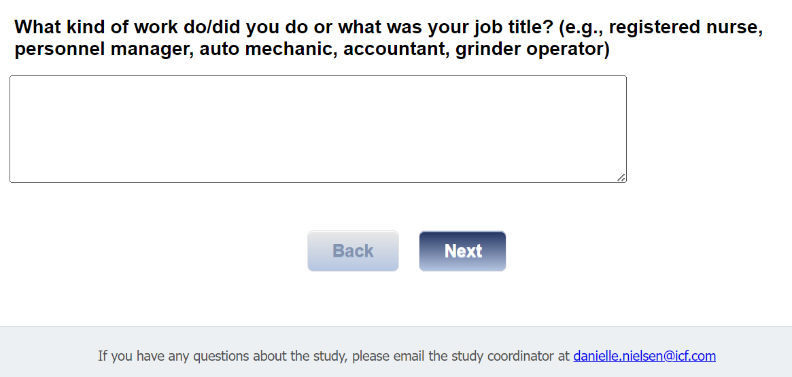

[ASK ALL]
[MUL=8]
Q8.
What is the current primary source of your health insurance?
01 A plan purchased through an employer or union (including plans purchased through another person’s employer)
02 A private nongovernmental plan that you or another family member buys on your own
03 Medicare
04 Medigap
05 Medicaid
06 Military-related health care
07 Indian Health Service
08 State-sponsored health plan
09 Other government programs (specify)
10 No coverage of any type [EXCLUSIVE]
11 Other (specify)

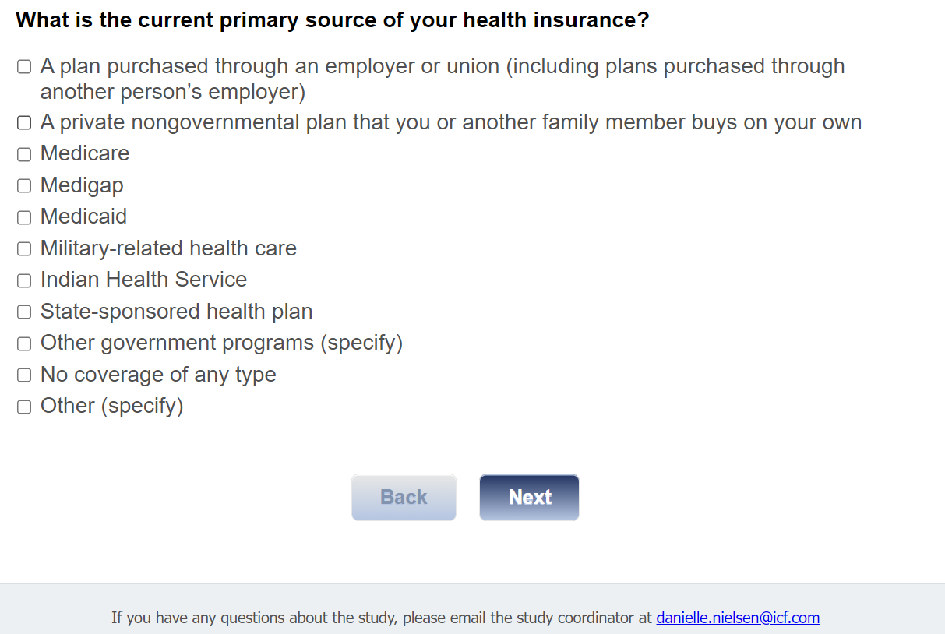

[ASK ALL]
Q9.
Below is a list of income groups. Please select which group best represents your total combined family income for the past 12 months. (This includes the total income before taxes earned in the past year by all family members living with you. Please include money from jobs, net income from business, farm or rent, pensions, dividends, welfare, social security payments, and any other money received by you or any other family member living with you).
01 Less than $10,000
02 $10,000 - $19,999
03 $20,000 - $39,999
04 $40,000 - $59,999
05 $60,000 - $100,000
06 Greater than $100,000

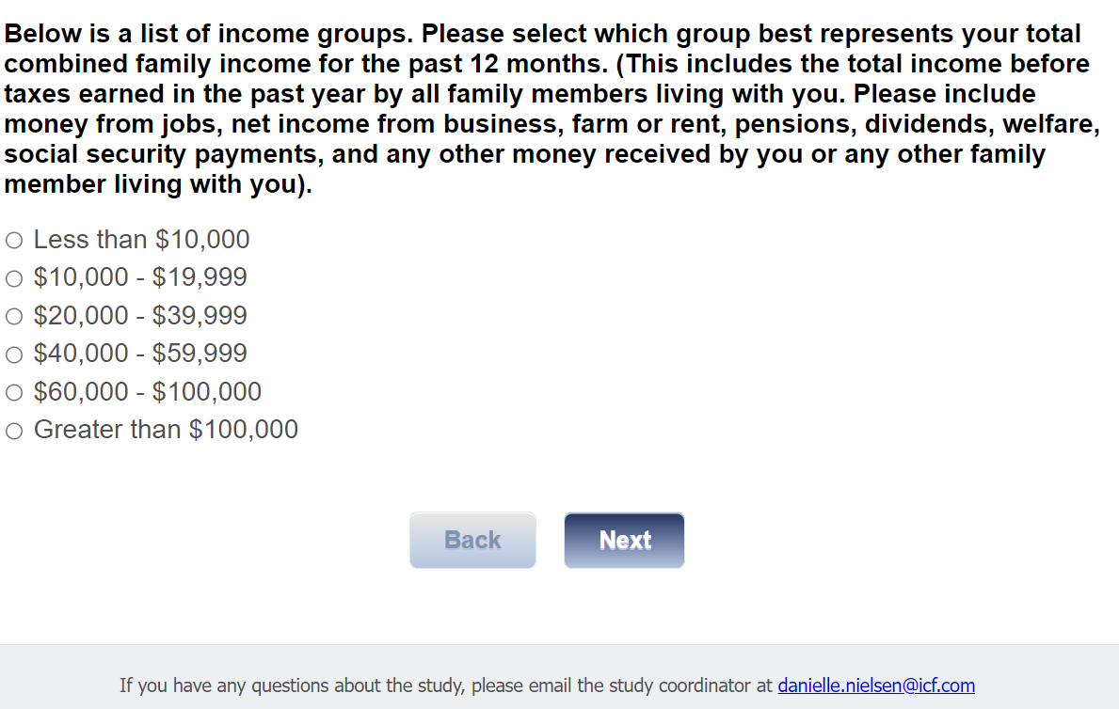

[ASK ALL]
Q10.
What is your date of birth? (mm/dd/yyyy)
Numeric text box [mm/dd/yyyy]

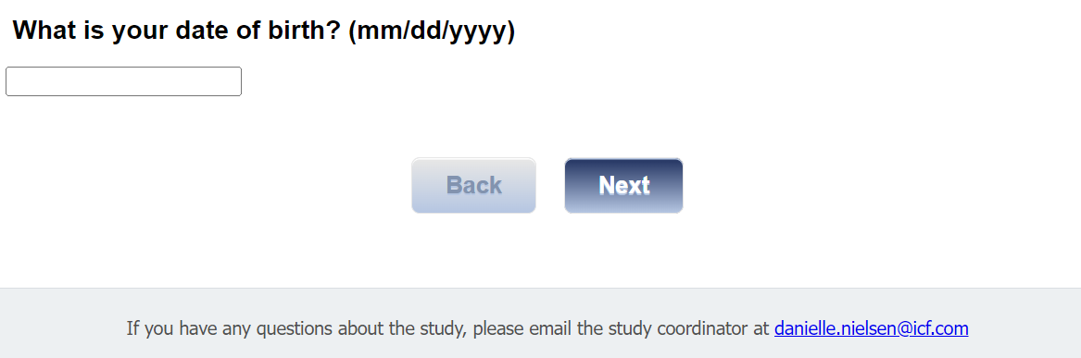

[ASK ALL]
ZIP.
In what zip code do you live? (enter 5-digit numeric zip code)
[TEXT BOX]
[MASK VALIDATION OF 5 DIGITS]
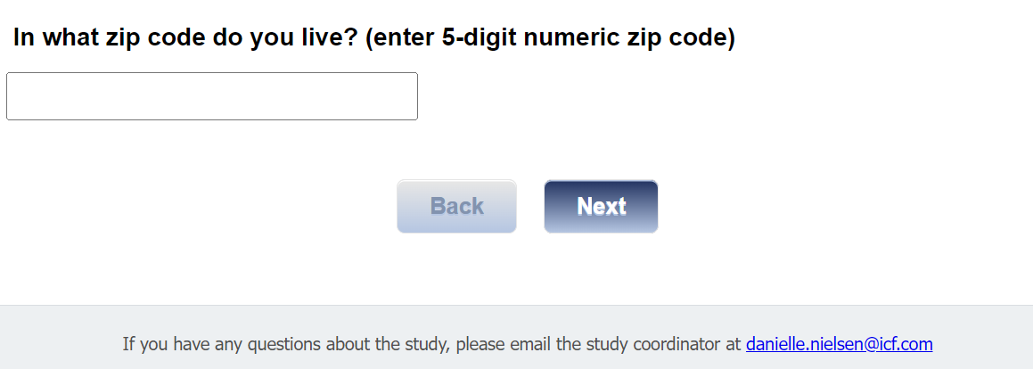

Section 2: Prostate Cancer Experience
[ASK ALL]
Q11.
For this next set of questions, we’d like to understand your personal and family experience with prostate cancer and prostate cancer screening. If you are unsure about the answer to a specific question, please estimate the answer to the best of your ability.

Do you have a family history of prostate cancer?
Family history of prostate cancer is defined as having a first-degree relative (father, son, or brother) who had prostate cancer, or having two close relatives on the same side of the family who had prostate cancer.
01 Yes
02 No
03 Don’t know

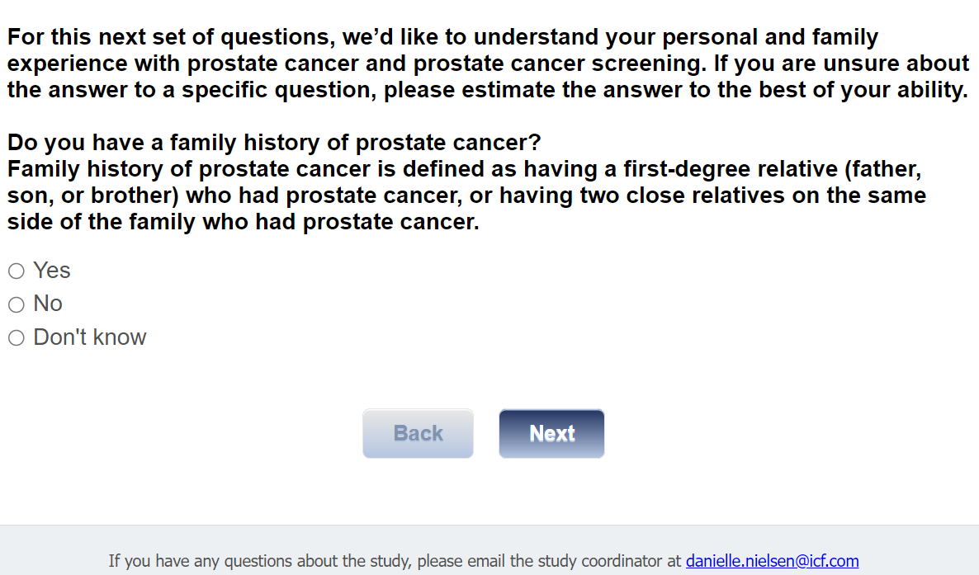

[ASK IF Q11=01]
[MUL=5]
Q12.
Please check all individuals in your family that had prostate cancer:
01 Father
02 Brother
03 Grandfather
04 Uncle
05 Other (Specify) [TEXT BOX]

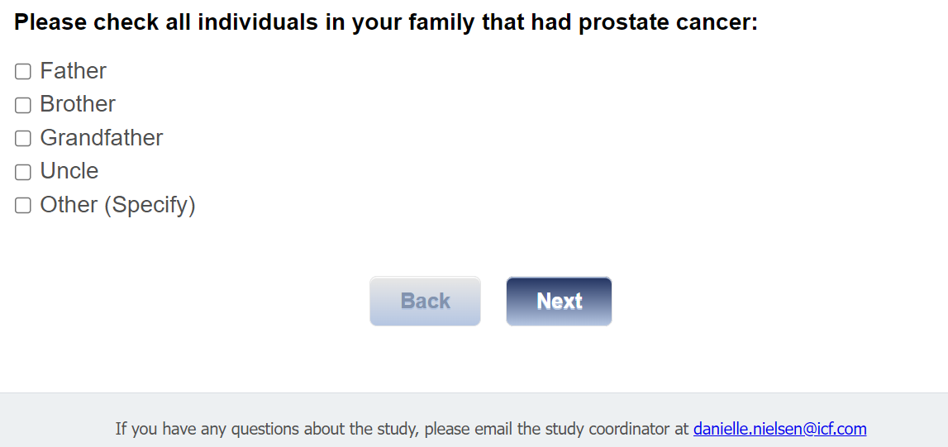

[ASK If Q12= 01-05]
Q13.
[IF Q12 HAS ONLY ONE RESPONSE INSERT “At what age was this family member’s prostate cancer found? Please estimate to the best of your ability”; IF Q12=MUL, INSERT “What was the age of the family member who had the most recent diagnosis, if known? Please estimate to the best of your ability”]
01 Younger than 55 years
02 55-64 years
03 65-74 years
04 75 years or older

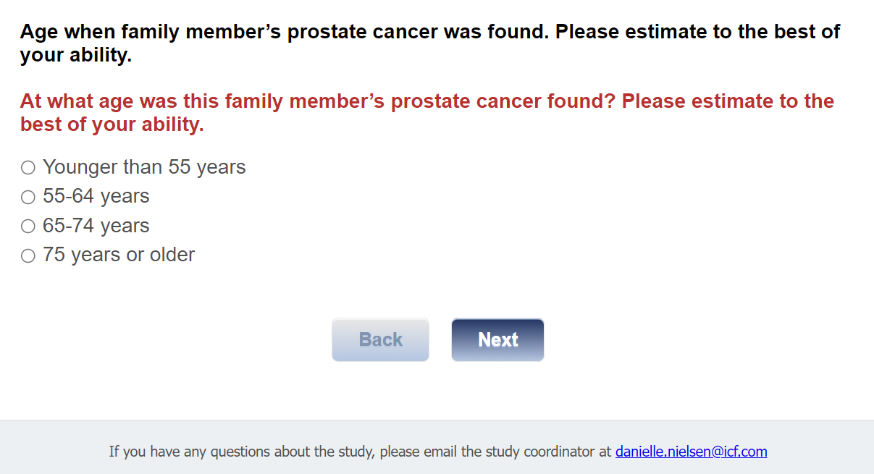

[ASK IF Q11=01]
Q13a.
Do you have any male children?
01 Yes
02 No

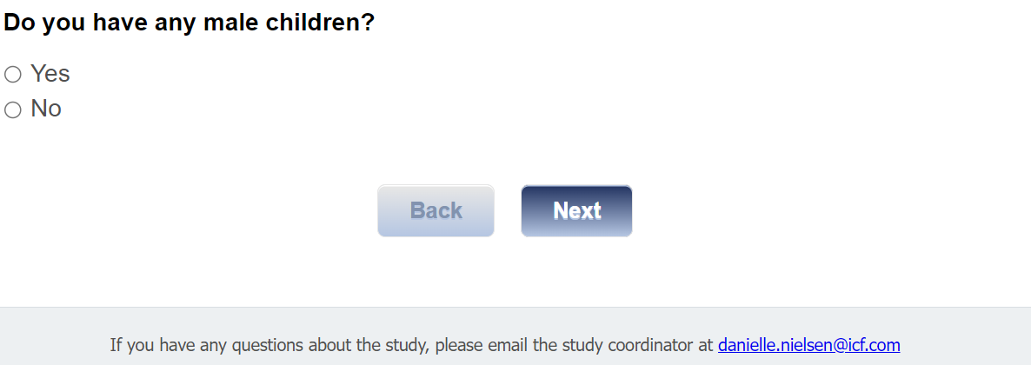

[ASK if Q13a=01]
Q14.
How many male children do you have?
RANGE 0-8 [NUMBER BOX]

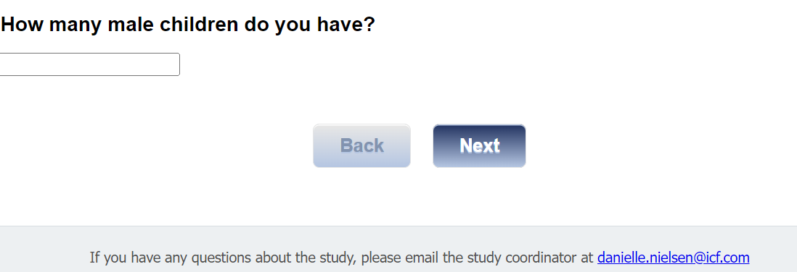

[ASK IF Q14=1]
Q15_1.
Was your male child ever diagnosed with prostate cancer?
01 Yes
02 No

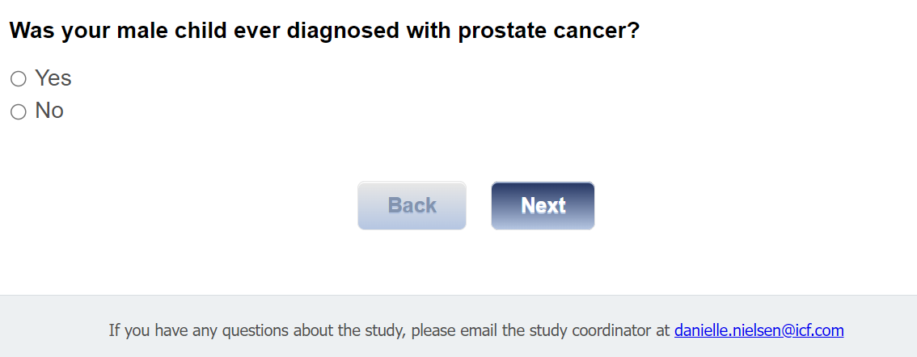

[ASK IF Q14=2-8]
Q15.
How many of your male children have been diagnosed with prostate cancer?
RANGE 0-[Q14]

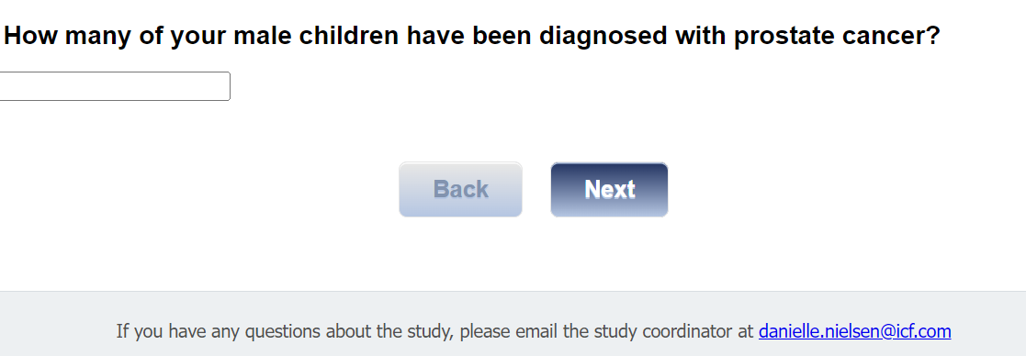

[Start Loop MC; REPEAT UP TO 5 TIMES; IF q15 > 1 INSERT ORDER OF CHILD (1st, 2ND, 3RD, ETC.) AS NOTED IN QUESTION BELOW]
[If Q15_1=01, Q15=1]

[ASK IF Q15=1-5 OR Q15_1=01]
Q16.
At what age did your [first/second/third/fourth/fifth] male child who was diagnosed with prostate cancer receive their prostate cancer diagnosis?
RANGE 5-95 [NUMBER BOX]

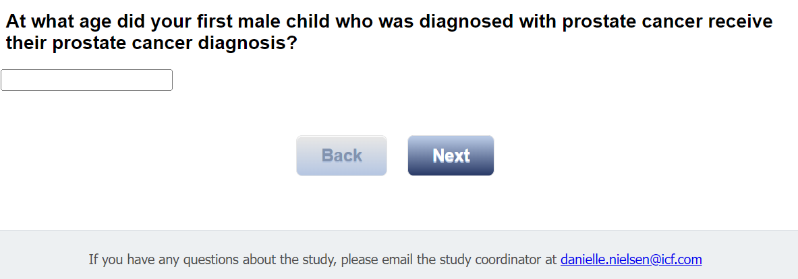

[end Loop MC]

[ASK ALL]
Q17.
Have you had a prostate cancer screening (digital rectal exam, prostate-specific antigen test) in the last three years?
01 Yes
02 No

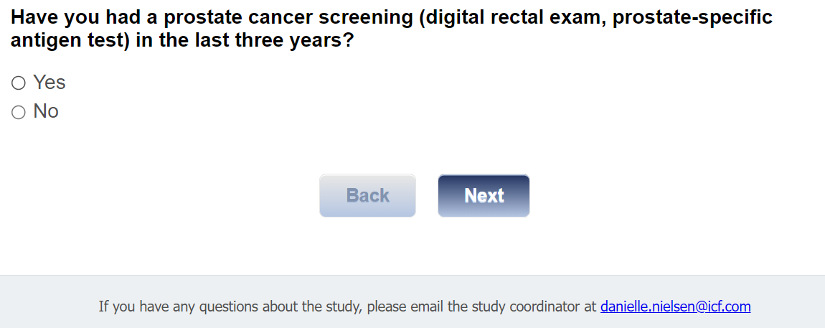

[ASK ALL]
Q18.
Have you ever had the following:

 | 01 Yes | 02 No
Q18a. A prostate infection (prostatitis)?
Q18b. Enlarged prostate (BPH)?
Q18c. Prostate surgery for BPH?
Q18d. Prostate biopsy?

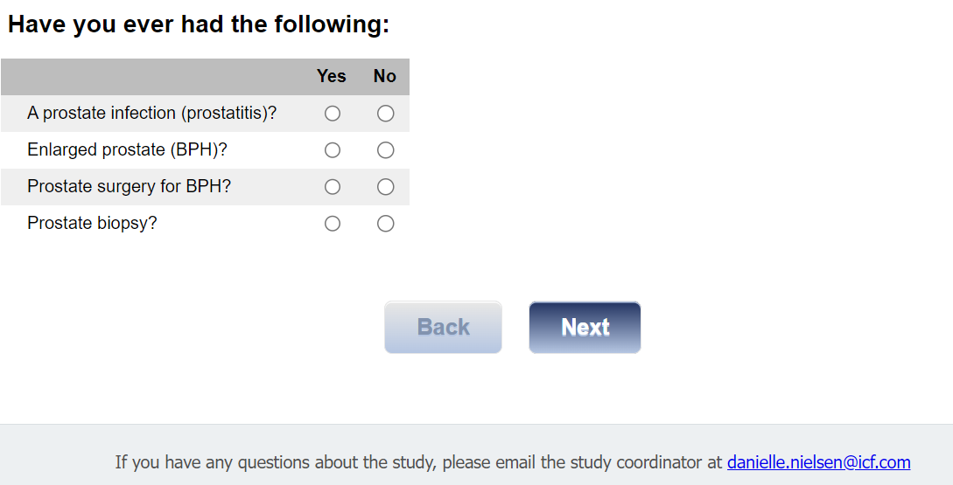

[ASK If Q18d= 01]
Q18d1
How many prostate biopsies have you had?
RANGE 1-9 [NUMBER BOX]

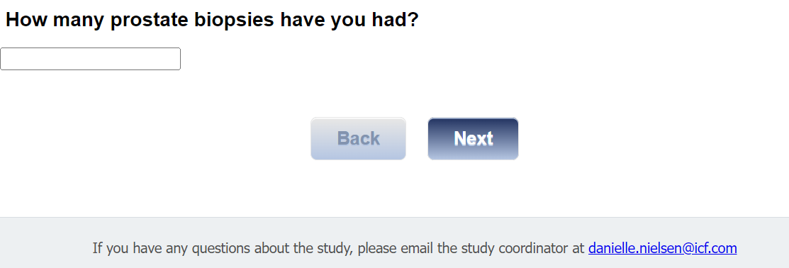

[ASK If Q18d1= 1-9]
Q18d2
In what year did you have your most recent prostate biopsy?
RANGE 1950-2023 [NUMBER BOX, no comma]

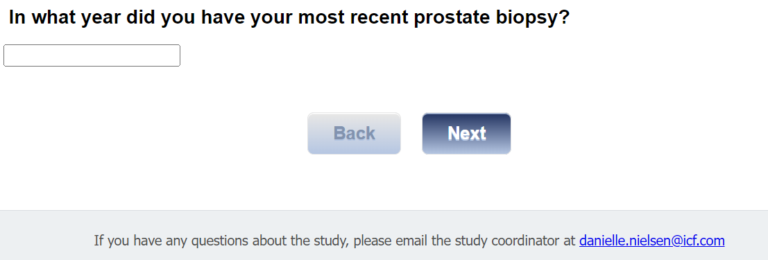

[ASK If Q18d1= 1-9]
Q18d3
What was the result of your most recent prostate biopsy?
01 Negative
02 Positive

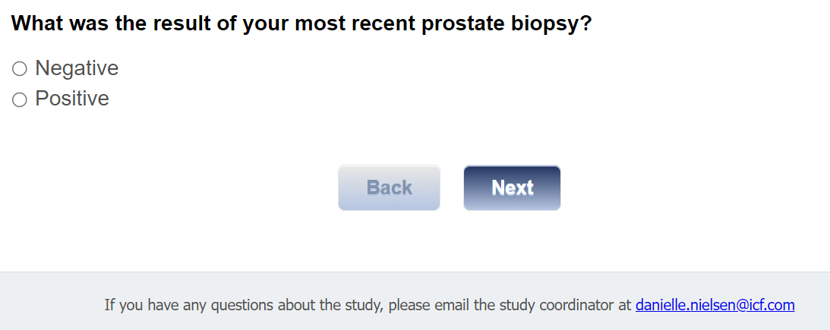

Section 3: Prostate Cancer Knowledge

[ASK ALL]
Q19
Next, we’d like to get a sense of your prostate cancer knowledge. If you are unsure how to answer a question, please select the “Not sure” response.

The prostate gland is a reproductive organ located below the bladder.
01 True
02 False
03 Not sure

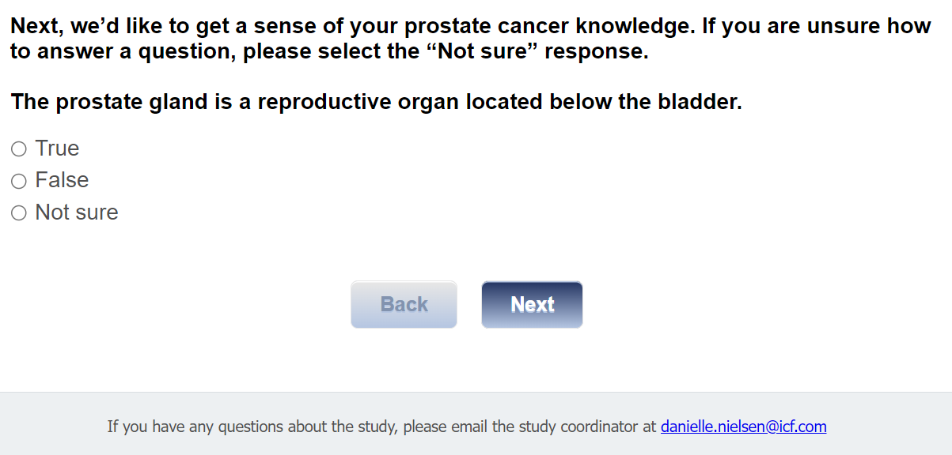

[ASK ALL]
Q19a
The prostate gland makes some of the fluid that’s part of semen.
01 True
02 False
03 Not sure

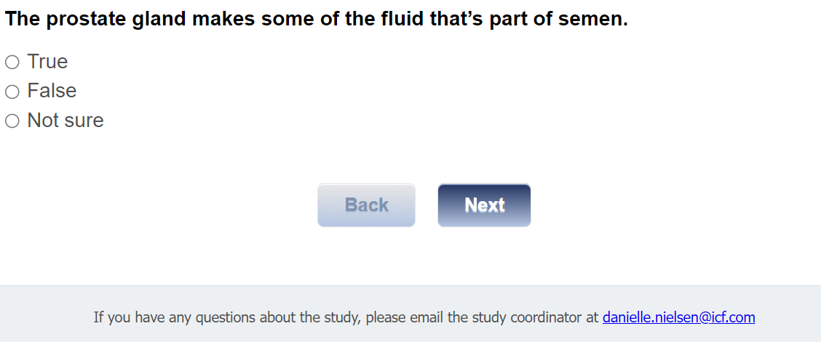

Risk Factors

[ASK ALL]
Q20
Older men are more likely to get prostate cancer.
01 True
02 False
03 Not sure

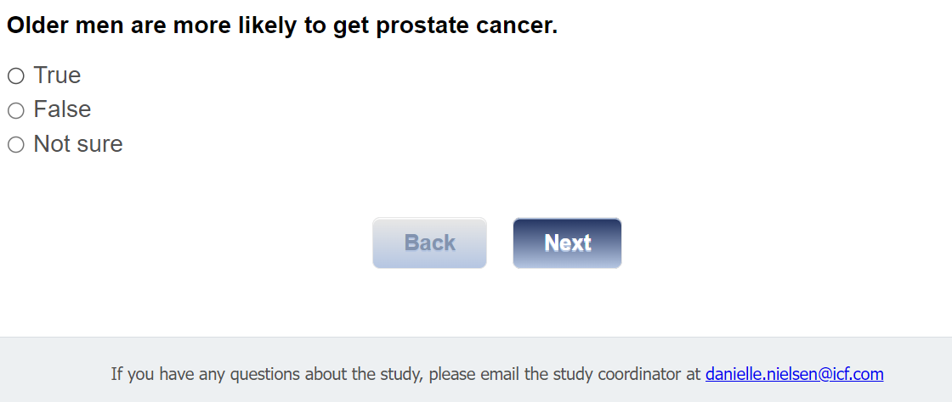
[ASK ALL]
Q21
More Black or African American men are diagnosed with prostate cancer than White men.
01 True
02 False
03 Not sure

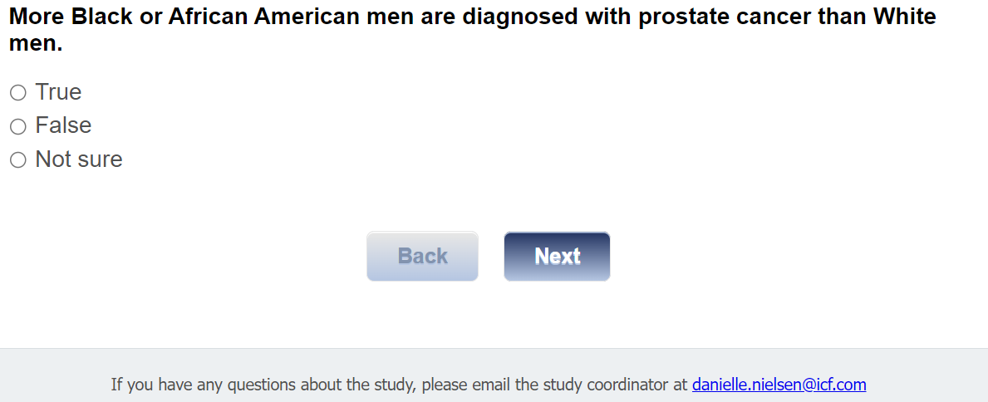

[ASK ALL]
Q22
Men who have fathers or brothers with prostate cancer are more likely to get prostate cancer than those who do not.
01 True
02 False
03 Not sure

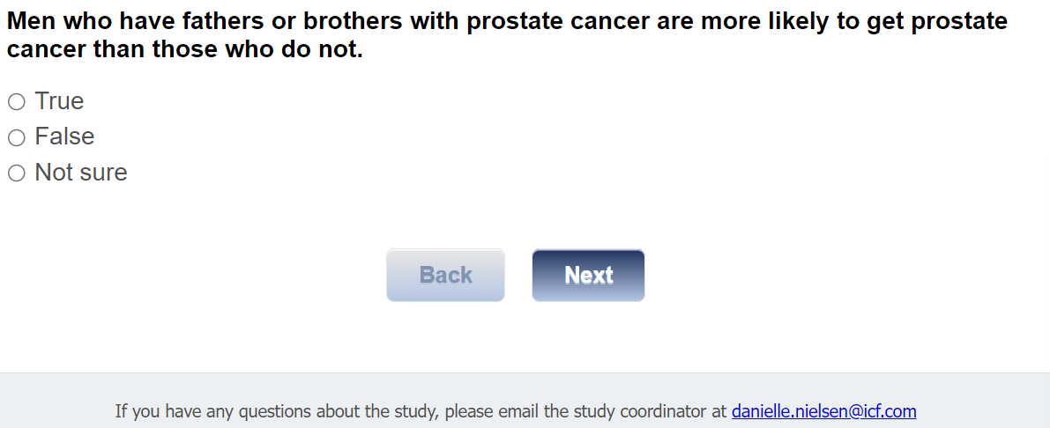

[ASK ALL]
Q23.
Who do you think is more likely to get prostate cancer?
01 White men
02 Black or African American men
03 Hispanic or Latino men
04 Asian men
05 Race or ethnicity is not a factor
97 Not sure

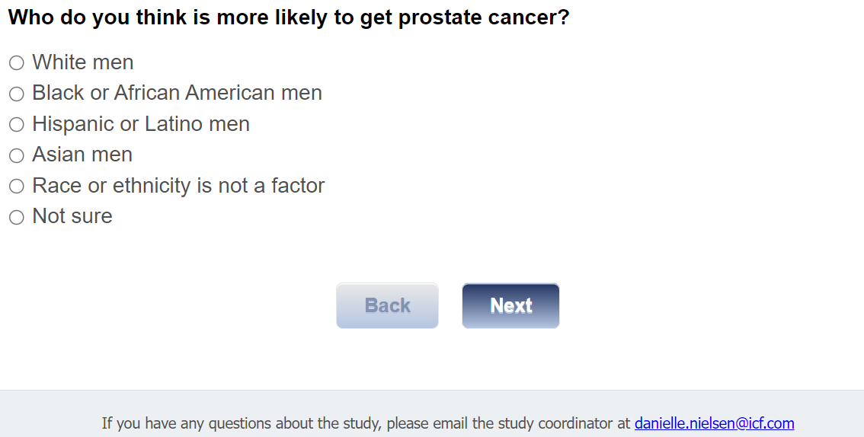

[ASK ALL]
Q24.
Who do you think is more likely to get prostate cancer?
01 A man whose father has had prostate cancer
02 A man whose father has not had prostate cancer
03 It doesn’t make any difference
97 Not sure

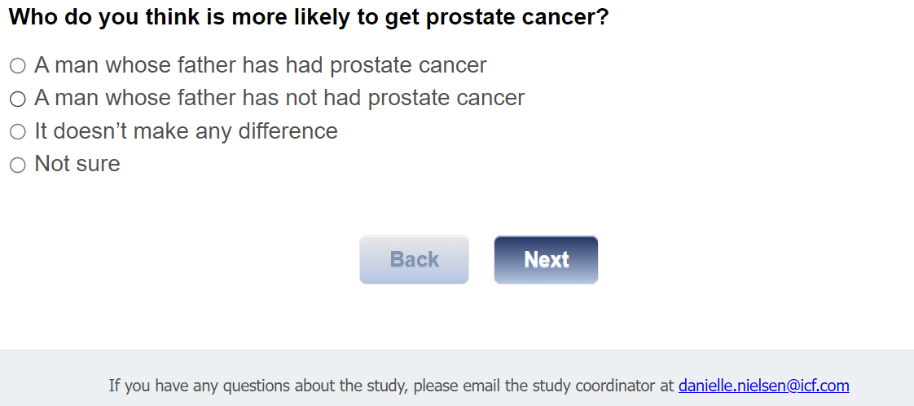

Screening

[ASK ALL]
Q25.
A prostate-specific antigen, or PSA blood test can be done to check for prostate cancer.
01 True
02 False
97 Not sure

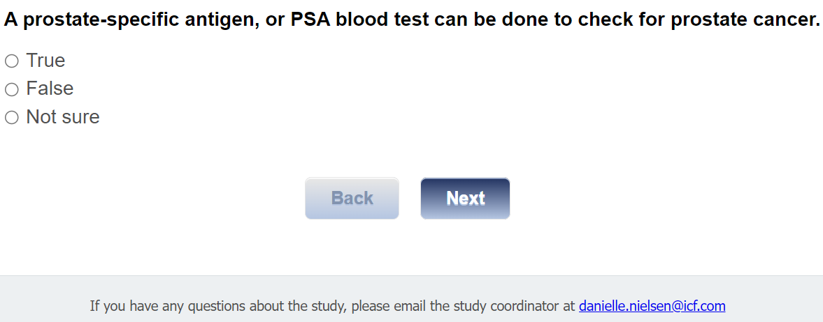

[ASK ALL]
Q26.
A digital rectal exam or DRE can be done to check for prostate cancer.
01 True
02 False
97 Not sure

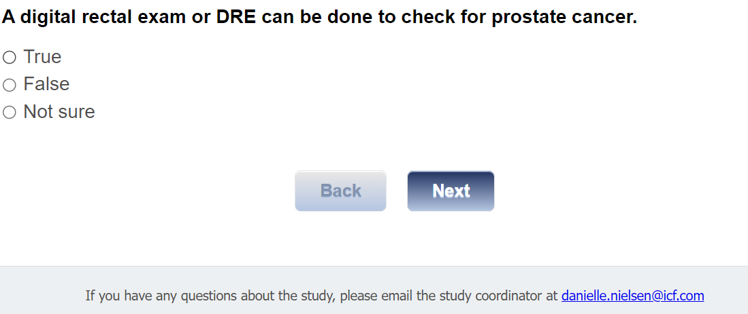

[ASK ALL]
Q27.
The only way a man can know for sure if he has prostate cancer is to have a prostate biopsy.
01 True
02 False
97 Not sure

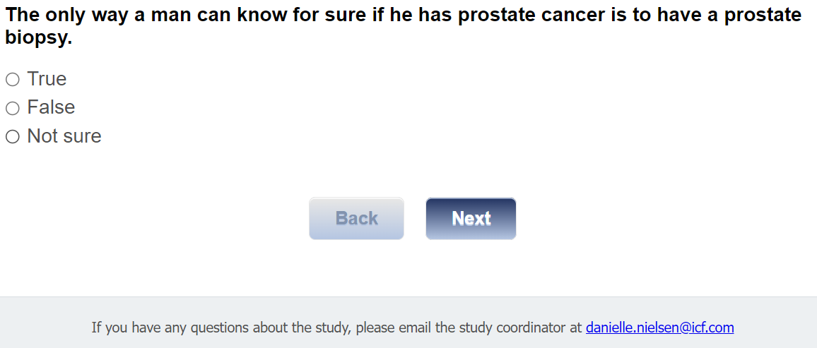

[ASK ALL]
Q28.
A prostate biopsy is when a blood test is used to check for proteins in the blood.
01 True
02 False
97 Not sure

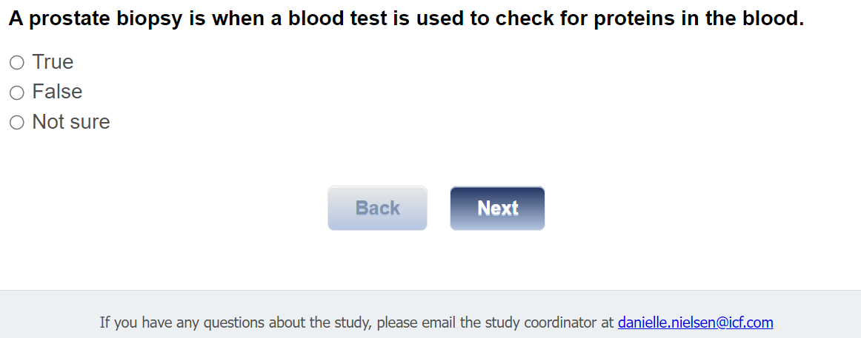

[ASK ALL]
Q29.
Neither the PSA nor DRE are 100% accurate.
01 True
02 False
97 Not sure

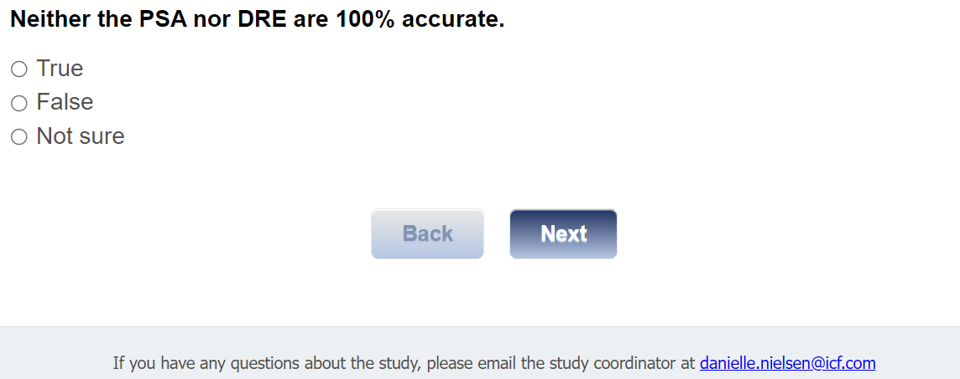

Warning Signs
[ASK ALL]
Q30.
A man can have prostate cancer and have no symptoms.
01 True
02 False
97 Not sure

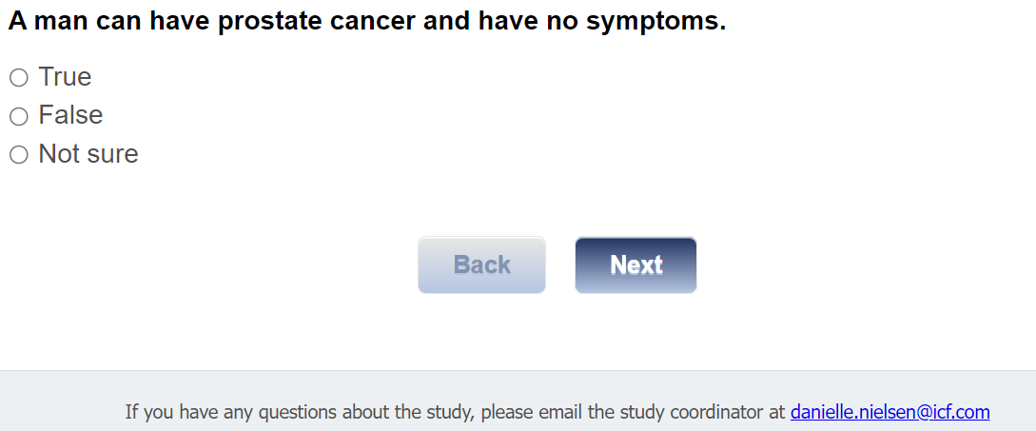

Section 4: Health Literacy
[ASK ALL]
Q34.
Next, we’d like to collect information about your understanding of health information, and how confident you are completing medical forms and learning about your medical conditions. Answer each of the following questions using either never, occasionally, sometimes, often, or always.

 | 01 Never | 02 Occasionally | 03 Sometimes | 04 Often | 05 Always
Q34a. How often do you have someone help you read hospital materials?
Q34b. How often do you have problems learning about a medical condition because of difficulty understanding written information?
Q34c. How often do you have a problem understanding what is told to you about a medical condition?
Q34d. How confident are you filling out medical forms by yourself?

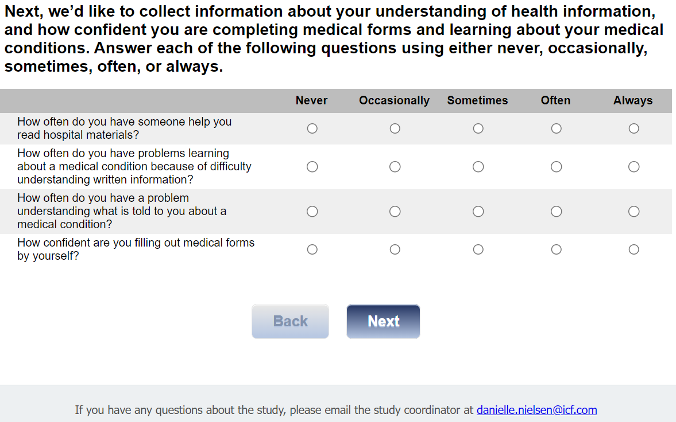

Section 5: Digital Literacy
[ASK ALL]
Q35.
For this next set of statements, we would like to ask for your opinion and about your experience using the internet for health information. For each statement, please indicate which response best reflects your opinion and experience right now using strongly agree, agree, neither, disagree, or strongly disagree.

 | 01 Strongly Agree | 02 Agree | 03 Neither | 04 Disagree | 05 Strongly Disagree
Q35a. I know how to find helpful resources on the internet.
Q35b. I know how to use the internet to answer my health questions.
Q35c. I know what health resources are available on the internet.
Q35d. I know where to find helpful health resources on the internet.

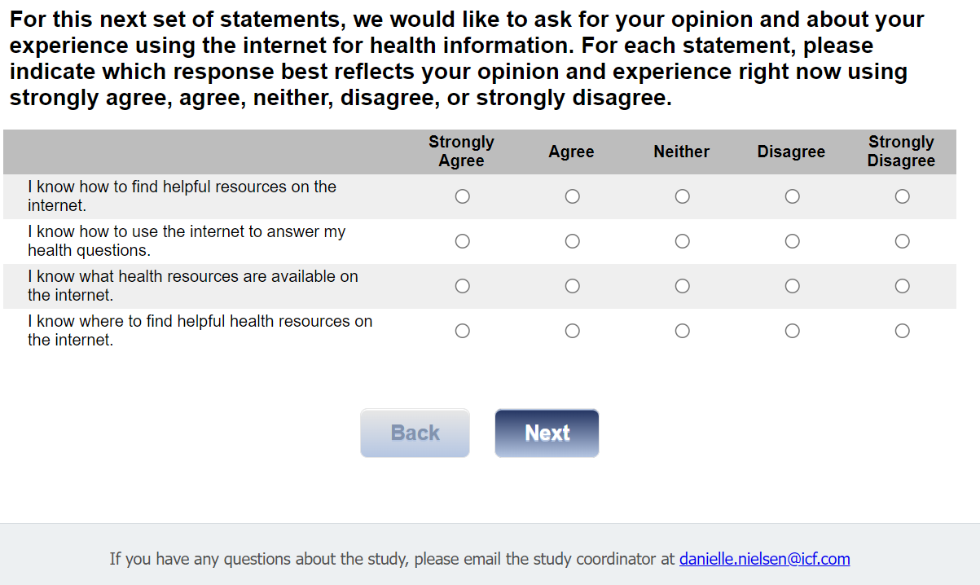

[ASK ALL]
Q35e_h.

 | 01 Strongly Agree | 02 Agree | 03 Neither | 04 Disagree | 05 Strongly Disagree
Q35e. I know how to use the health information I find on the internet to help me.
Q35f. I have the skills I need to evaluate the health resources I find on the internet.
Q35g. I can tell high quality from low quality health resources on the internet.
Q35h. I feel confident in using information from the internet to make health decisions.

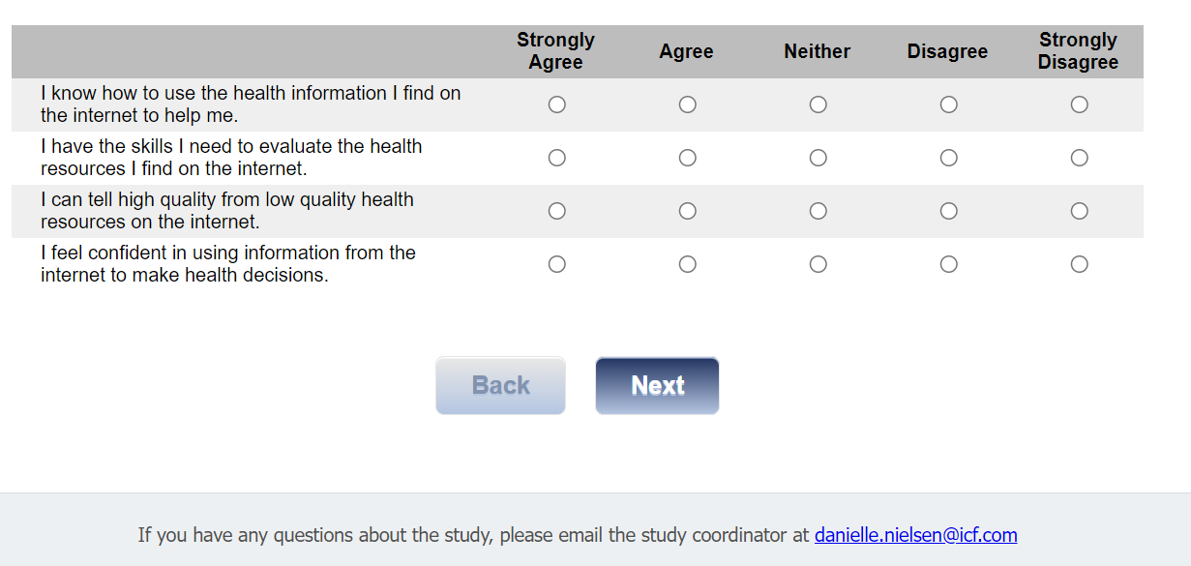

Section 6: Decisional Conflict
[ASK ALL]
Q36.
As it relates to prostate cancer screening, for this next set of questions, please indicate your agreement with each statement, using either strongly agree, agree, neither, disagree, or strongly disagree.

 | 01 Strongly Agree | 02 Agree | 03 Neither | 04 Disagree | 05 Strongly Disagree
Q36a. I know which prostate cancer screening options are available to me.
Q36b. I know the benefits of each option.
Q36c. I know the risks and side effects of each option.
Q36d. I am clear about which benefits matter most to me.

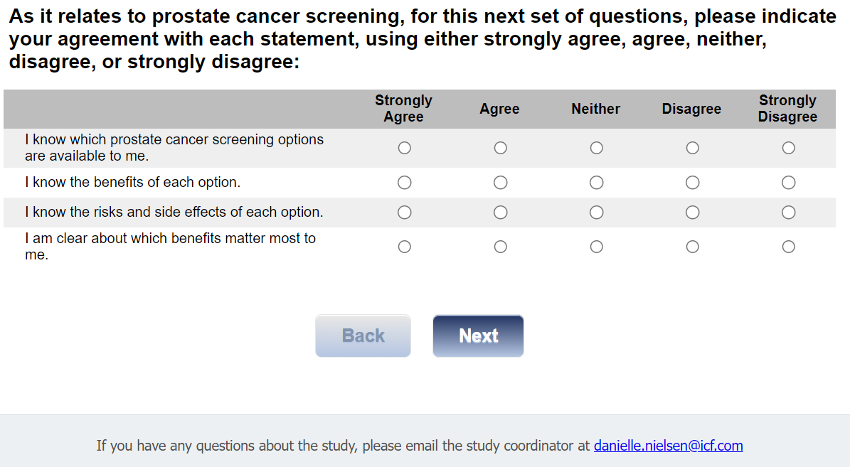

[ASK ALL]
Q36e_h.
Relating to prostate cancer screening,
 | 01 Strongly Agree | 02 Agree | 03 Neither | 04 Disagree | 05 Strongly Disagree
Q36e. I am clear about which risks and side effects matter most.
Q36f. I am clear about which is more important to me (the benefits or the risks and side effects).
Q36g. I have enough support from others to make a choice about prostate cancer screening.
Q36h. I am choosing without pressure from others.

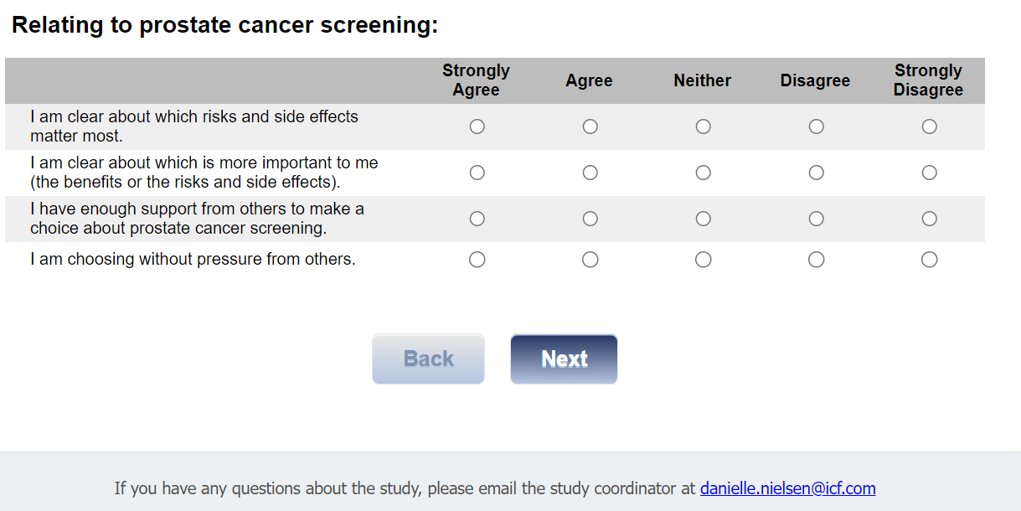

[ASK ALL]
Q36i_l.
Relating to prostate cancer screening,
 | 01 Strongly Agree | 02 Agree | 03 Neither | 04 Disagree | 05 Strongly Disagree
Q36i. I have enough advice to make a choice.
Q36j. I am clear about the best choice for me.
Q36k. I feel sure about what to choose.
Q36l. This decision is easy for me to make.

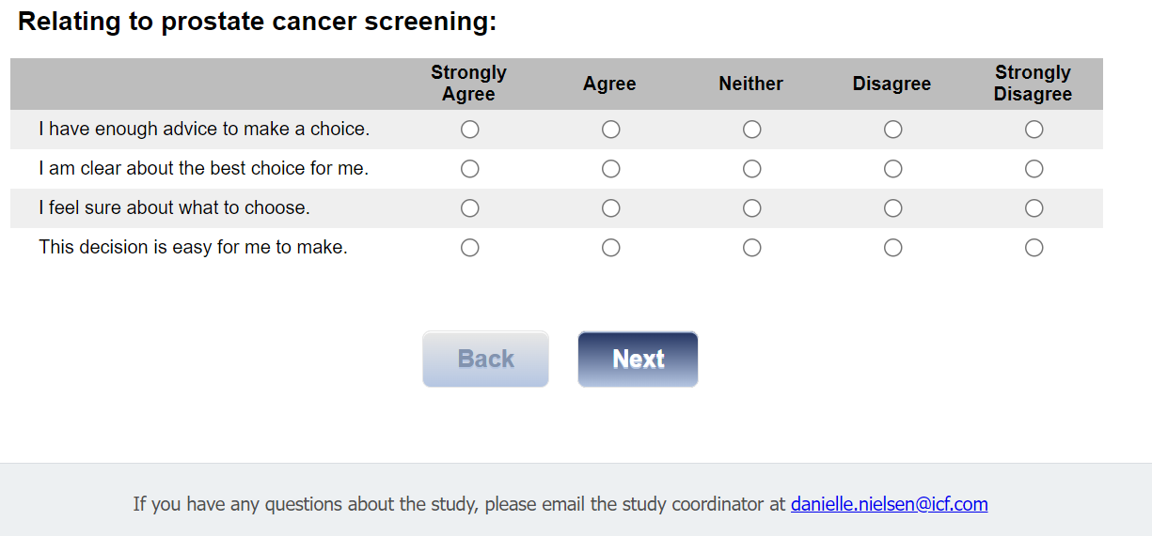

[ASK ALL]
Q36m_p.

Relating to prostate cancer screening,

 | 01 Strongly Agree | 02 Agree | 03 Neither | 04 Disagree | 05 Strongly Disagree
Q36m. I feel I have made an informed choice.
Q36n. My decision shows what is important to me.
Q36o. I expect to stick with my decision.
Q36p. I am satisfied with my decision.

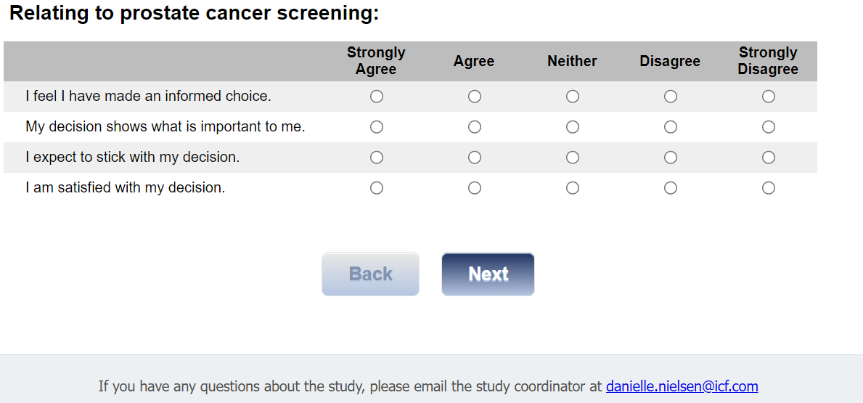

Section 7: Autonomous Decision Making
[ASK ALL]
Q37.
Please check the response that best describes how you prefer to be involved in making decisions about screening for prostate cancer.
01 I prefer to make the final decision.
02 I prefer to make the final decision after seriously considering my health care provider’s opinion.
03 I prefer that my health care provider and I share responsibility for the final decision.
04 I prefer that my health care provider makes the final decision after he/she seriously considers my opinion.
05 I prefer that my health care provider makes the final decision.

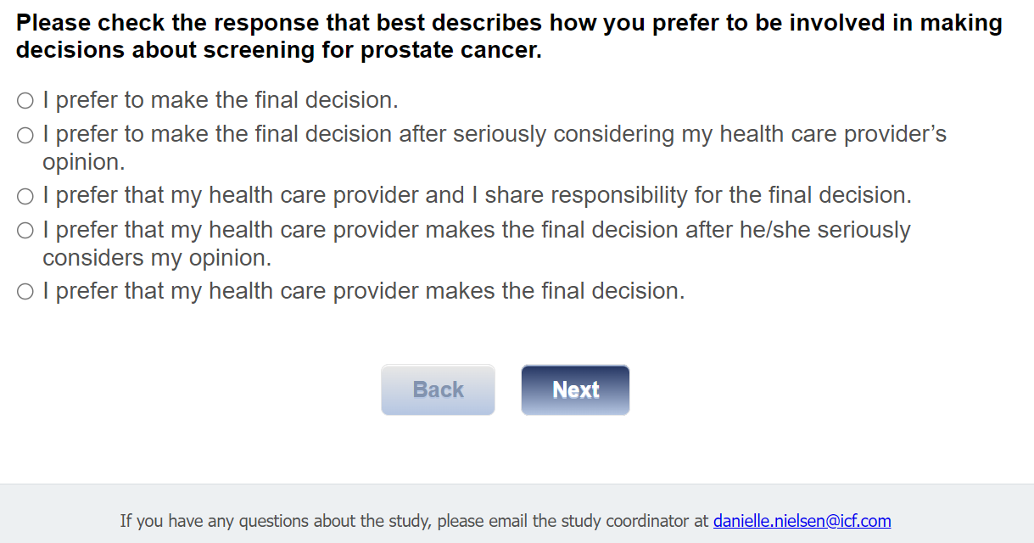

Section 8: Previous Exposure to Informational Materials About Prostate Cancer Screening
[ASK ALL]
Q38.
Have you ever read any informational materials about prostate cancer screening?
01 Yes
02 No

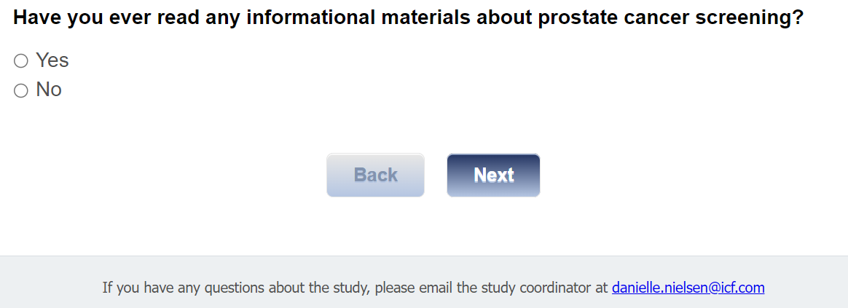

[ASK IF Q38=01]
Q39.
What informational materials about prostate cancer screening did you read?
[TEXT BOX]

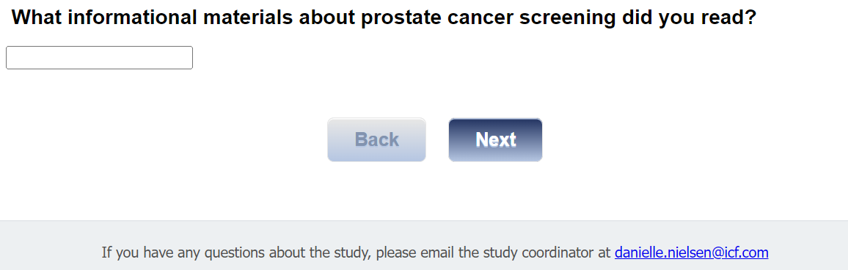

[ASK IF Q38=01]
Q40.
How long ago did you read these materials?

01 Within the past month
02 Within the past 2-3 months
03 Within the past 4-6 months
04 Within the past 7-12 months

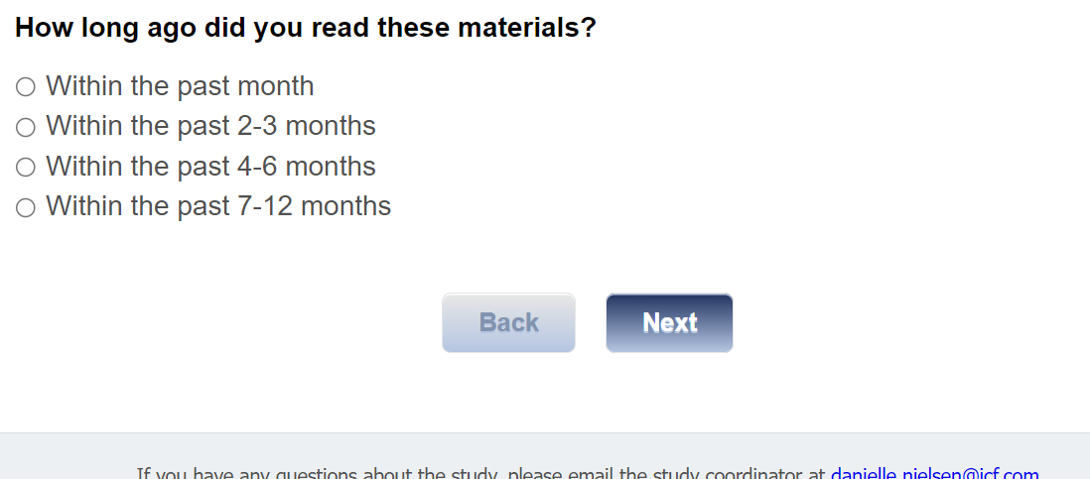

[ASK IF Q38=01]
[MUL=4]
Q41.
Where did you get these materials? Check all that apply.

01 My doctor gave them to me
02 At the doctor’s office or clinic
03 I looked for them online
04 Other, specify [TEXT BOX]

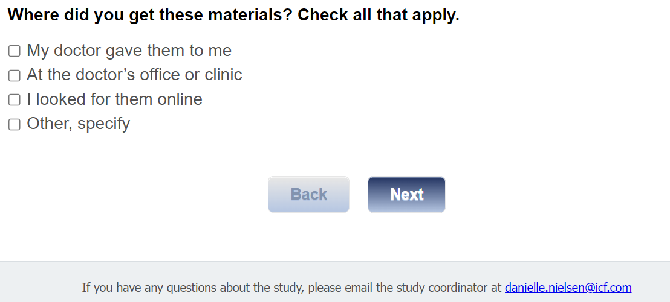

[ASK IF Q38=01]
Q42.
How much of the material did you read?

01 All of it
02 Most of it
03 Some of it

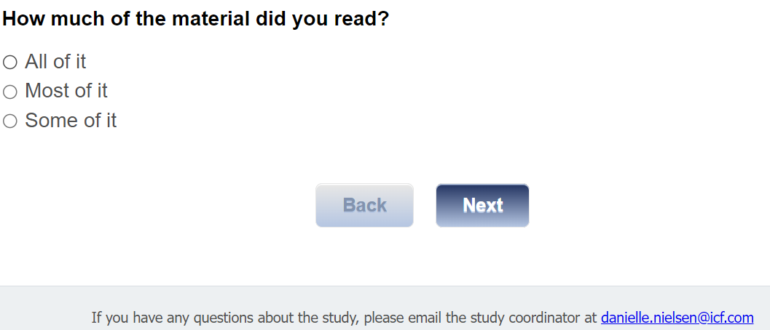

[ASK IF Q38=01]
[MUL=3]
Q43.
What kind of material was it? Check all that apply.
01 Paper pamphlet or brochure
02 Web page or interactive web site
03 Other, specify [TEXT BOX]

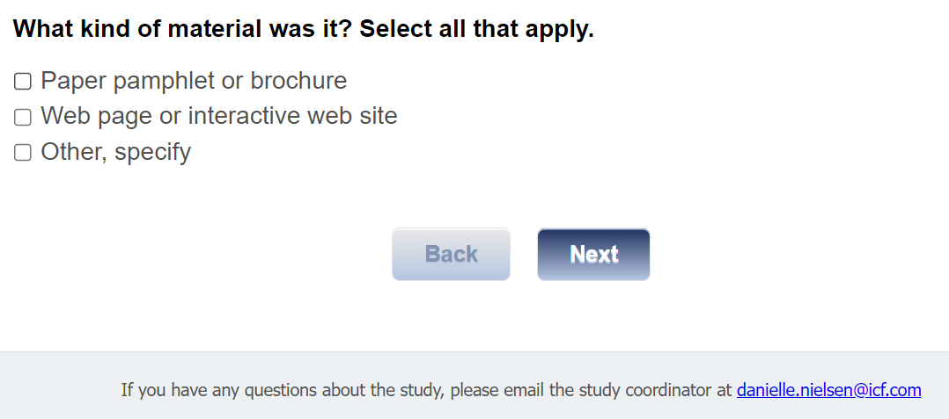

Section 9: Gift Code
[ASK ALL]
[REQUIRED]
J1int. In appreciation for the time you have spent answering our questions, we would like to give you a $25 Amazon gift code. Would you like the gift code?

01 Yes
02 No

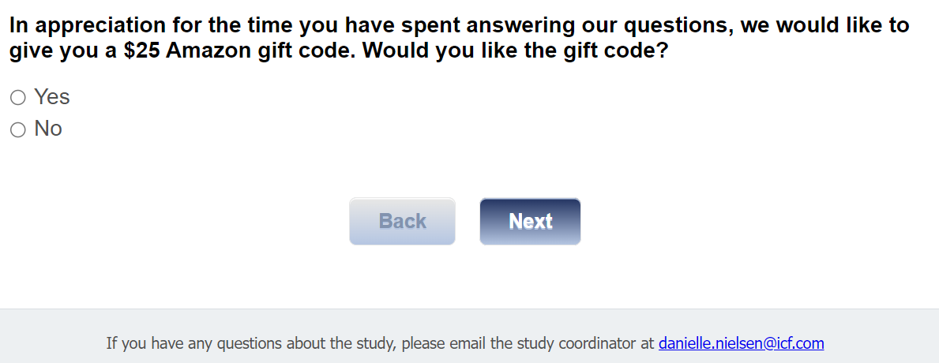

[ASK if J1int=01]
J1.
Thank you for completing this survey. Your $25 Amazon gift code is displayed below. You will also receive an email with this $25 gift code for your records.

<insert GIFT_CODE>

The code is a unique number you can use to purchase items online at Amazon.com. You may enter the code online when you are ready to make a purchase at Amazon.com. There is no expiration date.

Also, within the next week, you will receive an email with a weblink to information about prostate cancer screening for your review. The email will also include a weblink to a survey for your completion. Please be sure to review the information about prostate cancer screening prior to completing the survey.

If you have any questions, please contact the project manager, Danielle Nielsen at Danielle.Nielsen@icf.com.

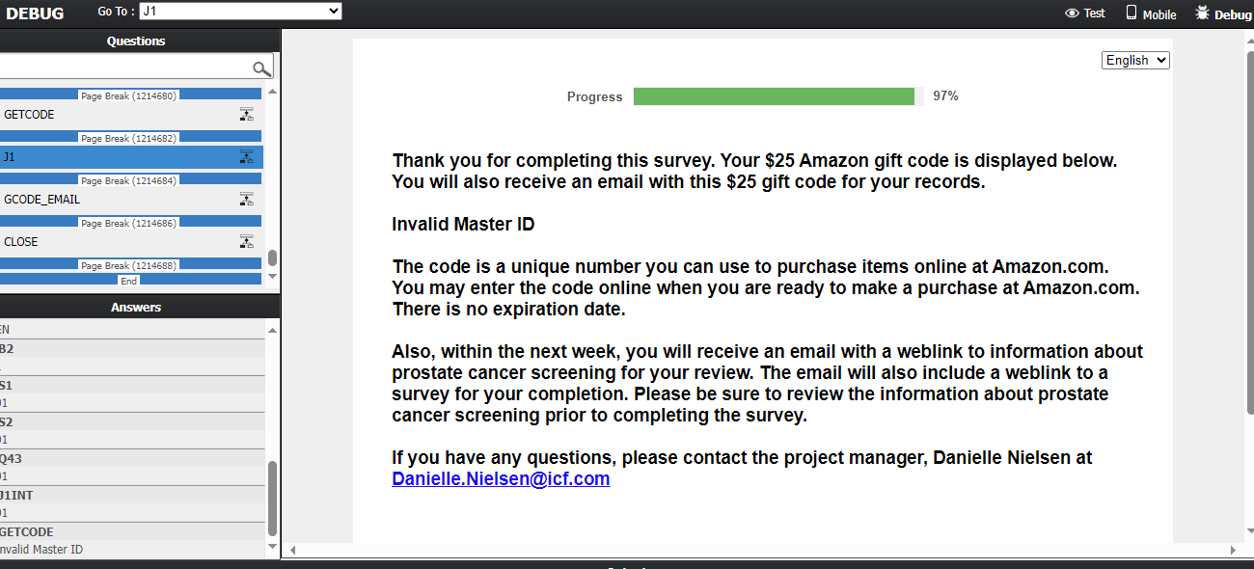

[ASK if J1int=01]
Email1
To receive your code via email, please enter your email address here:
[TextBox]

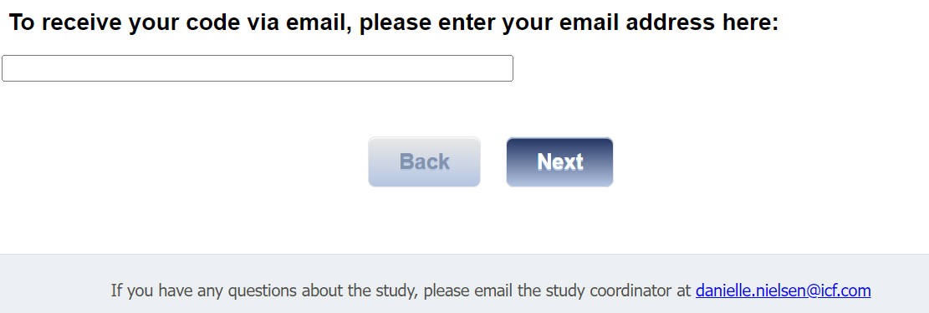

[ASK if J1int=01]
Send <gcode email> to <Email1> from <CDCSurvey@icfsurvey.com>GCode_Email.
Hello!
Thank you for completing the first survey of the CDC Prostate Cancer Evaluation Study!
Here is your Amazon gift code for $25:

<GIFT_CODE>

HOW TO USE YOUR AMAZON GIFT CODE
The code is a unique number you can use to purchase items online at amazon.com. You may enter the code online when you are ready to make a purchase at amazon.com. There is no expiration date.
Save this code in a safe space until you are ready to use it. Some ideas to keep it safe are:
- Write it down on a sheet of paper and keep it in a safe and hidden location.
- Take a photo of the code with your phone.
- Save the code in your Amazon.com account. If you have an amazon.com account, you can save your code in your account until you are ready to spend it.
Type in this link: https://www.amazon.com/gc/redeem/
Or, follow these instructions:
- Go to amazon.com
- In the blue banner, click on "Gift Cards & Registry"
- On the gift cards page, choose "redeem a gift card"
- Type or copy/paste the gift code into the "Enter claim code" field

Thank you once again for your time and feedback!

regards,
Debbie Krugipudi
CDC Prostate Evaluation Study Support Staff

[ASK ALL]
CLOSE.
Thank you for completing this survey!

If you have any questions, please contact the project manager, Danielle Nielsen at Danielle.Nielsen@icf.com.

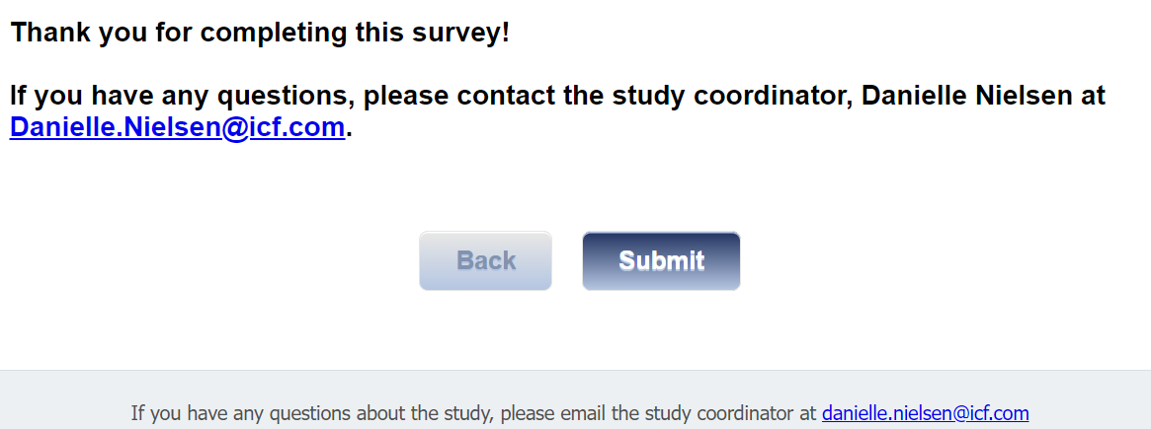

Exit Pre- exposure survey at this point

