Screen 1



Screen 2 (top)

Screen 2 (bottom)

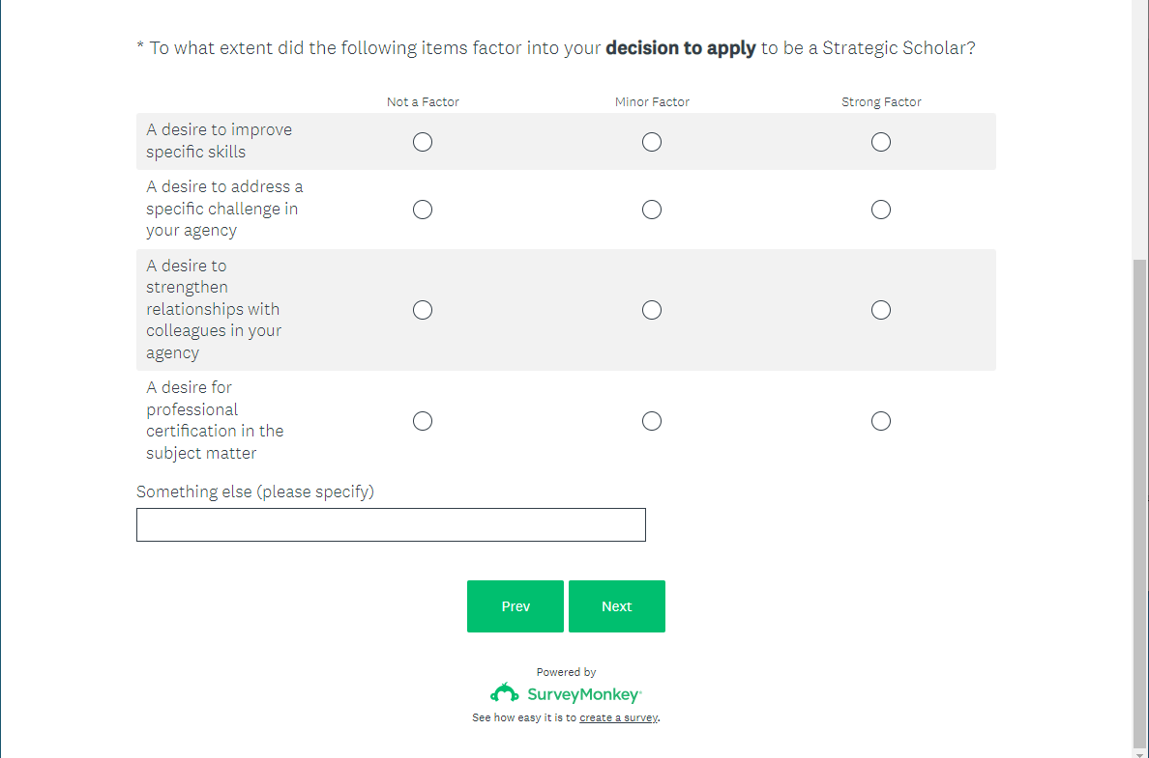

Screen 3 (top)



Screen 3 (bottom)

Screen 4 (top)

Screen 4 (bottom)

Screen 5

Screen 6 (top)

Screen 6 (bottom)

Screen 7

Screen 8

