***Invitation Email***

**Join a 60-minute Building Blocks Focus Group to Improve the Surveillance Data Lifecycle**

**Why focus groups?**

We want to gather input from state, tribal, local, and territorial (STLT) public health agencies to inform the prioritization and design of “Building Blocks” — tools to help public health departments more efficiently and effectively collect, use, analyze, and share surveillance data.

These focus groups will be conducted in a workshop format, where everyone’s voice will be heard.

**What do we want to know?**

We want to identify STLTs’ pain points and needs along various steps of the surveillance data lifecycle (data access and collection, data orchestration, storage, cleansing and integration, analysis and visualization, dissemination and sharing).

We’ll initially have a topic-centered approach for these groups with a specific focus on: childhood lead poisoning, Legionnaires' disease, listeria, HIV, and Data Exchange. (*Data Exchange is the platform through which CDC will exchange data with partners and the public; for Data Exchange focus groups, we're seeking to hear from jurisdictions who report directly to the CDC.).

**Who should participate?**

We want to hear from STLT public health agency staff who interact with surveillance data at any point along the lifecycle (including but not limited to epidemiologists, IT staff, nurses and administrators).

**How do you sign up?**

Focus groups will start in September (specific dates to be determined). Please use this link to sign up:<https://www.surveymonkey.com/r/L35PNRK>

**If you have any questions, please send an email to:** [**dmibuildingblocks@cdc.gov**](mailto:dmibuildingblocks@cdc.gov)

**WE LOOK FORWARD TO LEARNING FROM YOU!**

***Signup Form***

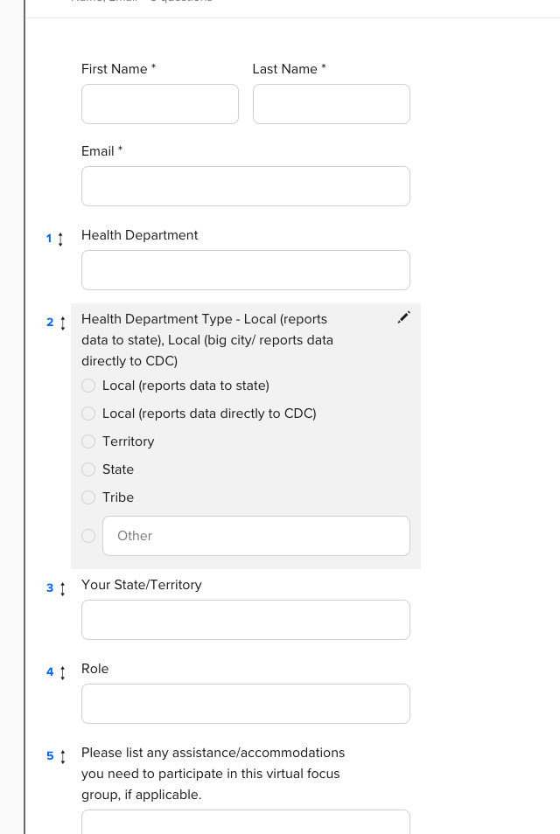

***Mural.co***

*Mural.co view - only link*

[**https://app.mural.co/invitation/mural/primedatainput6410/1663796185904?sender=ubd1733f5f0b3715f56919452&key=31ed5423-3ccc-42fb-b15c-a412bdcec80d**](https://app.mural.co/invitation/mural/primedatainput6410/1663796185904?sender=ubd1733f5f0b3715f56919452&key=31ed5423-3ccc-42fb-b15c-a412bdcec80d)

*Screenshot of the Mural.co board*

