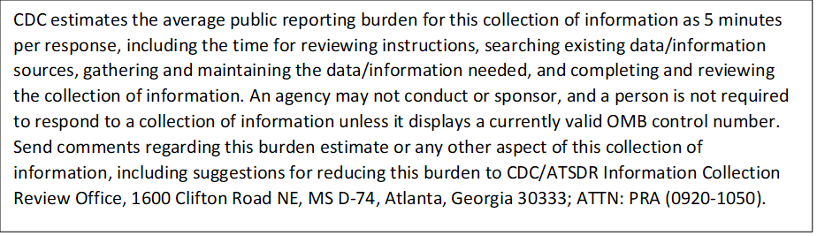

**Post-Program Discussion Guide**

[*Introduction of interviewer name, organization, and role*}

Thanks so much for agreeing to speak with us today.

Is this still a convenient time for you?

As we stated in our email, the goal of this discussion is to better understand the extent to which the program helped to improve your skills, and if you have any recommendations for improving the program.

There are no right or wrong answers to the questions I’ll ask, only opinions. Please feel free to share your candid thoughts. You are the expert here, and there is no one else we can ask to get the unique information that you can tell me about your experiences in the program.

The call should last about 30 minutes.

Please remember that any information you share with us is confidential (i.e., your name will not be associated in any way with your responses). The information we gather will be used to inform possible future adaptations to the program.

With your permission, we would like to take notes during our conversation.

Do you have any questions before we begin?

______________________________________________________________________________

First, I would like to ask you some questions about your overall experience in the program.

1. To start, how would you summarize your time participating in the program?

* + Probe: What skills and knowledge did you develop?
  + Probe: What components of the program best facilitated your learning?

1. If you could, what would you change about this experience?
   * Are there any specific topics you would change?
   * Are there any changes you would make to the format of the sessions, virtual or in-person?
2. Was the information covered during the sessions helpful?

* Probe: Did the session materials enhance your learning during the sessions?
* Probe: Are there any other materials or topics that you would have liked covered during the program?

1. Do you think participating in the program improved your work?

* Probe: If so, please describe how your work has improved.
* Probe: How do you know your work has improved?

1. Which aspects of the sessions did you find most useful?

* Probe: Is there anything about the structure or content of the sessions that could be improved?

1. Which aspects of the sessions did you find least useful?
2. How would you describe your overall satisfaction with the program?
3. If the program were to be implemented again, do you have any recommendations on how to improve the program?

* Probe: Are there any materials that could be developed?
* Probe: Is there any type of additional support that’s needed or that would be helpful to participants?

1. Would you recommend this training to peers, supervisor, or others in your organization?
2. How do you intend to use what you learned during this training in your work?
   * Probe: How/in what way will you use the skills and knowledge you gained

Thank you so much for sharing your experience with the mentoring program. If you think of anything else after this call, feel free to contact the NNPHI evaluation team (Emily Costello, ecostello@nnphi.org). Thank you again for your time.