***Invitation Email***

**Join a 60-minute Interview to Define the Design of Public Health Shared Services**

**Why interviews?**

We want to gather input from state, territorial, and local (STLT) public health authorities to inform the prioritization and design of “Building Blocks” — tools to help public health departments more efficiently and effectively collect, use, analyze, and share surveillance data.

These focus groups will be conducted in a workshop format, where everyone’s voice will be heard.

**What do we want to know?**

We want to identify STLTs’ pain points and needs along various steps of the data lifecycle (data access and collection, data orchestration, storage, cleansing and integration, analysis and visualization, dissemination and sharing) and understand how a well implemented shared service could serve your needs.

We’ll have a topic-centered approach for these conversations centered on: changes to national notifiable disease reporting; reducing burden of STLT data sharing with CDC using the "one front door" policy**;** ease for STLTs to use eCR data;

**Who should participate?**

We want to hear from STLT public health agency staff who interact with data at any point along the lifecycle (including but not limited to PHA leadership, epidemiologists, IT staff, nurses and administrators).

**How do you participate?**

Interviews will begin in March (specific dates to be determined). Please use this link to sign up:<https://www.surveymonkey.com/r/L35PNRK>

**If you have any questions, please send an email to:** [**dmibuildingblocks@cdc.gov**](mailto:dmibuildingblocks@cdc.gov)

**WE LOOK FORWARD TO LEARNING FROM YOU!**

***Signup Form***

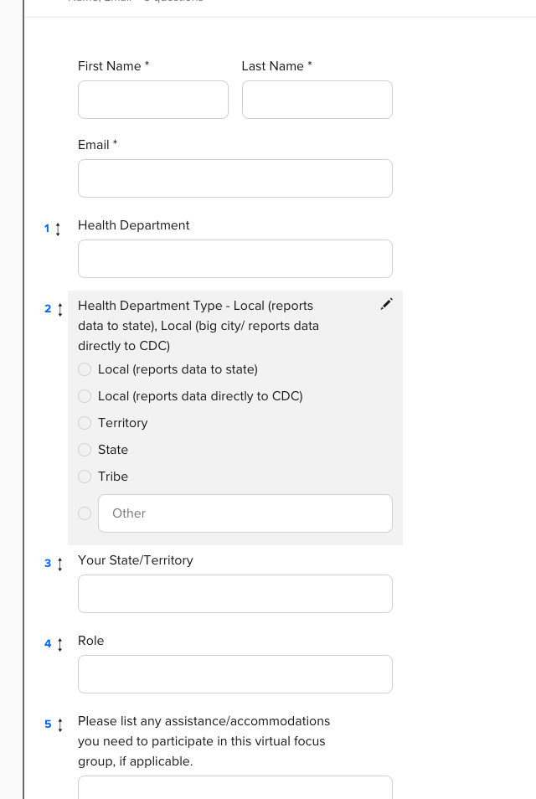

**INTERVIEW TEMPLATE**

UXX – [Topic] User Interview – Name

Date X/XX/2022

Jurisdiction XX

Participant(s) Name - Title

Other attendees Name – Moderator Name – Note taker Name - Observer

Background info Ï [Anything we already know already from past interviews, email exchanges, etc]

Notes

Interview notes

·

Action items

Post-conversation discussion

The public reporting burden of this collection of information is estimated to average **60 minutes** per response, including the time for reviewing instructions, searching existing data sources, gathering and maintaining the data needed, and completing and reviewing the collection of information. An agency may not conduct or sponsor, and a person is not required to respond to a collection of information unless it displays a currently valid OMB control number. Send comments regarding this burden estimate or any other aspect of this collection of information, including suggestions for reducing this burden to - CDC/ATSDR Reports Clearance Officer; 1600 Clifton Road NE, MS D-74, Atlanta, Georgia 30333 ATTN: PRA (0920-1050).

***Mural.co***

*Mural.co view - only link*

[**https://app.mural.co/invitation/mural/primedatainput6410/1663796185904?sender=ubd1733f5f0b3715f56919452&key=31ed5423-3ccc-42fb-b15c-a412bdcec80d**](https://app.mural.co/invitation/mural/primedatainput6410/1663796185904?sender=ubd1733f5f0b3715f56919452&key=31ed5423-3ccc-42fb-b15c-a412bdcec80d)

*Screenshot of the Mural.co board*

