**DOH TA Satisfaction Survey Process Flow Mockup**

***Step 1:*** Once a Technical Assistance Case is closed, the recipient will receive an email with a link to submit a Satisfaction Survey.

**Text of email with link to survey:**

Hello,

A Technical Assistance provider recently closed your Technical Assistance case.

Please take a moment to tell us about your Technical Assistance experience by clicking on the link below. Survey responses will be visible to the Division of Oral Health Program Services Team and not national partners. Completing the survey is optional.

[Link to survey will be here]

Case Number: Case Number will appear here

Subject: Subject of case will appear here

TA Provider(s): (TA providers for the case will be listed here)

We appreciate your response.

Thank you,

Division of Oral Health Program Services Team

***Step 2:*** Once a recipient follows the survey link, they will be taken to the survey.

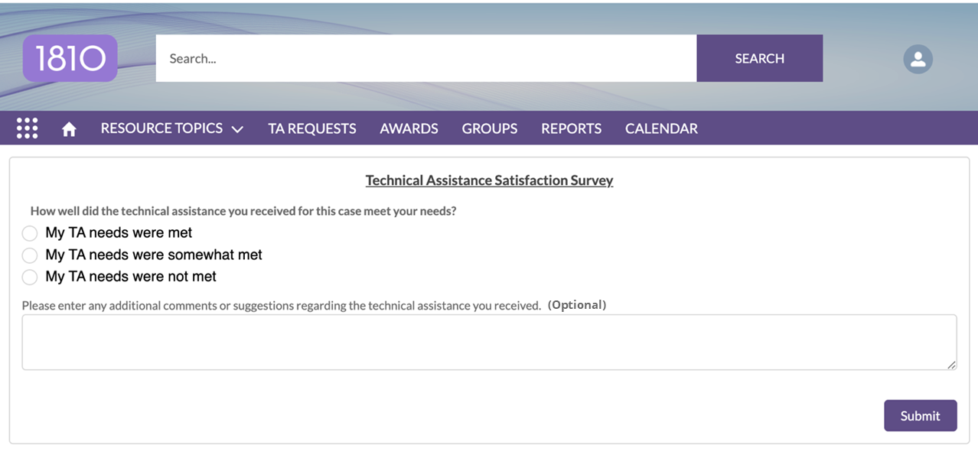

***Step 3:*** Recipients will select one of the following options regarding their Technical Assistance experience:

* My TA needs were met
* My TA needs were somewhat met
* My TA needs were not met

Users can also add additional comments or suggestions in text box and then **Submit** the survey.

***Note:*** Survey responses will be visible only to internal CDC users and not national partners.

***Note:*** 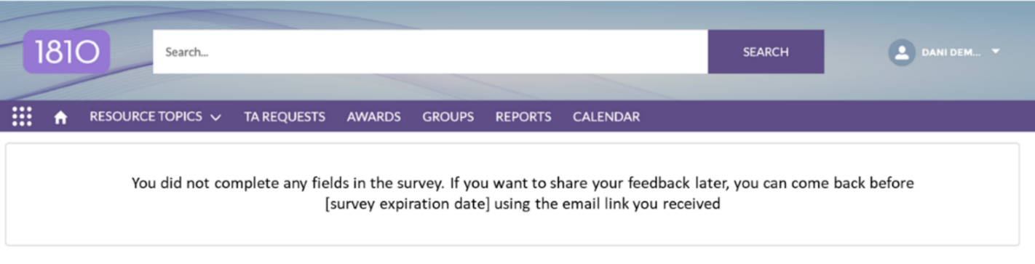If a person does not submit a response, they will see the following screen.