**Attachment 2. 2023 CDC Science Ambassador Fellowship Summer Course Satisfaction Survey Screenshots**

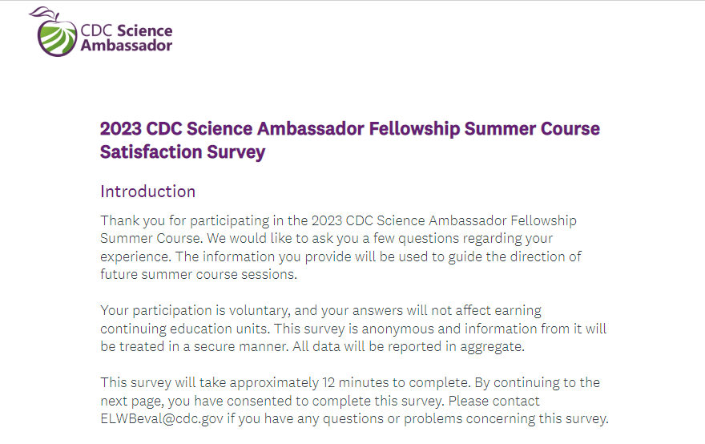

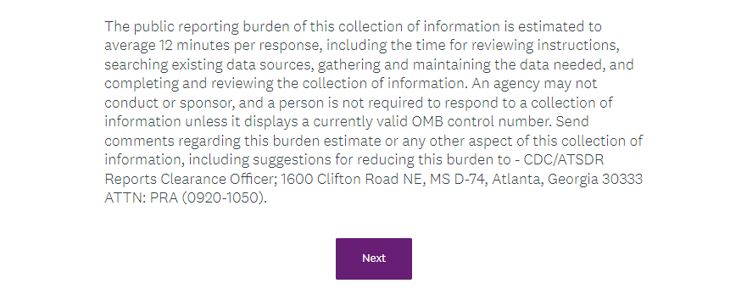

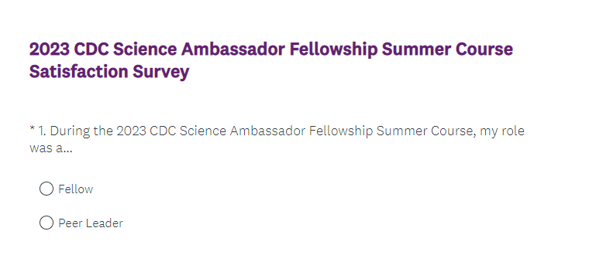

**Skip logic for question 1 determines which questions the respondent sees on the next page. Questions 2 – 10 are for fellows only.**

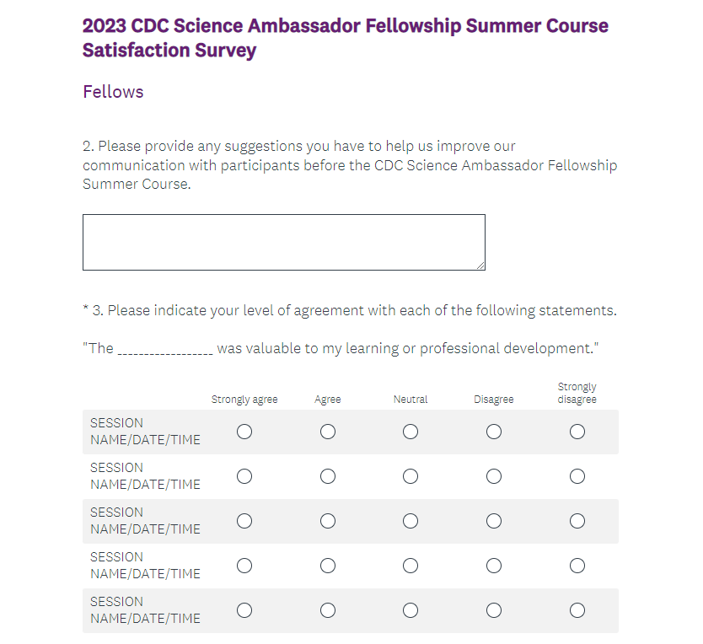

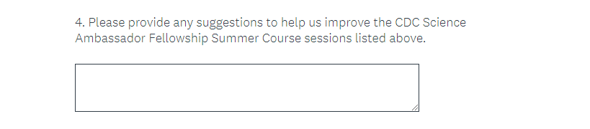

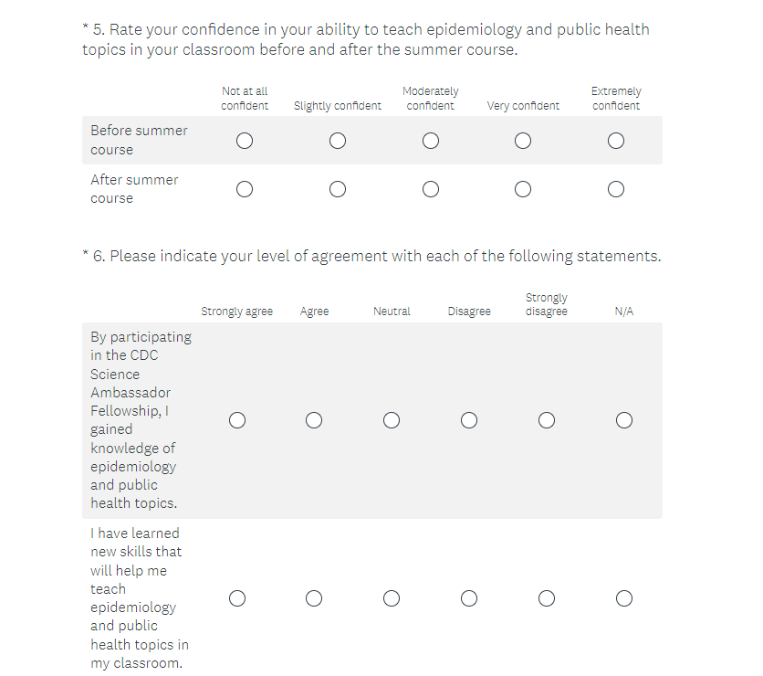

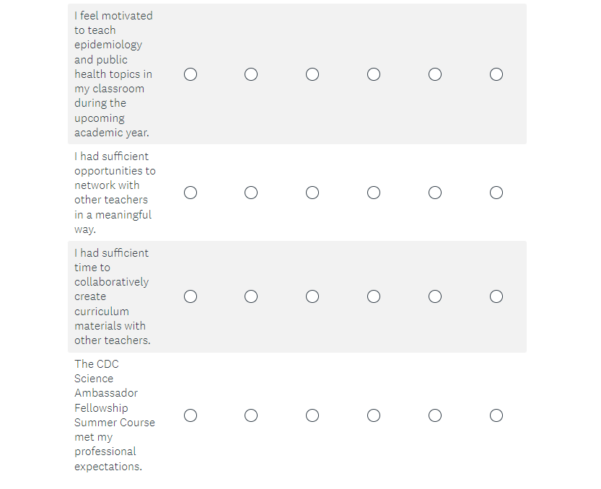

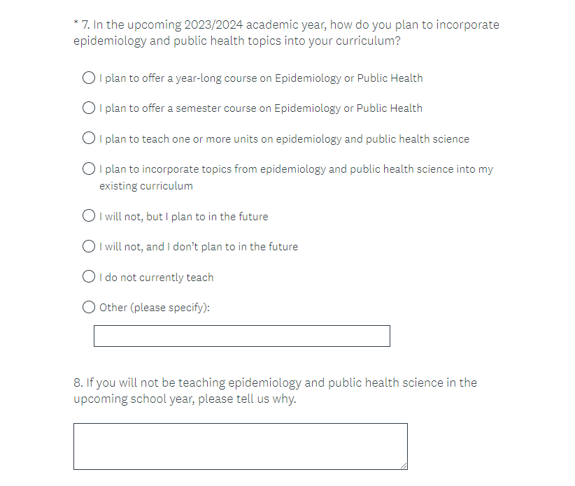

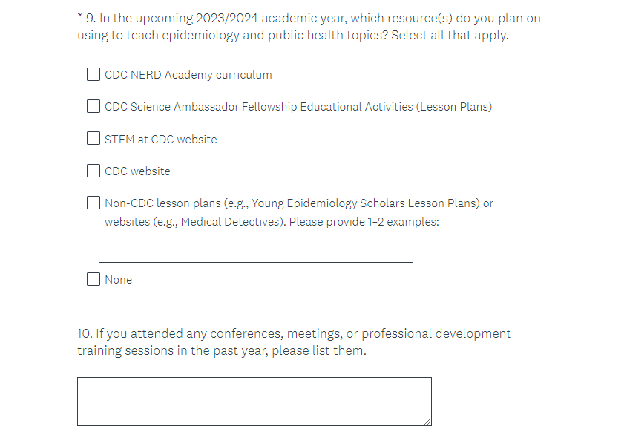

**Skip logic from question 1 is the reason question numbers go back to 2. Questions 11 – 12 (also potentially labeled 2-3) for peer leaders only.**

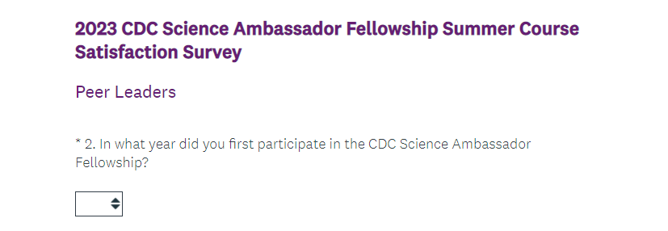

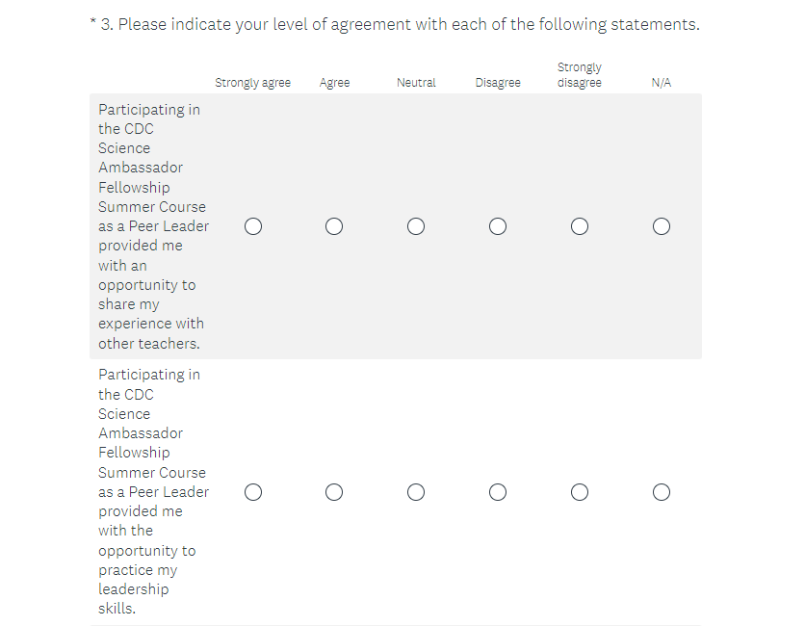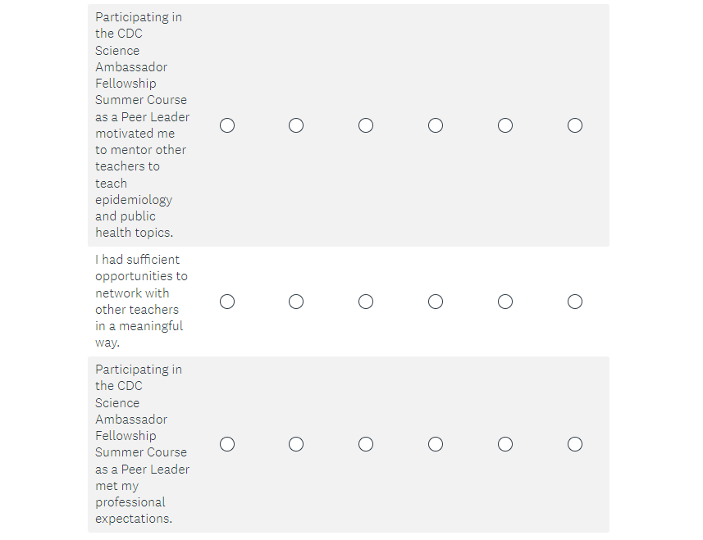

**Questions 13-16 (also potentially labeled 4-7) are for all respondents.**

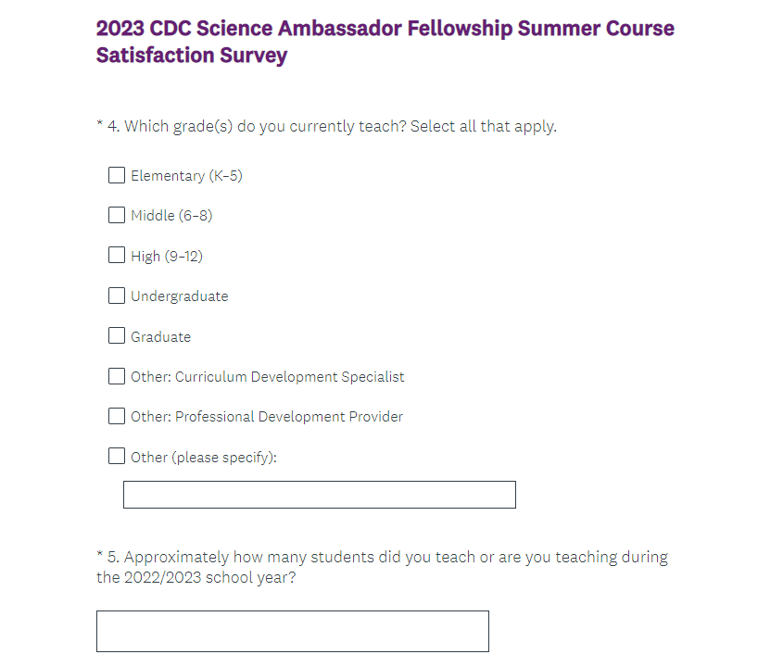

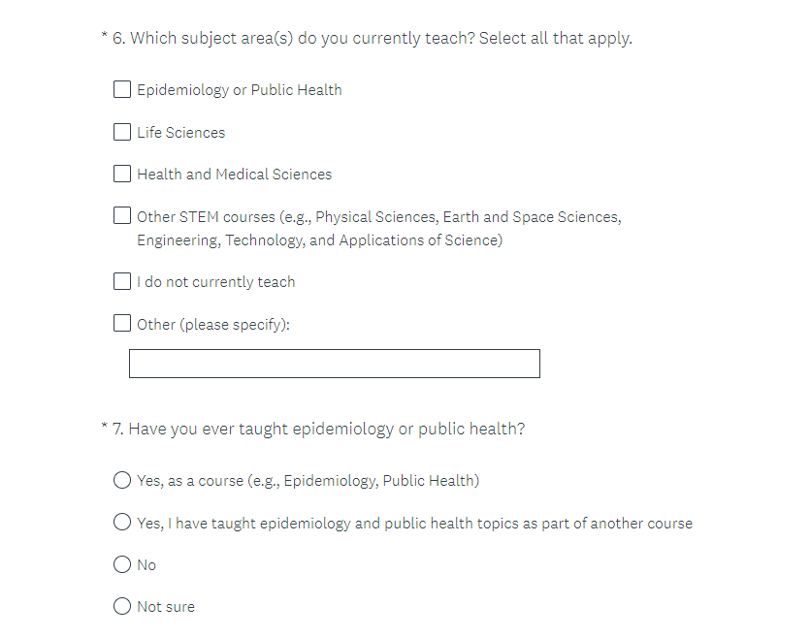

**Skip logic for question 16 (also potentially labeled 7) determines which questions the respondent sees. Respondents who indicate they have taught public health previously see questions 17-18 (also potentially labeled 8-9). Respondents who indicate that they have not skip to question 19 (also potentially labeled 10 or 8).**

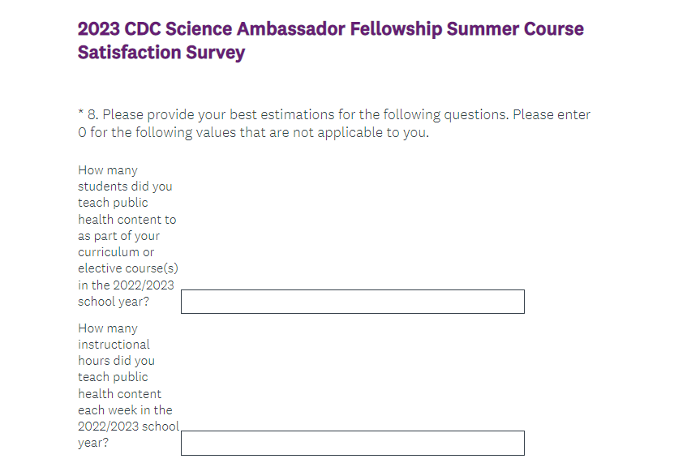

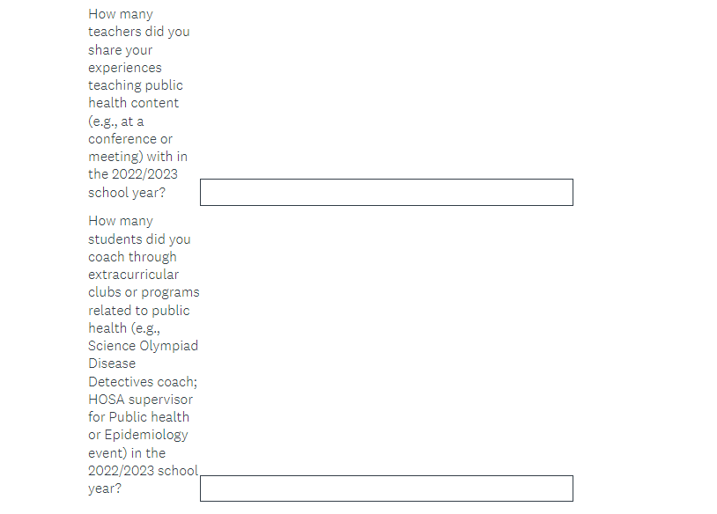

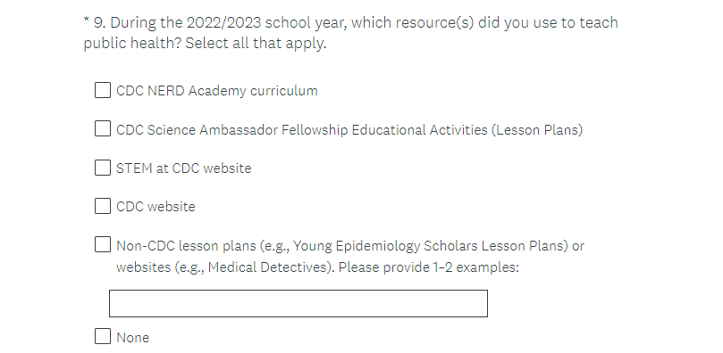

**Questions 19-27 (also potentially labeled 10-19 or 8-17) are for all respondents. These questions are all voluntary and may be skipped.**

