ATTACHMENT 1

Recruitment for Private Sector Respondent

Focus Group: Email Invitation

Subject Line: Join our focus group on CDC’s Cancer Data Visualizations tool
Message:
Dear [Name],
We invite you to participant in a 1-hour virtual focus group on CDC’s U.S. Cancer Statistics Data Visualizations tool.

The purpose is to obtain your opinions and insights on the design, content, and ways to improve the function and utility of the tool. Your input will help inform future development of the online tool.

How do you sign-up?
Focus groups will start in [month]. Please use this link to sign-up: [Survey Monkey link].

Your privacy is important to us. All responses provided during the focus group will be anonymized in all project reports. Identifying information, specifically your name and email address, will only be used for scheduling the focus group.

If you have any questions, please email [contractor staff member’s email address].

We look forward to learning from you!

Kind regards,
[CDC staff member’s signature]

Focus Group: Survey Monkey form

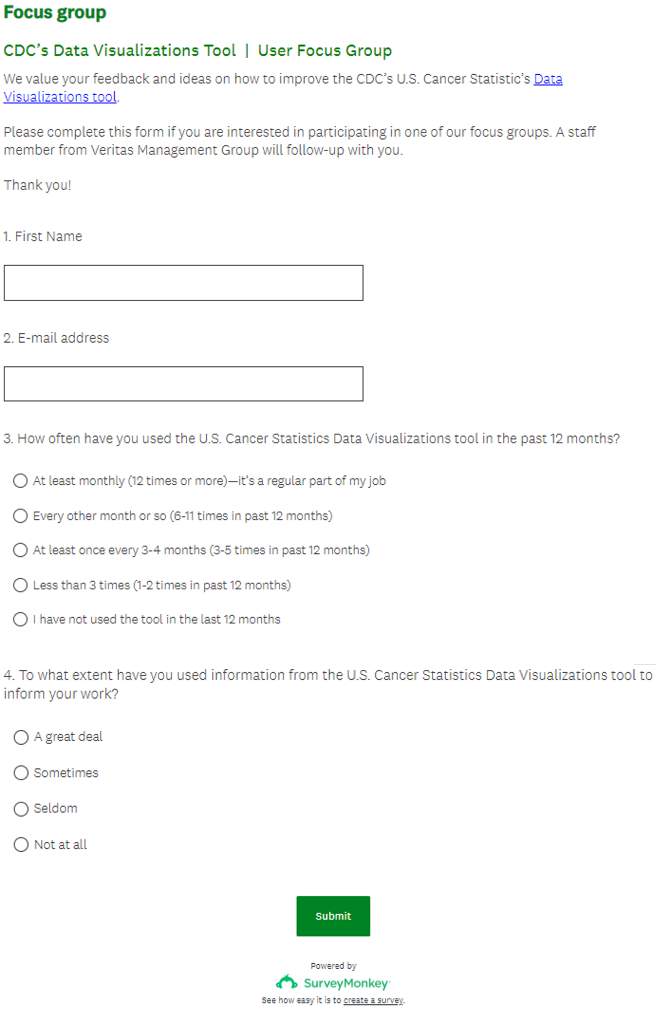

Focus Group: Scheduling text

Subject Line: Scheduling your focus group: CDC’s Cancer Data Visualizations tool
Message:
Dear [Name],
Thank you for your interest in participating in our focus group! Please use this Calendly link [link] to pick a time to meet.
Below is additional information about the focus group.
We look forward to talking with you!
Best regards,
[Veritas Management Group member’s signature]
Purpose of this evaluation
You are being asked to participate in a focus group being conducted by Veritas Management Group on behalf of the CDC’s Division of Cancer Prevention and Control. You will be asked for feedback on the U.S. Cancer Statistics Data Visualizations tool.
You will need
- Access to a computer or device with internet connection to join a Zoom [or Microsoft Teams] video-conference call.
Please remember that:
- Taking part in this discussion is voluntary
- You are not required to answer the questions
- This discussion will last about 1 hour
- The focus group will be recorded
- You are free to leave at any time or refuse recording
Benefits
There are no direct benefits to you. Your comments may improve efforts to make the U.S. Cancer Statistics Data Visualizations tool more accessible and useful for users.
Privacy
Your name and image will not be used in any project report. None of the statements you make will be linked to you by name. Recordings and notes will only be used internally by Veritas Management Group staff to create project reports for CDC.
Persons to Contact
If you need more information about participating in the focus group, contact: [contractor staff member’s name and email address].

Personal Interview: Email Invitation

Subject Line: Looking for your feedback: CDC’s Cancer Data Visualizations tool
Message:
Dear [Name],
We invite you to participant in a 1-hour interview regarding the CDC’s U.S. Cancer Statistics Data Visualizations tool.

The purpose is to obtain your opinions and insights on the design, content, and ways to improve the function and utility of the tool. Your input will help inform future development of the online tool.

How do you sign-up?
Interviews will be scheduled in [month]. Please use this link to sign-up: [Survey Monkey link].

Your privacy is important to us. All responses provided during the interview will be anonymized in all project reports. Identifying information, specifically your name and email address, will only be used for scheduling the interview.

If you have any questions, please email [contractor staff member’s email address].

We look forward to learning from you!

Kind regards,
[CDC staff member’s signature]

Personal Interview: Survey Monkey form
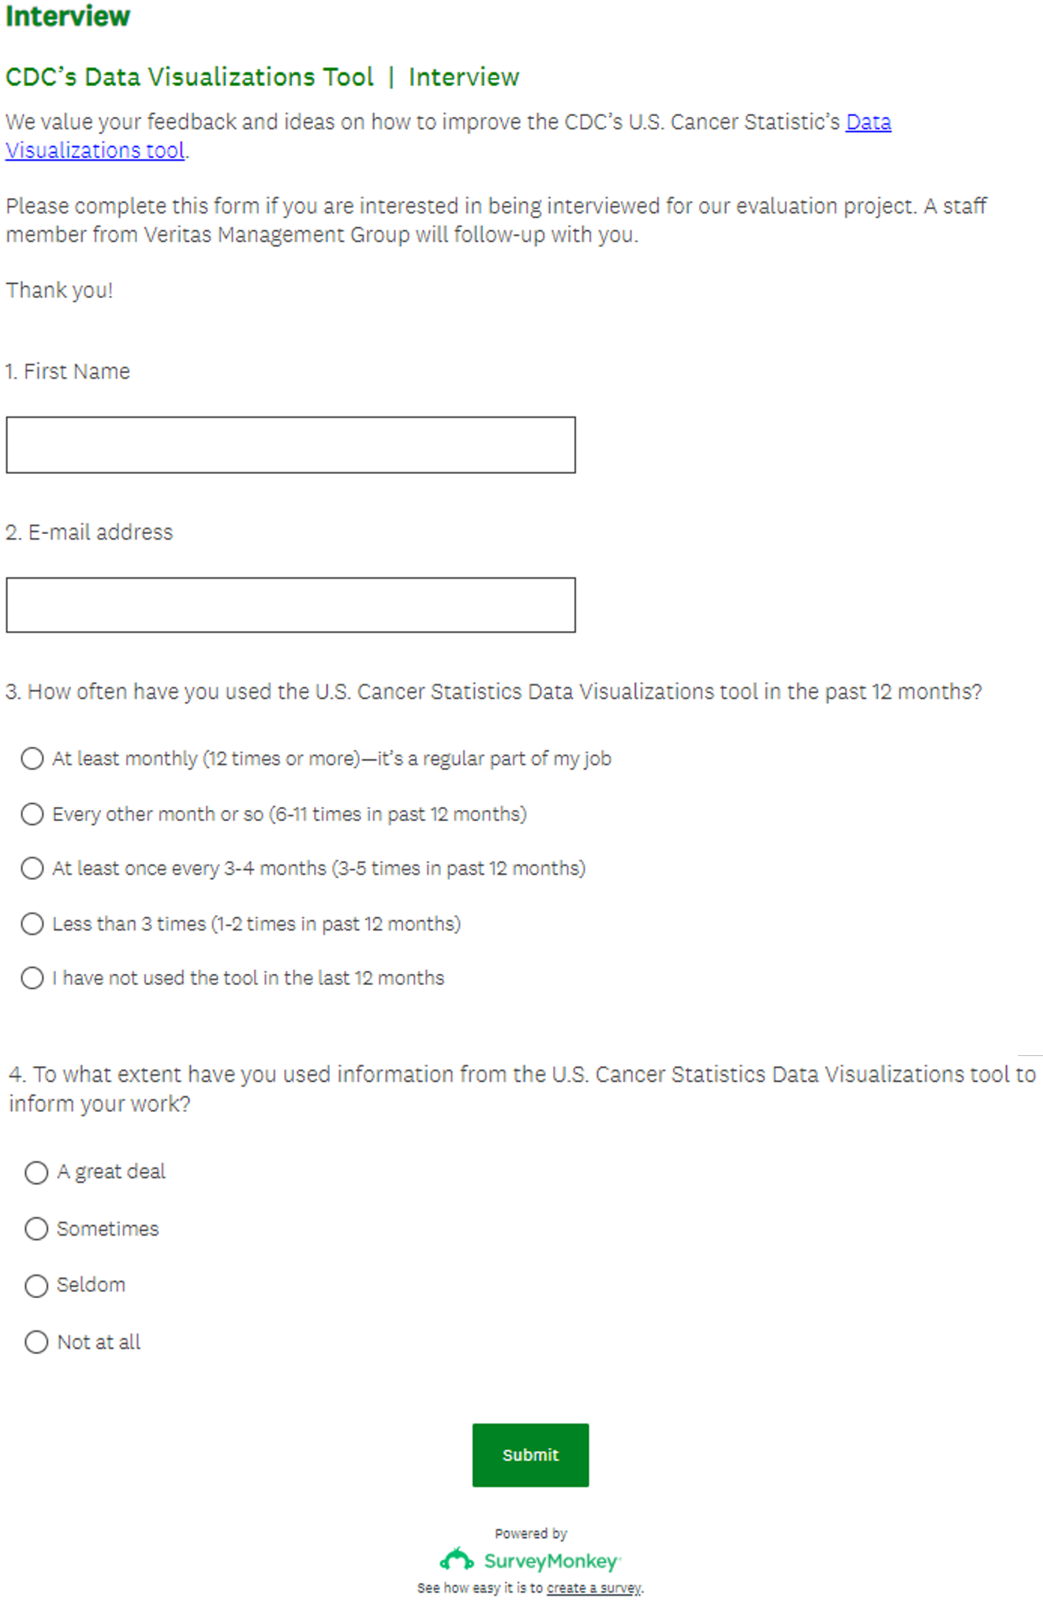

Personal Interview: Scheduling text

Subject Line: Scheduling your interview: CDC’s Cancer Data Visualizations tool
Message:
Dear [Name],
Thank you for your interest in participating in our evaluation project! Please use this Calendly link [link] to pick a time to meet.
Below is additional information about the interviews.
We look forward to talking with you!
Best regards,
[Veritas Management Group member’s signature]
Purpose of this evaluation
You are being asked to participate in an interview being conducted by Veritas Management Group on behalf of the CDC’s Division of Cancer Prevention and Control. You will be asked for feedback on the U.S. Cancer Statistics Data Visualizations tool.
You will need
- Access to a computer or device with internet connection to join a Zoom [or Microsoft Teams] video-conference call.
Please remember that:
- Taking part in this discussion is voluntary
- You are not required to answer the questions
- This discussion will last about 1 hour
- The focus group will be recorded
- You are free to leave at any time or refuse recording
Benefits
There are no direct benefits to you. Your comments may improve efforts to make the U.S. Cancer Statistics Data Visualizations tool more accessible and useful for users.
Privacy
Your name and image will not be used in any project report. None of the statements you make will be linked to you by name. Recordings and notes will only be used internally by Veritas Management Group staff to create project reports for CDC.
Persons to Contact
If you need more information about participating in the focus group, contact: [contractor staff member’s name and email address].

