Invitation Email

NBS 7.0 Demo Access
Thanks so much for meeting with us [when meeting happened].
We are excited to announce the NBS 7.0.0 demo, which includes various new features and enhancements tailored to improve your work as a public health expert! The NBS 7.0 demo will also include all the features and benefits from previous versions through 6.0.12.
To give you a preview of what's in store, we've prepared a demo site where you can try out some of the new features and updates firsthand.
Features in NBS 7.0.0 include:
- Patient Search 1.1
- Patient Data Profile 1.0
- Patient Data Entry 1.0
- Patient Delete 1.0

Attached to this email are several references to aid you in exploring the NBS 7.0.0 demo site.
- Check out the NBS 7.0.0 Demo Rollout Presentation for a recap of today’s discussion.
- Read the NBS 7.0.0 Demo Features Guide for detailed information on each updated feature’s functionality and additional information about limitations of the demo, friendly reminders about usage, how to submit feedback, link to a demo recording, and other useful information.
- Access the NBS 7.0.0 Demo training video presentation for an overview of new features in NBS 7.0.0 and learn how to make the most of your user experience. (https://cdcnbscentral.com/projects/70release-materials/files)

We value your feedback and will use it to improve the NBS experience, so please take some time to explore the demo site and share your thoughts with us!
Your login information is as follows:
Demo site address – NBS (https://app.demo-cdc-nbs.eqsandbox.com/nbs/login)
Username – [username]
No Password
Please provide feedback [link to survey] by [date]. If you cannot access the survey, please reach out to us at nbs@cdc.gov and we will work with you on an alternate method for feedback. We will be sharing the demo site with other jurisdictions soon and all feedback will be synthesized and shared back during an upcoming NUG/SME call.
Public reporting burden of this collection of information is estimated to average 15 minutes per response, including the time for reviewing instructions, searching existing data sources, gathering and maintaining the data needed, and completing and reviewing the collection of information. An agency may not conduct or sponsor, and a person is not required to respond to a collection of information unless it displays a currently valid OMB Control Number. Send comments regarding this burden estimate or any other aspect of this collection of information, including suggestions for reducing this burden to CDC/ATSDR Reports Clearance Officer, 1600 Clifton Road NE, MS H21-8, Atlanta, Georgia 30333; ATTN: PRA 0920-1050

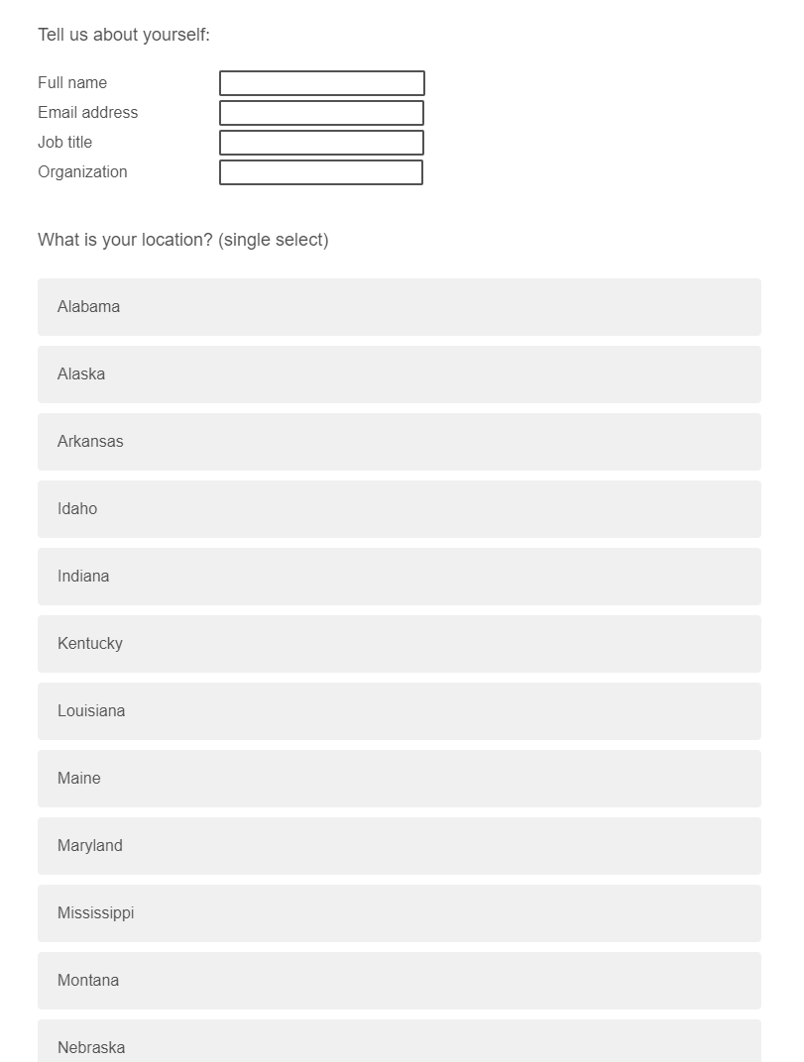
Qualtrics survey
