Respiratory Virus Response (RVR) Data Dashboard cdc.gov feedback survey collection: Screenshots

**Screenshot: Survey Invite**  
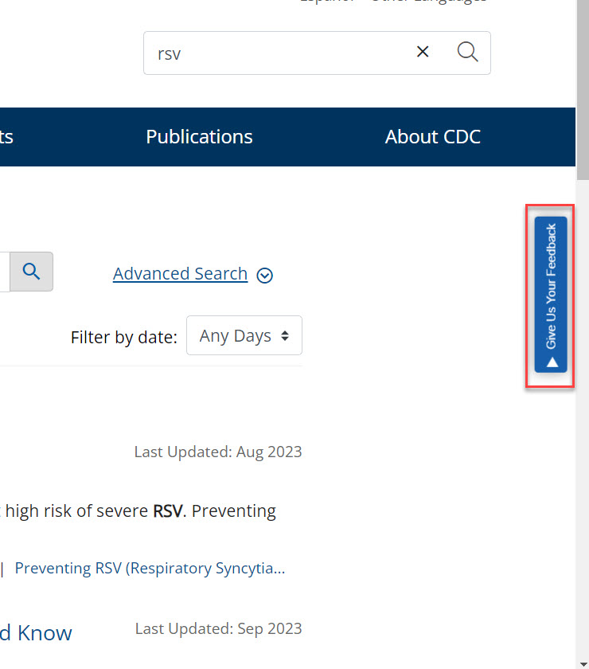

**Screenshot: Survey on the website**