***Invitation Email***

**Join a 90-minute PHDS 2.0 Focus Group to revisit CDC’s public health data strategy for FY 2024.**

**Why focus groups?**

We want to gather input from state, tribal, local, and territorial (STLT) public health agencies as well as public health partners to inform the revision of Public Health Data Strategy (PHDS) goals and milestones for the new fiscal year. Topics in the focus groups will be a) resonance of current goals, b) prioritization of goals, and c) validation of the milestones set for the coming year. The PHDS 2.0 will be a tool to help CDC more efficiently and effectively work to collect, use, analyze, and share surveillance data to meet customer needs.

These focus groups will be conducted in a workshop format, where everyone’s voice will be heard.

**What do we want to know?**

We want to identify public health pain points and they are related to CDC goals. We also want to prioritize the goals & milestones to work more effectively at addressing these pain points.

We’ll initially have a topic-centered approach for these groups with a specific focus on the existing PHDS 1.0 goals:

**Who should participate?**

We want to hear from STLT public health agency staff who interact with surveillance data at any point along the lifecycle (including but not limited to epidemiologists, IT staff, nurses and administrators).

**How do you sign up?**

Focus groups will held November 6-14th. Please use this link to sign up:

[[insert](https://www.surveymonkey.com/r/L35PNRK) link here]

**If you have any questions, please send an email to:** [**dmibuildingblocks@cdc.gov**](mailto:dmibuildingblocks@cdc.gov)

**WE LOOK FORWARD TO LEARNING FROM YOU!**

Public reporting burden of this collection of information is estimated to average 90 minutes per response, including the time for reviewing instructions, searching existing data sources, gathering and maintaining the data needed, and completing and reviewing the collection of information. An agency may not conduct or sponsor, and a person is not required to respond to a collection of information unless it displays a currently valid OMB control number. Send comments regarding this burden estimate or any other aspect of this collection of information including suggestions for reducing this burden to CDC/ATSDR Reports Clearance Officer; 1600 Clifton Road NE, MS H21-8 Atlanta, Georgia 30333; ATTN: PRA (0920-1050)

***Signup Form***

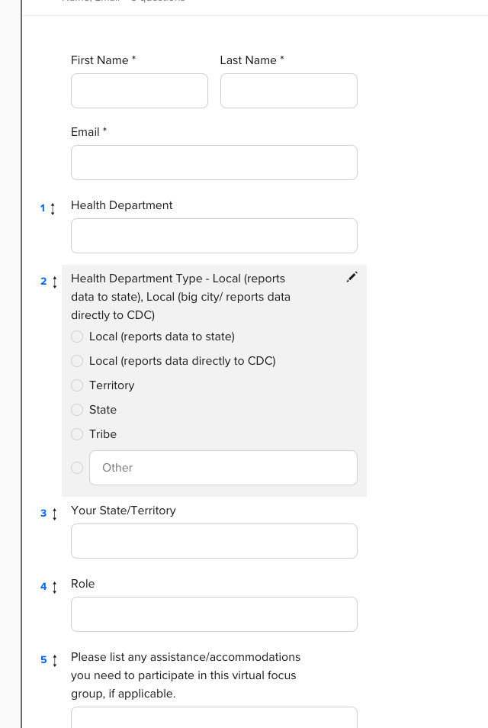

***Mural.co***

*Mural.co view - only link*

<https://app.mural.co/t/primedatainput6410/m/primedatainput6410/1698240745702/78e18a536766086648894b0797de0029e6cbae79?sender=u90053609a796446034c81828>

*Screenshot of the Mural.co board outline*

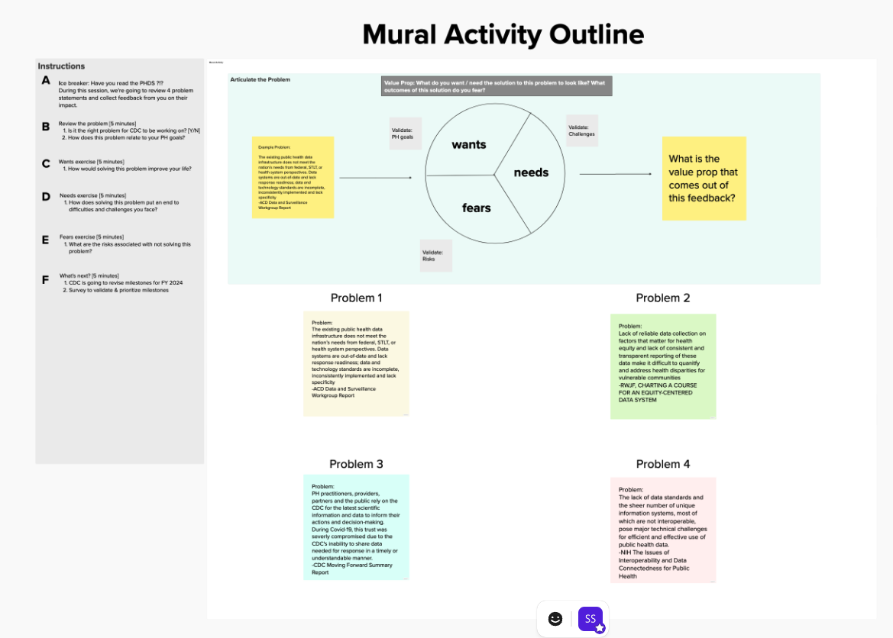

*Screenshot of the Mural.co board Problem 1*

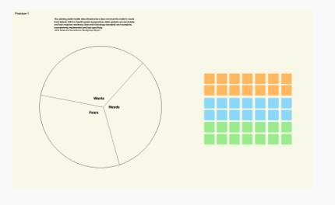

*Screenshot of the Mural.co board Problem 2*

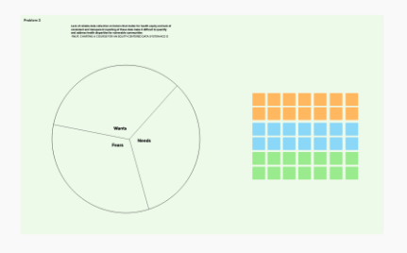

*Screenshot of the Mural.co board Problem 3*

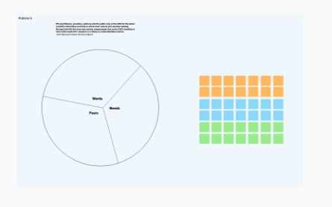

*Screenshot of the Mural.co board Problem 4*

