**Survey Invitation Screenshots from APHL RQ Awards Website**

These invitations to complete the survey are displayed on the APHL Fellowship/Internship application website, RQ Awards. These invitation messages supplement the email invitations that are sent to the survey respondents to complete the surveys during their application to the Career Pathways in Public Health Laboratory Science Program.

Fellowship

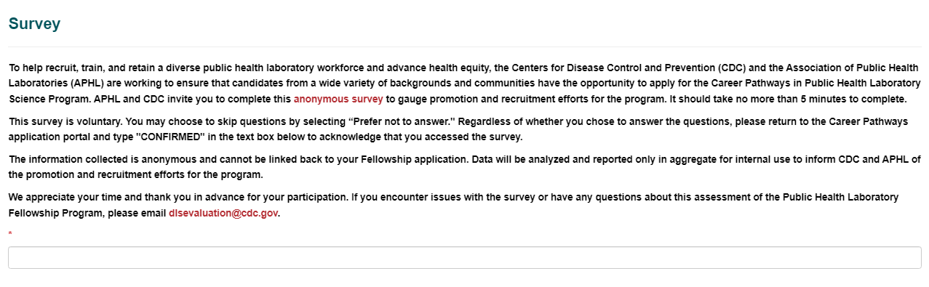

Internship

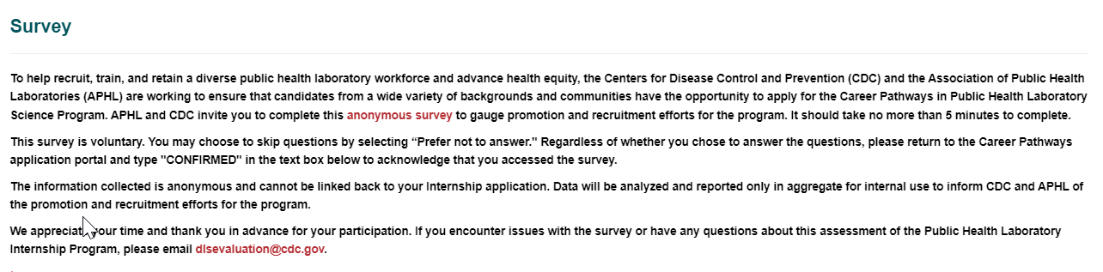

Genomic Data Internships

