Request for Approval under the “Generic Clearance for the Collection of Routine Customer Feedback” (OMB Control Number: 0920-1050)

Instruction: This form should be completed by the primary contact person from the Program sponsoring the collection.
DETERMINE IF YOUR COLLECTION IS APPROPRIATE FOR THIS GENERIC CLEARANCE MECHANISM:
Instruction: Before completing and submitting this form, determine first if the proposed collection is consistent with the scope of the Collection of Routine Customer Feedback generic clearance mechanism. To determine the appropriateness of using the Collection of Routine Customer Feedback generic clearance mechanism, complete the checklist below.
If you select “yes” to all criteria in Column A, the Collection of Routine Customer Feedback generic clearance mechanism can be used. If you select “yes” to any criterion in Column B, the Collection of Routine Customer Feedback generic clearance mechanism cannot be used.

Column A | Column B
The information gathered will only be used internally to CDC.  [ X ] Yes [ ] No | Information gathered will be publicly released or published.  [ ] Yes [ X ] No
Data is qualitative in nature and not generalizable to people from whom data was not collected.  [ X ] Yes [ ] No | Employs quantitative study design (e.g. those that rely on probability design or experimental methods)  [ ] Yes [ X ] No
There are no sensitive questions within this collection (e.g. sexual orientation, gender identity).  [ X ] Yes [ ] No | Sensitive questions will be asked (e.g. sexual orientation, gender identity).  [ ] Yes [ X ] No
Collection does not raise issues of concern to any other Federal agencies.  [ X ] Yes [ ] No | Other Federal agencies may have equities or concerns regarding this collection.  [ ] Yes [ X ] No
Data collection is focused on determining ways to improve delivery of services to customers of a current CDC program.  [ X ] Yes [ ] No | Data will be used to inform programmatic or budgetary decisions, for the purpose of program evaluation, for surveillance, for program needs assessment, or for research.  [ ] Yes [ X ] No
The collection is targeted to the solicitation of opinions from respondents who have experience with the program or may have experience with the program in the future.
[ X ] Yes [ ] No

Did you select “Yes” to all criteria in Column A?
If yes, the Collection of Routine Customer Feedback generic clearance mechanism may be appropriate for your investigation. You may proceed with this form.
Did you select “Yes” to any criterion in Column B?
If yes, the Collection of Routine Customer Feedback generic clearance mechanism is NOT appropriate for your investigation. Stop completing this form now.

TITLE OF INFORMATION COLLECTION:

Case Service Design: A Day in the Life Qualitative Study

PURPOSE:

Case surveillance occurs each time public health agencies at the local, state, or national levels collect information about a case or person diagnosed with a disease or condition that poses a serious health threat to Americans. The goal of this project is to improve CDC products and services that receive, process, and use case surveillance data.

Data collection methods include semi-structured qualitative interviews and contextual inquiries with participants to understand the current state of case data exchange so we can improve the process. We plan to do this at a minimum of 15 different sites. There will be at least 2-3 participants per site.

DESCRIPTION OF RESPONDENTS:
The respondents we hope to talk to may have a variety of roles: data entry folks, case investigators, data analysts, surveillance system managers, surveillance program managers or infectious disease program managers at state, tribal, or local health departments.

TYPE OF COLLECTION: (Check one)
Instruction: Please sparingly use the Other category

[ ] Customer Comment Card/Complaint Form [ ] Customer Satisfaction Survey
[ ] Usability Testing (e.g., Website or Software) [ ] Small Discussion Group
[ ] Focus Group [X] Other: Semi-structured qualitative interviews and contextual inquiries

CERTIFICATION:

I certify the following to be true:
- The collection is voluntary.
- The collection is low-burden for respondents and low-cost for the Federal Government.
- The collection is non-controversial and does not raise issues of concern to other federal agencies.
- The results are not intended to be disseminated to the public.
- Information gathered will not be used for the purpose of substantially informing influential policy decisions.

Name: Elizabeth Manning

To assist review, please provide answers to the following question:

Personally Identifiable Information:
- Is personally identifiable information (PII) collected? [X] Yes [ ] No
- If Yes, is the information that will be collected included in records that are subject to the Privacy Act of 1974? [ ] Yes [X ] No
- If Applicable, has a System or Records Notice been published? [ ] Yes [ X ] No

Gifts or Payments:
Is an incentive (e.g., money or reimbursement of expenses, token of appreciation) provided to participants? [ ] Yes [ X ] No

If Yes: Please describe the incentive. If amounts are outside of customary incentives, please also provide a justification

BURDEN HOURS

Category of Respondent | No. of Respondents | Participation Time | Burden  (In hours)
Semi structured interviews with state, tribal, or local governments. | 60 | 1 hour | 60 hours
Contextual interviews with state, tribal, or local governments. | 60 | 3 hours | 180 hours
Total |  |  | 240 hours

FEDERAL COST: The estimated annual cost to the Federal government is $54,400

Item | Estimated Hours | Hourly Rate | Total Cost
Staff FTE | 240 | $95 | $22,800
Travel: personnel costs | 80 | $95 | $7,600
Travel: flights, hotels, etc |  |  | $24,000
Totals |  |  | $54,400

If you are conducting a focus group, survey, or plan to employ statistical methods, please provide answers to the following questions:

The selection of your targeted respondents
- Do you have a customer list or something similar that defines the universe of potential respondents and do you have a sampling plan for selecting from this universe? [ ] Yes [X] No

If Yes: Please provide a description of both below (or attach the sampling plan)
If No: Please provide a description of how you plan to identify your potential group of respondents and how you will select them or ask them to self-select/volunteer

We consulted with internal subject matter experts and national partners like CSTE and NACCHO to understand which public health departments would give us the best variety across factors like population, disease burden, funding, and governance.

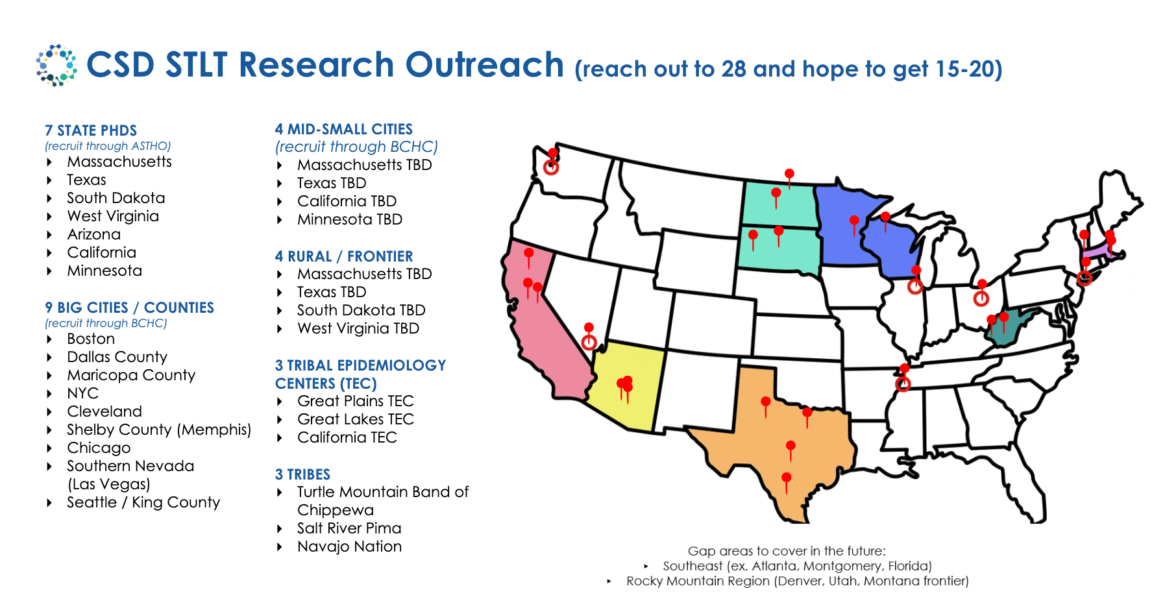

Administration of the Instrument
- How will you collect the information? (Check all that apply)
[ ] Web-based or other forms of Social Media
[ ] Telephone
[X ] In-person
[ ] Mail
[ ] Other, Explain

- Will interviewers or facilitators be used? [ X ] Yes [ ] No

Please make sure that all instruments, instructions, and scripts are submitted with the request.

Instructions for completing Request for Approval under the “Generic Clearance for the Collection of Routine Customer Feedback”

TITLE OF INFORMATION COLLECTION: Provide the name of the collection that is the subject of the request. (e.g. Comment card for soliciting feedback on xxxx)

PURPOSE: Provide a concise description of the purpose of this collection and how it will be used. If this is part of a larger study or effort, please include this in your explanation.

DESCRIPTION OF RESPONDENTS: Provide a concise description of the targeted group or groups for this collection of information. These groups must have experience with the program.

TYPE OF COLLECTION: Check one box. If you are requesting approval of other instruments under the generic, you must complete a form for each instrument. The ‘Other’ category should be used only in the contexts in which the provided categories cannot reasonably apply.

CERTIFICATION: Please read the certification carefully. If you incorrectly certify, the collection will be returned as improperly submitted or it will be disapproved.

Personally Identifiable Information: Provide answers to the questions.

Gifts or Payments: As a general matter, incentives are not appropriate for customer service collections; however, incentives may be appropriate for focus groups or in-depth usability studies, especially when participants must travel to a site to participate. In the latter circumstance, the incentive should include travel costs. Customary incentives for focus groups in the Federal government are $40 for a one-hour interview and $75 for a 90-minute focus group. If you answer yes to the question, please describe the incentive and provide a justification for amounts other than those cited above; justifications should be limited to Federal studies of a similar design and subpopulation.

BURDEN HOURS:
Category of Respondents: Identify who you expect the respondents to be in terms of the following categories: (1) Individuals or Households; (2) Private Sector; (3) State, local, or tribal governments; or (4) Federal Government. Only one type of respondent can be selected.
No. of Respondents: Provide an estimate of the Number of respondents.
Participation Time: Provide an estimate of the amount of time required for a respondent to participate (e.g. fill out a survey or participate in a focus group)
Burden: Provide the Annual burden hours: Multiply the Number of responses and the participation time and divide by 60.

FEDERAL COST: Provide an estimate of the annual cost to the Federal government.

If you are conducting a focus group, survey, or plan to employ statistical methods, please provide answers to the following questions:

The selection of your targeted respondents. Please provide a description of how you plan to identify your potential group of respondents and how you will select them. If the answer is yes, to the first question, you may provide the sampling plan in an attachment.

Administration of the Instrument: Identify how the information will be collected. More than one box may be checked. Indicate whether there will be interviewers (e.g. for surveys) or facilitators (e.g., for focus groups) used.

Please make sure that all instruments, instructions, and scripts are submitted with the request.

