**Attachment E: Attendee Post-Event Survey Email Invitation**

From: NNPHI Convenings [convenings@nnphi.org](mailto:convenings@nnphi.org)

To: [Auto-Populated- Individual Email Address of Registrant]

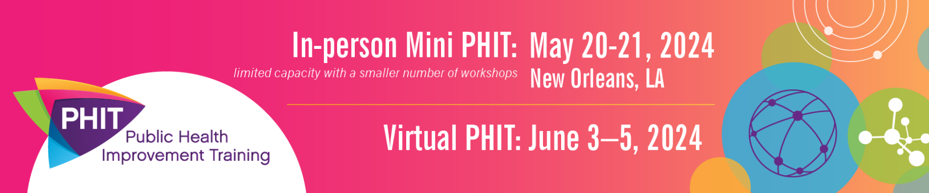

Dear [FirstName],

Thank you for attending the 2024 [in-person Mini/virtual] Public Health Improvement Training (PHIT)! We hope you left this unique training event equipped with new skills, tools, and ideas to put to use in your agency.

In the spirit of quality improvement, please take a moment to **complete a brief, post-event survey**. Your response will not be linked to your name or other identifying information and should take less than four minutes. We rely on your feedback to plan and improve future training events.

We will close this survey on [Date]. Don’t miss this chance to let us know how to best serve you!

**Materials and Session Recordings:**

All session materials and select session recordings are now available within Cvent (our virtual conference platform). We will continue to add session recordings, so stay tuned.

To access your Cvent account, please click **here**.

For assistance with Cvent, please email [Brittany Bunn at [bbunn@nnphi.org](mailto:bbunn@nnphi.org?subject=Open%20Forum%20Pathable%20Assistance%20)].

**Stay connected:**

The [Public Health Performance Improvement Network (phPIN)](https://nnphi.org/relatedarticle/public-health-performance-improvement-network-phpin/) is a learning community and peer exchange network for those of you providing leadership in performance improvement in public health. Join other practitioners in public health to network, access just-in-time resources, and share emerging practices on the topics of most interest to you.

Thanks again for being a part of PHIT 2024.  
  
PHIT Team  
National Network of Public Health Institutes

