***Invitation Email***

**Subject**: CDC Engagement Panel Opportunity

**Body:**

Hello,  
  
We are reaching out to CDC engagement panel members for an upcoming project. We identified your name as a potential participant for the ReportStream Usability Survey.  
  
If you have **5-10 minutes**, please take this brief survey to help us understand how we can communicate clearer about CDC’s data transfer products.

The survey involves looking at 4 different passages of text and answering questions about what you understand or do not understand. It is not a test with right or wrong answers. We want to learn what makes sense to you.

The survey will be open until [insert one week from send date].

Follow this link to the survey:  
 ${l://SurveyLink?d=Take the Survey}

Or copy and paste the URL below into your internet browser:  
${l://SurveyURL}

Follow the link to opt out of future emails:  
${l://OptOutLink?d=Click here to unsubscribe}  
  
Thank you for your time. Please reach out with any questions about the survey that we are administering or your participation in the engagement panel.  
  
Best,  
Jt Williams  
Human-Centered Design Lead  
CDC

***Qualtrics survey***

**Intro screen**

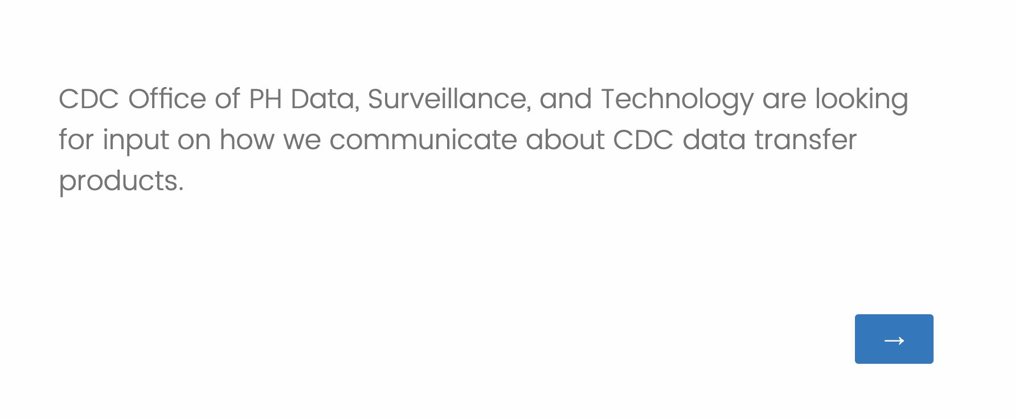

**Question 1: Filter**

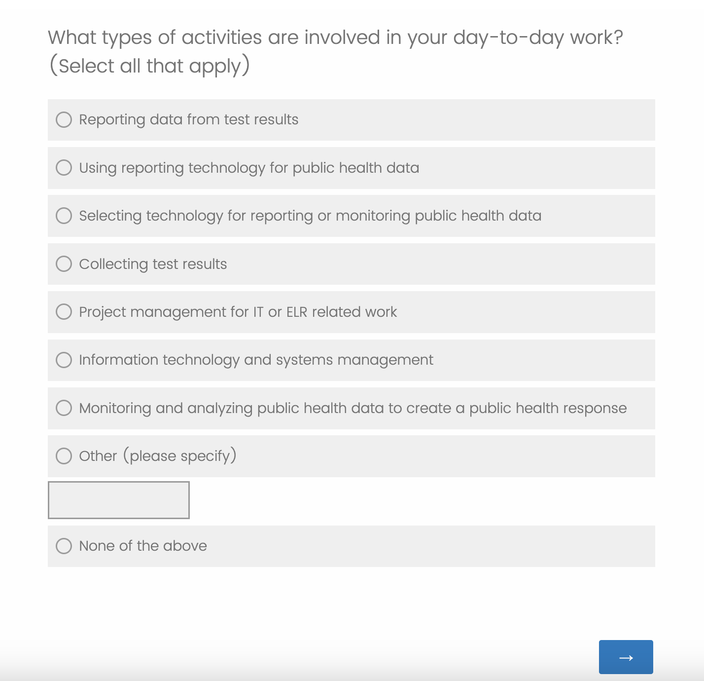

**Passage 1**

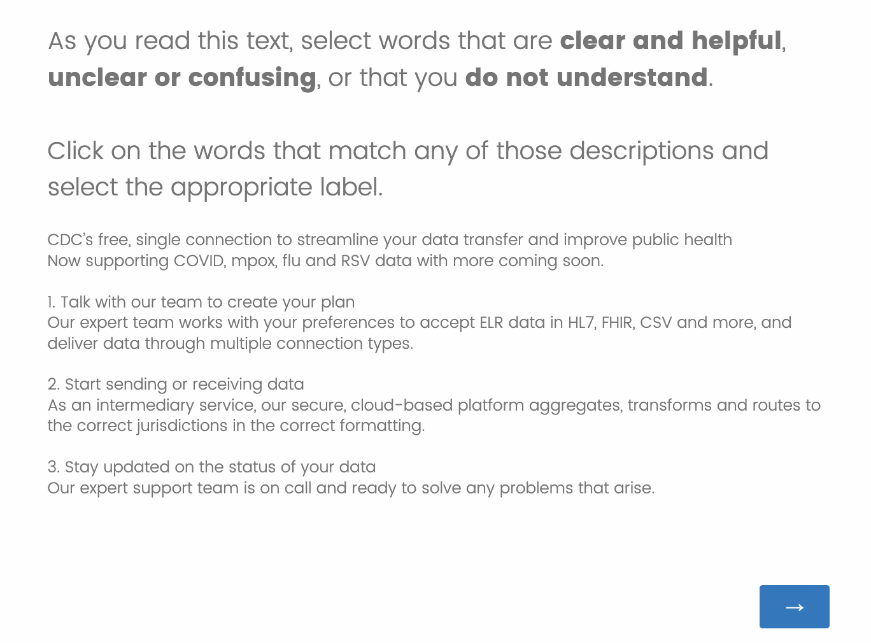

**Passage 1: Example of how to highlight a word.**

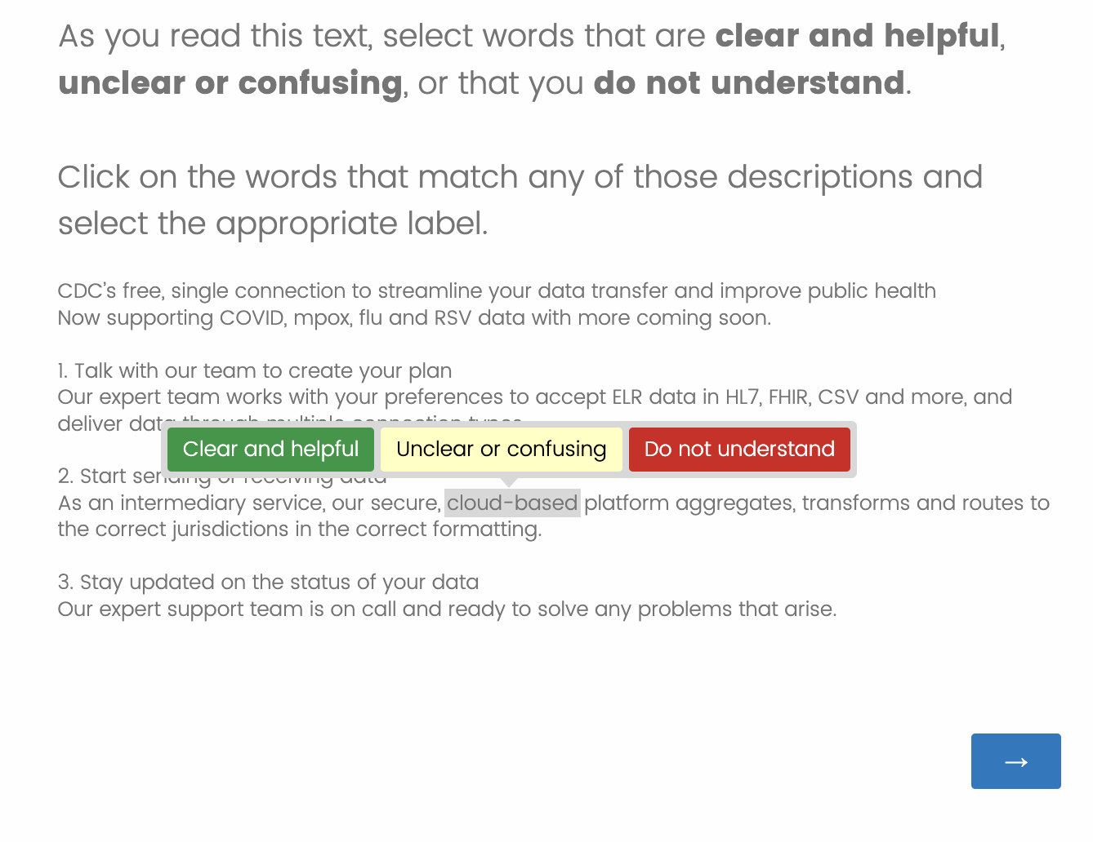

**Optional comprehension question after each passage of text**

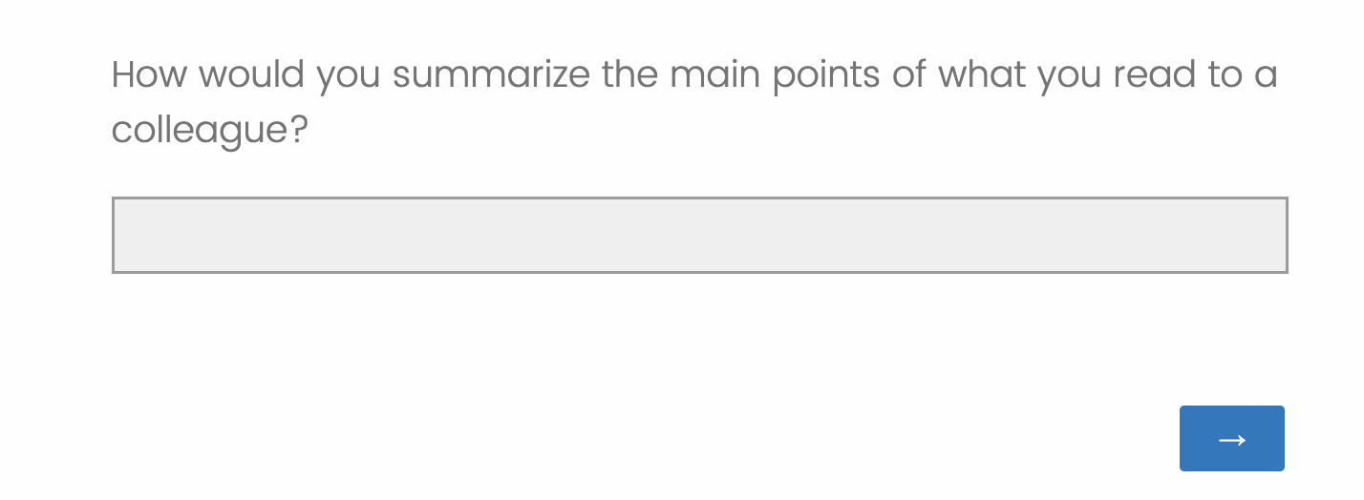

**Passage 2**

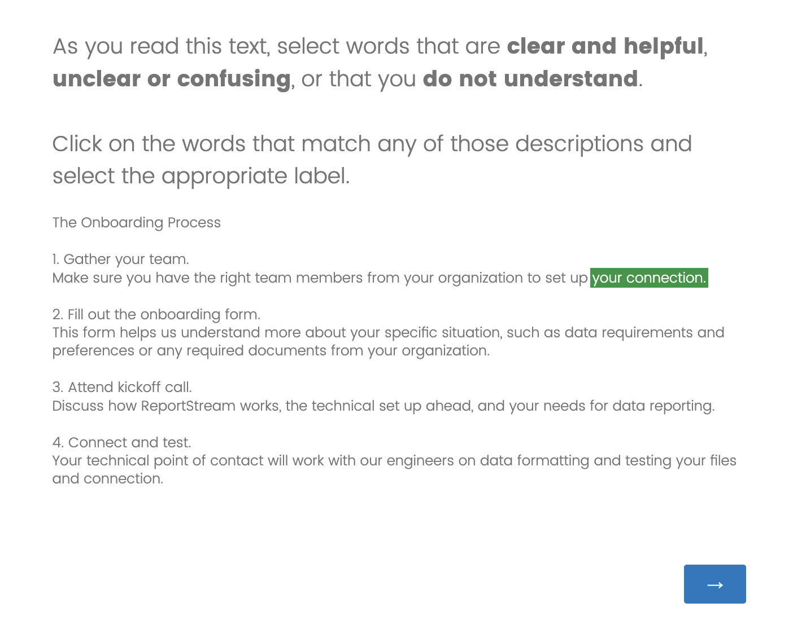

**Passage 3**

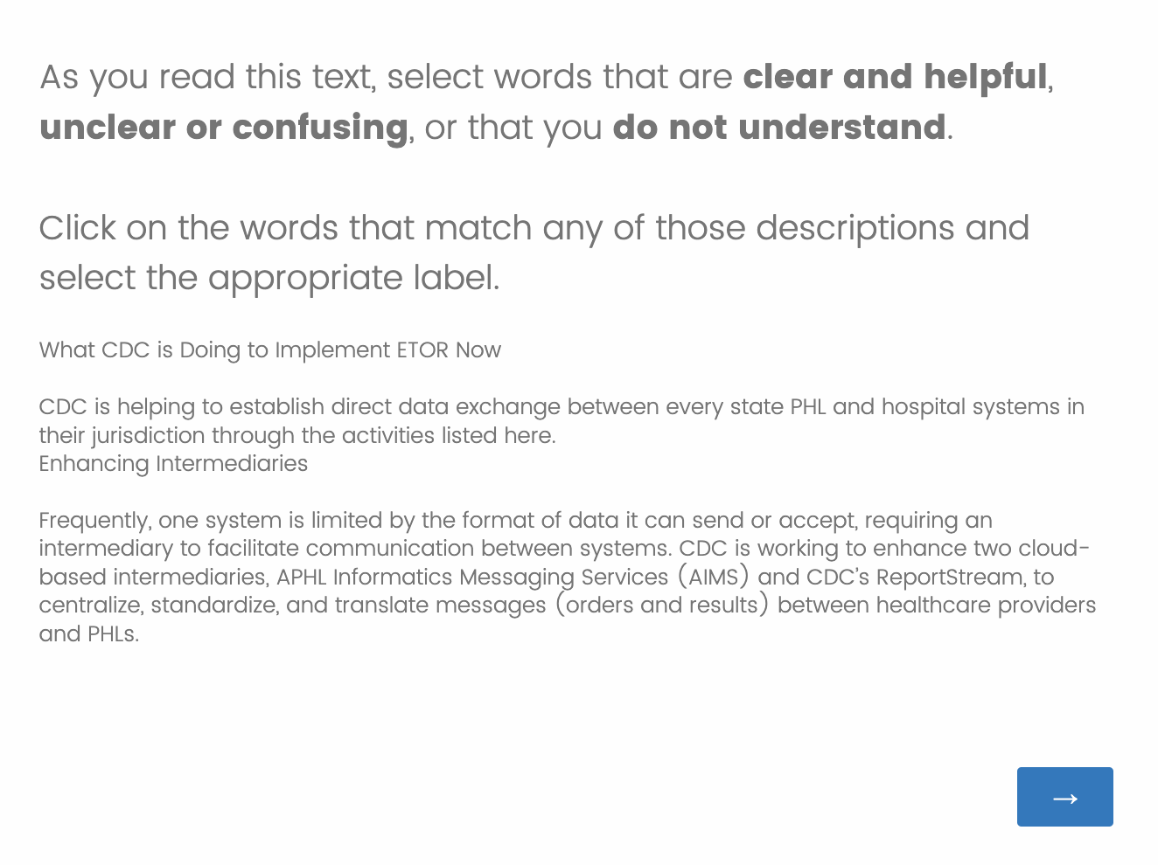

**Passage 4**

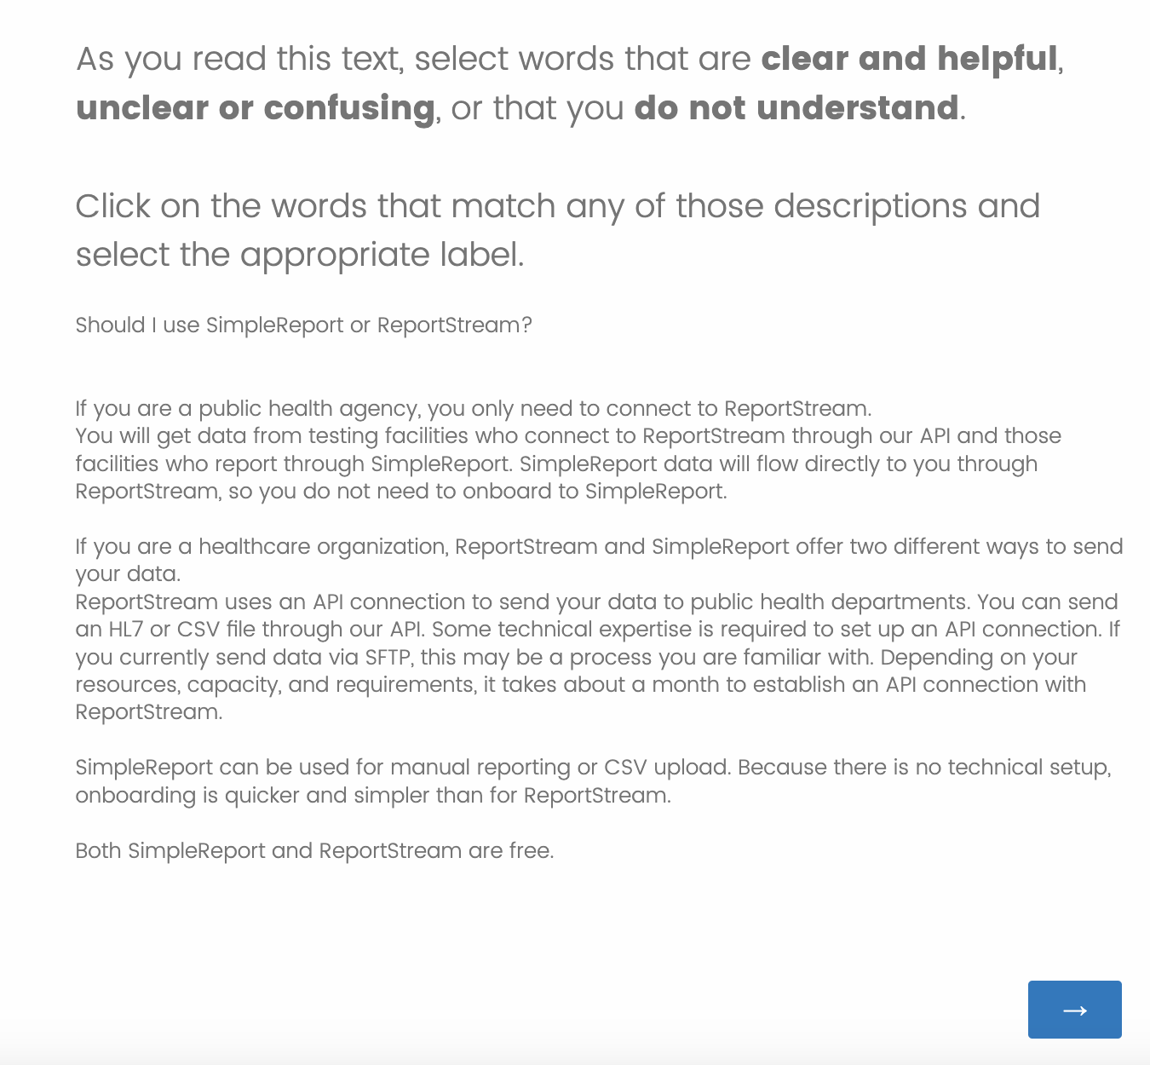

**Public reporting burden of this collection of information is estimated to average 10 minutes per response, including the time for reviewing instructions, searching existing data sources, gathering and maintaining the data needed, and completing and reviewing the collection of information. An agency may not conduct or sponsor, and a person is not required to respond to a collection of information unless it displays a currently valid OMB control number. Send comments regarding this burden estimate or any other aspect of this collection of information, including suggestions for reducing this burden to CDC/ATSDR Reports Clearance Officer; 1600 Clifton Road NE, MS H21-8, Atlanta, Georgia 30333; ATTN: PRA (0920-1050).**