ATTACHMENT 4a

Week 1 Task Questions for MFHP Usability Study

Week 1 Task Questions:

### Week 1: Getting familiar with the app and setting up a personal profile

#### Week 1 Task(s):

Task 1: Please download the My Family Health Portrait: Cancer mobile app on your mobile device. Follow the instructions below:

Android:

Step 1: Open the Google Play store on your device.

Step 2: Search “MFHP: Cancer” in Google Play

Step 3: Select the app from the list and click “install”

Step 4: Inspect the app name and icon- confirm that they display as expected (see image below to confirm).

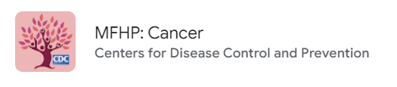

iOs:

Step 1: Open the App Store on your device.

Step 2: Search “MFHP: Cancer” in the App Store

Step 3: Select the app from the list and click “install”

Step 4: Inspect the app name and icon- confirm that they display as expected (see image below to confirm).

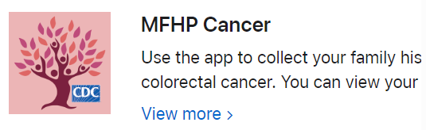

Task 2: Open the app and go through the welcome/onboarding screens to better understand how the app works and get familiar with the app.

Task 3: Fill out your personal profile with your health history and information including personal information like your date of birth, health conditions, and cancer history.

Once you have finished your own personal profile, please do not proceed with entering any more information until you get the next set of instructions in youremail from the moderator.

#### Week 1 Survey Questions:

1. On a scale of 1 to 5, how was the experience of getting started with the app?
   1. 1-5 (1 being very bad to 5 being very good)
2. On a scale of 1 to 5, was the app clear about what to do to get started?
   1. 1-5 (1 being very unclear to 5 being very clear)
3. On a scale of 1 to 5, how easy or hard was it to set up your personal profile on the app?1-5 (1 being very hard to 5 being very easy
4. Please tell us about your experience with getting started with the app.What did you think about the first screens you saw? Did they give you a good idea about what the app does?
   1. [Open-ended]
5. How about setting up your personal profile- did you have any problems? Did you think the number of questions we asked was right? Too much? Too little? Were they clear to you?
   1. [Open-ended]