***Invitation Email***

**Subject: Invitation to Participate in Feedback Discussion on Improving Case Data Entry Workflows**

Dear ,

I hope this message finds you well! My name is Miringu, a Technology Practitioner from Skylight Digital, and I am part of an ongoing effort in partnership with the CDC. We are initiating interviews aimed at improving the manual case data entry process within health departments.

The purpose of the feedback discussion is to gather data that will be used to improve upon current CDC efforts to enhance manual case data entry processes. Our goal is to develop strategies that support public health professionals like yourself by streamlining data management tasks, thereby improving overall operational workflow and response capabilities.

We would be honored if you or one of your staff members in the following capacities could participate in this feedback discussion:

* Case Reporting Data Entry
* Case Reporting Data Surveillance
* Case Reporting Data Analyst
* Case Reporting Data Manager

**Your involvement would entail participating in a 60 minute interview.**

Why Participate?

* This is a great opportunity to highlight the challenges and inefficiencies your team may be encountering and to propose solutions that are truly impactful.
* Your input can directly influence the development of tools and strategies aimed at enhancing public health data management nationwide.
* By improving data entry processes, you contribute to the broader goal of enhancing public health response capabilities through more efficient and accurate data handling.

We are committed to ensuring that your participation is rewarding and that the findings from this study provide tangible benefits to your team and others across the country. All information shared during the study will be handled with the utmost confidentiality and will only be used for research purposes.

We look forward to hearing from you!

**Discussion Guide**

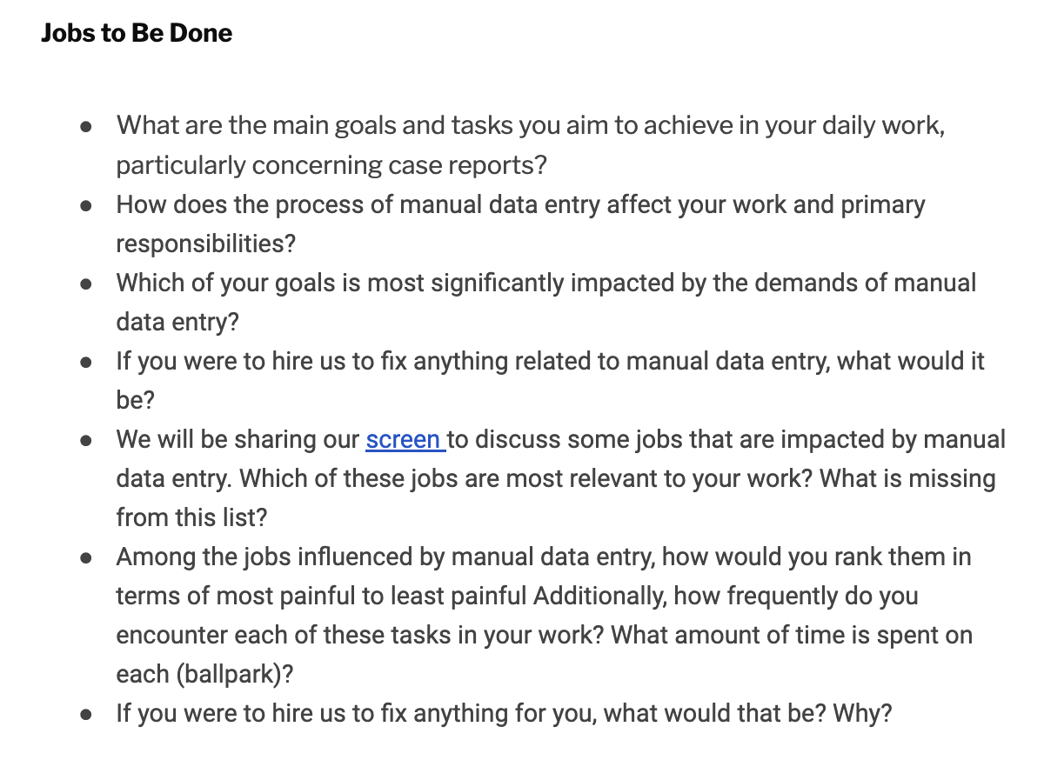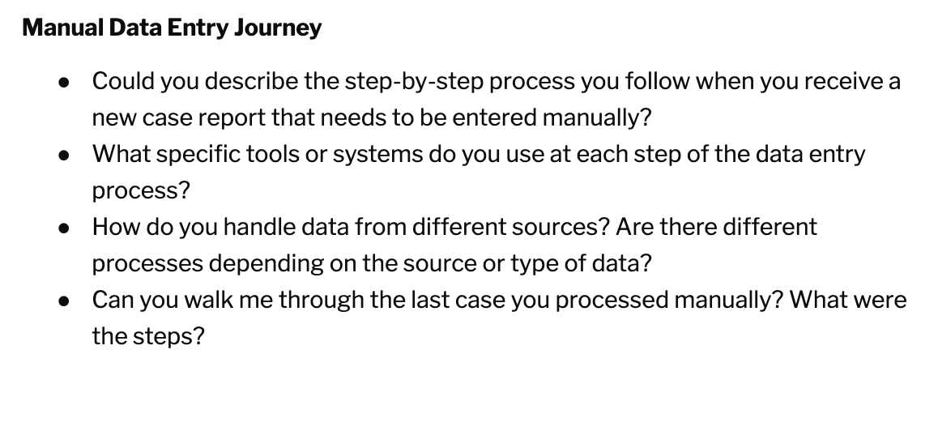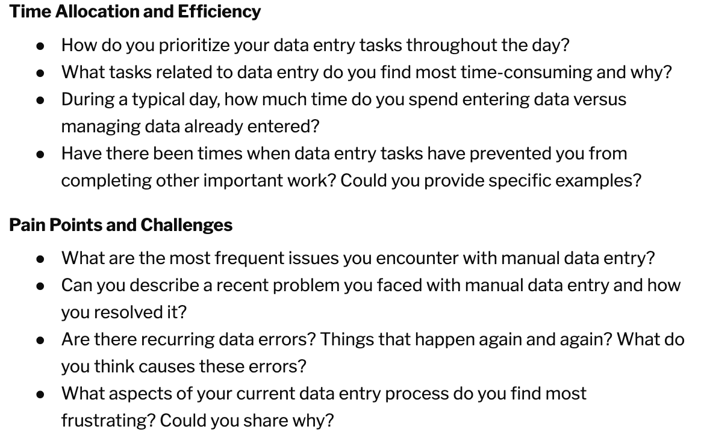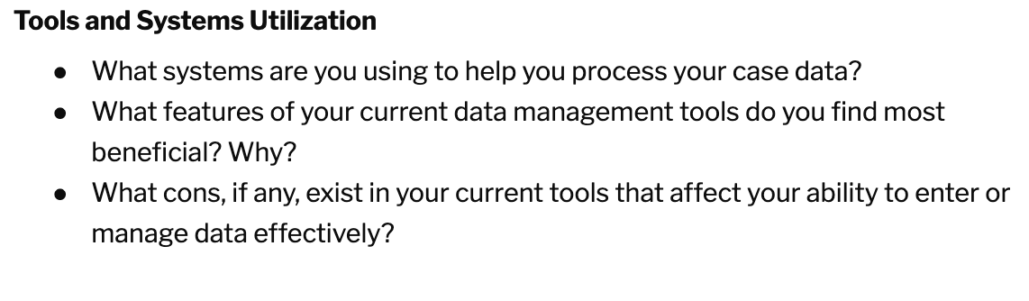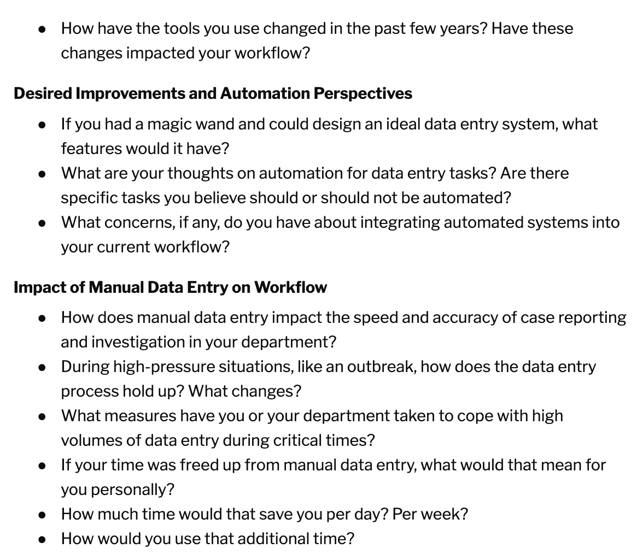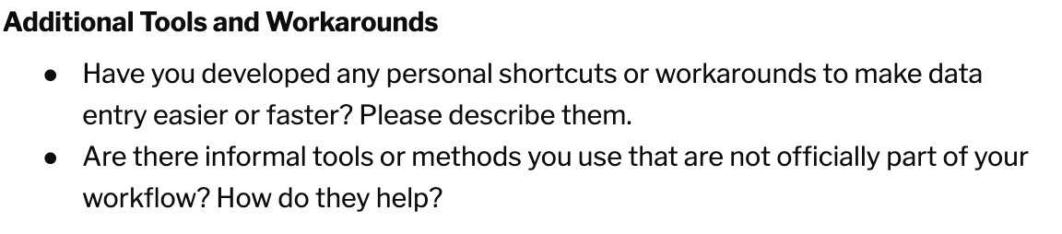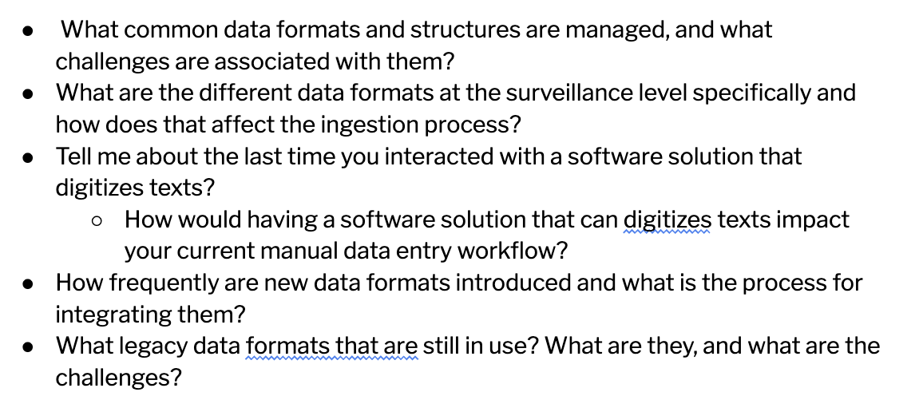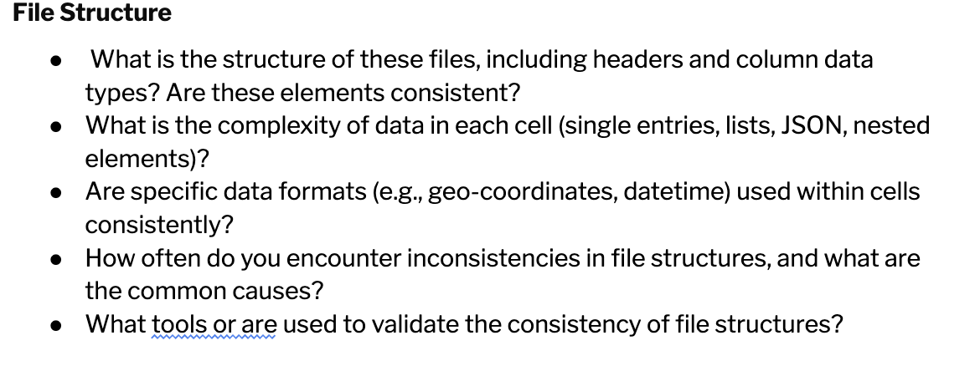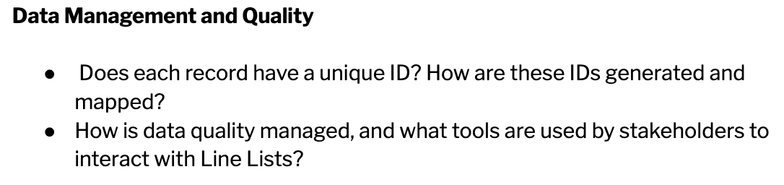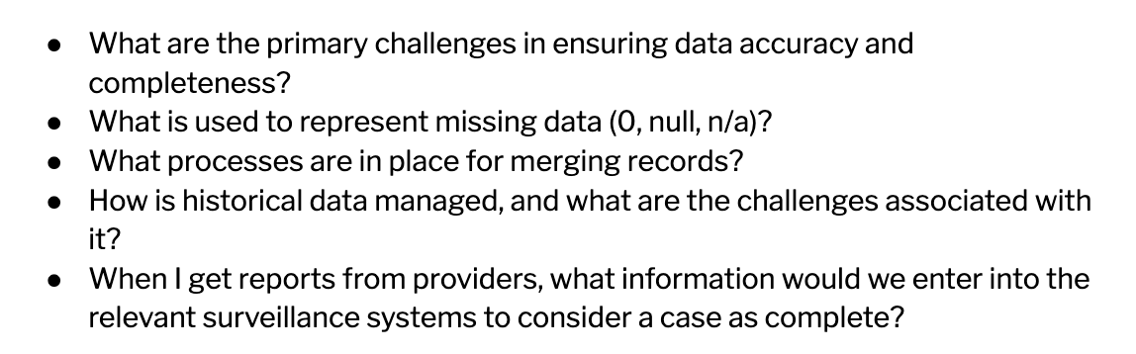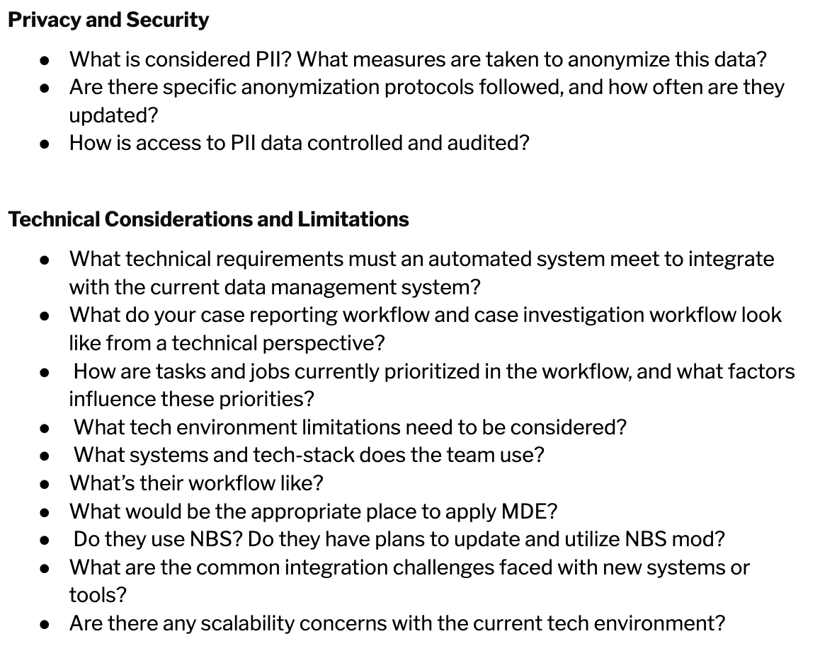

Public reporting burden of this collection of information is estimated to average 60 minutes per response, including the time for reviewing instructions, searching existing data sources, gathering and maintaining the data needed, and completing and reviewing the collection of information. An agency may not conduct or sponsor, and a person is not required to respond to a collection of information unless it displays a currently valid OMB Control Number. Send comments regarding this burden estimate or any other aspect of this collection of information, including suggestions for reducing this burden to CDC/ATSDR Reports Clearance Officer, 1600 Clifton Road NE, MS H21-8, Atlanta, Georgia 30333; ATTN: PRA 0920-1050