Form Approved

OMB No. 0920-1050

Exp. 6/30/2025

**Guiding Questions for the PHHS Block Grant and PHIG Listening Sessions (followed by open discussion/listening):**

1. How do you choose when and how to use PHHSBG vs PHIG funds?
2. What are your thoughts around the value and unique aspects of PHHSBG and PHIG, especially in relation to one another?
3. How would PHHSBG elimination affect your jurisdiction?
4. How would you like to work together on communicating value of these programs after this session?

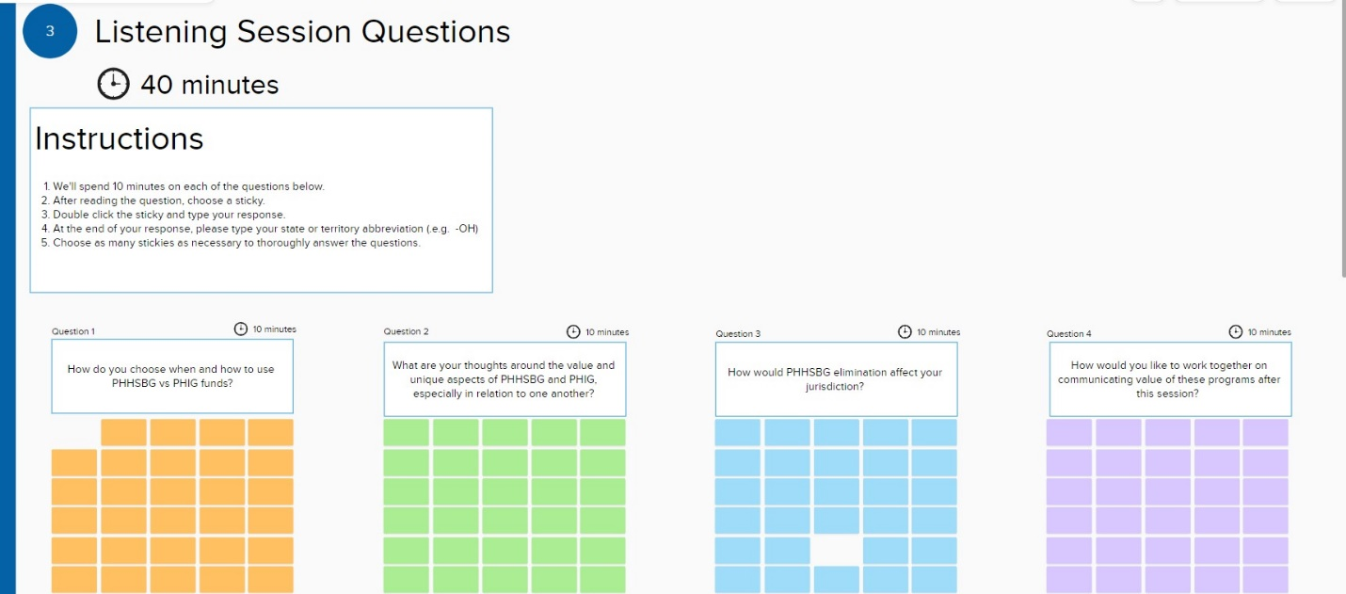

Public reporting burden of this collection of information is estimated to average 90 minutes per response, including the time for reviewing instructions, searching existing data sources, gathering and maintaining the data needed, and completing and reviewing the collection of information. An agency may not conduct or sponsor, and a person is not required to respond to a collection of information unless it displays a currently valid OMB control number. Send comments regarding this burden estimate or any other aspect of this collection of information including suggestions for reducing this burden to CDC/ATSDR Reports Clearance Officer; 1600 Clifton Road NE, MS H21-8 Atlanta, Georgia 30333; ATTN: PRA (0920-1050)