Attachment 3: Essentials for Parenting Toddlers Focus Group Facilitator’s Guide
Discussion Categories | Approximate Time
Welcome, Introduction, and Ground Rules | 10 minutes
Topic 1: Emotion Coaching | 8 minutes
Topic 2: Ignoring | 8 minutes
Topic 3: Time-out | 8 minutes
Topic 4: Time-in | 8 minutes
Topic 5: Time-out vs. Time-in | 8 minutes
Topic 6: Praise, Rewards, and Social Rewards | 8 minutes
Closing | 2 minutes
Total Time | 60 minutes

Instructions for Using this Guide
As a semi-structured guide, the questions below are designed to guide the moderator through key topics to answer the evaluation questions. However, these questions may be modified or reorganized based on the flow of the discussion.
- Italicized text: This text consists of instructions for the interviewer and is not intended to be read verbatim out loud.
- [BRACKETED, GRAY TEXT]: This text is where the facilitator or notetaker inserts applicable information, typically names or contact information.
- Concept sets: This project has a total of six concepts. Concept-specific probing questions will be asked for each of the six concepts.

Welcome & Introduction (up to 5 minutes)
Facilitators will introduce themselves and set expectations for the focus group by reading the following:
My name is [FACILITATOR NAME]. I work at [CONSULTANCY NAME]. I am here with my colleague [INSERT NOTETAKER NAME], who will be taking notes today.
Today, our discussion will focus on the knowledge that parents and caregivers like yourselves have about parenting and providing care for toddlers and preschoolers ages 2-4, as well as common parenting practices. The information you share with us today will help us create future content to provide evidence-based parenting strategies to parents and caregivers across the country. We will present various concepts about parenting toddlers and preschoolers and then ask you questions about your reactions and responses to these concepts. The focus group will be largely conversational, so please feel free to raise any additional points or share your own unique insights on our messages. Our discussion should last around 60 minutes.
Before we start, I’d like to remind you that your involvement is voluntary, and you may end your participation at any time. If at any point you feel uncomfortable, you may take a break or end your participation. Your feedback is valuable to us and the success of our messaging on this topic. You each can provide specific insight and opinions, so we do want to hear from each of you, but you are not required to answer all the questions. There are no right or wrong answers. To make sure we don’t miss anything, this session will be recorded. However, we will only use these recordings to inform a written recommendations report. The recordings will be stored on a secure computer folder and will be deleted 3 years after the project’s completion. Your responses are confidential, and our report will not identify you or any other participant. If you are willing to participate in this focus group discussion and have it be recorded, please say, “Yes.”
If someone no longer wants to participate, thank the person and dismiss them.
If you have any questions about the focus group discussion afterwards, please contact the Banyan research team at banyanresearch@banyancom.com.
Do you have any questions for me before we get started?
Ok, great. I will now go over the ground rules for today’s discussion.

Ground Rules (up to 5 minutes)
[Display slide with ground rules on screen]
To help this session go smoothly, here are some ground rules for our discussion:
- Please speak one at a time – this will help us hear one another and enable us to take good notes.
- Please speak clearly and loudly.
- You can raise your hand to speak (physically or by using the raise hand feature) or speak up after another person has finished speaking.
- You do not have to speak in any particular order, and you may speak directly to each other. This is a group conversation and you do not have to address your comments to me.
- There are no right or wrong answers.
- You do not have to agree with the views of other people in the group. In fact, if you disagree, we hope you will share your perspective so we can understand the full range of views in the group.
- Respect others and their different viewpoints.
- Please maintain each other’s privacy. What’s said in the room stays in the room.
- There are a lot of you in the room and we’d like to hear from everyone. Some of you may be more comfortable speaking than others, so at times I may ask more talkative people to let others share first, or invite a quieter person to share their thoughts.
- Please put away or silence any distractions like phones, tablets, or TVs for our discussion, and mute yourself when you are not speaking.
Facilitator begins recording.
Before we get started, let’s introduce ourselves to each other. Let’s go around and share:
- The name you would like us to call you today
- The first place you go when you need information to help you with your toddler or preschooler (e.g., a relative/friend, social media, book, website)

Concept Introductions and Initial Reaction Question (up to 2 minutes per topic)
Facilitators will introduce each concept listed below (A-F) by presenting participants with a summary of the concept on a slide and reading it to them. Previews of these Concept Summaries are provided at the end of this document.

Here is a description of [concept name]. I’ll read it to you.
Read the concept summary from the slide to them.
In a sentence or two, sum up your initial reaction to this concept as it is described here.

- Emotion Coaching
- Ignoring
- Time-out
- Time-in
- Time-out vs. Time-in
- Praise, Rewards, and Social Rewards

Concept-specific Probing Questions (up to 6 minutes per topic)
After participants share initial reactions to each concept summary, the facilitator will ask the following probing questions (1-4) as time permits, for each concept (A-F). These probes help us go beyond general impressions and learn more about participants’ perceptions of each concept’s novelty, clarity, delivery formats, and practical applicability.

- What is new to you about this concept?
- Which parts of this concept description seemed unclear to you? What could make it more clear?
- In what ways could another tool such as a checklist or a video demonstration about using this concept be helpful to you?
  - Probe [if not useful]: What other tools would you find useful?
  - Probe [if not useful]: Why would these tools not feel useful?
- What aspects of this concept seem practical or applicable to you? Which parts of [insert concept name] are you motivated to try in your approach to parenting?

Final Catch-all Question (only if extra time remains)
After presenting the final concept, if time permits, the facilitator will ask a final catch-all question to capture any major topics participants may feel were missing from the discussion. Facilitators will prioritize leaving room for this question with Spanish-speaking focus groups in order to ensure there is time to cover major cultural blindspots.
- What other parenting techniques or topics would you like to know more about or see covered in a resource for parents of toddlers and preschoolers?

Conclusion (2 minutes)
Thank you for taking the time to participate in today's discussion. This has been very helpful and your feedback is valuable. We hope you have enjoyed today's discussion.
If you have any questions, please feel free to contact me. As a reminder, our contact information is on the screen and included in the information you received explaining your rights as a participant. Thank you again for your time today.

Concept Summaries (for reference)
These are the full concept summaries / descriptions participants will see on the slides during the focus group discussion (from list A-F, above).

Concept A: Emotion Coaching
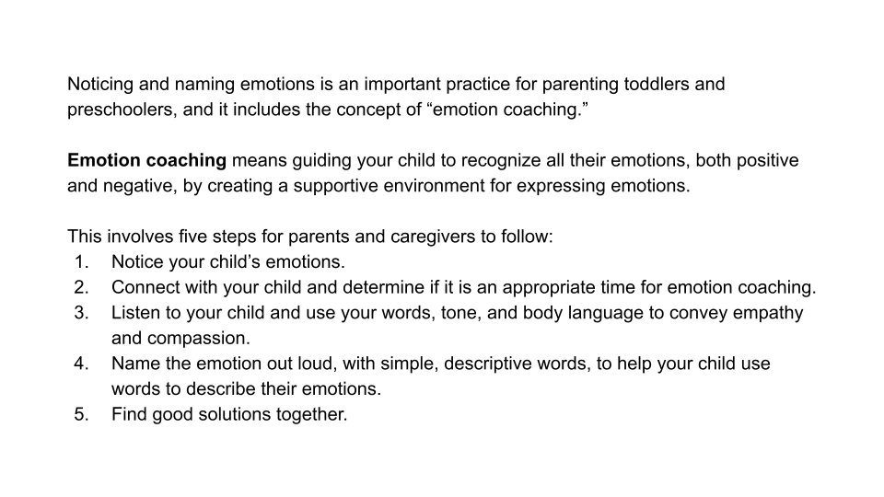
Concept B: Ignoring
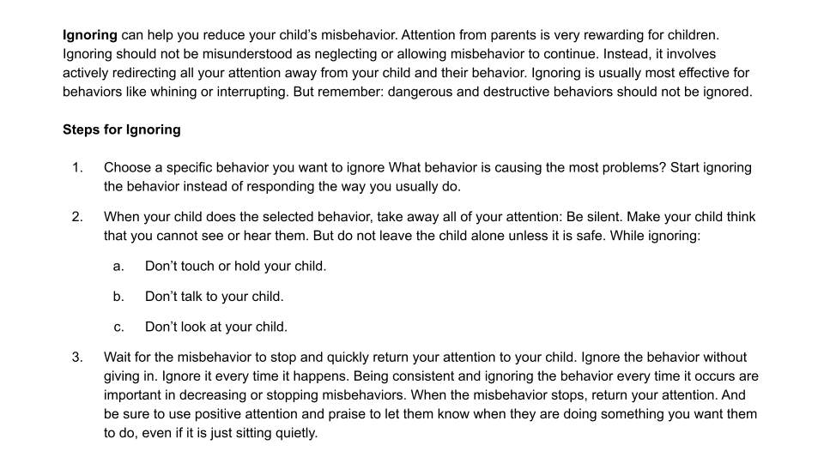
Concept C: Time-out
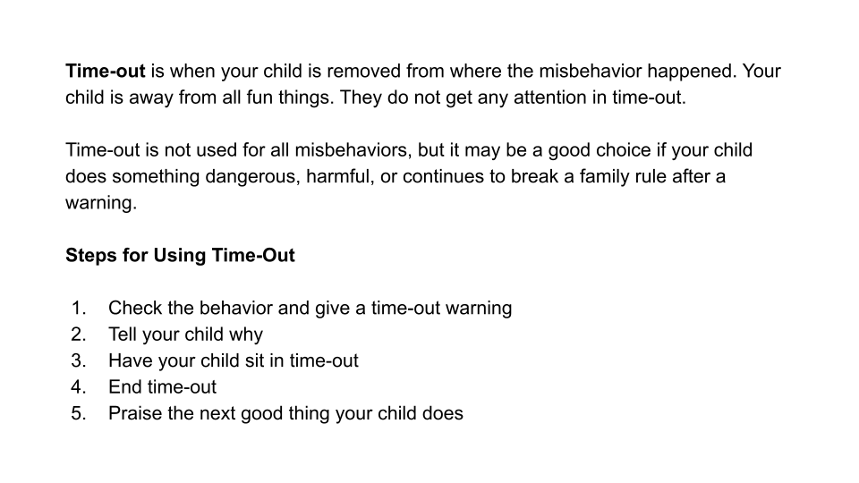
Concept D: Time-in
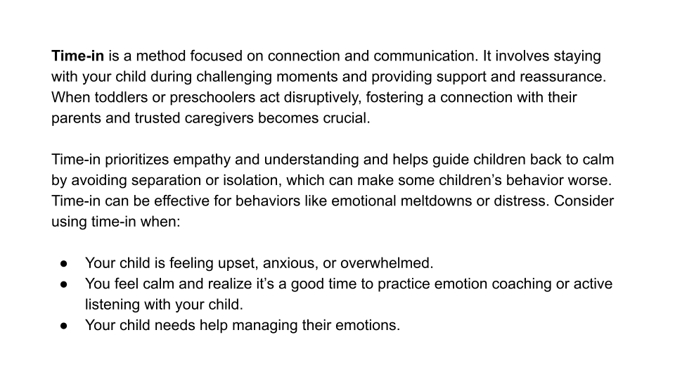
Concept E: Time-in vs. Time-out
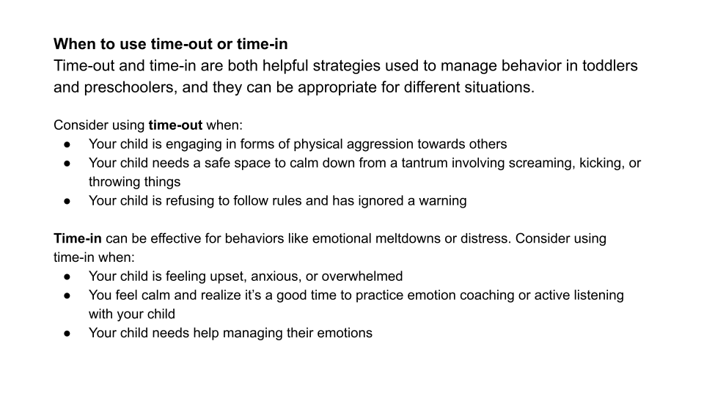
Concept F: Rewards, Social Rewards, and Praise
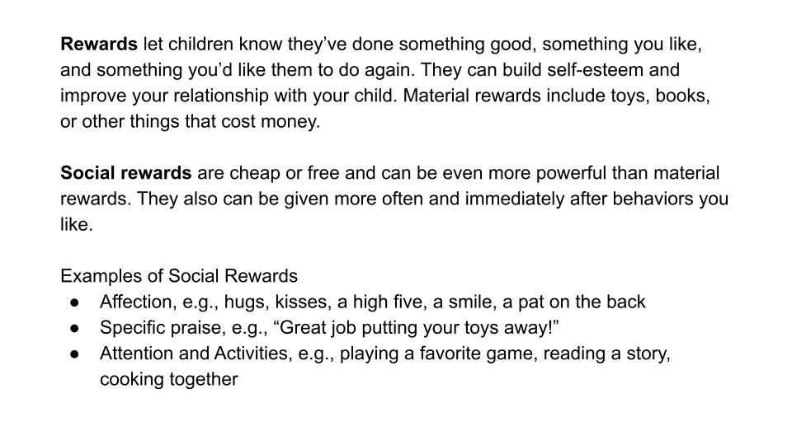

We will not only translate these questions for Spanish-speaking focus groups, but we will also be sure to rephrase and interpret them to prompt participants to share relevant cultural nuances or considerations with respect to the concepts we discuss.

