Attachment D

# CDC Digital Content Customer Satisfaction Survey:

# Survey Introduction (Instructions)

Instructions similar to the following will be shown in the popup survey on the participant’s computer/device screen. The survey is presented to randomly selected visitors to CDC.gov:

***We’d welcome your feedback!***Would you take a brief survey so we can improve your experience on our site?

* Yes, I’ll give feedback
* No thanks

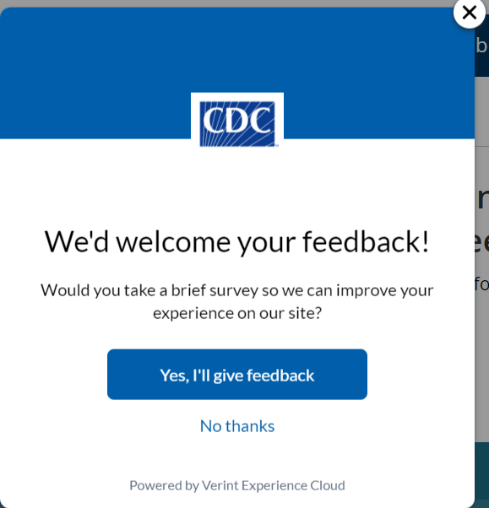

If the visitor chooses to participate in the survey, a second window appears with instructions similar to the following:

***Please keep this window open!***We'll ask you some questions after you finish your visit.  
The survey will appear in this window. You can minimize it for now or simply click on the window of our website.

