**All email communications are contained within this document**

### Invitation Email for Demographic Survey (Associated with Survey 1)

To: IndividualSubject line*:* Welcome to the 2025 CDC ECHO Biosafety Community of Practice

Dear Colleague,

The Division of Laboratory Systems at the Centers for Disease Control and Prevention welcomes you to the 2025 Extension for Community Healthcare Outcomes (ECHO) Biosafety Community of Practice (CoP). To better understand our audience for the ECHO sessions, we are conducting a voluntary survey of all attendees. The survey includes 6 demographic questions about your facility, role, and the personnel at your facility.

Please click on the link below to complete the demographic survey. The survey will take no more than one minute to complete. Your responses will be anonymous, and no unique identifying information will be sought or kept. If you filled out a previous demographic survey, please still complete this survey. The feedback we receive will be summarized in aggregate only and used for describing program reach. If you encounter issues with this survey, please email [dlsbiosafety@cdc.gov](mailto:dlsbiosafety@cdc.gov).

We appreciate your time and thank you in advance for your participation. If you have questions about the ECHO Biosafety CoP or the evaluation component, please contact [dlsbiosafety@cdc.gov](mailto:dlsbiosafety@cdc.gov).

**Follow this link to the Survey:**   
[Take the Survey](https://dlsevaluation.gov1.qualtrics.com/jfe/preview/previewId/c42bffab-378e-427b-9441-3afce7241cfd/SV_ekEUSEwQdf1D13M?Q_CHL=preview)

Or copy and paste the URL below into your internet browser:  
<https://dlsevaluation.gov1.qualtrics.com/jfe/preview/previewId/c42bffab-378e-427b-9441-3afce7241cfd/SV_ekEUSEwQdf1D13M?Q_CHL=preview>

Sincerely,

ECHO Biosafety Program Lead

Safety Team, Quality and Safety Systems

Division of Laboratory Systems (DLS)

Office of Laboratory Systems and Response

Centers for Disease Control and Prevention

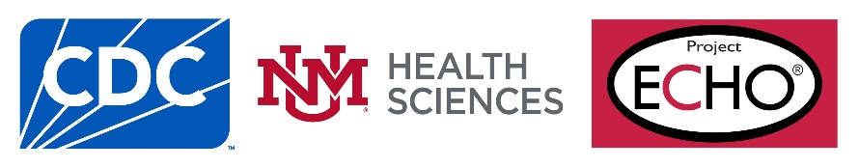

Email Reminder for Post-Session Survey (Associated with Survey 2)

*Note: the link to this post-session survey will be shared in the chat at the end of the session, one email reminder will be sent to attendees after the session to collect additional responses.*

To: All Attendees

Cc: [dlsbiosafety@cdc.gov](mailto:dlsbiosafety@cdc.gov)

Subject: REMINDER - ECHO Biosafety Program Community of Practice – **[Month]** Post-Session Survey

Dear Biosafety Colleague,

Thank you to those of you who completed the ECHO Biosafety Community of Practice (CoP) evaluation survey for the **[Month]** session on **[Session Title]**. Your feedback is essential in helping CDC improve the ECHO Biosafety CoP sessions. If you have already completed this survey during the **[Month]** session, please disregard this message.

For those of you who did not have a chance to complete the survey, please click on the following link to complete the survey by **[Survey Close Date]:** <https://dlsevaluation.gov1.qualtrics.com/jfe/form/SV_5b68Vgx5wPN9f8y>. You also may copy and paste the link into your browser.

This survey should take no more than 2 minutes to complete, and your participation is entirely voluntary. Your responses will be anonymous, and no unique identifying information will be sought or kept. The feedback we receive will be summarized in aggregate only and used for program improvement.

We appreciate your time and thank you in advance for your valuable feedback. If you have any questions about the ECHO Biosafety CoP or the evaluation component, please contact [dlsbiosafety@cdc.gov](mailto:dlsbiosafety@cdc.gov).

Kind Regards,

ECHO Biosafety Program Lead

Safety Team, [Quality and Safety Systems](https://www.cdc.gov/csels/dls/qualitysafetysystem.html)

[Division of Laboratory Systems (DLS)](https://www.cdc.gov/csels/dls/)

Office of Laboratory Systems and Response

Centers for Disease Control and Prevention

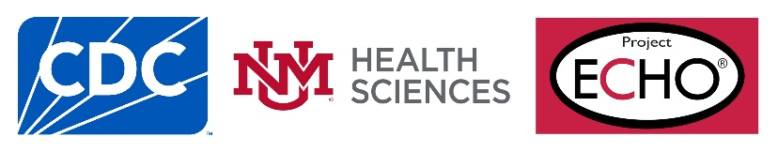

### Invitation Email for 6-Month Follow-up Surveys (Associated with Survey 3)

To: Individual

Subject: Project ECHO Biosafety Community of Practice Session – Follow-up Evaluation Survey

Dear Colleague,

Thank you for participating in the ECHO Biosafety Community of Practice (CoP) sessions facilitated by the Division of Laboratory Systems, Centers for Disease Control and Prevention.

To help us better understand to what extent the sessions are meeting the learning objectives, please click on the link below to complete a voluntary survey about the ECHO Biosafety sessions that you have attended in the past 6 months. This brief 6-question survey asks about the use of the content in your personal or facility work practices, factors that helped or hindered use of the content, and suggestions to enhance engagement in the CoP after the sessions end. The feedback you provide will also inform future session development.

Survey questions will take no more than 2 minutes to complete. Your responses will be anonymous, and no unique identifying information will be sought or kept. The feedback we receive will be summarized in aggregate only and used for program improvement. If you encounter issues with this evaluation survey, please email [dlsbiosafety@cdc.gov](mailto:dlsbiosafety@cdc.gov).

**Follow this link to the Survey:**

[Take the Survey](https://dlsevaluation.gov1.qualtrics.com/jfe/preview/previewId/8ca0183c-c945-40bc-bfef-c4c59532e286/SV_8HMSxZbrtegbA7Y?Q_CHL=preview)

Or copy and paste the URL below into your internet browser:

<https://dlsevaluation.gov1.qualtrics.com/jfe/preview/previewId/8ca0183c-c945-40bc-bfef-c4c59532e286/SV_8HMSxZbrtegbA7Y?Q_CHL=preview>

Thank you for sharing your feedback to improve the ECHO Biosafety Community of Practice. If you have any questions about the ECHO Biosafety CoP or the evaluation component, please contact [dlsbiosafety@cdc.gov](mailto:dlsbiosafety@cdc.gov).

Sincerely,

ECHO Biosafety Program Lead

Safety Team, Quality and Safety Systems

Division of Laboratory Systems (DLS)

Office of Laboratory Systems and Response

Office of Laboratory Science and Safety

Centers for Disease Control and Prevention

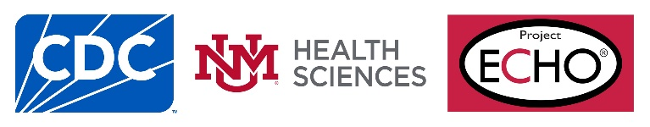

### Email Reminder (Associated with Survey 3)

To: Individual who have not responded

From: dlsbiosafety@cdc.gov

Subject: REMINDER - Project ECHO Biosafety Community of Practice Sessions – Follow-up Evaluation Survey

Dear Biosafety Colleague,

Thank you for attending one or more of the last six [ECHO Biosafety Community of Practice sessions](https://www.cdc.gov/safelabs/resources-tools/echo-biosafety.html) facilitated by the CDC Division of Laboratory Systems between January and June 2025. You should have received a follow-up evaluation survey on [Survey Sent Date] from “DLS Evaluation” with the subject line “Project ECHO Biosafety Community of Practice Session – Follow-up Evaluation Survey.”

**This is a friendly reminder to please complete a short survey about your experiences at the ECHO Biosafety sessions.** This survey will help us understand to what extent the ECHO Biosafety sessions have served your needs.Your feedback is critically important to us and guides the development of future ECHO sessions.

The survey should take no more than 2 minutes to complete and will remain open until **[Survey Close Date]**. Your responses will be anonymous, and no unique identifying information will be sought or kept. The feedback we receive will be summarized in aggregate only and used for program improvement.

Click the link below to access the survey or copy and paste it into your web browser.

Survey link: <https://dlsevaluation.gov1.qualtrics.com/jfe/form/SV_7aItdVDsGzauBF4>

If you encounter issues with the evaluation survey, please email [dlsbiosafety@cdc.gov](mailto:dlsbiosafety@cdc.gov). Thank you for sharing your feedback to improve the ECHO Biosafety Community of Practice.

Kind Regards,

ECHO Biosafety Project Lead

Safety Team, [Quality and Safety Systems](https://www.cdc.gov/csels/dls/qualitysafetysystem.html)

[Division of Laboratory Systems (DLS)](https://www.cdc.gov/csels/dls/)

Office of Laboratory Systems and Response

Centers for Disease Control and Prevention

