Form Approved
OMB Control Number: 0920-1050
Exp Date: 07/31/2024

Title: Customer Feedback Survey about the Electronic Import Permit Program (eIPP) Information System

CDC would like to know more about your experience using the eIPP information system, the electronic permit application system for CDC's Import Permit Program. Please complete this brief, anonymous survey by DATE. The information collected in this survey will inform improvements to the eIPP information system. Please visit CDC Import Permit Program, www.cdc.gov/cpr/ipp/ or email, eIPPSupport@cdc.gov.

1. With regards to import permits, which best describes your organizational role?
Administrator/Logistics/Manager
Biosafety Officer
Customs Attorney
Customs Broker
Principal Investigator/Researcher
Project/Lab Manager
Other (open ended)

2. On average, how many import permit applications do you complete each year?
0
1–4
5–9
10+
Other (open ended)

3. Primarily, what is the intended use of infectious materials you import? Select all that apply.
Clinical Trials
Diagnostic
Education
Production
Research
Other (open ended)

4. Have you used the eIPP information system during the past year? (forced response and skip pattern)
Yes (if “Yes” proceed to Page 2)
No (if “No,” direct to open-ended final comment box)
Unsure (if “Unsure,” direct to open-ended final comment box)

CDC estimates the average public reporting burden for this collection of information as 10 minutes per response, including the time for reviewing instructions, searching existing data/information sources, gathering and maintaining the data/information needed, and completing and reviewing the collection of information. An agency may not conduct or sponsor, and a person is not required to respond to a collection of information unless it displays a currently valid OMB control number. Send comments regarding this burden estimate or any other aspect of this collection of information, including suggestions for reducing this burden to CDC/ATSDR Information Collection Review Office, 1600 Clifton Road NE, MS D-74, Atlanta, Georgia 30333; ATTN: PRA (0920-1050).

- - - - - - - - - - - - - - - - - - - - - - - - - - - - - - - - - - - - - - - NEW PAGE- - - - - - - - - - - - - - - - - - - - - - - - - - - - - -- - - - - - - -

Now we are going to ask about your experience using the eIPP information system.

Some of the questions below are from the validated User Experience Questionnaire. This questionnaire is an evidenced-based tool to help us better understand a user’s experience with an interactive product, like the eIPP information system. For more information, visit www.ueq-online.org/.

5. Please rate your overall level of satisfaction with the eIPP information system.
Very dissatisfied
Dissatisfied
Neither dissatisfied nor satisfied
Satisfied
Very satisfied
Not applicable
Prefer not to answer

The series of prompts below will help us better understand your experience using the eIPP information system.

Each prompt displays a pair of contrasting attributes that may apply to the eIPP information system. The circles between the attributes represent gradations between the pairs. Please express your agreement with the attributes by selecting the circle that most closely reflects your experience using the eIPP information system.

Please don’t think too long about your decision, go with your first reaction. You may not be totally sure about your agreement with the statement or find it does not completely apply to the eIPP information system. Nevertheless, please try to select an answer for all prompts. Most importantly, we want your personal opinion. There are no wrong or right answers.

Example: Both of the responses below would mean that you rate the eIPP information system as more "Easy" than "Complicated."

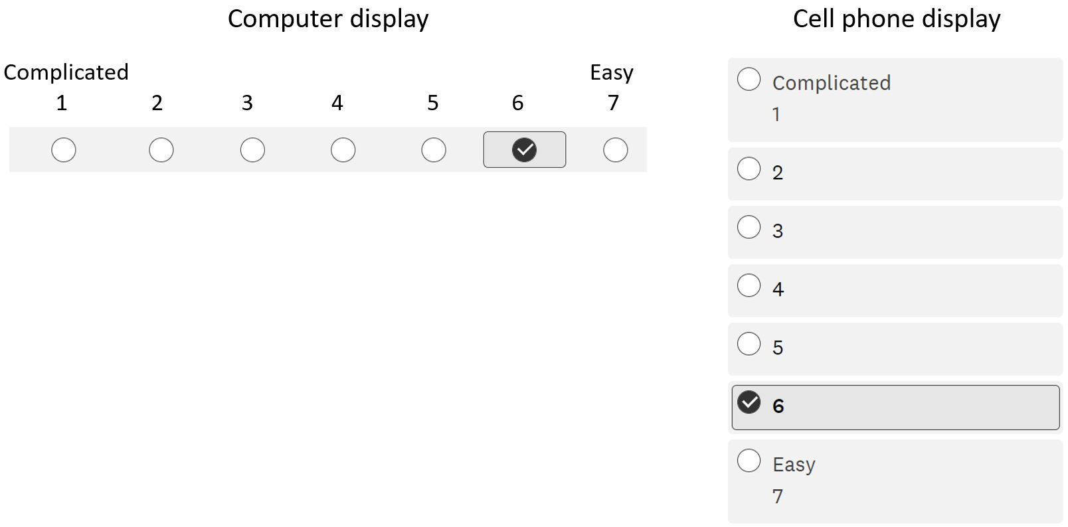

6. Please express your agreement with the attributes by selecting the circle that most closely reflects your experience using the eIPP information system.

 | 1 | 2 | 3 | 4 | 5 | 6 | 7
Annoying | ○ | ○ | ○ | ○ | ○ | ○ | ○ | Enjoyable
Not understandable | ○ | ○ | ○ | ○ | ○ | ○ | ○ | Understandable
Creative | ○ | ○ | ○ | ○ | ○ | ○ | ○ | Dull
Easy to learn | ○ | ○ | ○ | ○ | ○ | ○ | ○ | Difficult to learn
Valuable | ○ | ○ | ○ | ○ | ○ | ○ | ○ | Inferior
Boring | ○ | ○ | ○ | ○ | ○ | ○ | ○ | Exciting
Not interesting | ○ | ○ | ○ | ○ | ○ | ○ | ○ | Interesting
Unpredictable | ○ | ○ | ○ | ○ | ○ | ○ | ○ | Predictable
Fast | ○ | ○ | ○ | ○ | ○ | ○ | ○ | Slow
Inventive | ○ | ○ | ○ | ○ | ○ | ○ | ○ | Conventional
Obstructive | ○ | ○ | ○ | ○ | ○ | ○ | ○ | Supportive
Good | ○ | ○ | ○ | ○ | ○ | ○ | ○ | Bad
Complicated | ○ | ○ | ○ | ○ | ○ | ○ | ○ | Easy
Unlikable | ○ | ○ | ○ | ○ | ○ | ○ | ○ | Pleasing
15. Usual | ○ | ○ | ○ | ○ | ○ | ○ | ○ | Leading edge
Unpleasant | ○ | ○ | ○ | ○ | ○ | ○ | ○ | Pleasant
Secure | ○ | ○ | ○ | ○ | ○ | ○ | ○ | Not secure
Motivating | ○ | ○ | ○ | ○ | ○ | ○ | ○ | Demotivating
Meets expectations | ○ | ○ | ○ | ○ | ○ | ○ | ○ | Does not meet expectations
Inefficient | ○ | ○ | ○ | ○ | ○ | ○ | ○ | Efficient
Clear | ○ | ○ | ○ | ○ | ○ | ○ | ○ | Confusing
Impractical | ○ | ○ | ○ | ○ | ○ | ○ | ○ | Practical
Organized | ○ | ○ | ○ | ○ | ○ | ○ | ○ | Cluttered
Attractive | ○ | ○ | ○ | ○ | ○ | ○ | ○ | Unattractive
Friendly | ○ | ○ | ○ | ○ | ○ | ○ | ○ | Unfriendly
Conservative | ○ | ○ | ○ | ○ | ○ | ○ | ○ | Innovative

- - - - - - - - - - - - - - - - - - - - - - - - - - - - - - - - - - - - - - - NEW PAGE- - - - - - - - - - - - - - - - - - - - - - - - - - - - - - - - - - - - - -

CDC Import Permit Program is committed to continuous improvement. Now we would like you to imagine the ideal eIPP information system.

7. With that ideal eIPP information system in mind, please respond to the following statements; ranging from 1–7 with "Completely unimportant" on the left to "Very important" on the right.

 | Completely unimportant  1 | 2 | 3 | 4 | 5 | 6 | Very important 7
The eIPP information system should be easy to understand, clear, simple, and easy to learn. | ○ | ○ | ○ | ○ | ○ | ○ | ○
Users should be able to perform tasks within the eIPP information system quickly and efficiently. | ○ | ○ | ○ | ○ | ○ | ○ | ○
The eIPP information system should be attractive, enjoyable, and pleasant. | ○ | ○ | ○ | ○ | ○ | ○ | ○
Interacting with the eIPP information system should be predictable, secure, and meet users’ expectations. | ○ | ○ | ○ | ○ | ○ | ○ | ○
Using the eIPP information system should be interesting, exciting, and motivating. | ○ | ○ | ○ | ○ | ○ | ○ | ○
The eIPP information system should be innovative, inventive, and creatively designed. | ○ | ○ | ○ | ○ | ○ | ○ | ○

- - - - - - - - - - - - - - - - - - - - - - - - - - - - - - - - - - - - - - - NEW PAGE- - - - - - - - - - - - - - - - - - - - - - - - - - - - - -- - - - - - - -

Almost done. Please complete these last few questions.

8. What do you like about the eIPP information system?
(open ended)

9. What do you dislike about the eIPP information system?
(open ended)

10. What should be added to the eIPP information system?
(open ended)

11. Please provide any additional comments here.
(open ended)

12. Which type of device did you use to complete this survey?
Cell phone
Traditional computer (ex. desktop or laptop)
Tablet
Other (open ended)

- - - - - - - - - - - - - - - - - - - - - - - - - - - - - - - - - - - - - - END OF SURVEY- - - - - - - - - - - - - - - - - - - - - - - - - - - - - - - - - - - -

Thank you for completing the customer feedback survey about the eIPP information system. The information collected in this survey will inform improvements to the eIPP information system. Please visit CDC Import Permit Program, www.cdc.gov/cpr/ipp/, or email, eIPPSupport@cdc.gov.

