Attachment E: Survey Access from Event Home Screen and Centralized Survey Landing Page

Screenshot of PHIT event Web application home screen button that redirects to attendees’ centralized survey landing page:
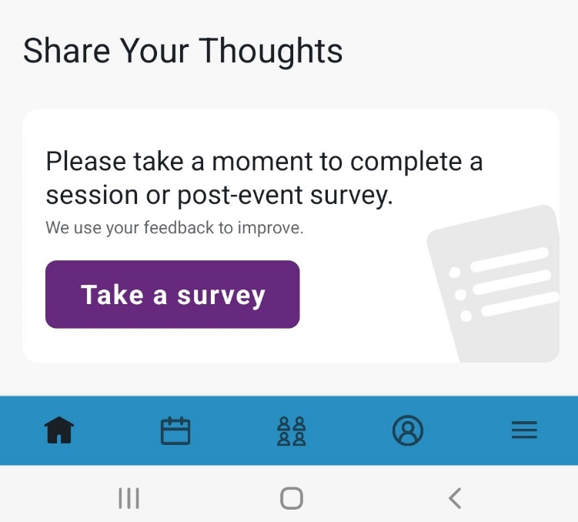

Screenshot of sample attendee’s centralized survey landing page:


