Attachment 2

Screenshots of

My Family Health Portrait:Cancer

Mobile Application Evaluation Question

*Note: Mockups utilize Latin placeholder text for data collection disclaimer language, as well as a sample OMB approval number and expiration date.

Android:

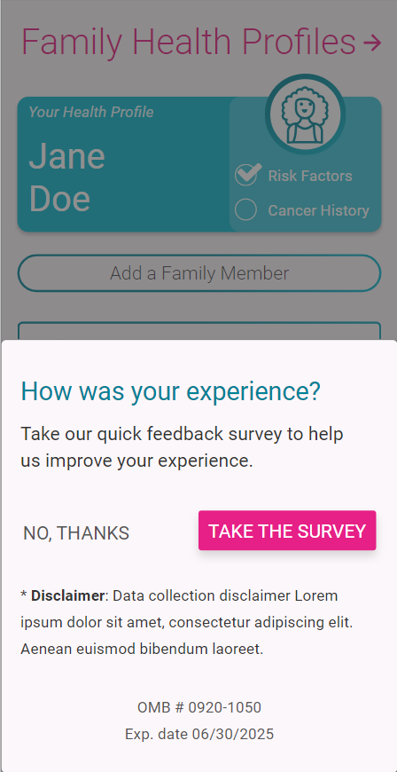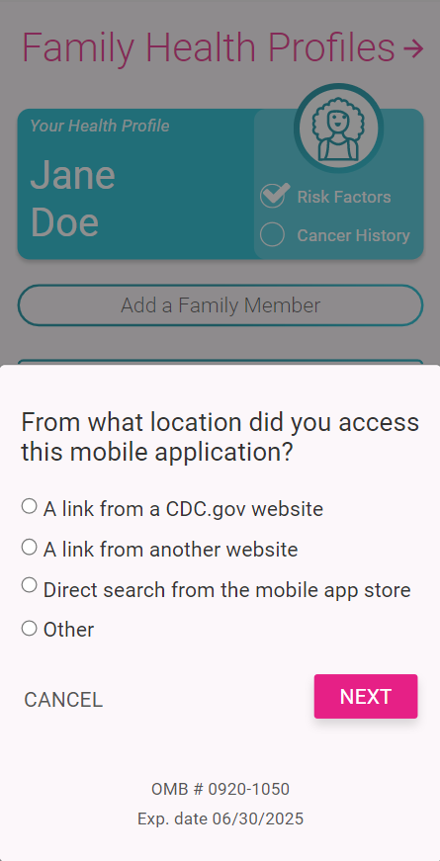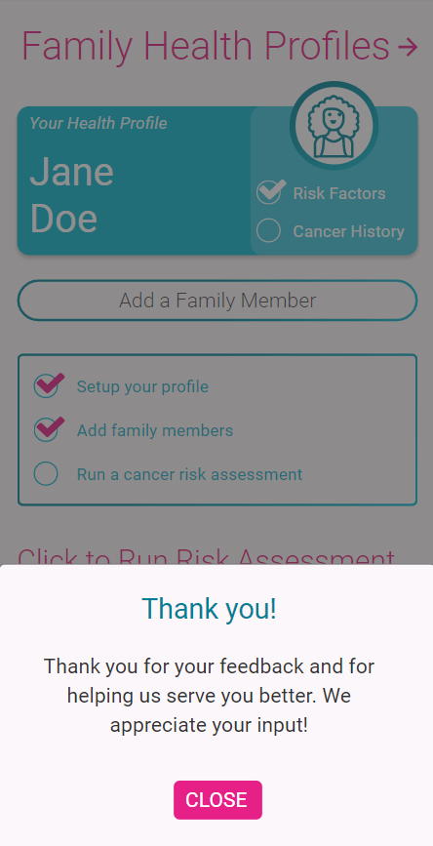

iOS:
