Form Approved
OMB Control Number: 0920-1282
Expiration Date: 06/30/2026

DP23-0020: A Strategic Approach to Advancing Health Equity for Priority Populations with or at Risk for
Diabetes (2320)
Centers for Disease Control and Prevention
dfdfdf



Component C
Performance Measure Data Collection Platform
March 2024

Public reporting burden of this collection of information is estimated to average 8 hours per response per year, including the time for reviewing instructions, searching existing data sources, gathering and maintaining the data needed, and completing and reviewing the collection of information. An agency may not conduct or sponsor, and a person is not required to respond to a collection of information unless it displays a currently valid OMB control number. Send comments regarding this burden estimate or any other aspect of this collection of information, including suggestions for reducing this burden to CDC/ATSDR Reports Clearance Officer; 1600 Clifton Road NE, MS D-74, Atlanta, Georgia 30333; Attn: OMB-PRA (0920-1282)
Table of Contents
Performance Measure Reporting Cadence 3
Guidance for Reviewing Performance Measure Screenshots 3
DP23-0020 Home Screen – Component C 4
DP23-0020- Performance Measure Template Key-Component C 4
DP23-0020 Measure 1.a – Component C 8
DP23-0020 Measure 2.1 – Component C 10
DP23-0020 Measure 2.a – Component C 12
DP23-0020 Measure 2.b – Component C 14
DP23-0020 Measure 3.1 – Component C 16
DP23-0020 Measure 3.2 – Component C 18
DP23-0020 Measure 3.3 – Component C 20
DP23-0020 Measure 3.a – Component C 22
DP23-0020 Measure 4.1 – Component C 24
DP23-0020 Measure 4.2 – Component C 26
DP23-0020 Measure 4.a – Component C 28
DP23-0020 Measure 5 – Component C 30

Performance Measure Reporting Cadence
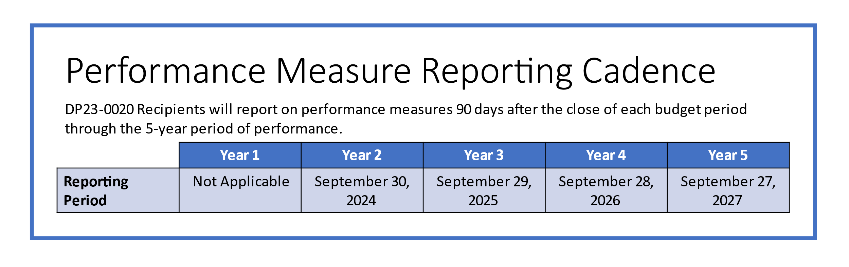

Guidance for Reviewing Performance Measure Screenshots
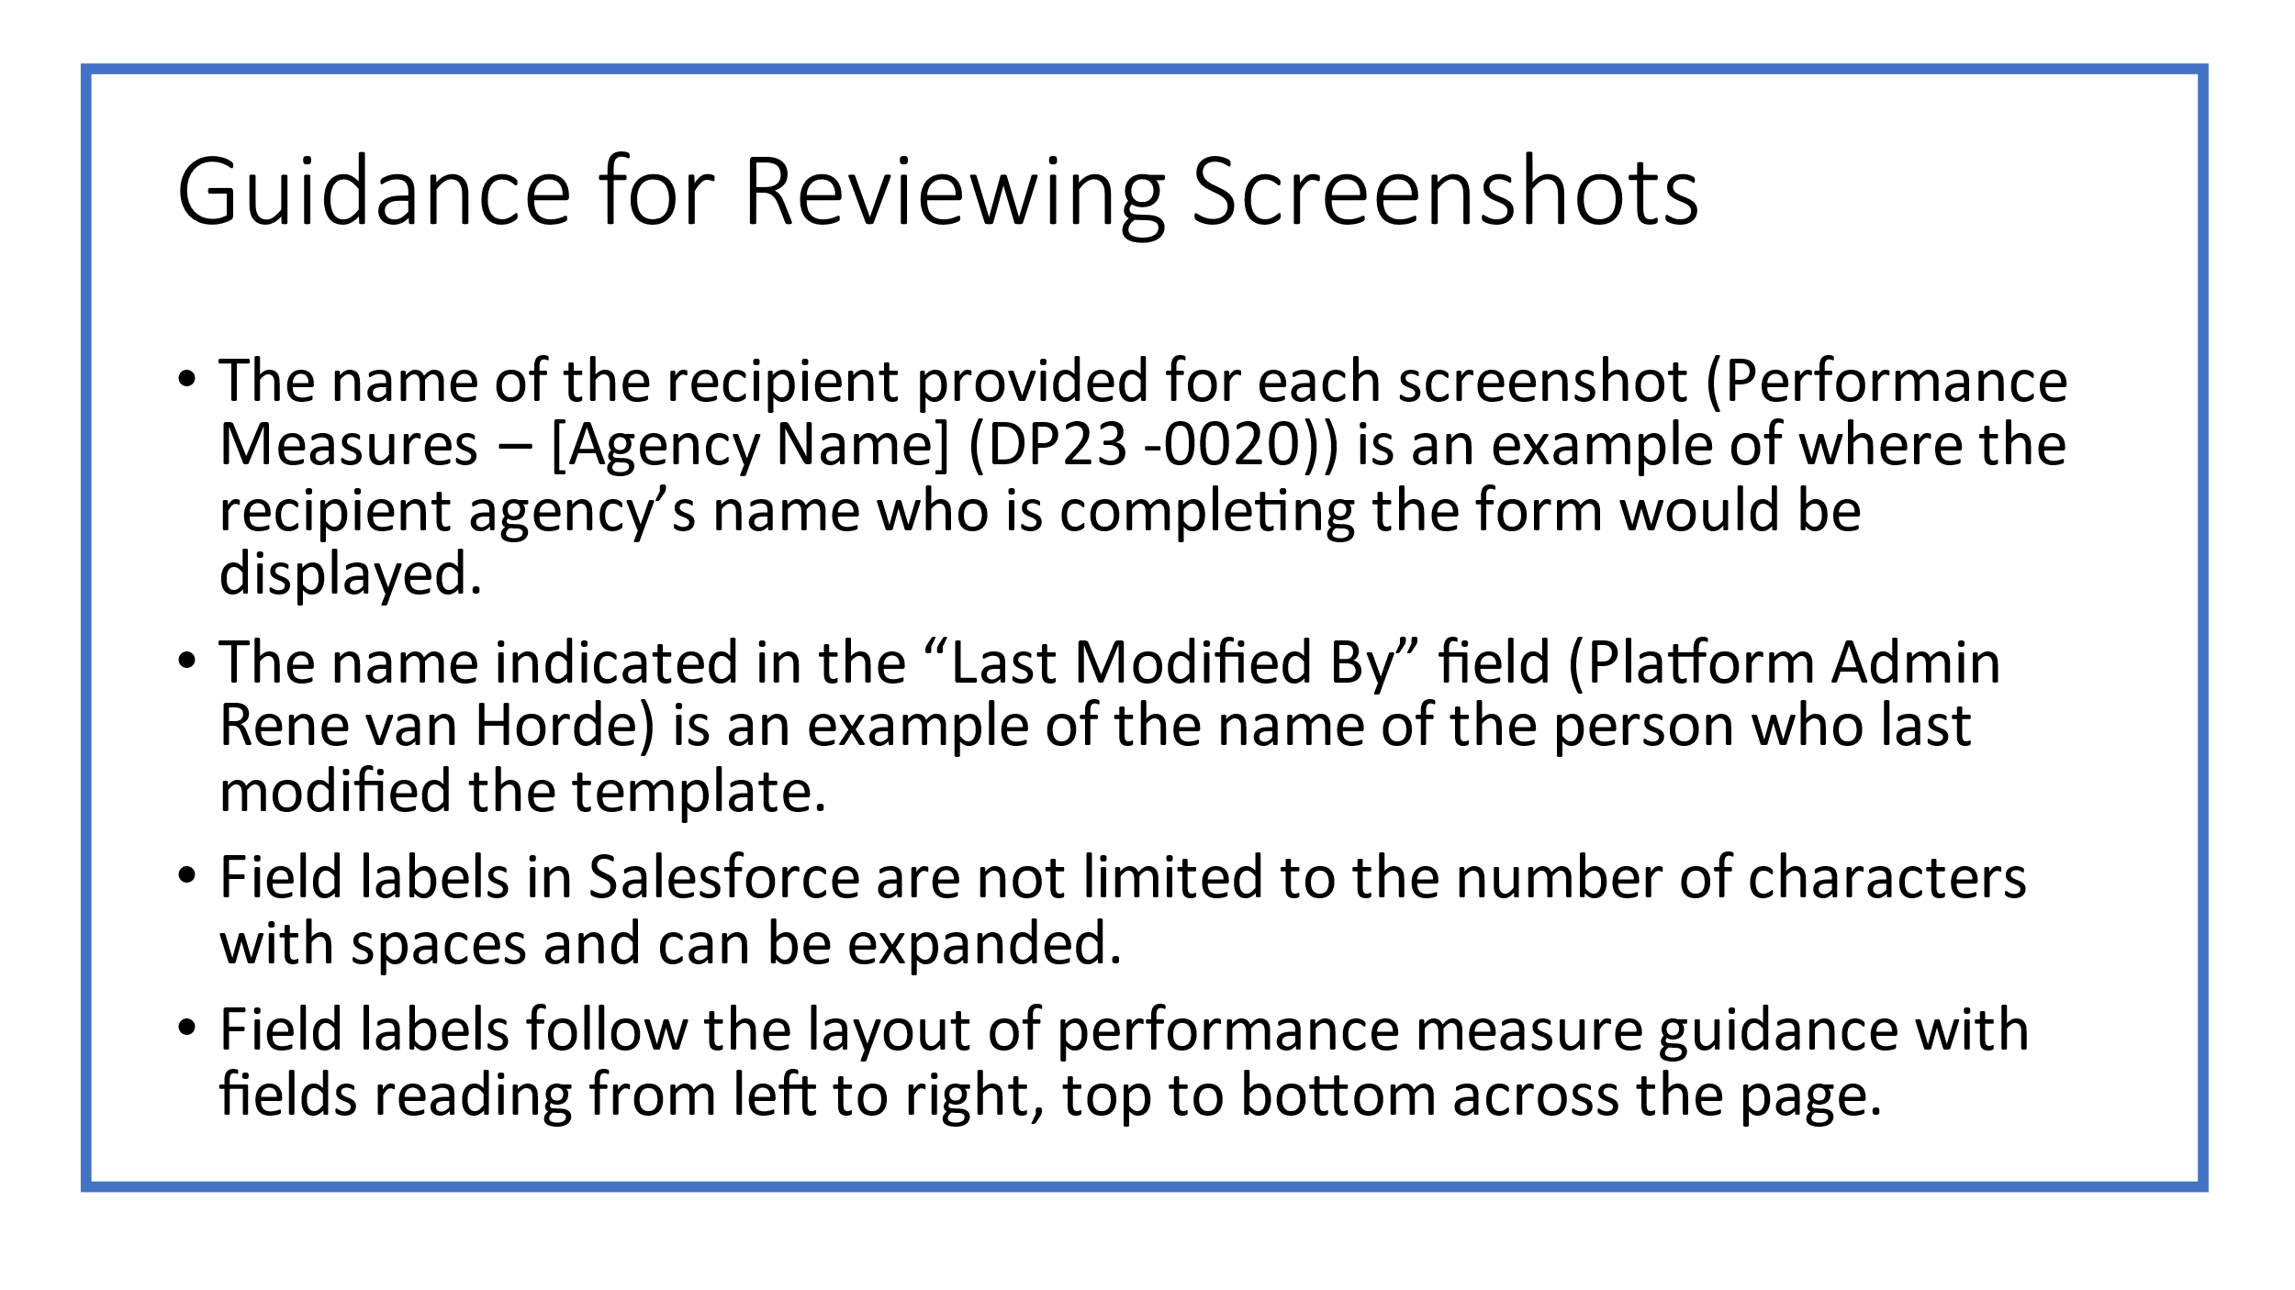

DP23-0020 Home Screen – Component C
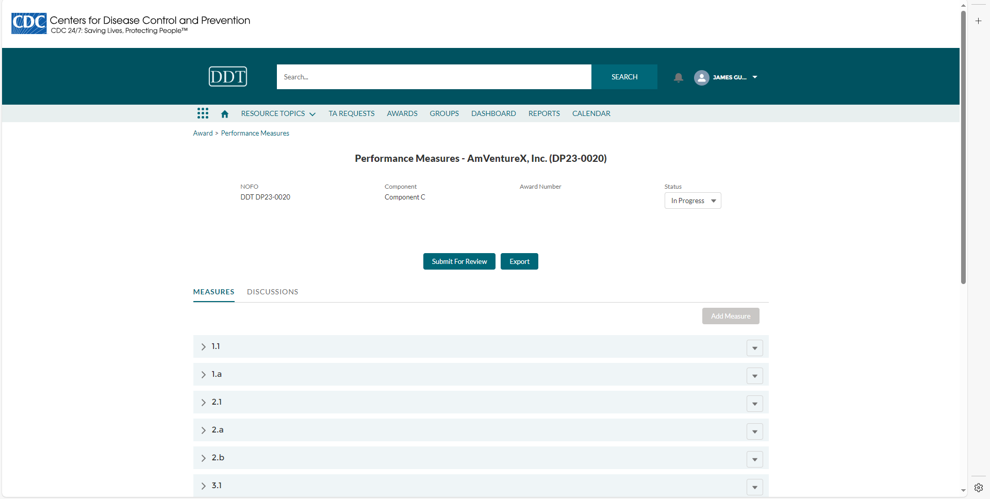

DP23-0020- Performance Measure Template Key-Component C
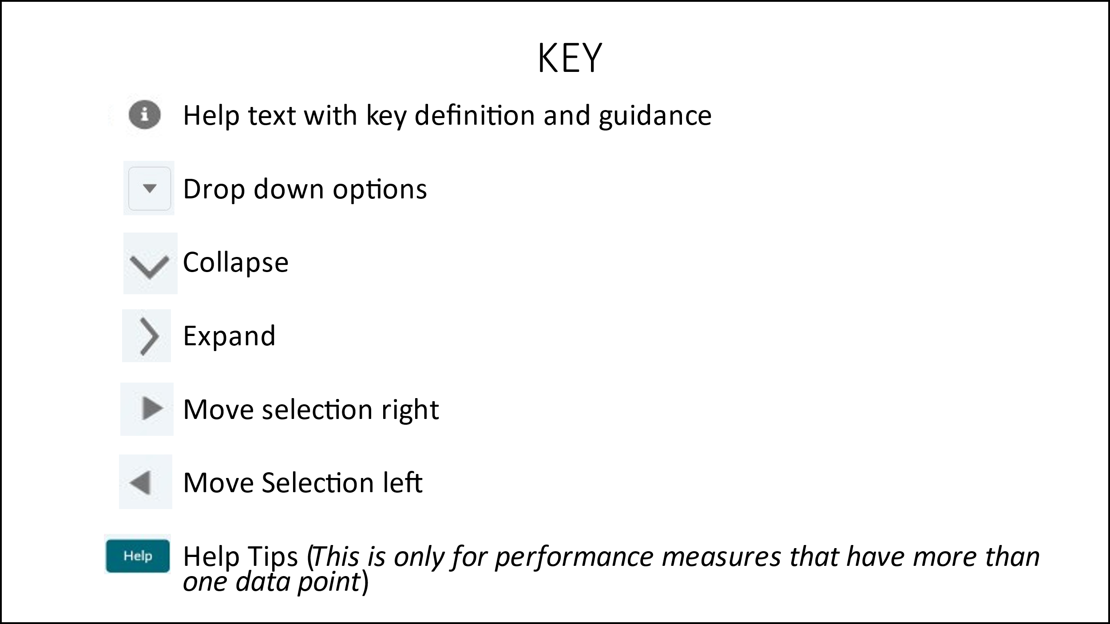

DP23-0020 Measure 1.1 – Component C
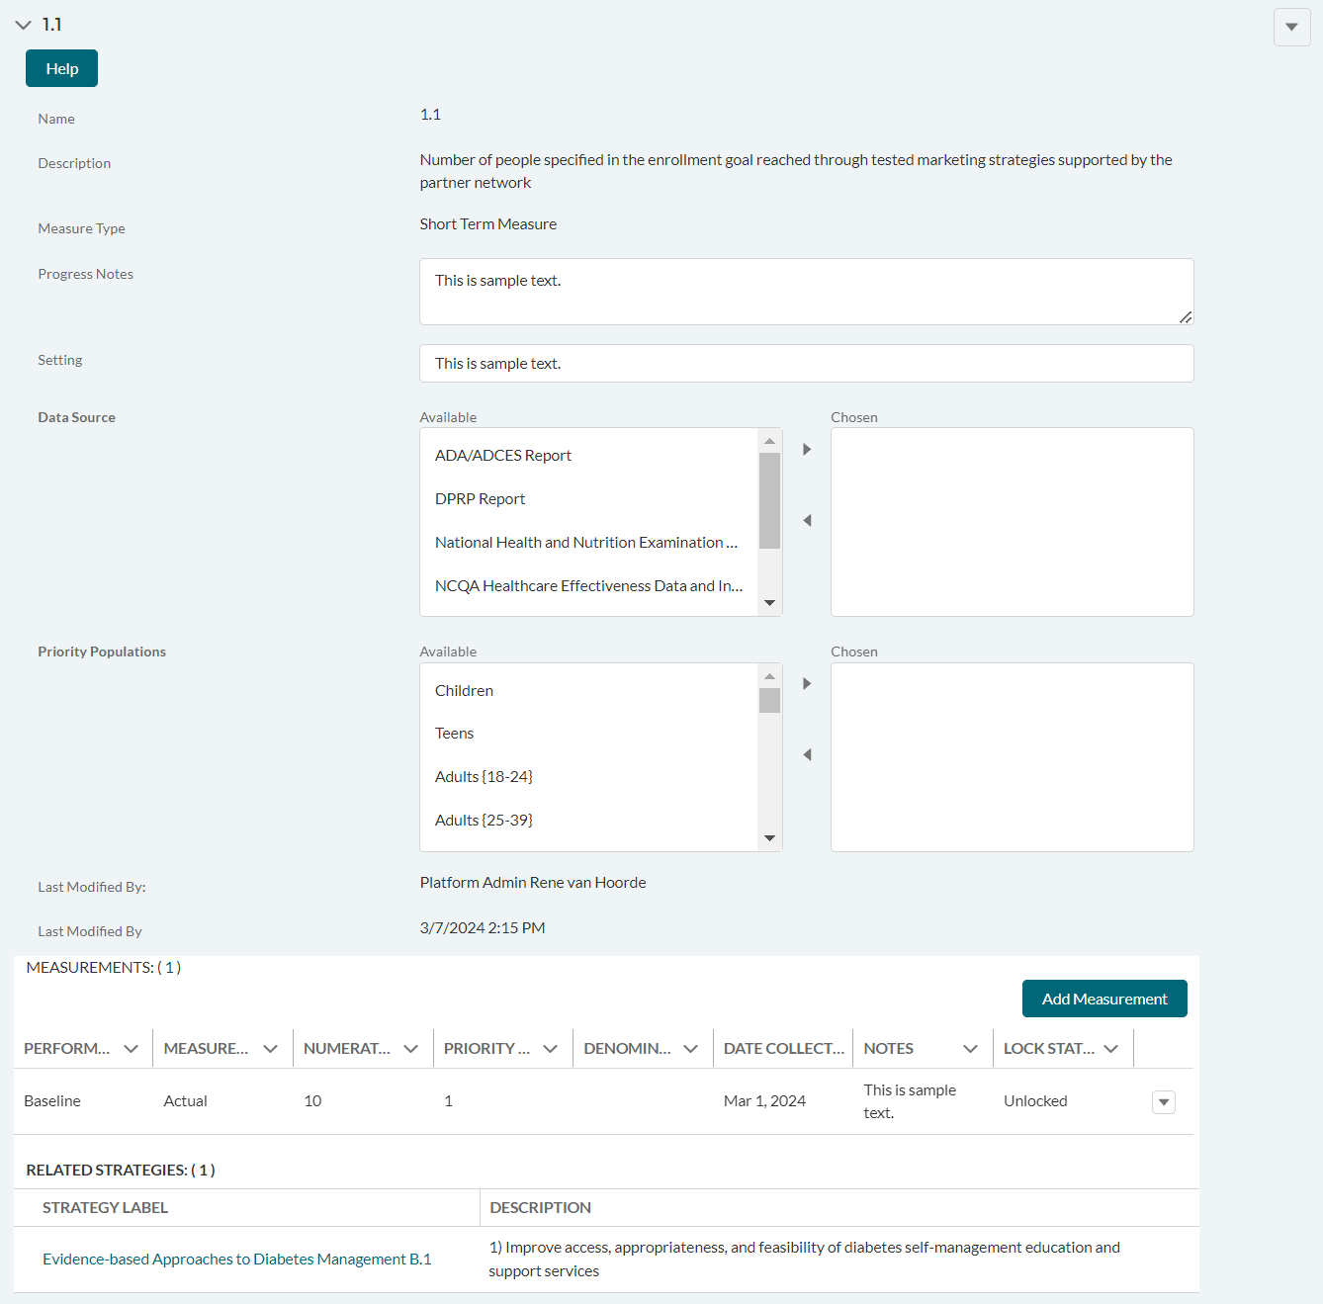

DP23-0020 Measure 1.1 _Add Measurement Option – Component C
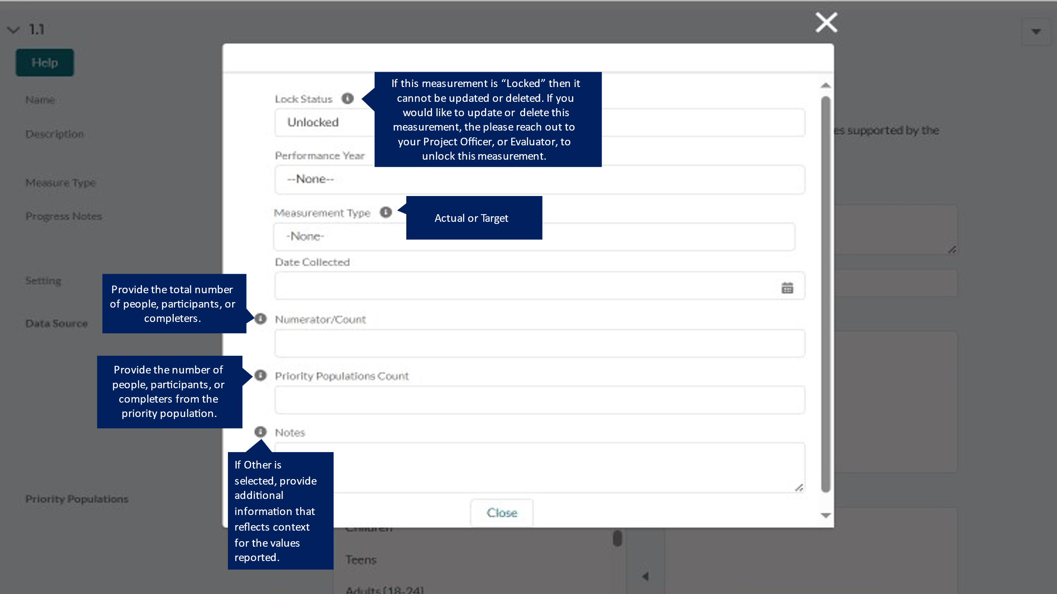

DP23-0020 Measure 1.a – Component C
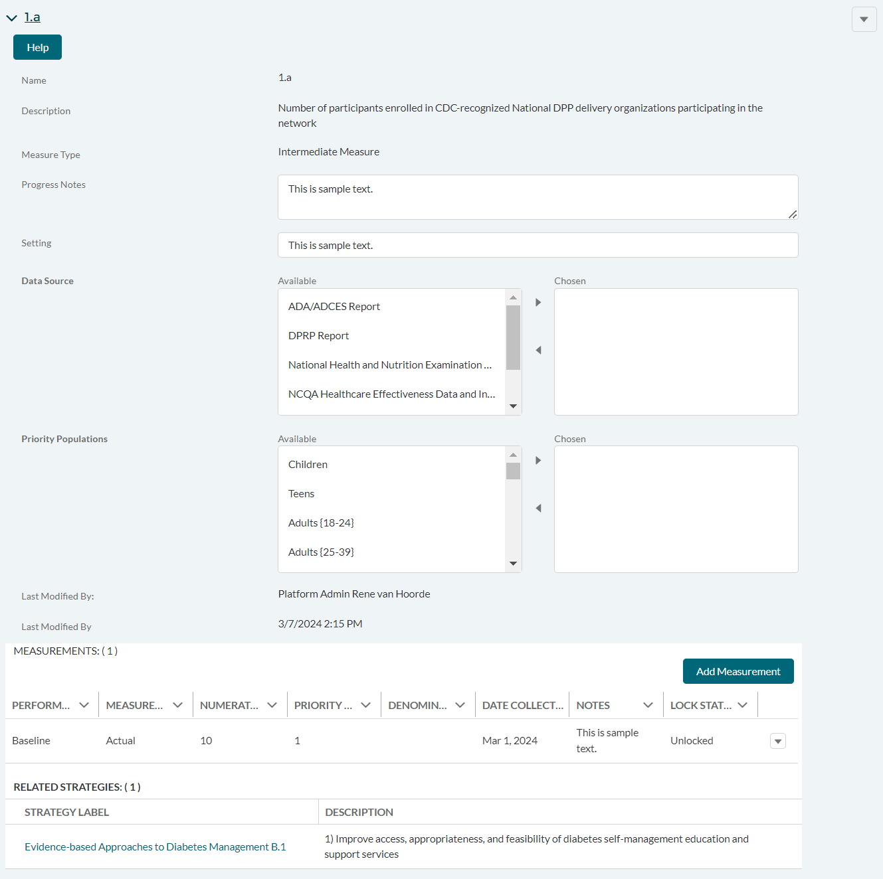

DP23-0020 Measure 1.a _Add Measurement Option – Component C
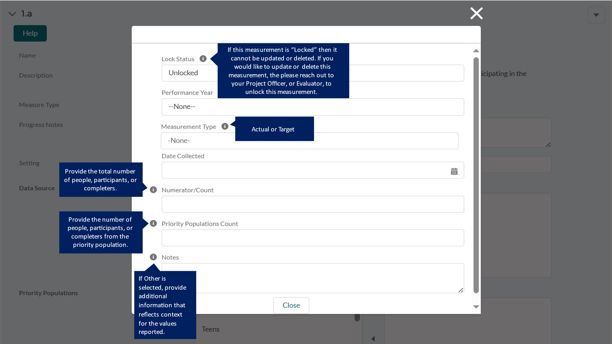

DP23-0020 Measure 2.1 – Component C
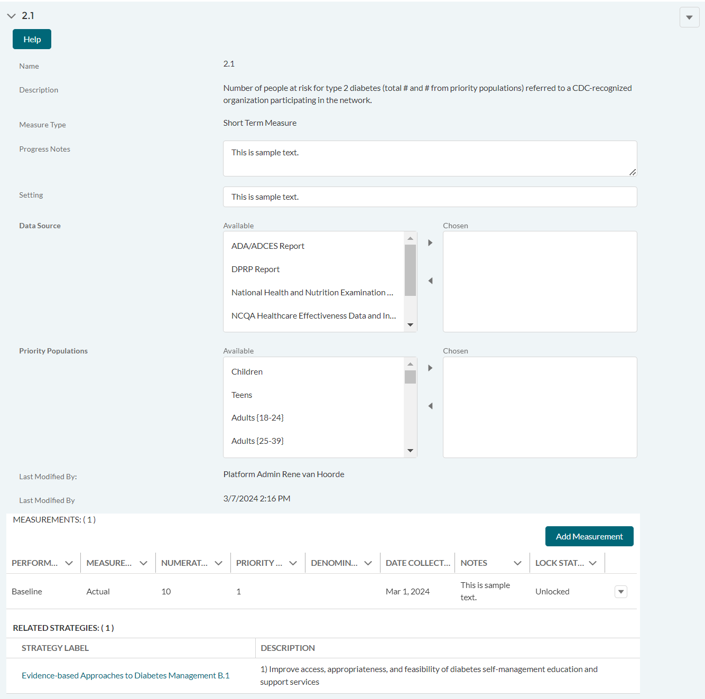

DP23-0020 Measure 2.1 _Add Measurement Option – Component C
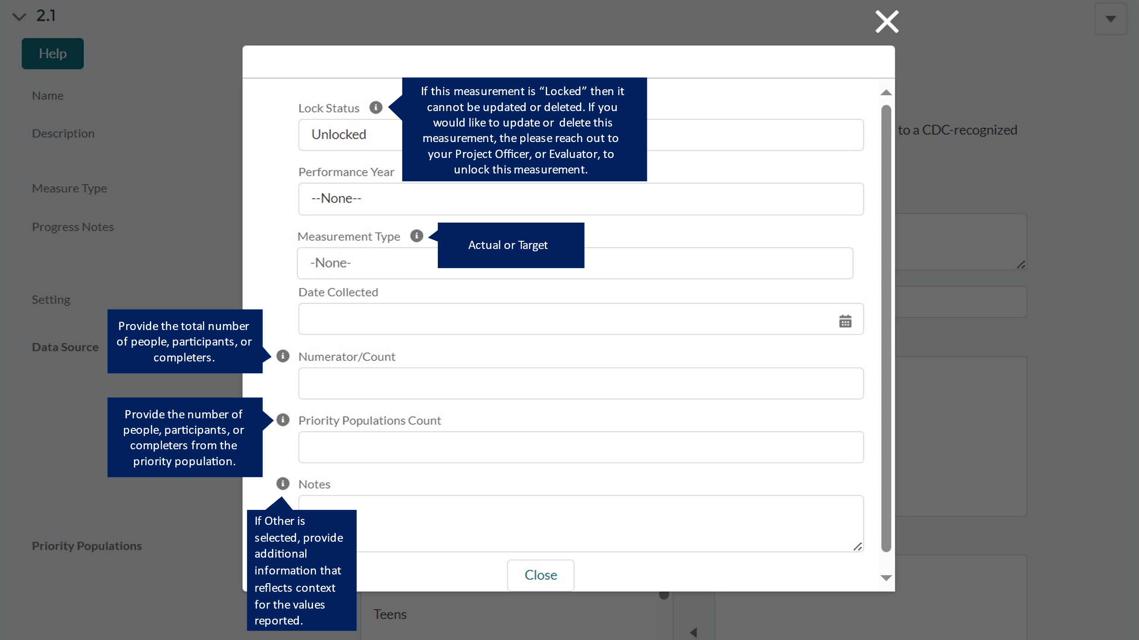

DP23-0020 Measure 2.a – Component C
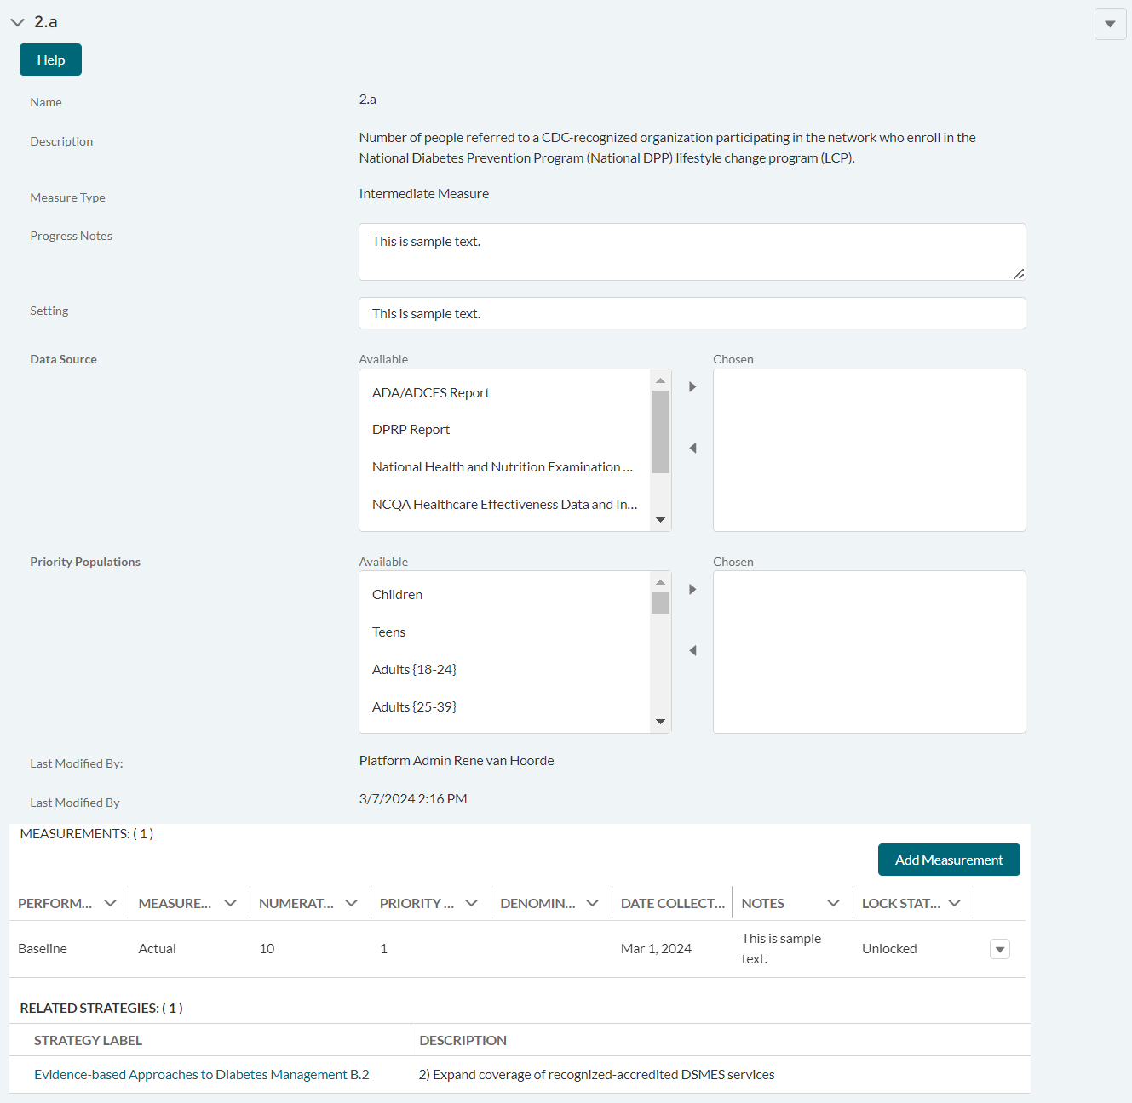

DP23-0020 Measure 2.a _Add Measurement Option – Component C
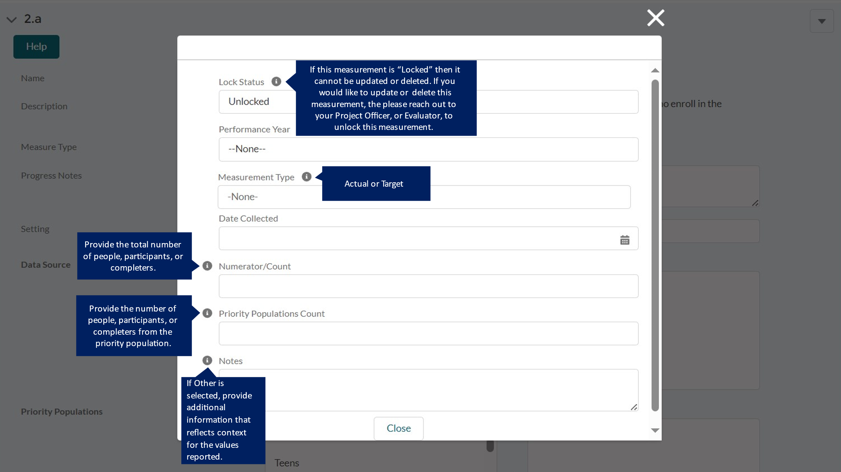

DP23-0020 Measure 2.b – Component C
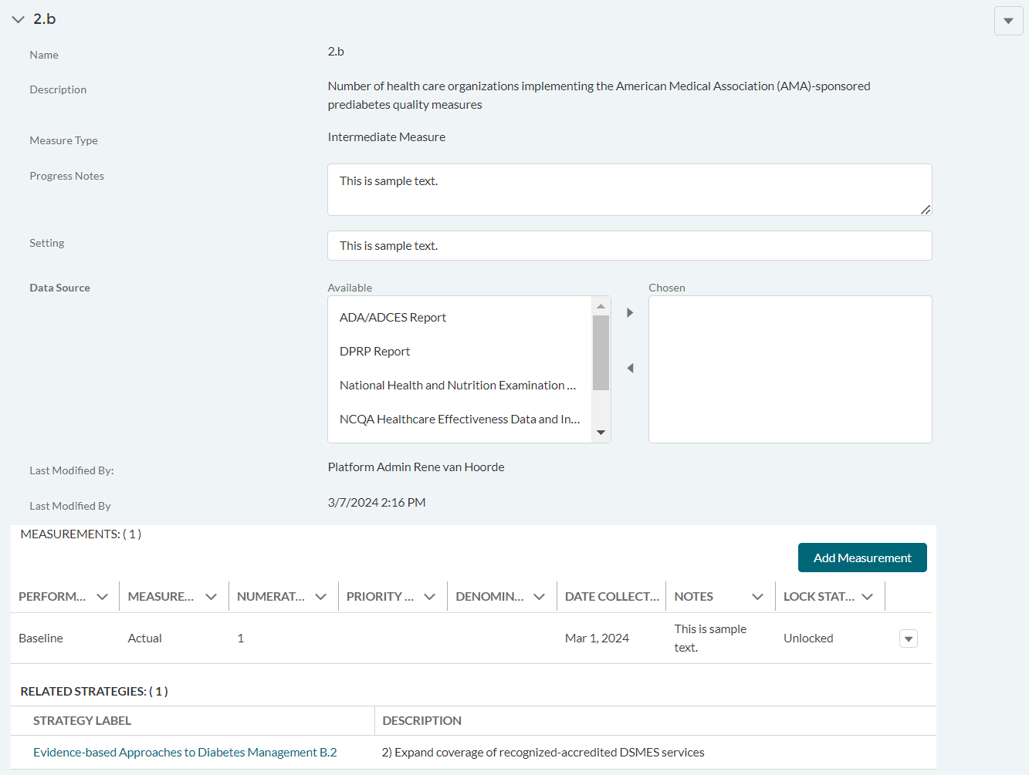

DP23-0020 Measure 2.b _Add Measurement Option – Component C
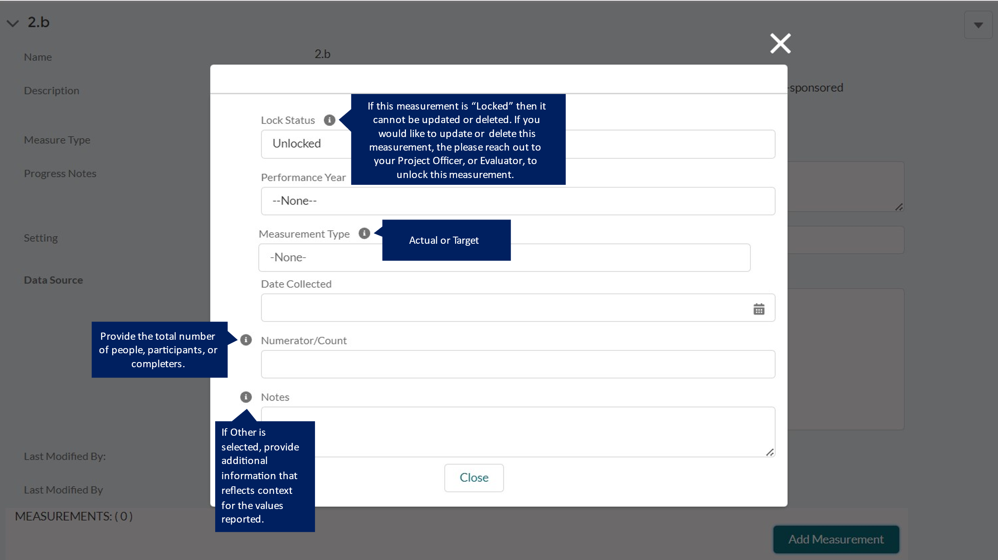

DP23-0020 Measure 3.1 – Component C
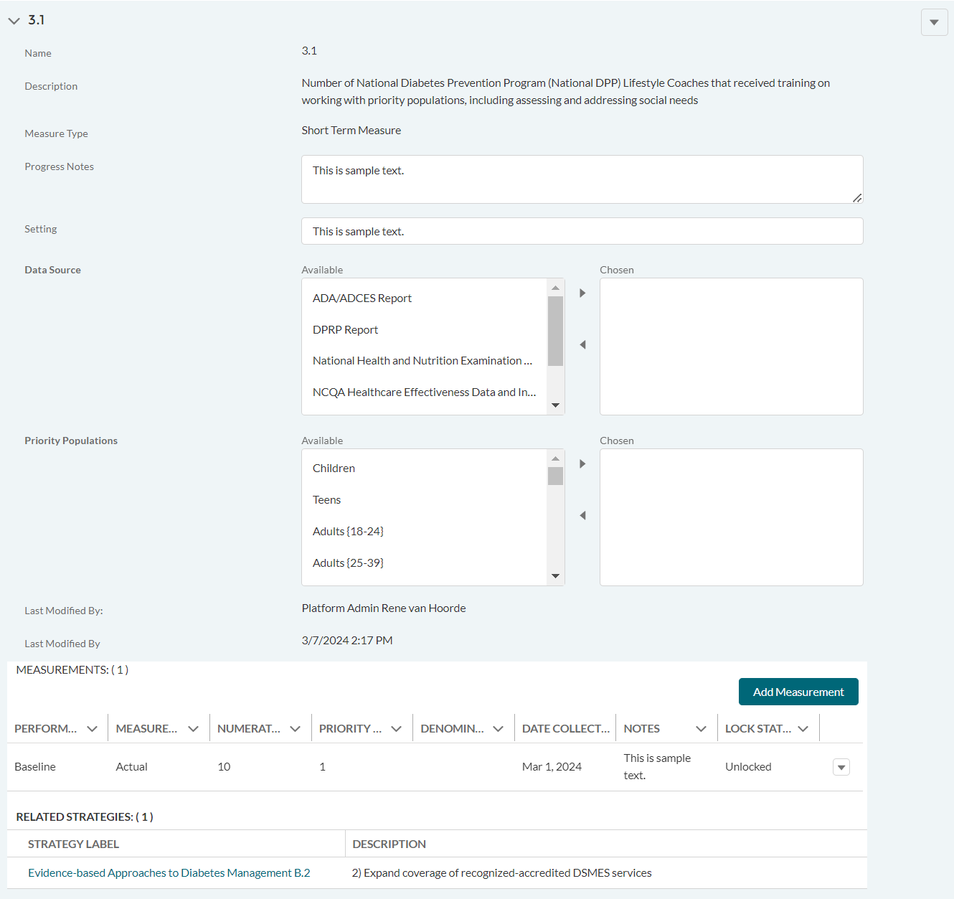

DP23-0020 Measure 3.1 _Add Measurement Option – Component C
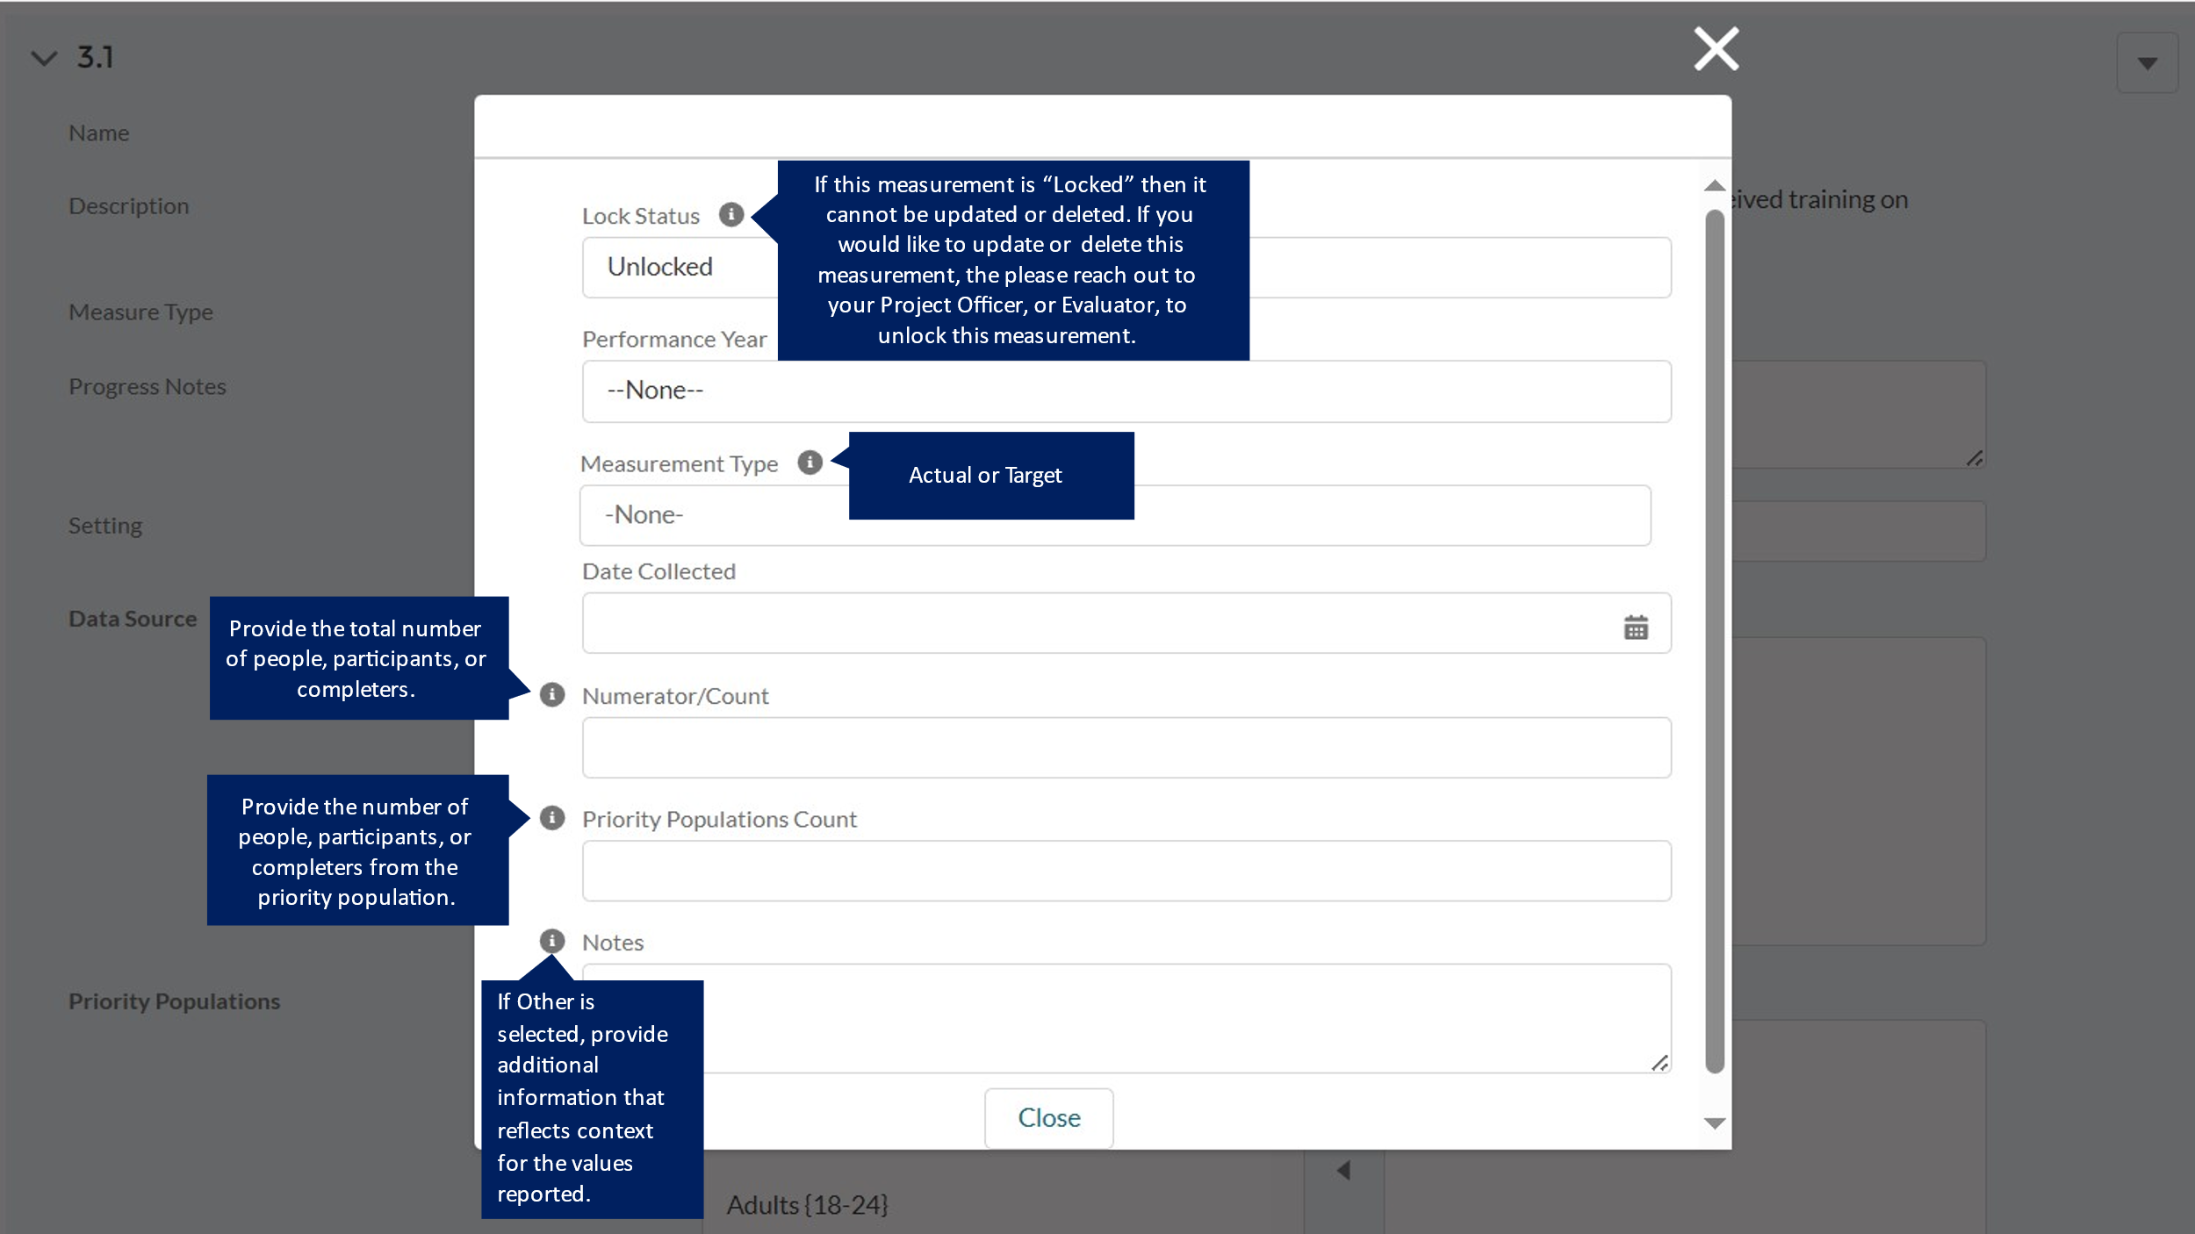

DP23-0020 Measure 3.2 – Component C
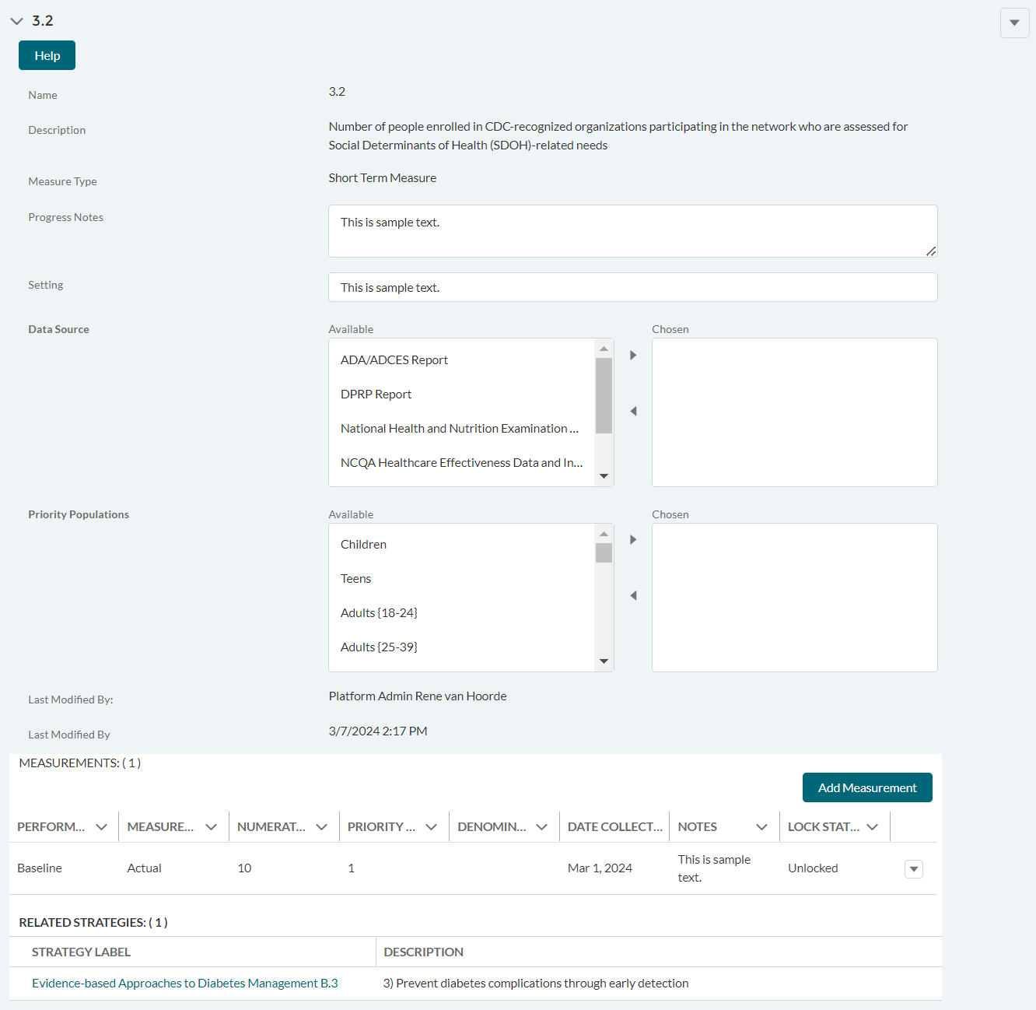

DP23-0020 Measure 3.2 _Add Measurement Option – Component C
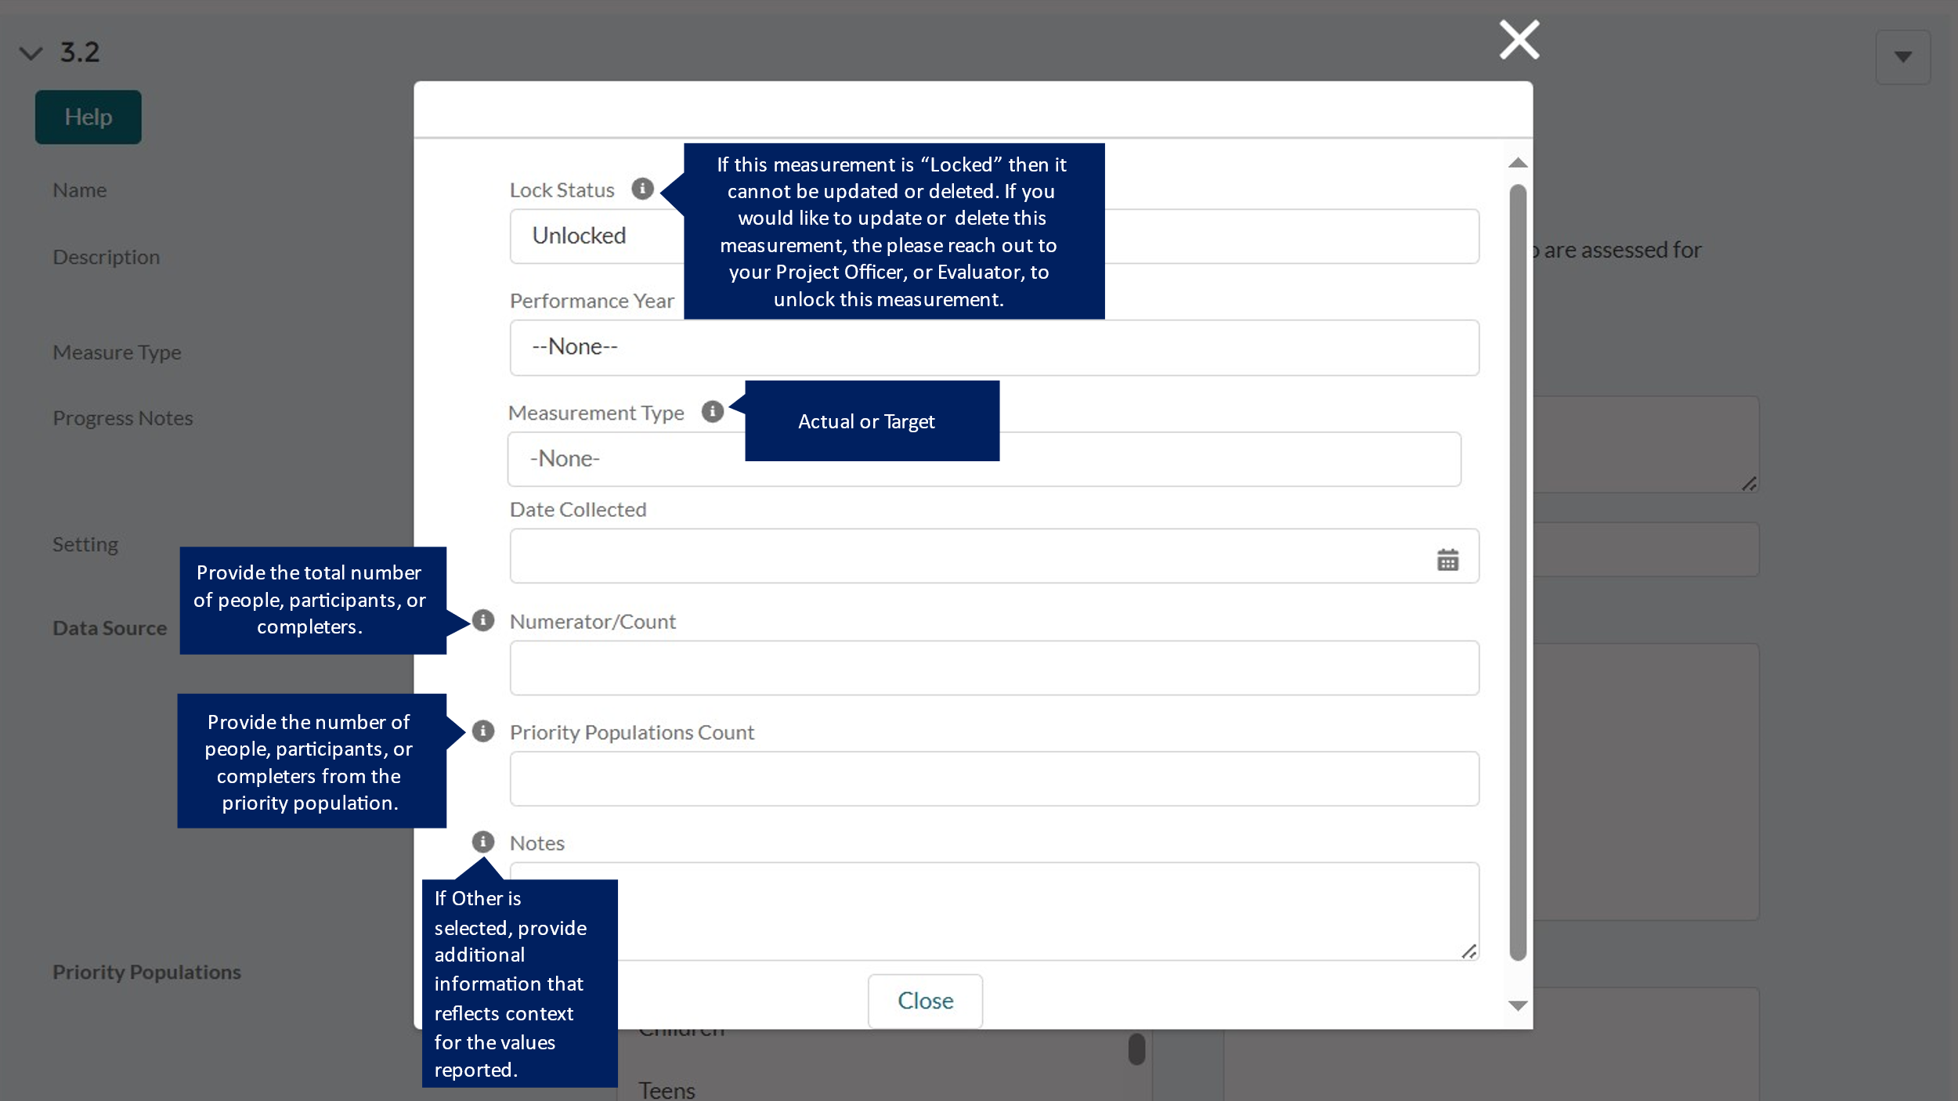

DP23-0020 Measure 3.3 – Component C
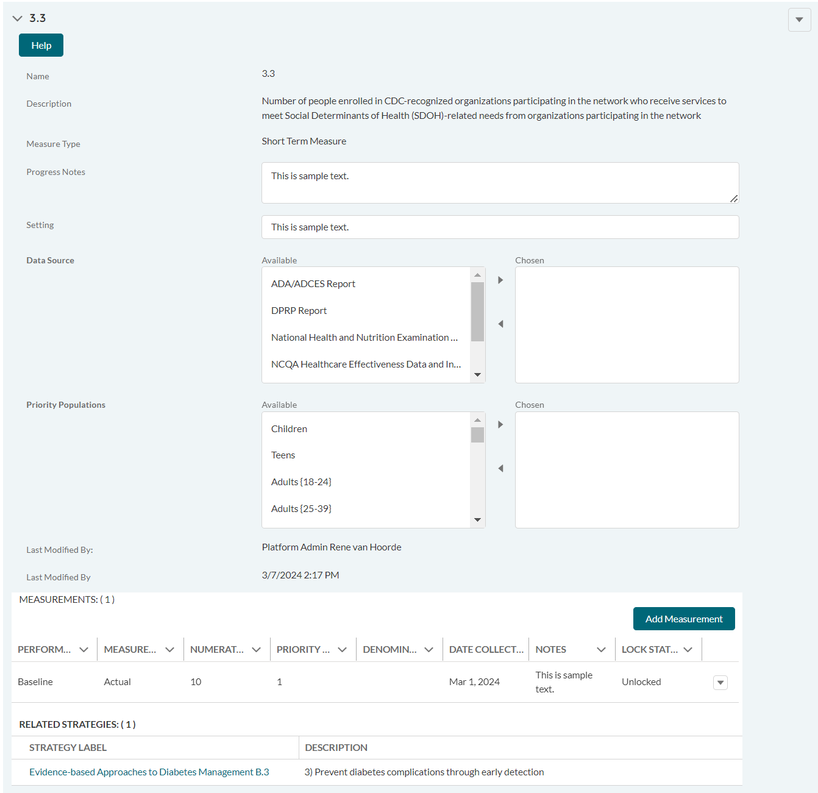

DP23-0020 Measure 3.3 _Add Measurement Option – Component C
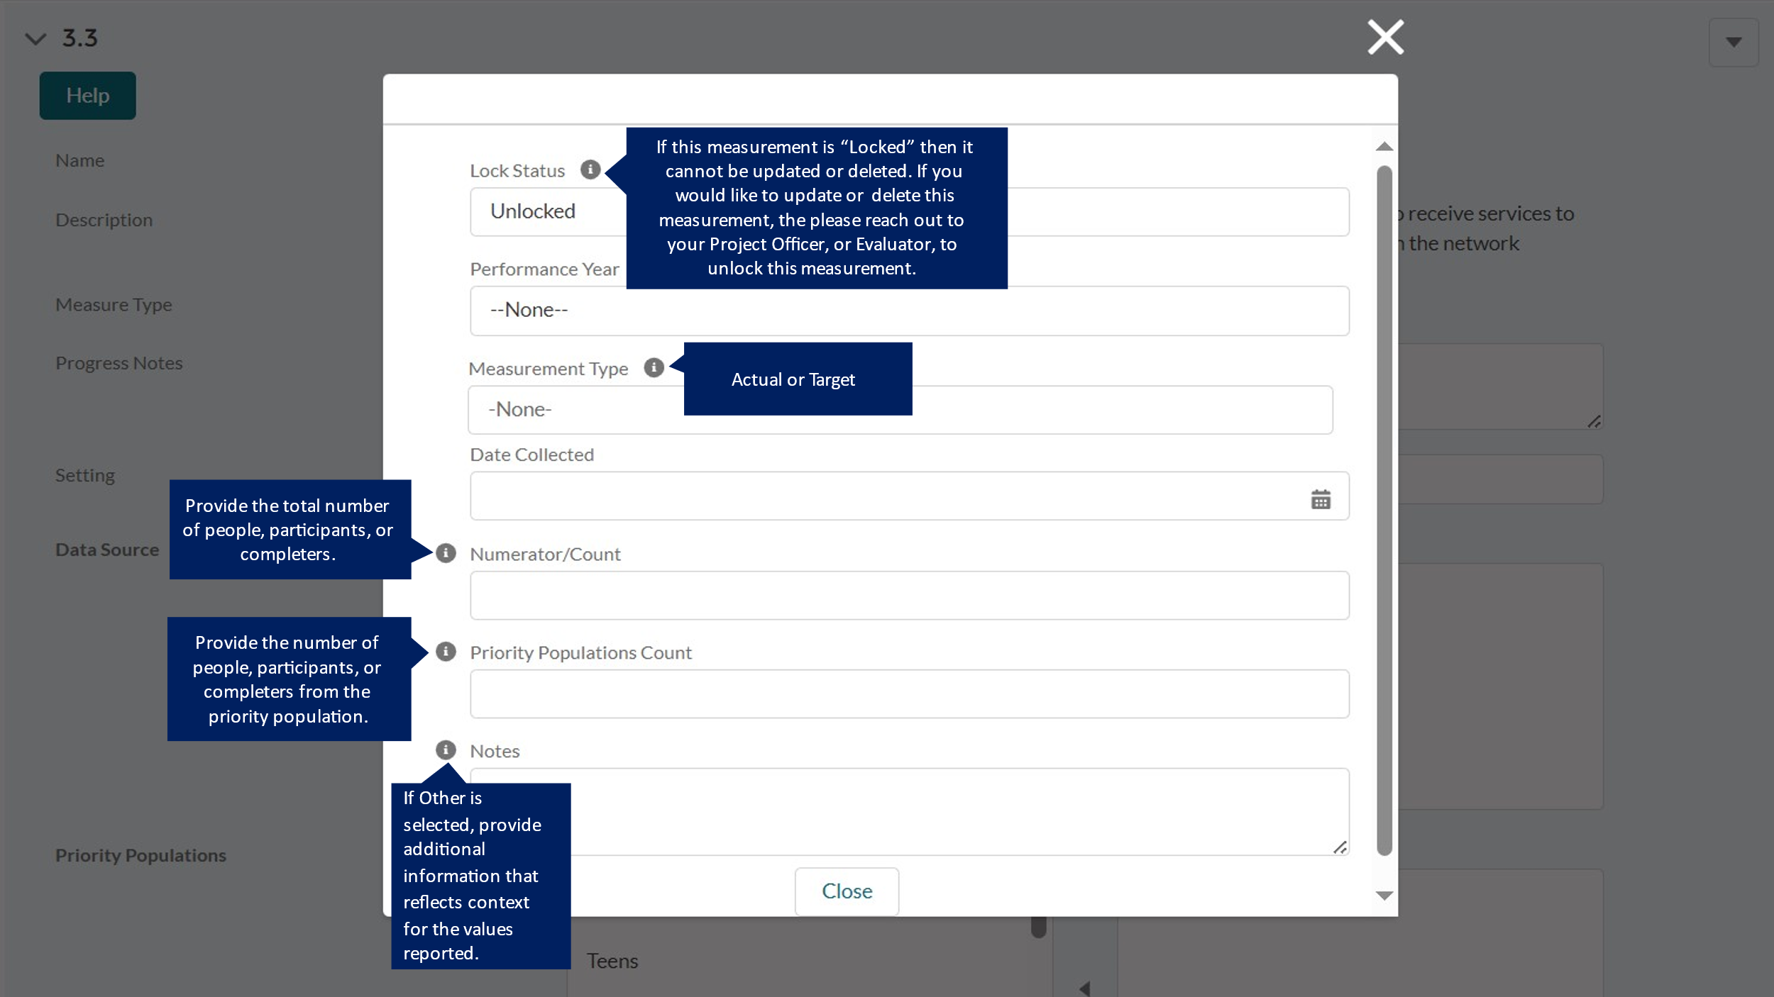

DP23-0020 Measure 3.a – Component C
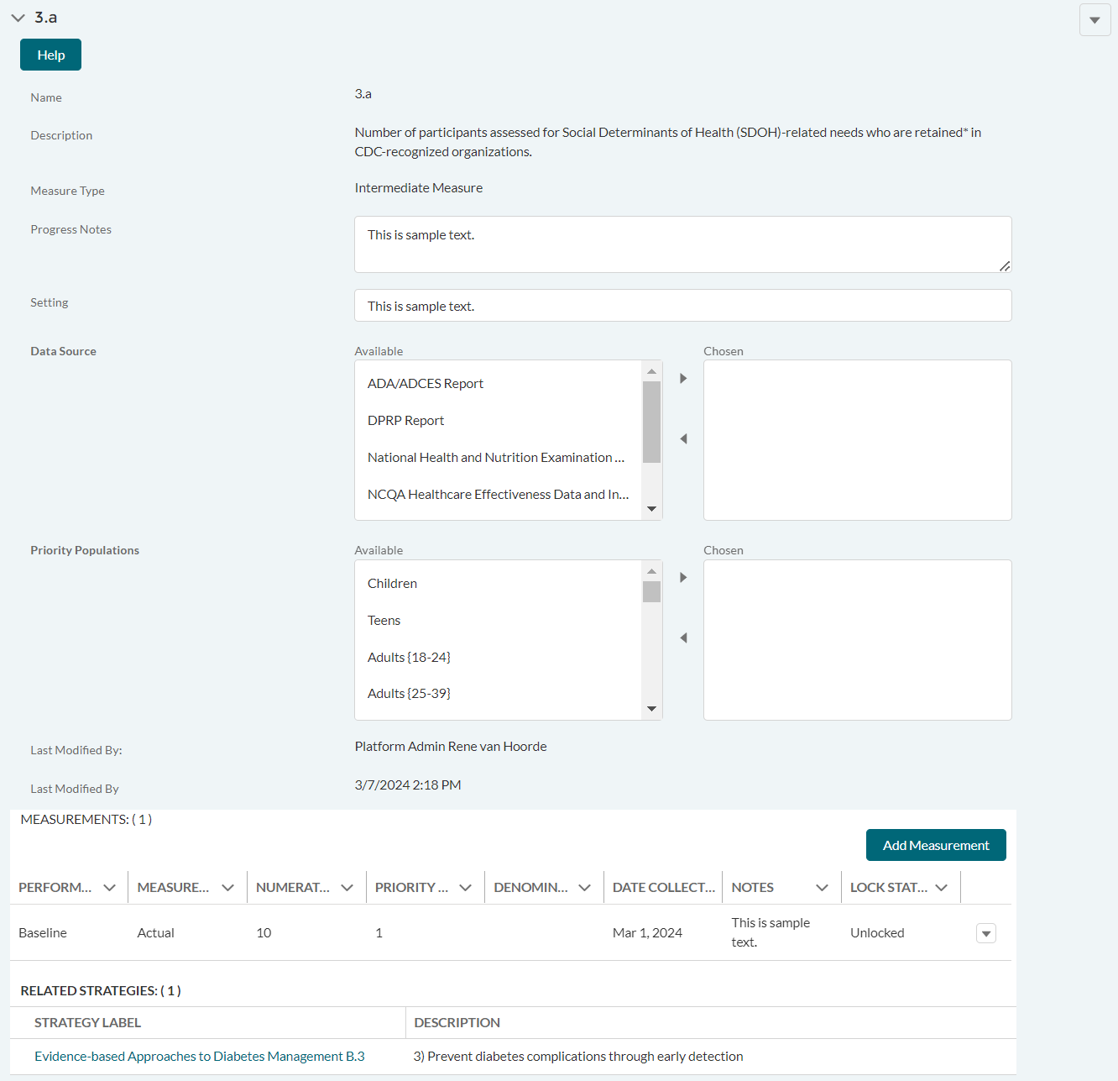

DP23-0020 Measure 3.a _Add Measurement Option – Component C
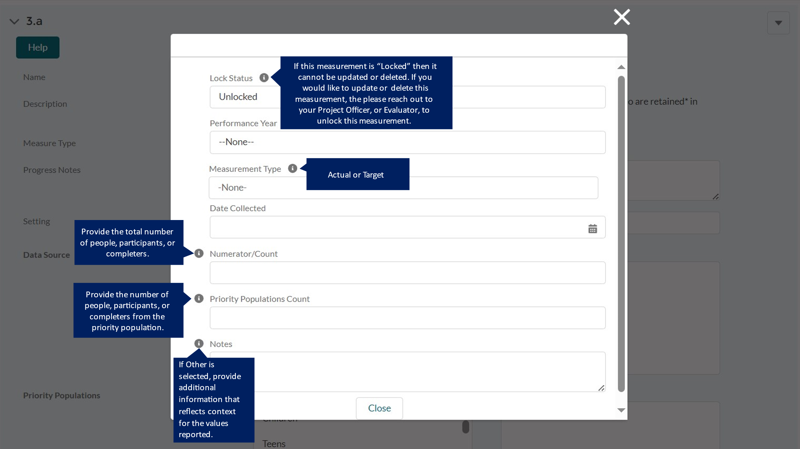

DP23-0020 Measure 4.1 – Component C
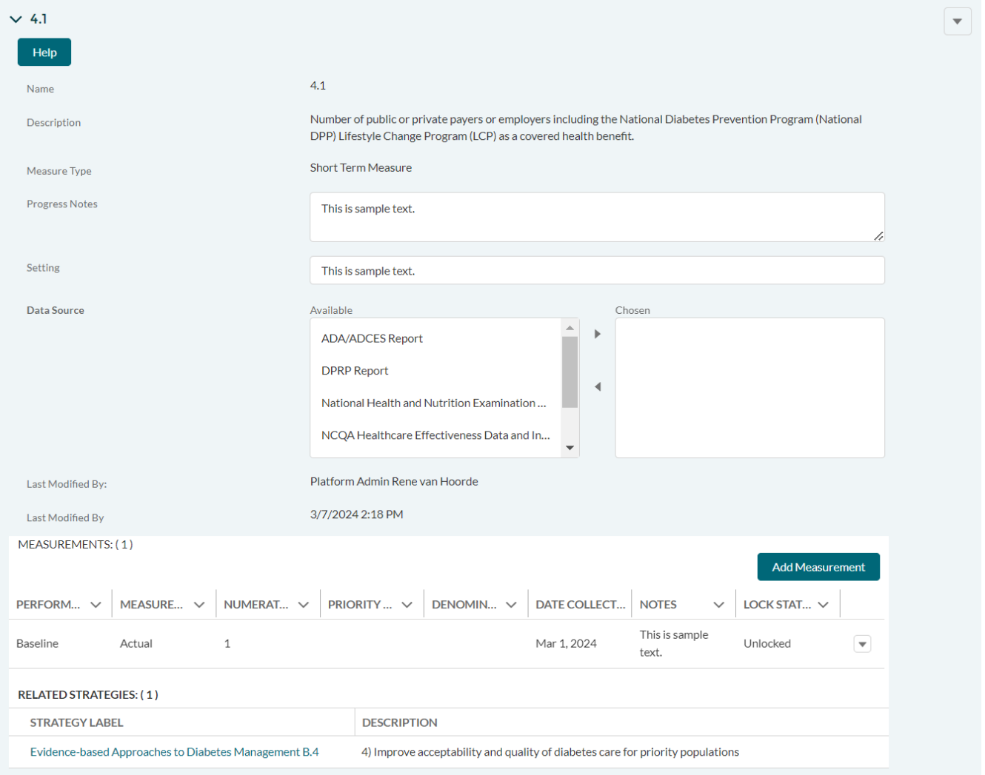

DP23-0020 Measure 4.1 _Add Measurement Option – Component C
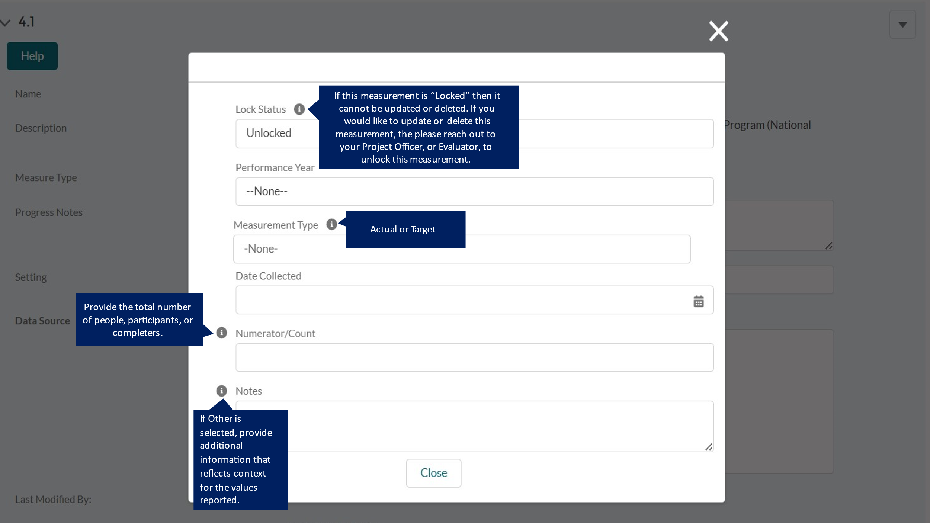

DP23-0020 Measure 4.2 – Component C
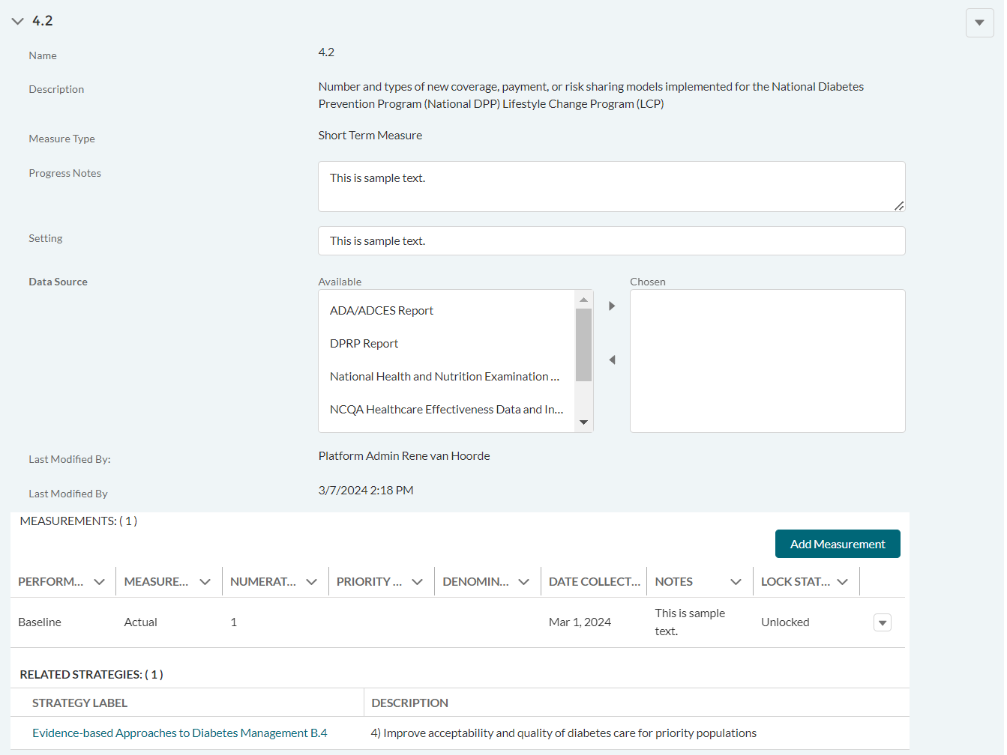

DP23-0020 Measure 4.2 _Add Measurement Option – Component C
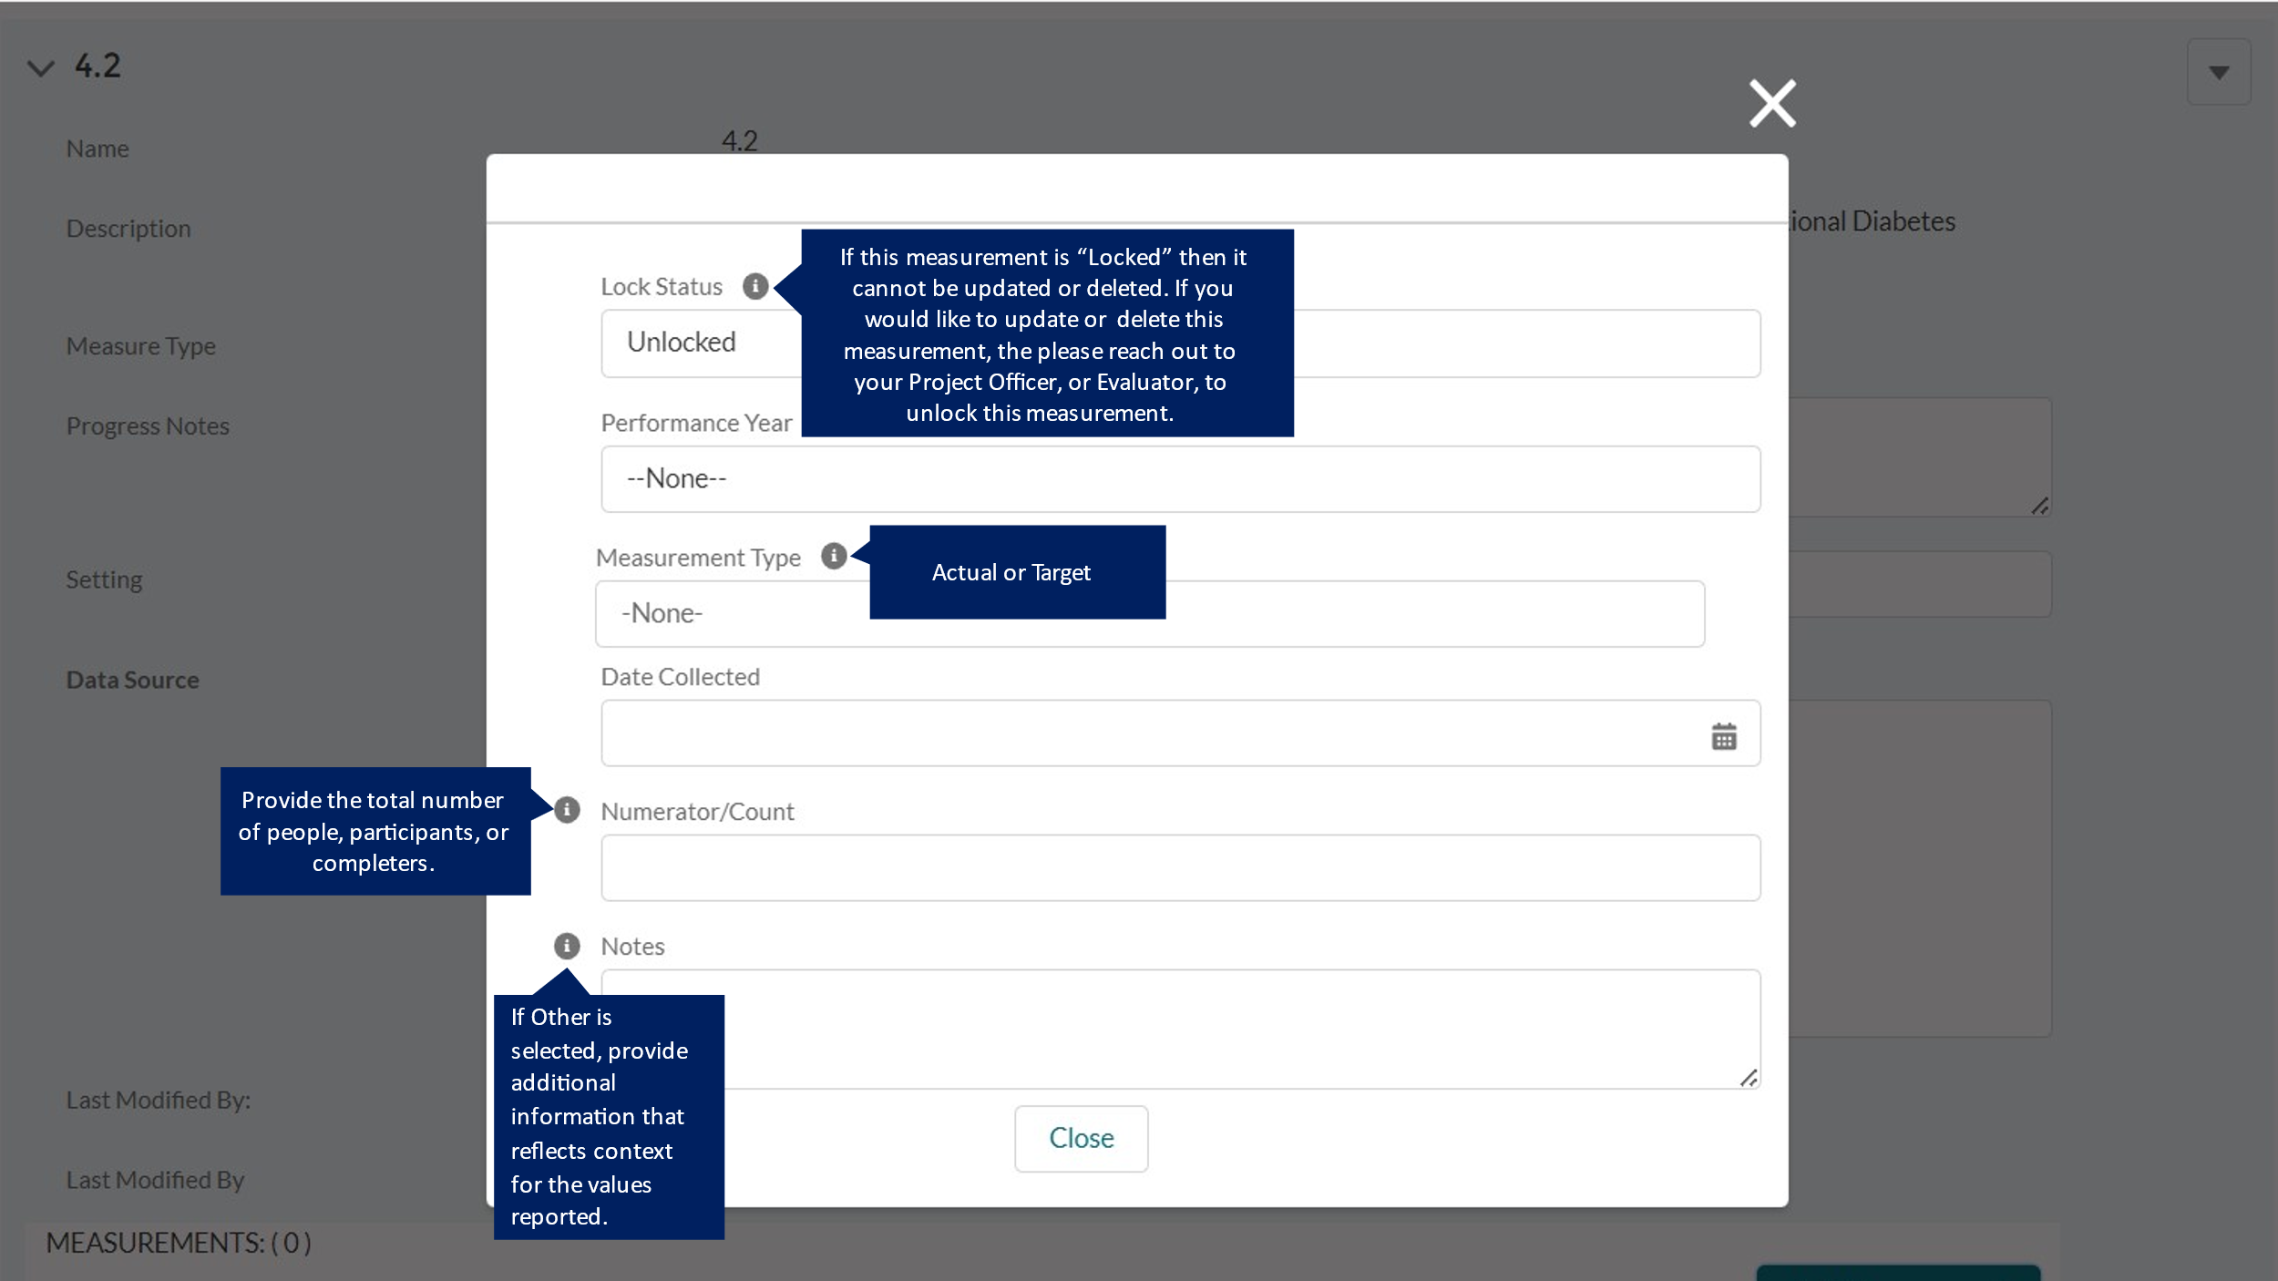

DP23-0020 Measure 4.a – Component C
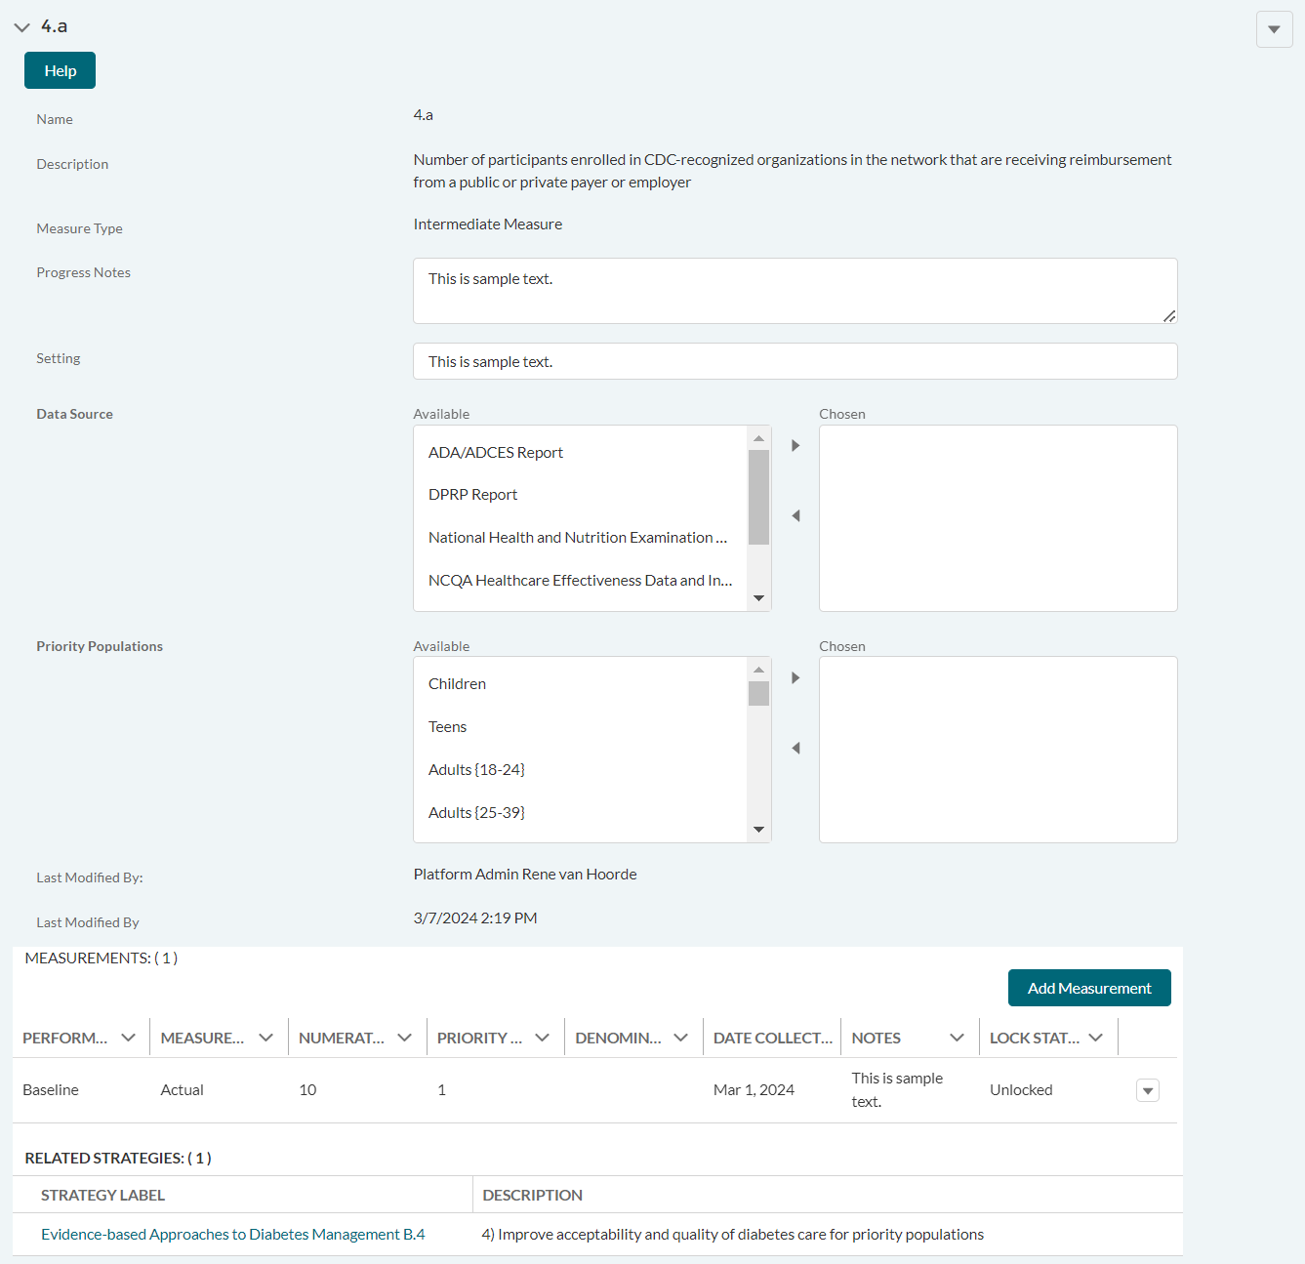

DP23-0020 Measure 4.a _Add Measurement Option – Component C
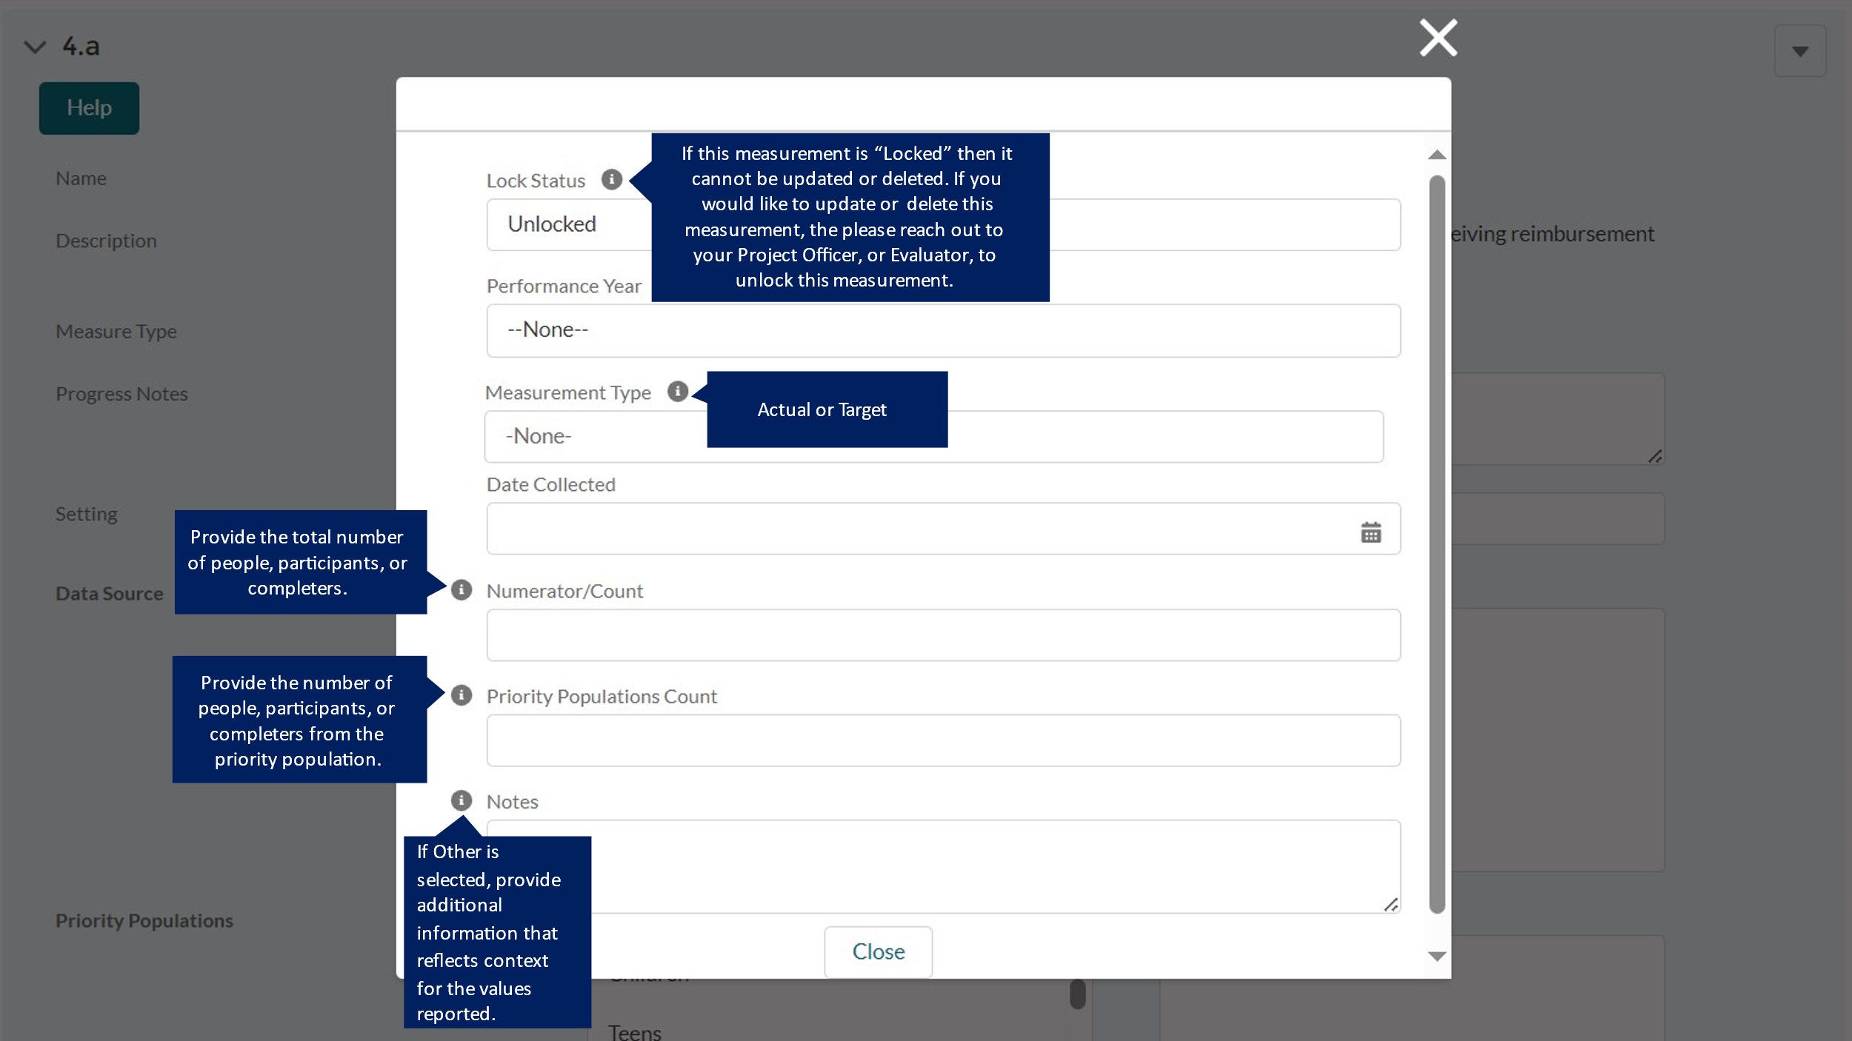

DP23-0020 Measure 5 – Component C
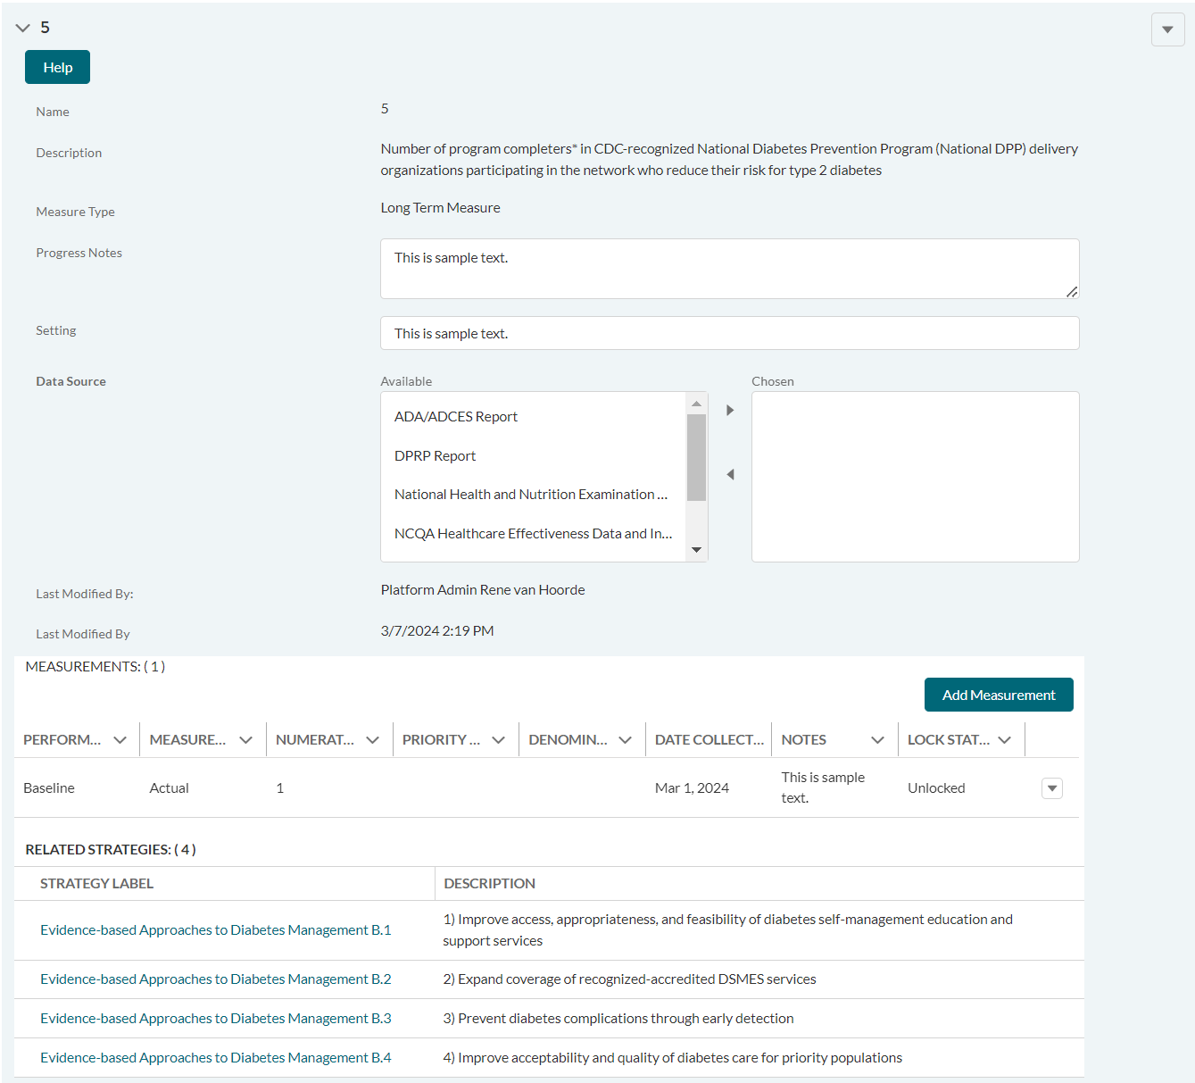

DP23-0020 Measure 5 _Add Measurement Option – Component C
