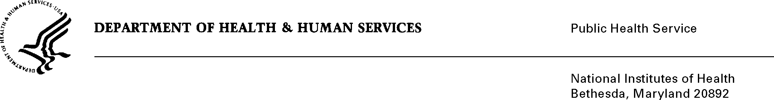

DATE: March 10, 2025

TO: Office of Management and Budget (OMB)

NIH, OIRA Desk Officer

THROUGH: Project Clearance Chief, NIH

Reports Clearance Officer, DHHS

FROM: Cesar Perez-Gonzalez

Science Program Administrator

SUBJECT: Electronic Individual Development Plan (eIDP) (National Eye Institute), OMB#: 0925-0772 and December 31, 2027

This is a request for OMB to approve a modification of Electronic Individual Development Plan (eIDP) (National Eye Institute)*,* originally approved on December 3, 2024. The eIDP system allows a trainee to develop an annual Individual Development Plan (IDP), an effective tool for trainees to think about their career goals and skills needed to achieve them during their time at the NEI. Trainees work together with their research mentor to organize and summarize their research projects, consider career goals, and set training goals and expectations. Trainees can also use the eIDP to work with the Training Director to address deficiencies in training that can negatively affect career plans. The site has been modified after approval to comply with Directive 15 to include Middle Eastern/North African in the Racial/Ethnic demographics and to comply with an Executive Order 14168 replace Gender with Sex. This will not increase the burden on the user.

Thank you,

Address: Building 10, Room 10D45

10 Center Dr

Bethesda, MD 20892

Telephone: 301-827-7755

Fax: 301-451-6764

Email: cesarp@nei.nih.gov

Your full consideration is appreciated.