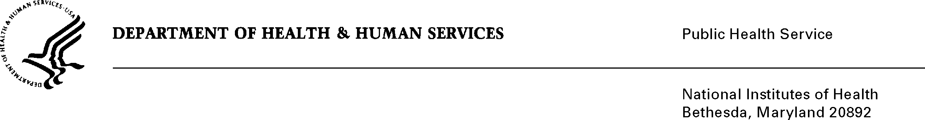

DATE: March 24, 2025

TO: Office of Management and Budget (OMB)

NIH, OIRA Desk Officer

Through: Project Clearance Chief, NIH

Reports Clearance Officer, DHHS

FROM: Matthew R. Lockhart, MBA

Director, Division of Loan Repayment, OER, OD

SUBJECT: Change Request to a Currently Approved Form

(OMB # 0925-0361, Expiration Date 01/31/2026)

This is a request for OMB approval of non-substantial modifications to the National Institutes of Health Loan Repayment Programs information collection (OMB No. 0925-0361). These changes do not alter the approved data collection, burden hours, or number of respondents. We are revising one question and its corresponding answer options on the Personal Information Form (NIH 2674-1) to ensure compliance with Executive Order 14168.

Attachment A – Personal Information Form (NIH 2674-1), Track Changes

Attachment B – Personal Information Form (NIH 2674-1), Clean Copy

Your full consideration is appreciated.