OMB Control Number: 0970-0558, Expiration Date: 11/30/2026

Data entry field in HSES:

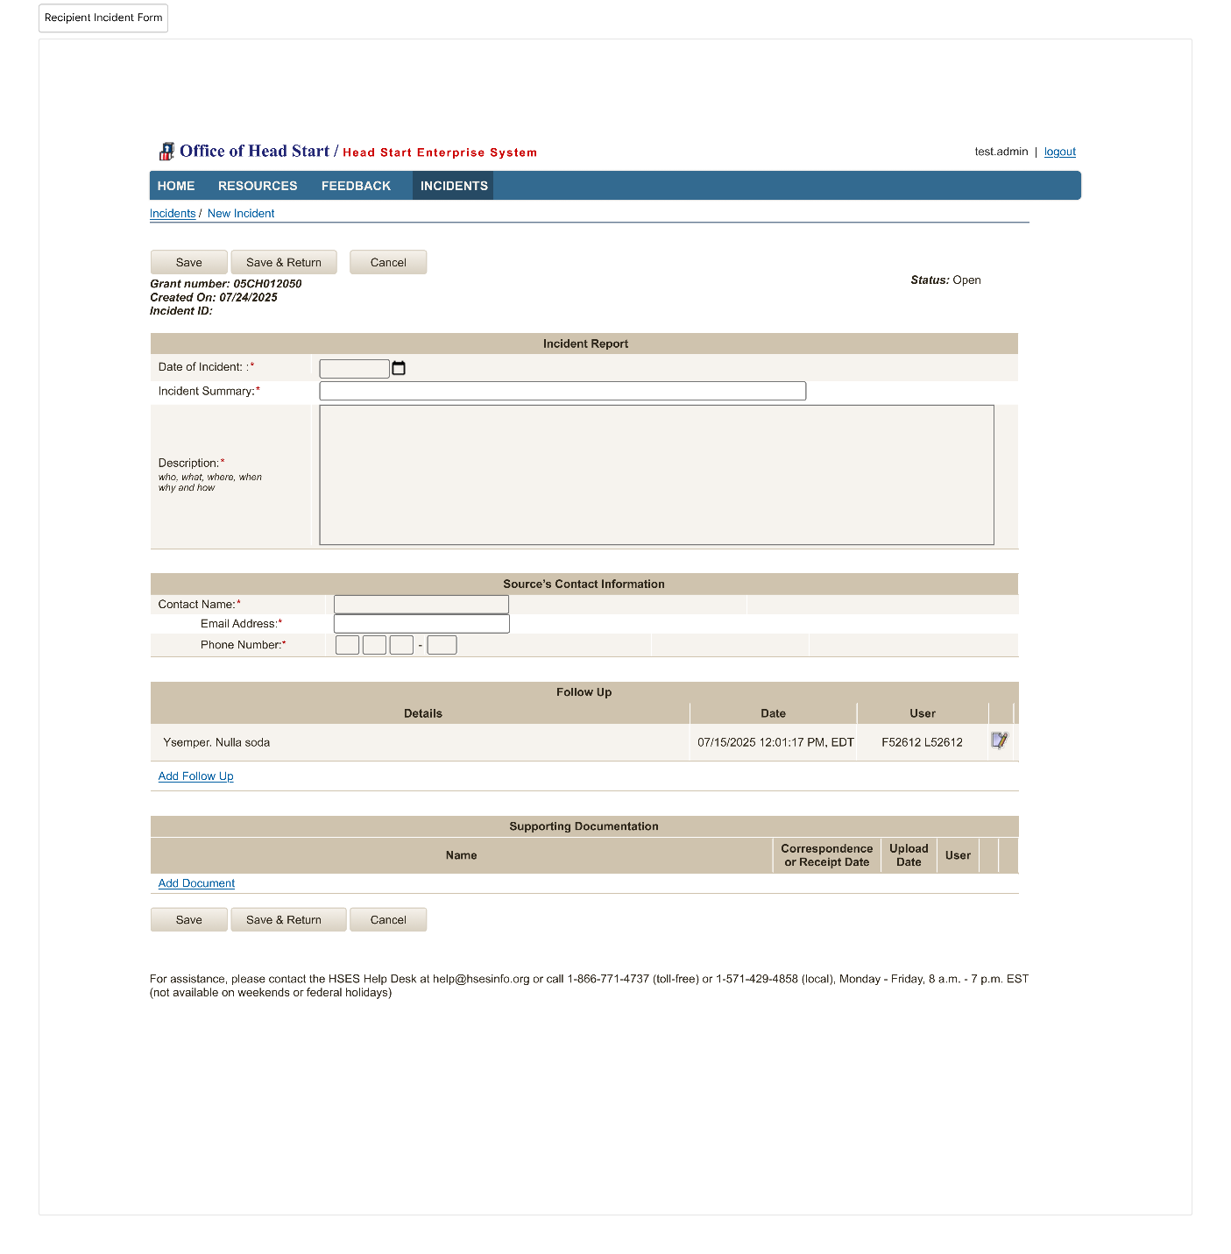
PAPERWORK REDUCTION ACT OF 1995 (Pub. L. 104-13) STATEMENT OF PUBLIC BURDEN: The purpose of this information collection is to support the Office of Head Start’s (OHS) responsibility to ensure children’s health and safety in Head Start settings, in alignment with the Head Start Program Performance Standards (HSPPS) at 45 CFR §1302.102(d)(1)(ii). These standards, updated on August 21, 2024, require programs to report significant incidents affecting the health or safety of children to the responsible HHS official immediately, but no later than seven calendar days following an incident.

Public reporting burden for this collection of information is estimated to average 10 minutes per grant recipient, including the time for reviewing instructions, gathering and maintaining the data needed, and reviewing the collection of information. This is a mandatory collection of information (HSPPS at 45 CFR §1302.102(d)(1)(ii).)). An agency may not conduct or sponsor, and a person is not required to respond to, a collection of information subject to the requirements of the Paperwork Reduction Act of 1995, unless it displays a currently valid OMB control number. The OMB # is 0970-0558 and the expiration date is 11/30/2026. If you have any comments on this collection of information, please contact the HSES Helpdesk Help@hsesinfo.org or (866) 771-4737.

