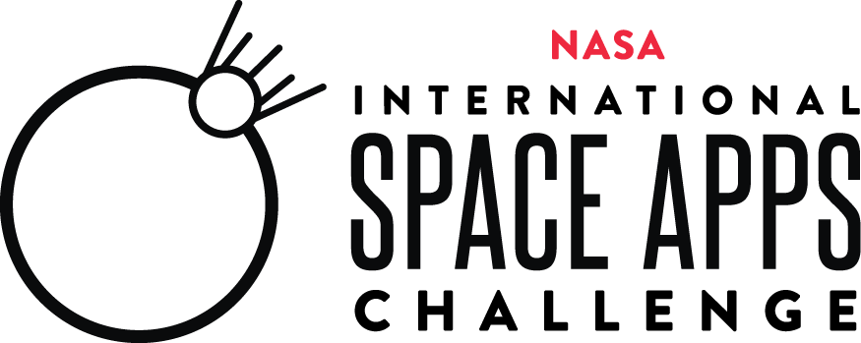

**2022 Collaborator Satisfaction Survey**

Thank you for participating as a NASA International Space Apps Challenge Collaborator. In order to provide an amazing experience for our Space Apps community we are asking for your feedback on the 2022 event. Please complete this short survey by **[date].**

This information collection meets the requirements of 44 U.S.C 3507, as amended by section 2 of the Paperwork Reduction Act of 1995. You do not need to answer these questions unless we display a valid Office of Management and Budget control number. The OMB control number for this information collection is 2700-0153 and it expires on 07/31/2024. We estimate that it will take about 10 minutes to read the instructions, gather the facts, and answer the questions. You may send comments on our time estimate above to [hq-spaceapps@mail.nasa.gov](mailto:hq-spaceapps@mail.nasa.gov). Send only comments relating to our time estimate to this address.

1. Are you a 2022 Space Apps Global Collaborator or Amplification Collaborator?*
   * Global Collaborator
   * Amplification Collaborator
2. Why did you choose to be a NASA International Space Apps Challenge 2022 Collaborator? (Open Answers)*
3. What is your level of satisfaction with the NASA International Space Apps Challenge 2022 collaboration? (Select one)*

|  |  |  |  |  |
| --- | --- | --- | --- | --- |
| Very Dissatisfied | Dissatisfied | Neutral | Satisfied | Very Satisfied |

1. How can your NASA International Space Apps Challenge Collaborator experience be improved? (Open Answers)*
2. Which element(s) of the NASA International Space Apps Challenge did you like the most? (Open Answers)*
3. Based on your experience, what is the likelihood you will be a Collaborator in future NASA International Space Apps Challenges? (Select one)*

|  |  |  |
| --- | --- | --- |
| Not Likely | Somewhat Likely | Very Likely |

1. Please rate your level of satisfaction with the following aspects of the NASA International Space Apps Challenge collaboration. (Select one for each aspect)*

|  |  |  |  |  |  |  |
| --- | --- | --- | --- | --- | --- | --- |
|  | Strongly Disagree | Disagree | Neither Agree Nor Disagree | Agree | Strongly Agree | N/A |
| I thought the onboarding process was clear. |  |  |  |  |  |  |
| I found the Collaborator Communications Toolkit to be helpful. |  |  |  |  |  |  |
| I thought the Collaborator Terms & Conditions were clear. |  |  |  |  |  |  |

1. How would you improve any of the above aspects of the NASA International Space Apps Challenge Collaboration? (Open Answers) (Optional)
   * Collaborator Onboarding Process: _____________________
   * Collaborator Communications Toolkit: __________________
   * Collaborator Terms & Conditions: ______________________

1. How did you promote the 2022 NASA International Space Apps Challenge to your community? (Select all that apply)
   * Facebook
   * Instagram
   * Twitter
   * Newsletter to community
   * Newsletter to company employees
   * Email to community
   * Email to company employees
   * Slack Workspace
   * Shared during an event
   * Other: __________________ (open answer)

If they answered ‘Global Collaborator’ to question #1, then ask # 10, 11, 12:

1. How many Space Apps participants used your Global Offer? (Open Answers)
2. What was your experience in the Global Offer Chat Channel? (Open Answers)
3. Please share a story about a Space Apps participant using your Global Offer to create their project. (Open Answers)
4. Please provide us with any other comments or elaborate as needed on any of your previous answers. <open answers text box> (Optional)