NASA Ames Center Master Plan Survey
Introduction
NASA Ames Research Center (ARC) is in the process of updating its Center Master Plan in alignment with the Agency Master Plan and guide development decisions at ARC over the next twenty years. The Center Master Plan will focus on four districts: Ames Campus, NASA Research Park (NRP), Bay View, and Eastside Airﬁeld (see map on the survey).
One of the challenges facing ARC is suﬀicient funding to maintain facility and all infrastructure assets in good condition. In this context, please give your input with the intent of a more aﬀordable operations and creating better work environment for everyone, while striving to meet our bold NASA mission. Your participation is voluntary and anonymous.
Click "Next" to get started with the survey. If you'd like to leave the survey at any time, just click "Exit this survey". Your answers will be saved.
Paperwork Reduction Act Statement: This information collection meets the requirements of 44 U.S.C 3507, as amended by section 2 of the Paperwork Reduction Act of 1995. You do not need to answer these questions unless we display a valid Oﬀice of Management and Budget control number. The OMB control number for this information collection is 2700-0153 and it expires on 07/31/2024. We estimate that it will take about 5 minutes to read the instructions, gather the facts, and answer the questions. You may send comments on our time estimate above to soheila.dianati@nasa.gov. Send only comments relating to our time estimate to this address.

NASA ARC Master Planning Districts

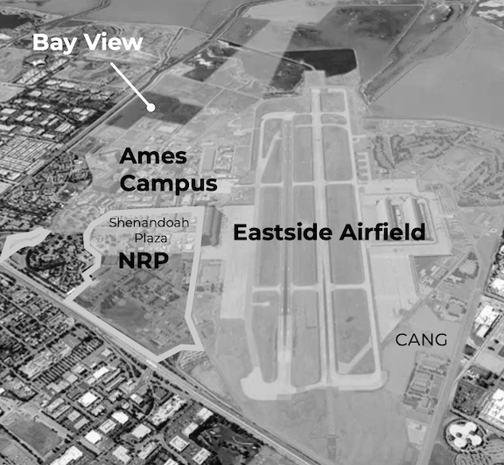

NASA Ames Center Master Plan Survey
General Information
- 1. What is your primary aﬀiliation?
NASA ARC civil servant working majority on-site at ARC NASA ARC civil servant working majority oﬀ-site
NASA ARC contractor working majority on-site at ARC NASA ARC contractor working majority oﬀ-site
Other (please specify)

- 2. How many years have you worked for ARC?
0-5
6-10
11-15
16-20
21-25
26-30
31+

- 3. What is the ARC organization you work for?
A Aeronautics Directorate

C Oﬀice of the Chief Financial Oﬀicer

D Oﬀice of the Director

H California Human Resources Oﬀice

I Oﬀice of the Chief Information Oﬀicer J Center Operations Directorate
P Programs & Projects Directorate

Q Safety and Mission Assurance Directorate

R Engineering Directorate

S Science Directorate
T Exploration Technology Directorate Other (please specify)

* 4. What is your career level?
Early-Career (0-10 years)
Mid-Career (11-20 years)
Senior-Career (21 years and beyond)

NASA Ames Center Master Plan Survey
Planning: Where are we now?
Strengths and Weaknesses refer to ARC's current state. In answering the following questions, please consider your answers in terms of current conditions related to the built environment at ARC.
- What do you think are the STRENGTHS of ARC? (strengths are current assets that should be preserved and replicated; an example is "campus setting")

- What are the WEAKNESSES of ARC? (weaknesses are current liabilities that need to be ﬁxed or removed; an examples is "aging infrastructure.")

NASA Ames Center Master Plan Survey
Planning: Where are we going?
Opportunities and Threats refer to future possibilities or challenges facing ARC. In answering the following questions, please consider your answers in terms of future conditions related to the built environment at ARC.
- What are OPPORTUNITIES at ARC? (opportunities are elements that ARC can capitalize on in the future; an example is "more outdoor greenspaces.")

- What are CHALLENGES at ARC that impact future growth and development? (challenges are elements that stand in the way of future development at ARC; an example is "sea level rise.")

- What are key concerns regarding how the center evolves over the next twenty years?

Very Important Somewhat Important Not Important
Walkability
Bikeability
Vehicle Parking
Infrastructure Condition
Security
Urban Encroachment/Interface
Climate Change Risk Mitigation
Protecting Green Space
Partnership Integration
Changing Programs and/or Missions
Collaboration Space Options
Recreational Opportunities
Accessibility for Individuals with Disabilities

Lack of suﬀicient funds Other (please specify)

- What solutions to these challenges, if any, can you suggest at this point?

NASA Ames Center Master Plan Survey
Planning: Where do we want to be?
In answering the following questions, please consider your answers in terms of desirable conditions related to the built environment at ARC.
11. Please rate the below Planning Patterns for ARC (patterns are design objectives that help guide center planners)
Very Important Somewhat Important Not Important
Clear Wayﬁnding (signage and landscaping)
Climate- Adapted/Low- Maintenance Landscaping
Collaboration Areas

Windows in Open Oﬀice Areas
Windows in Private Oﬀices
Courtyards and Quads
Enduring Structures and Materials
Flexible Laboratories
Inﬁll Development (located in the existing campus core)
Low-Impact Development (manage stormwater on-site)
Multi-Story Buildings
Outdoor Gathering Spaces

Perimeter Parking Resilient Facilities Safe Crosswalks Secure Perimeter
Visible Building and
Gateway Entries

Walkable Campus

- In your opinion, what makes a great campus?

- What is your planning VISION for the development of ARC? (a planning vision informs key goals for future planning at ARC; an example is "an active and sustainable workplace.")

NASA Ames Center Master Plan Survey
Thank You
We appreciate your input. If you have any additional comments or questions, please send an email to Soheila Dianati, soheila.dianati@nasa.gov

Thanks again!

