Survey would be available here: <https://forms.office.com/g/FyACcZcYFb>

An email from our Center Director’s office would go out to AFRC-Public (all civil servant and contractor employees at NASA), and it would look like this:

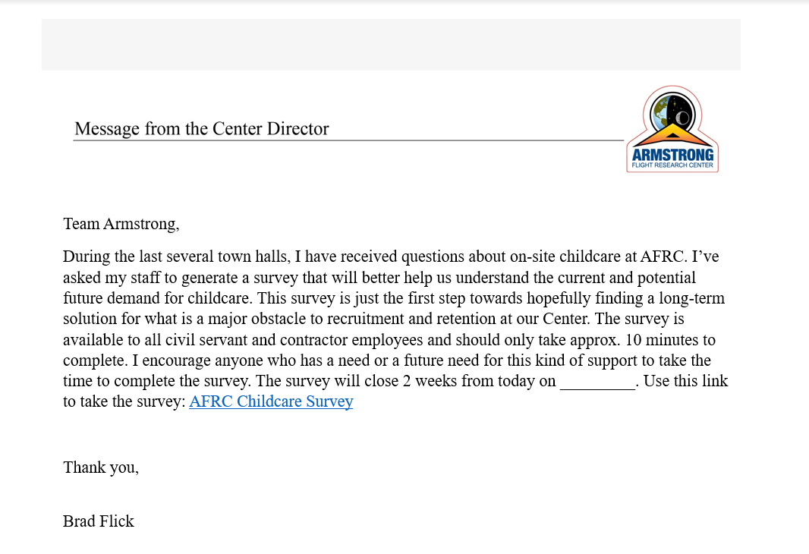

The survey would be posted on our internal NASA Armstrong site, Inside Armstrong, under Center Announcements:

