# Extended Engagement

**WHO:**  Customers who are engaged in a longer-term engagement with Information Data and Analytics Services (IDAS) services **(NASA Internal Only – Civil Servants and Contractors)**

**WHEN:**  After Service Level Agreement (SLA) established and signed. (emailed or Team chat)

Paperwork Reduction Act Statement: This information collection meets the requirements of 44 U.S.C 3507, as amended by section 2 of the Paperwork Reduction Act of 1995. You do not need to answer these questions unless we display a valid Office of Management and Budget control number. The OMB control number for this information collection is 2700-0153 and it expires on 08/31/2027. We estimate that it will take about 5 minutes to read the instructions, gather the facts, and answer the questions. You may send comments on our time estimate above to agency-idas-customer-care@mail.nasa.gov. Send only comments relating to our time estimate to this address.

**Opening Questions: Pre-filled whenever possible**

1. Please select the service(s) you are receiving from IDAS. (Drop down list of options)
   * Scientific and Technical Information (STI) Consultation
   * Scientific and Technical Information (STI) Approval and Release Compliance Services
   * Scientific and Technical Information (STI) Distribution Services
   * Scientific and Technical Information (STI) Training
   * Records Storage
   * Records Reference Services
   * Records Disposition
   * Records Management Consultation
   * Records Management Training
   * Forms Services
   * Digital Persistent Identifier (DPI) Services
   * Data Sharing
   * Data Set Management
   * Data Visualization
   * Data Analytics
   * Consulting and Support for Data Governance Implementation and Stewardship
   * Data Science and Analytics as a Service
   * Data Engineering as a Service
2. Who are the primary IDAS team members you have been working with on this project? (Fill in field)

**Core Questions:**

1. Overall, how satisfied have you been with IDAS engagement to date?

*Capture with a star rating*

*    *

1. Please rate the following statements…

*Capture with the following Likert scale*

|  |  |  |  |  |  |
| --- | --- | --- | --- | --- | --- |
|  | Strongly Agree | Agree | Neutral | Disagree | Strongly Disagree |
| The IDAS team members are knowledgeable and have the expertise to support my project. |  |  |  |  |  |
| The IDAS team has been responsive and communicates effectively. |  |  |  |  |  |
| The proposal(s) and cost estimate(s) produced are high quality. |  |  |  |  |  |
| The IDAS team understands my needs and customizes support to meet my requirements. |  |  |  |  |  |

1. Would you recommend engaging with IDAS to others?
   1. Yes
   2. No
2. Any additional feedback to help us improve?

*Open ended question (Long form)*

**Extended IDAS Engagement Screenshot**

**Page 1**

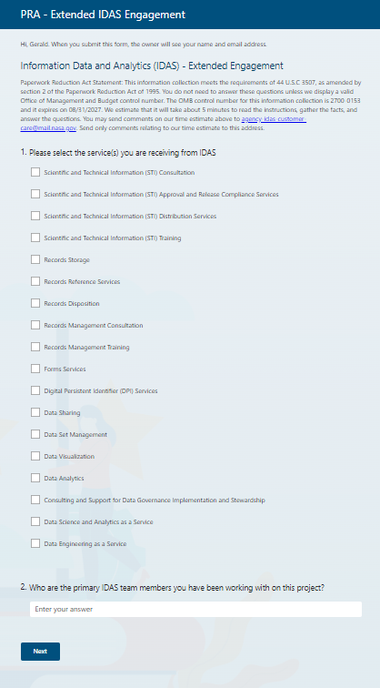

**Extended IDAS Engagement Screenshot**

**Page 2**

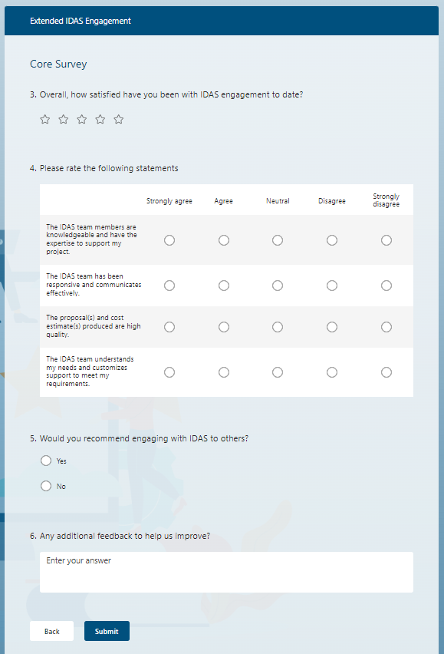

**IDAS Extended Engagement Email**

RE: Request for Feedback - Thank you for Engaging with Information Data and Analytics Services (IDAS)

Dear IDAS Customer [or specific name],

Thank you for signing a Service Level Agreement (SLA) with Information Data and Analytics Services (IDAS). We would like to learn from your experience.

Please take five minutes to fill out the following survey: [survey link].

Thank you again and we look forward to providing services to you.

Have a great day!

The IDAS Team