# Intake Portal Feedback

**WHO**: Customers you have submitted a request through the Information Data and Analytics Services (IDAS) ServiceNow Portal **(NASA Internal Only – Civil Servants and Contractors)**

**WHEN:** As part of the acknowledgement receipt

Paperwork Reduction Act Statement: This information collection meets the requirements of 44 U.S.C 3507, as amended by section 2 of the Paperwork Reduction Act of 1995. You do not need to answer these questions unless we display a valid Office of Management and Budget control number. The OMB control number for this information collection is 2700-0153 and it expires on 08/31/2027. We estimate that it will take about 5 minutes to read the instructions, gather the facts, and answer the questions. You may send comments on our time estimate above to agency-idas-customer-care@mail.nasa.gov. Send only comments relating to our time estimate to this address.

1. Overall, what was your experience with the IDAS Service Portal?

*    *

1. How easy was it to find the service you were looking for?
   1. Very easy
   2. Easy
   3. Neutral
   4. Difficult
   5. Very difficult
2. How easy was it to fill out the form for the service?
   1. Very easy
   2. Easy
   3. Neutral
   4. Difficult
   5. Very difficult
3. Any additional feedback to help us improve?

*Open ended question (Long form)*

**Intake Portal Feedback Screenshot**

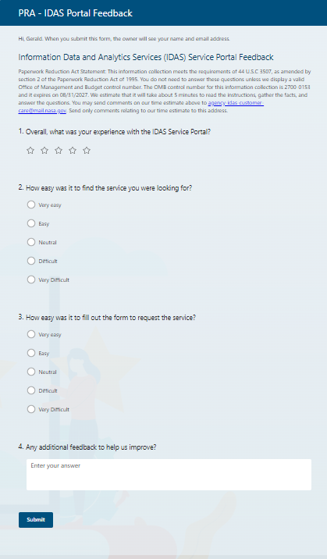

**IDAS Intake Portal Feedback Email**

RE: Request for Feedback - Thank you for Engaging with Information Data and Analytics Services (IDAS)

Dear IDAS Customer [or specific name],

Thank you for submitting a request with Information Data and Analytics Services (IDAS). We would like to learn from your experience with the Service Intake Portal.

Please take five minutes to fill out the following survey: [survey link].

Thank you again and we look forward to providing services to you.

Have a great day!

The IDAS Team