# Service Complete - Extended

**WHO:**  Customers who engage in Service Level Agreement (SLA) development with Information Data and Analytics Services (IDAS)that does not result in a signed SLA **(NASA Internal Only – Civil Servants and Contractors)**

**WHEN:**  Within 24 hours of customer being notified of services being completed. (Emailed or Teams chat)

Paperwork Reduction Act Statement: This information collection meets the requirements of 44 U.S.C 3507, as amended by section 2 of the Paperwork Reduction Act of 1995. You do not need to answer these questions unless we display a valid Office of Management and Budget control number. The OMB control number for this information collection is 2700-0153 and it expires on 08/31/2027. We estimate that it will take about 5 minutes to read the instructions, gather the facts, and answer the questions. You may send comments on our time estimate above to agency-idas-customer-care@mail.nasa.gov. Send only comments relating to our time estimate to this address.

**Optional Opening Questions: Pre-filled whenever possible**

1. Please select the service(s) you received from IDAS. (Drop down list of options)
   1. Data engineering
   2. Data science and analytics
   3. Etc.
2. Who were the primary IDAS team members you worked with on this project? (Fill in field)
   1. (Potentially pre-filled)

**Core Questions:**

1. Overall, how satisfied are you with the services provided?

*Capture with a star rating*

*    *

1. Please rate the following statements…

*Capture with the following Likert scale*

|  |  |  |  |  |  |
| --- | --- | --- | --- | --- | --- |
|  | Strongly Agree | Agree | Neutral | Disagree | Strongly Disagree |
| The IDAS team members were knowledgeable and had the expertise to support my project. |  |  |  |  |  |
| The IDAS team was responsive and communicated effectively. |  |  |  |  |  |
| The deliverables and services produced were high quality. |  |  |  |  |  |
| The IDAS team understood my needs and customized the support to meet my requirements. |  |  |  |  |  |

1. Did the services meet your timelines and budget?
   1. Yes
   2. No
2. Would you recommend this service to others?
   1. Yes
   2. No
3. Any additional feedback to help us improve?

*Open ended question (Long form)*

**Extended Service Complete Screenshot**

**Page 1**

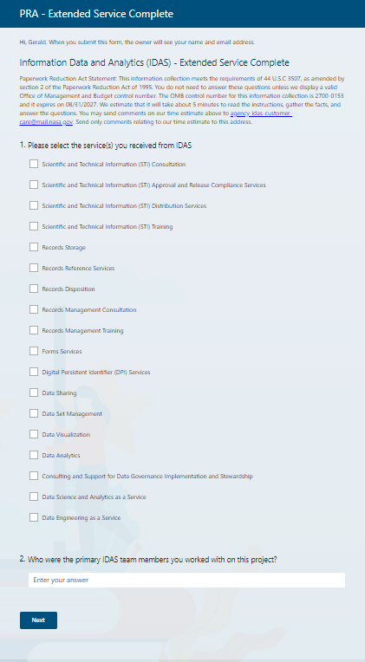

**Extended Service Complete Screenshot**

**Page 2**

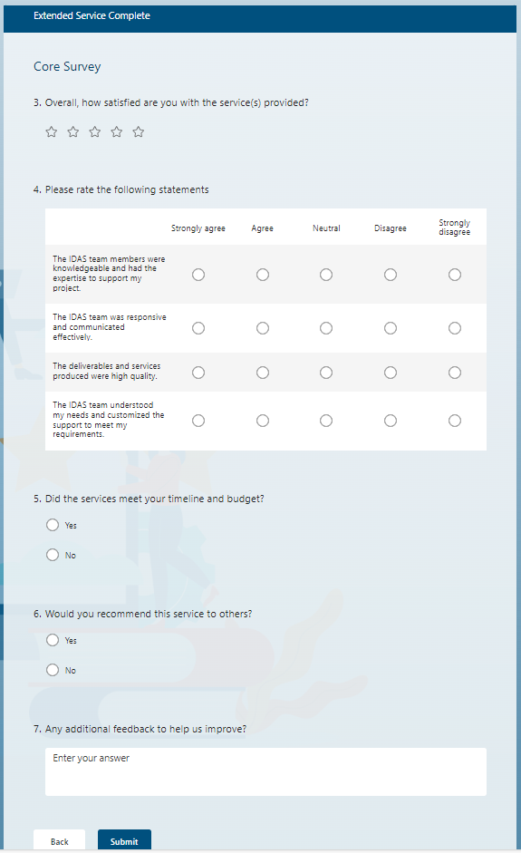

**IDAS Service Complete – Extended Email**

RE: Request for Feedback - Thank you for Engaging with Information Data and Analytics Services (IDAS)

Dear IDAS Customer [or specific name],

Thank you for Engaging with Information Data and Analytics Services (IDAS). The IDAS service you request is complete, and we would like to learn from your experience.

Please take five minutes to fill out the following survey: [survey link].

Thank you again and we hope to provide services to you in the future.

Have a great day!

The IDAS Team