# Services Declined

**WHO:**  Customers who began developing a custom Service Level Agreement (SLA) with Information Data and Analytics Services (IDAS), but decide not to proceed with service delivery **(NASA Internal Only – Civil Servants and Contractors)**

**WHEN:**  Within 24 hours of customer decision not to move forward with the SLA. (Emailed or Teams chat)

Paperwork Reduction Act Statement: This information collection meets the requirements of 44 U.S.C 3507, as amended by section 2 of the Paperwork Reduction Act of 1995. You do not need to answer these questions unless we display a valid Office of Management and Budget control number. The OMB control number for this information collection is 2700-0153 and it expires on 08/31/2027. We estimate that it will take about 5 minutes to read the instructions, gather the facts, and answer the questions. You may send comments on our time estimate above to agency-idas-customer-care@mail.nasa.gov. Send only comments relating to our time estimate to this address.

**Optional Opening Questions: Pre-filled whenever possible**

1. Please select the service you considered receiving from IDAS. (Drop down list of options)
   * Scientific and Technical Information (STI) Consultation
   * Scientific and Technical Information (STI) Approval and Release Compliance Services
   * Scientific and Technical Information (STI) Distribution Services
   * Scientific and Technical Information (STI) Training
   * Records Storage
   * Records Reference Services
   * Records Disposition
   * Records Management Consultation
   * Records Management Training
   * Forms Services
   * Digital Persistent Identifier (DPI) Services
   * Data Sharing
   * Data Set Management
   * Data Visualization
   * Data Analytics
   * Consulting and Support for Data Governance Implementation and Stewardship
   * Data Science and Analytics as a Service
   * Data Engineering as a Service
2. Who were the primary IDAS team members you worked with on this project? (Fill in field)
   * (Potentially pre-filled)

**Core Questions:**

1. Overall, how satisfied have you been with IDAS engagement to date?

*Capture with a star rating*

*    *

1. What factors led to your decision not to continue with this IDAS service? (Check all that apply)
   1. I no longer need the services I requested
   2. IDAS cannot provide the services I need
   3. The proposed timeline
   4. The estimated cost
   5. Other (please describe)
2. Please rate the following statements…

*Capture with the following Likert scale*

|  |  |  |  |  |  |
| --- | --- | --- | --- | --- | --- |
|  | Strongly Agree | Agree | Neutral | Disagree | Strongly Disagree |
| The IDAS team members were knowledgeable and would have had the expertise to support my project. |  |  |  |  |  |
| The IDAS team was responsive and communicated effectively. |  |  |  |  |  |
| The proposal(s) and cost estimate(s) produced were high quality. |  |  |  |  |  |
| The IDAS team understood my needs and customized the support to meet my requirements. |  |  |  |  |  |

1. Would you consider engaging IDAS for other information or data related needs in the future?
2. Yes
3. No
4. Any additional feedback to help us improve?

*Open ended question (Long form)*

**IDAS Service Declined Screenshot**

**Page 1**

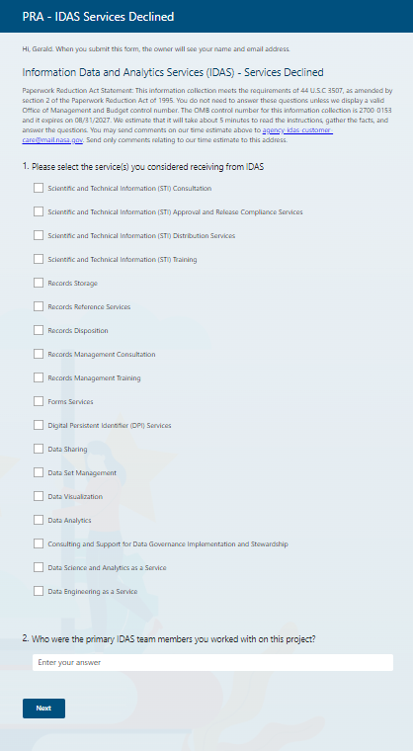

**IDAS Service Declined Screenshot**

**Page 2**

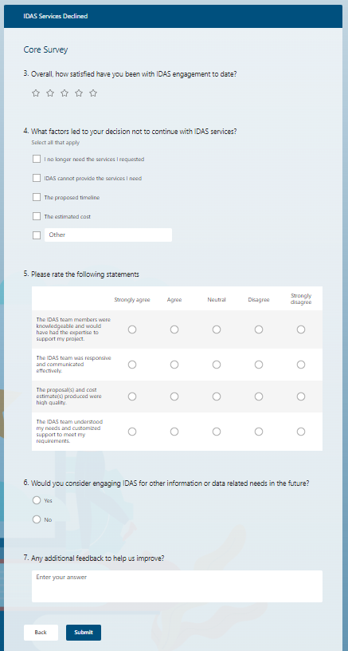

**IDAS Service Declined Sample Email**

RE: Request for Feedback - Thank you for Engaging with Information Data and Analytics Services (IDAS)

Dear IDAS Customer [or specific name],

Thank you for Engaging with Information Data and Analytics Services (IDAS). Although you have declined an IDAS service proposal, we still would like to learn from your experience.

Please take five minutes to fill out the following survey: [survey link].

Thank you again and we hope to provide services to you in the future.

Have a great day!

The IDAS Team