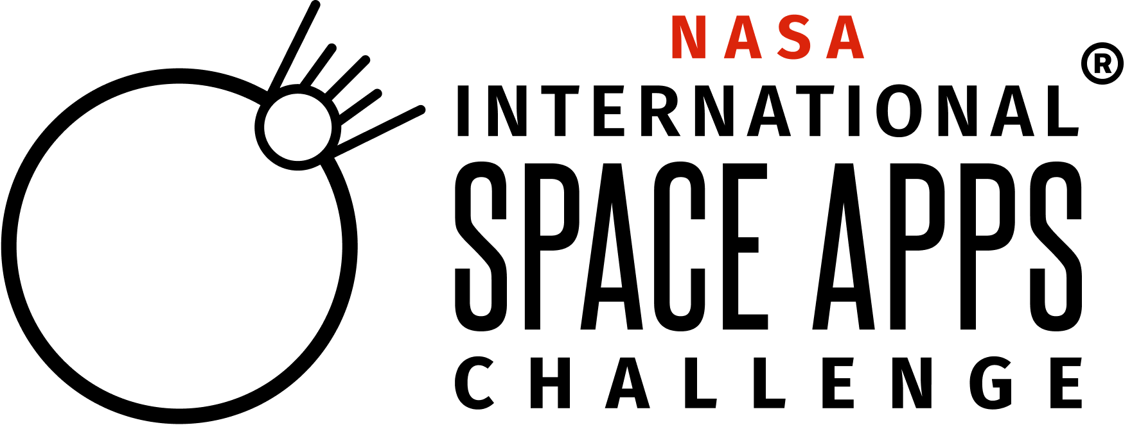
2025 NASA International Space Apps Challenge Satisfaction Survey
Thank you for participating in the 2025 NASA International Space Apps Challenge! The purpose of this survey is to measure individual satisfaction and feedback for the October 5-6, 2025 hackathon.Please complete this short survey by October 20, 2025.

Paperwork Reduction Act Statement:
This information collection meets the requirements of 44 U.S.C 3507, as amended by section 2 of the Paperwork Reduction Act of 1995. You do not need to answer these questions unless we display a valid Office of Management and Budget control number. The OMB control number for this information collection is 2700-0153 and it expires on 08/31/2027. We estimate that it will take about 7 minutes to read the instructions, gather the facts, and answer the questions. You may send comments on our time estimate above to hq-spaceapps@mail.nasa.gov. Send only comments relating to our time estimate to this address.

- What letter does your Local Event start with?
- A-L
- M-Z

[IF Q1 = option 1]
- Which Local Event did you participate in for the 2025 NASA Space Apps Challenge? (Dropdown with Events that start with A-L)
[IF Q1 = option 2]
- Which Local Event did you participate in for the 2025 NASA Space Apps Challenge? (Dropdown with Events that start with M-Z)

- How many times have you participated in a NASA Space Apps Challenge?*
  - [1 - 13]

- How satisfied were you with your experience participating in the 2025 NASA Space Apps Challenge? (Select one)*

1 | 2 | 3 | 4 | 5
  Very Dissatisfied |   Dissatisfied |   Neither Satisfied or Dissatisfied |   Satisfied |   Very Satisfied

- How did you learn about the 2025 NASA Space Apps Challenge? (Select all that apply)* (Randomize Options)
- Space Apps Social Media
- Facebook
- X
- LinkedIn
- Instagram
- YouTube
- My School
- My Place of Work
- Search Engine
- Organization Outside of School or Work (Club, Professional Association, etc.)
- Local Lead
- Word-of-Mouth (Family, Friend, etc.)
- Participated in the NASA Space Apps Challenge before
- Other (please specify) ________________________

- Why did you participate in the 2025 NASA Space Apps Challenge? (Select all that apply)* (Randomize Options)
- I have participated in the NASA Space Apps Challenge before
- I want to help address real-world problems.
- I enjoy meeting team members and participants from around the globe.
- I want to understand and/or learn more about the innovation process.
- I want to be a part of a community.
- The awards are motivating.
- It was led by NASA.
- My country's space agency was a partner.
- Other (please specify) ______________________

- Has your participation in the 2025 NASA Space Apps Challenge led to the development of any new relationships (including friendships, teammates, working relationships, or potential collaborations)?*
- Yes, my participation has led to the formation of at least one new relationship
- No, my participation has not led to the formation of any new relationships
Team Formation
- Which best describes your experience forming a team for the 2025 NASA Space Apps Challenge?*
- I created a team and was the only team member
- I created a team that was made up of multiple team members
- I joined an existing team
- I did not create or join a team
- Other (please specify)

[IF Q6 = option 1]
- Why did you decide to participate alone? (Select all that apply)*
- I was unable to find other participants interested in my challenge and/or project
- I prefer to work alone
- I had trouble using the NASA Space Apps Challenge website to find other team members
- Other (please specify):_________________

[IF Q6 = option 2, 3]
- How did you find your team members? (Select all that apply)*
- I met new team members at my Local Event
- I used the Find a Team page on the NASA Space Apps Challenge website to find my teammates
- I already knew my teammates going into the Hackathon
- I used Space Apps Connect (GitHub Discussions) to find my teammates
- Other (please specify):_________________

[IF Q6 = option 4]
- Why did you not create or join a team? (Select all that apply)*
- I did not know how to create or join a team
- I could not successfully navigate the Find a Team page on the NASA Space Apps Challenge website
- I could not communicate successfully with an already established team
- I did not feel my skills fit with a team
- I requested to be part of a team, but my request was not accepted
- Other (please specify):_________________

- Please rate your level of satisfaction with the following resources on the NASA Space Apps Challenge website. (Select one for each aspect)*
 | Very Dissatisfied | Dissatisfied | Neither Satisfied or Dissatisfied | Satisfied | Very Satisfied | Did Not Use (N/A)
Overall Website Content
Participant FAQ
Virtual Bootcamp Videos
Participant Guides
Challenge Data and Resources

- Do you have any comments and/or suggestions about the above resources on the NASA Space Apps Challenge website? (Open answers) (Optional)
  - Overall Website Content: _________
  - Participant FAQ: _________
  - Virtual Bootcamp Videos: _________
  - Participant Guides: _________
  - Challenge Data and Resources: _________

- Please rate your level of satisfaction with the following aspects of the 2025 NASA Space Apps Challenge. (Select one for each aspect)*
 | Very Dissatisfied | Dissatisfied | Neither Satisfied or Dissatisfied | Satisfied | Very Satisfied
Creating an Account and Logging In
Registering for the NASA Space Apps Challenge
Choosing a Local Event
Challenge Variety
Clarity of Challenge Statements
Team Formation Process
Project Submission Process
Space Apps Connect (Github Discussions)
Space Apps Messages
Local Lead Support
Technical Support
Space Apps Social Media Updates & Announcements

- Do you have any comments and/or suggestions about the above aspects of the 2025 NASA Space Apps Challenge? (Open answers) (Optional)
- Overall Registration Process: _________
- Creating an Account and Logging In: __________
- Registering for the NASA Space Apps Challenge: _________
- Choosing a Local Event: _________
- Challenge Statement Variety: ________
- Clarity of Challenge Statements: ________
- Team Formation Process: _________
- Project Submission Process: _________
- Space Apps Connect (GitHub Discussions): __________
- Space Apps Messages: __________
- Local Lead Support:__________
- Technical Support: _________
- Space Apps Social Media Updates & Announcements:

- Do you follow us on social media (Facebook, X, Instagram, YouTube)?
- Yes
- No

- Did you use Space Apps Connect (GitHub Discussions)?*
- Yes
- No

[IF Q12 = Yes]
- What did you use Space Apps Connect for? (Select all that apply)* (Randomize Options)
- I had a question(s) for a Subject Matter Expert (SME) about my challenge
- I had a question(s) for the Space Apps Global Organizing Team
- I had a question(s) about a Global Offer(s)
- I wanted to find teammates/a team to join
- I wanted to chat with people from my region/who speak my language
- Other (please specify) ______________________

[IF Q12 = No]
- Why did you not use Space Apps Connect? (Select all that apply)*
- I did not know that Space Apps Connect was available.
- I did not find Space Apps Connect to be convenient to access.
- I did not find Space Apps Connect easy to use.
- I did not need support from Space Apps Connect, but I knew it was an option.
- Other (please specify) ______________________

- Did you submit a project to be judged?*
- Yes
- No

[IF Q14 = No]
- Why did you not submit a project to be judged? (Select all that apply)*
- I did not complete project in time
- I had issues with joining a team
- I felt there was a lack of support and/or understanding during the hackathon
- I had technical difficulties
- I had personal circumstances that prevented me from submitting my project (medical, work, etc.)
- Other (please specify) ______________________

- Which of the following Global Collaborator offers did you use for your project? (Select all that apply)* (Randomize Options)
- GoDaddy Registry Domain & Website Builder
- Google Cloud
- Meteomatics Weather API
- Microsoft Planetary Computer
- Microsoft Teams
- Microsoft Azure
- Miro Team Plan
- Miro Education Plan
- Miro Hackathon Starter Template
- None of the Above

- Please rate the following statement:*
 | Strongly Disagree | Disagree | Neither Disagree or Agree | Agree | Strongly Agree
I feel my unique background and/or experiences were valued at the 2025 NASA Space Apps Challenge

Reflection
- Were you aware that NASA had open and publicly available data before participating in the 2025 NASA Space Apps Challenge?
Yes or No
- To what extent do you feel that your participation in the 2025 NASA Space Apps Challenge has increased your ability to do the following: (Select one for each row)*

 | Has NOT Increased | To a Little Extent | To Some Extent | To a Large Extent | To a Very Large Extent
My Ability to Access Free and Open NASA Data
My Ability to Use NASA Data to Address Real-World Problems
My Ability to Collaborate Effectively With Others

- What is your biggest takeaway or learning from participating in the 2025 NASA Space Apps Challenge? (open answers text box) (Optional)

- Would you like to share a picture that captures your 2025 NASA Space Apps experience? You can do so here!
Please don’t include any Personally Identifiable Information (PII) in your feedback or photos. Feel free to share highlights—like a cool presentation, a team pitch, or a photo of the venue (just make sure no name tags, badges, or screens with personal info are visible).
Only PDF, PNG, JPG, JPEG files are supported. File size limit is 16MB.

END OF SURVEY

