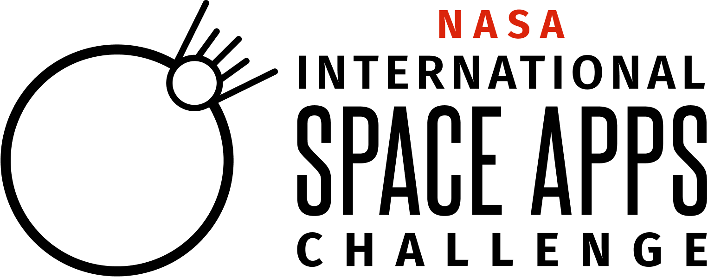
2025 NASA Space Apps Challenge Local Lead Survey
Thank you so much for making the 2025 NASA International Space Apps Challenge such an incredible success! The purpose of this survey is to understand your experience as a NASA Space Apps Challenge Local Lead.
Please only complete this form if you are the Local Lead for your approved Local Event. Please complete this survey by October 29, 2025.
We welcome your candid feedback and are also asking you to share some high-level stats and anecdotes so we can tell the story of the collective impact across all participating cities. Thank you, thank you, thank you for being part of this community!

Paperwork Reduction Act Statement:
This information collection meets the requirements of 44 U.S.C 3507, as amended by section 2 of the Paperwork Reduction Act of 1995. You do not need to answer these questions unless we display a valid Office of Management and Budget control number. The OMB control number for this information collection is 2700-0153 and it expires on 08/31/2027. We estimate that it will take about 10 minutes to read the instructions, gather the facts, and answer the questions. You may send comments on our time estimate above to info@spaceappschallenge.org. Send only comments relating to our time estimate to this address.

(Internal Note: * indicates a required question)

- What is your NASA Space Apps Challenge Local Event (city)?* (Open)

- What country or territory did your Local Event take place in?* (Open)

- Did you host your Local Event in person, virtual or both?*
- In person
- Virtual
- Both

- What other years have you or your organization hosted the NASA Space Apps Challenge?* (Check all that apply)
- 2012
- 2013
- 2014
- 2015
- 2016
- 2017
- 2018
- 2019
- 2020
- 2021
- 2022
- 2023
- 2024
- This was my first time hosting a NASA Space Apps Challenge Local Event

- Tell us an outcome story! What was the overall highlight of YOUR 2025 NASA Space Apps Challenge experience, and why was it so meaningful to you? Please limit your response to 150 words or less. (Open)

- Tell us about a participant or team experience from this year that was meaningful for you. What happened? Why does this experience stand out as important or representative of the NASA Space Apps Challenge in your city?

- Why is being part of the NASA Space Apps community important to you? Please limit your response to 150 words or less. (Open)

- How does NASA Space Apps help you create positive learning and community-building opportunities in your city? How are you shaping communities with NASA Space Apps? Please limit your response to 150 words or less. (Open)

- Please rate your level of satisfaction with the following aspects of the 2025 NASA Space Apps Challenge (Select one for each aspect)*
 | Very Dissatisfied | Dissatisfied | Neither Satisfied nor Dissatisfied | Satisfied | Very Satisfied
Access to Subject Matter Experts
Access to Navigators
GO-Team Availability/ Responsiveness
Web Team’s Responsiveness
Space Apps Messages Functionality
Space Apps Connect (GitHub Discussions)
Editing your Local Event page
Reviewing and nominating project submissions

- What platforms did YOU use to communicate with local participants during the 2025 NASA Space Apps Challenge? How often did you use these platforms? (Select one for each aspect)*
 | Never Used (Did Not Have Platform) | Never Used (Had Platform) | Almost Never | Occasionally / Sometimes | Almost Every Time | Always Used
Space Apps Connect (GitHub Discussions)

Video Conferencing (e.g., Zoom, Jitsi, BlueJeans, WebEx, etc.)

Social Media (e.g., Facebook, X, Instagram)

Independent Chat Platforms (e.g., Microsoft Teams, Discord)

Email
WhatsApp Group
Other (Please Specify)

Participants
- From what you could see, what platforms did PARTICIPANTS use to learn and collaborate with one another during the 2025 NASA Space Apps Challenge? (Select one for each aspect)*
 | Never Used (Did Not Have Platform) | Never Used (Had Platform) | Almost Never | Occasionally / Sometimes | Almost Every Time | Frequently Used | I Do Not Know
Space Apps Connect (GitHub Discussions)

Video Conferencing (e.g., Zoom, Jitsi, BlueJeans, WebEx, etc.)

Website Documents (e.g, Participant FAQ)

Independent Chat Platforms(e.g., Microsoft Teams)
Other (Please Specify)

- Please rate your level of satisfaction with the following learning resources and trainings (Select one for each aspect)*
 | Very Dissatisfied | Dissatisfied | Neither Satisfied nor Dissatisfied | Satisfied | Very Satisfied | I Did Not Use This
Space Apps Website Resources Page (Includes Participant Guides and Virtual Bootcamp Videos)
Local Lead Monthly Training Calls and Recordings
Local Lead Event Planning Kit
Participant Recruitment Toolkit

Local Lead Slack Channel and Email Responses
Office Hours with GO Team

- Please use this section to provide any feedback or comments about the NASA Space Apps website and/or learning resources and trainings. (Open)

- How prepared did you feel to support participants regarding the following aspects: (Select one for each aspect)*

 | Very Unprepared | Unprepared | Neither Unprepared or Prepared | Prepared | Very Prepared
Team Formation
Space Apps Connect (GitHub Discussions)
Challenges
Project Submission Process
Judging & Awards/Global Nominee Process
Social Media / Branding & Marketing
Global Collaborator Offers (e.g., Microsoft)
Participant Engagement / Participant Experience

- If you were hosting a Local Event in a non-English speaking country, were there any accessibility challenges related to language for your participants? (Select one)*
  - Yes
  - No
  - Not Applicable

- What were the language accessibility challenges? What resources would have been helpful to address the language related accessibility challenges your participants faced? (Logic question will appear if someone selects “Yes” in above question) (Open)

- Please rate the following statements: (Select one for each aspect)*
 | Strongly Disagree | Disagree | Neither Disagree or Agree | Agree | Strongly Agree
Participants Felt Comfortable Contributing Their Thoughts and/or Ideas.
Participants Felt Safe Sharing Different Perspectives.

- Did you see any harassment, bullying, or discrimination -- behavior that takes away from a safe environment? (Please check one)*
● Yes
● No
● Maybe

[IF Q6 = yes or maybe, ask Q7]
- Please describe what happened and how it was resolved: (Logic question will appear if someone selects “Yes” or “Maybe) in above question) (Open)

Global and Local Collaborators
- As far as you know, how popular were the Global Collaborator Offers UPDATE THESE among your participants: (Select one for each aspect)*
 | Very Unpopular | Unpopular | Neutral | Popular | Very Popular | I do not know
GoDaddy Registry Free Domain & Website Builder
Google Cloud
Meteomatics Weather API
Microsoft Azure
Microsoft Planetary Computer
Microsoft Copilot
Github Copilot
Microsoft Teams
Miro Starter Plan
Miro Education Plan
Miro Space Apps Miro Board Template
Tableau Desktop
Tableau Prep Builder

- Do you have any examples of positive or negative experiences with the Global Collaborations Offers? (Open)

- What types of tools/resources would make it easier for participants to create their projects if they had access to them? (Open)*

- Did you have any Local Collaborators for your 2025 NASA Space Apps Challenge Local Event?*
● Yes
● No

[IF Q5 = Yes, ask Q6 and Q7]
- Who were your Local Collaborators? What did the collaborations entail? (Open)

- If the collaborations were financial and you are willing to share, please let us know the sponsorship amounts. (Open)

The Future of the NASA Space Apps Challenge
- What key insights, lessons, or perspectives did you take away from your experience organizing the 2025 NASA Space Apps Challenge? (Open)

- Are there any aspects of the hackathon you feel like we should improve for future years? (Open)

