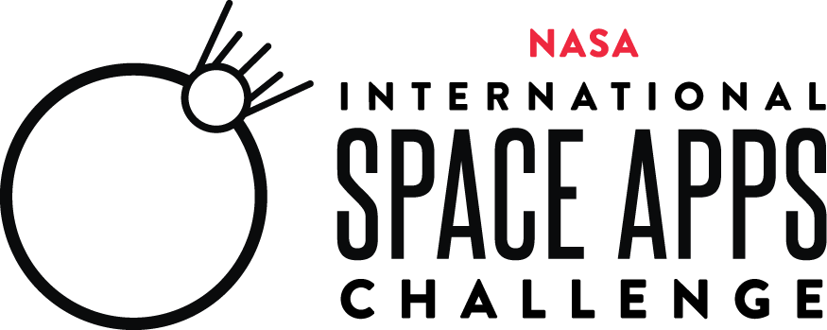
2025 NASA Space Apps Challenge Collaborator Satisfaction Survey

Thank you for participating as a NASA International Space Apps Challenge Collaborator! In order to provide an amazing experience for our NASA Space Apps community, we are asking for your feedback on the 2025 event. Please complete this short survey by October 24, 2025.

Paperwork Reduction Act Statement:
This information collection meets the requirements of 44 U.S.C 3507, as amended by section 2 of the Paperwork Reduction Act of 1995. You do not need to answer these questions unless we display a valid Office of Management and Budget control number. The OMB control number for this information collection is 2700-0153 and it expires on 08/31/2027. We estimate that it will take about 6 minutes to read the instructions, gather the facts, and answer the questions. You may send comments on our time estimate above to info@spaceappschallenge.org. Send only comments relating to our time estimate to this address.

(Internal Note. Please allow respondents to go back in the survey to change answers, if possible.
Also, * indicates a required question)

- Are you a 2025 NASA Space Apps Challenge Global Collaborator or Amplification Collaborator?*
  - Global Collaborator
  - Amplification Collaborator

- Why did you choose to be a 2025 NASA Space Apps Challenge Collaborator? (Open Answers)*

- What is your level of satisfaction with your 2025 NASA Space Apps Challenge collaboration? (Select one)*

Very Dissatisfied | Dissatisfied | Neutral | Satisfied | Very Satisfied

- How can your NASA Space Apps Challenge Collaborator experience be improved? (Open Answers)*

- Which element(s) of the 2025 NASA Space Apps Challenge did you like the most? (Open Answers)*

- Based on your experience, how likely would you be a Collaborator in future NASA Space Apps Challenges? (Select one)*

Very Unlikely | Unlikely | Neutral | Likely | Very Likely

- Please rate your level of satisfaction with the following aspects of your 2025 NASA Space Apps Challenge collaboration. (Select one for each aspect)*

 | Strongly Disagree | Disagree | Neither Agree Nor Disagree | Agree | Strongly Agree
I thought the onboarding process was clear.
I found the Collaborator Communications Toolkit to be helpful.
I thought the Collaborator Terms & Conditions were clear.

- How would you improve any of the above aspects of your 2025 NASA Space Apps Challenge Collaboration? (Open Answers) (Optional)
  - Collaborator Onboarding Process: _____________________
  - Collaborator Communications Toolkit: __________________
  - Collaborator Terms & Conditions: ______________________

- How did you promote the 2025 NASA Space Apps Challenge to your community? (Select all that apply)
  - Facebook
  - Instagram
  - X
  - Newsletter to community
  - Newsletter to company employees
  - Email to community
  - Email to company employees
  - Slack Workspace
  - Shared during an event
  - Other: __________________ (open answer)
10. Please provide us with any other comments or elaborate as needed on any of your previous answers. (Open Answers) (Optional)

If they answered ‘Global Collaborator’ to question #1, then ask # 11, 12
- How many NASA Space Apps Challenge participants used your Global Offer? (Open Answers)

- Please share a story about a NASA Space Apps Challenge participant using your Global Offer to create their project. (Open Answers)

- Please provide us with any other comments or elaborate as needed on any of your previous answers. <open answers text box -- optional>

